PLANNING STATEMENT

This statement has been prepared in support of the application for Full Plans to re-locate the erection of a new dwelling at Gwern y To Farm, Shocklach, previously approved under Planning Application P/2021/1144.

Background

The historical Planning Approval has been approved for the demolition of existing house and re build new dwelling on the existing foot print. The existing Farmhouse has been demolished in readiness for commencing the erection of the new dwelling. The location of the proposed dwelling is situated within the flood risk area see figure 1. Construction of the new dwelling has not yet commenced

Following demolition of the farmhouse the applicant has installed a temporary static caravan to live on site while the new dwelling is constructed. While living in the caravan the applicant and his family have experienced the extent of flooding to the property location and surrounding area. Photographs are attached indicating the severity of the flooding. As can be seen by the photographs the extent of flooding is dangerous and causes a health and safety risk for the applicant and his young children. During times of flooding the applicant and his family will not be able to leave or access the property safely.

There has been recent consultation from NRW to advise the Applicant and other local land owners that they intend to end the funding for the running of pumps in Shocklach. This has caused great concern and worry to the Applicant as stopping of the pumps will increase the extent of flooding and therefore increase the risk to the applicant and his family.

Proposal

The applicant proposes to re-locate the proposed dwelling to an area outside the flood risk zone (see figure 2). This proposal is on the grounds of eliminating the risk to the Applicant and his family. The applicant intends to use the existing approved drawings.

The NRW have been consulted with regards to the re-location of the property and have confirmed their recommendation of locating the development away from the flood risk area.

Drainage

The applicant proposes to re locate the treatment plant to an area outside the flood risk area. The discharge from the treatment plant will be discharged to a herringbone soakaway situated outside the flood risk zone reducing the risk of contamination.

Conclusion

Overall, therefore the application is for re-sitting of the new dwelling on grounds of health and safety to the applicant and his family, with the intention to provide a proposal with a sympathetic scale and form to the surrounding area.

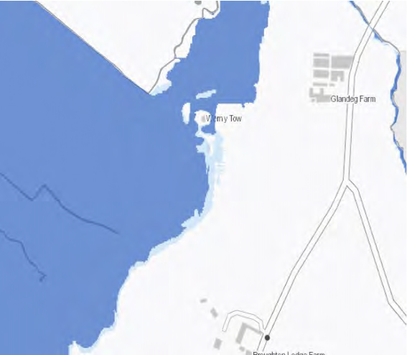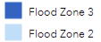
Contains Ordnance Survey data © Crown copyright and database right 2023 Natural Resources Wales copyright and database rights 2023

Figure 1. NRW Flood Zone mapping (NRW, 2023)

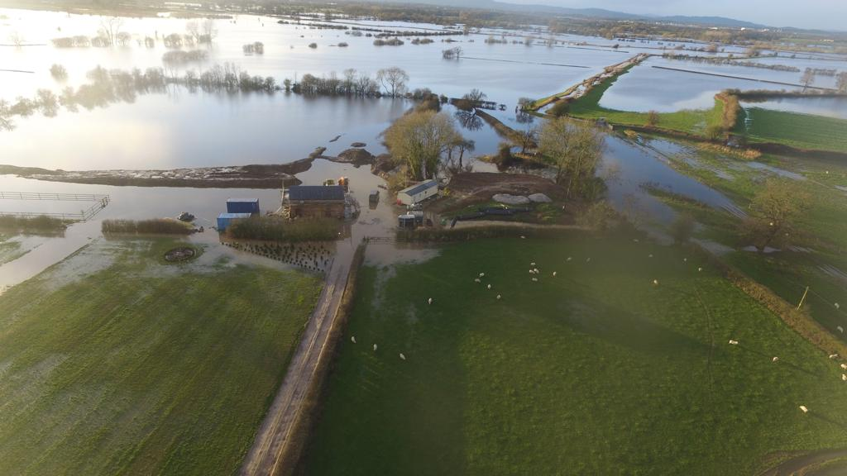

Photograph 1
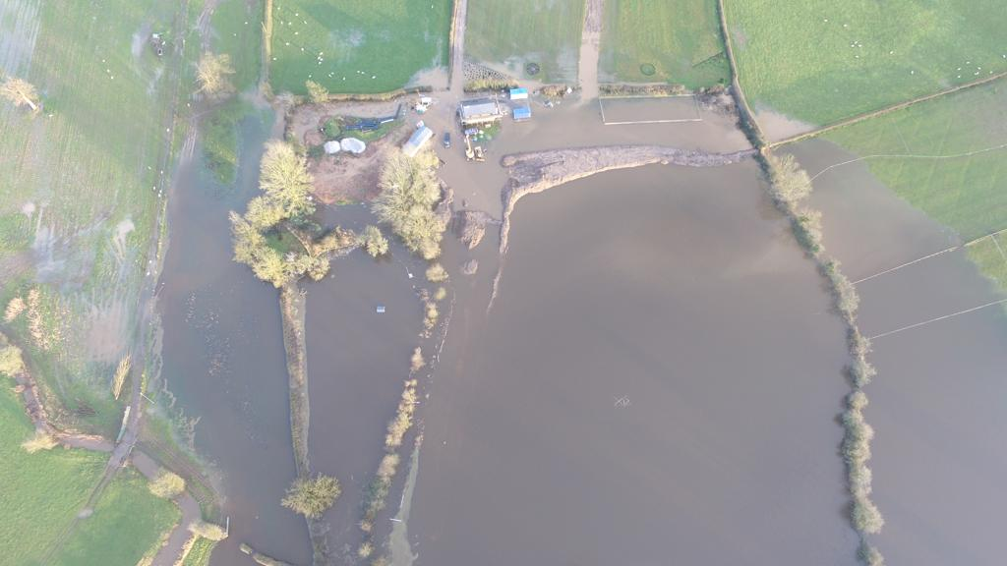

Photograph 2

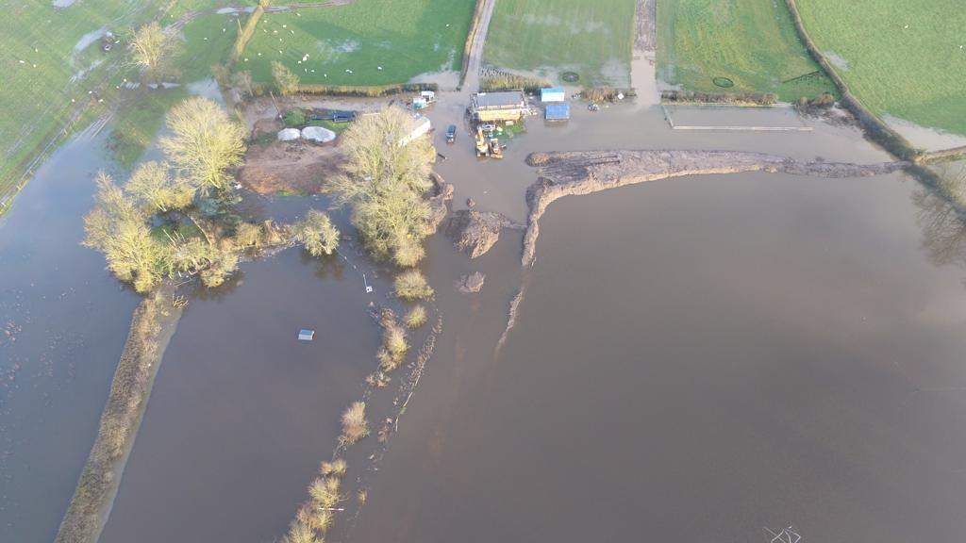

Photograph 3

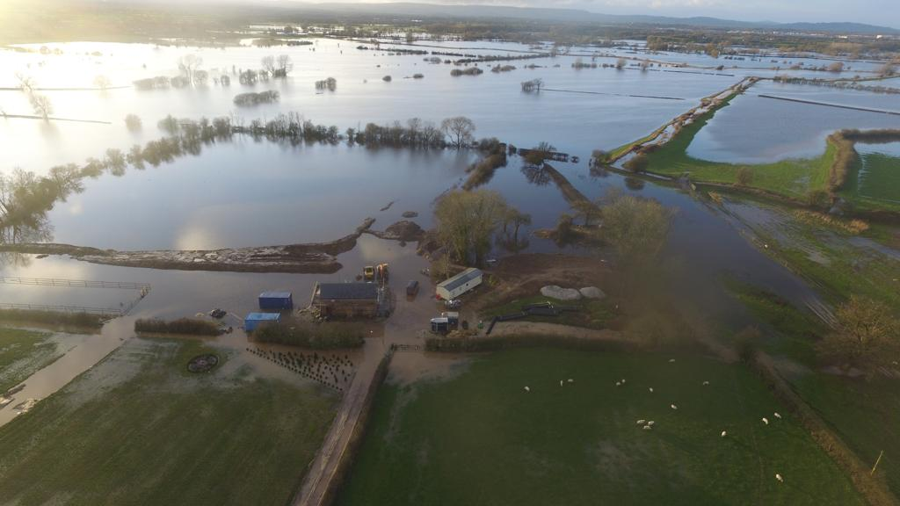

Photograph 4

