
Bob Dewey

PLANNING

SUPPORTING STATEMENT AND

ADDITIONAL INFORMATION
PROPOSED USE of MANÈGE
GLEBE FARM. BRONINGTON

Background: Glebe Farm has been operated as a livery yard and in 2006 (ref P/2006/0686) it use was authorised. That permission required the provision of passing places on the lane leading to the site from A 495.

Subsequently a new (replacement) manège was constructed in 2018 with the benefit of planning permission (ref P/2018/0657). This replaced a smaller area adjacent to the farm house on which there were no planning controls. Conditions were imposed which limited to private use in connection with the dwelling.

Extract from the permission:-
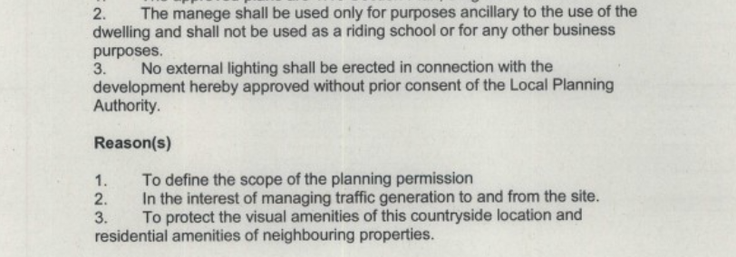

So far as we are aware, no discussion occurred prior to the imposition of condition 2 which presents some confusion in that the whole site has long established planning permission as a livery. It is understood that Highway Officers raised no objections to the proposal.

This new application is made to clarify the issues and avoid any possible future action by the Council. It also proposes to provide details of floodlighting which may be installed in the future.

INFORMATION

The following information is provide to assist the Council in determining this application,

The manege is intended to serve the existing livery users and only from time to time will be used for special equestrian events.

It is available for use by horses in livery from 9 am until 6 pm seven days per week. If floodlights are permitted, the evening usage may extend to 8 pm.

When the usage is extended to permit other owners to bring ponies/horses for competitions/displays this will only be at weekends and is normally limited to mornings and early afternoons. No evening events are envisaged. Occasionally, it may be hired out to individuals and local riding and pony clubs.

At present the site is manned solely by the applicant and his wife as residents of the adjoining farm house. In the future, it may be necessary to employ one or two staff members to assist in running the site. There is on site accommodation which they may be permitted to occupy. If events are arranged, a small number of additional casual labour will be brought into control operations.

A large area is already provided for parking of horse boxes and cars and this has been hard surfaced with self draining materials and will allow grass to grow through to soften the impacts. There is no possibility of vehicles having to stop on the adjoining lanes and there is no reason to expect this to occur. Staff will be instructed to ensure this does not happen.

The previous planning permission required the provision of passing places along the lane and these have been provided and allow vehicles to have a clear view of any oncoming traffic.

Riders attending the site on open days will arrive at various times to suit the agenda of any competitions and generally will leave soon after their horse have competed. It is expected that vehicles will arrive/depart at different times so there is no reason for traffic to need specific management on the public highway. This was clearly demonstrated at a small number of events which were mistakenly operated in breach of the condition. In the extremely unlikely event that problems arise, the applicants will easily ensure safe flows of traffic. Given the minimal traffic flows on the lane, it is difficult to see anyone else being inconvenienced.

Floodlights

The floodlights will be LED 33 watts units (see specification) affixed to poles approximately 10 metres high. This height is necessary allow them to be angled down on to the arena and to minimise any light spillage beyond the surfaced area. The nearest house is some distance away and if any issues were to arise, they would undertake to re-align the lights to prevent nuisance.

Conclusion:

The Council is urged to remove the two conditions as now requested.

Robert A Dewey BA(Hons) MBA Dipl Est mgmt., Dipl TP, Dipl Transp Std, MRTPI.
October 19 2021
Rev2

The Gables, Llanfynydd WREXHAM. LL11 5HG

tel: 01978 761315 (m) 07947 186 777

e mail bobdeweyplanning@gmail.com

