
1 Grenville terrace
Station road
Ruabon
Wrexham
LL14 6DL

07719407902
Pjr-roofing@hotmail.com

Existing roof elevation showing window to be replaced.
The current roof window is a standard velux centre pivot roof window. It is a 1180 x 780 size.

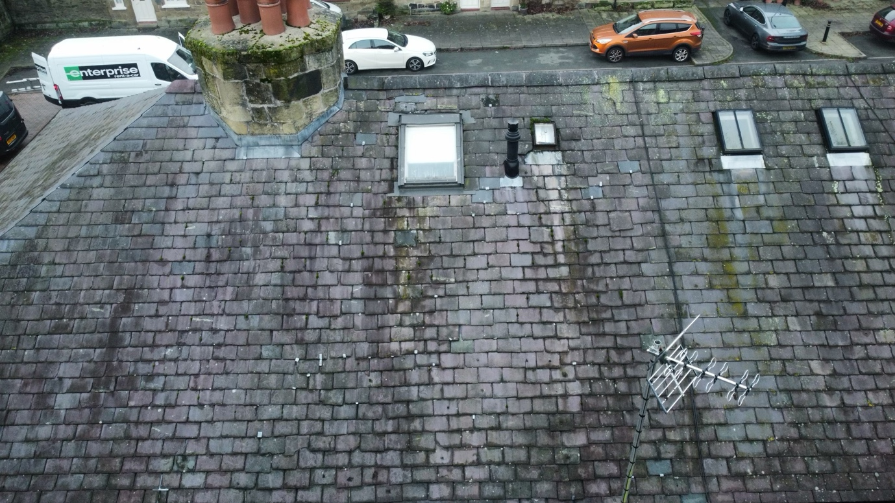

Proposal
We are proposing to change the current velux window for a conservation style keyLite alternative of the same size.
The new window will be the modern equivalent of the 2 similar windows next door and also match others in the terrace.
The new window will be a top hung window to accommodate escape in the event of a fire.
https://www.keyliteroofwindows.com/products/roof-windows/conservation/

