1 Bryn Alyn Barns – Heritage Impact Statement
This statement is designed to support a planning application for alterations to the listed dwelling at 1 Bryn Alyn Barns. The Barn is considered to be curtilage listed alongside the farmhouse (Bryn Alyn Farm) which is a good example of an early C19 farmhouse.
We are planning a number of minor changes to improve the dwelling as well as make required changes due to wear and tear.
The changes are listed with example images to support:
1: The existing front door is in need of replacement due to the timber of the door warping and splitting.
The existing door is painted timber cottage style door with a small window. The painted timber construction is in keeping with the two adjacent properties, however neither of the neighbouring properties have a window.
(Existing Door Images)
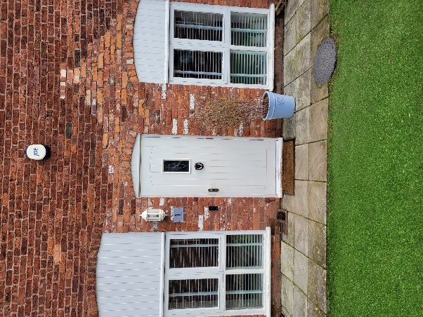
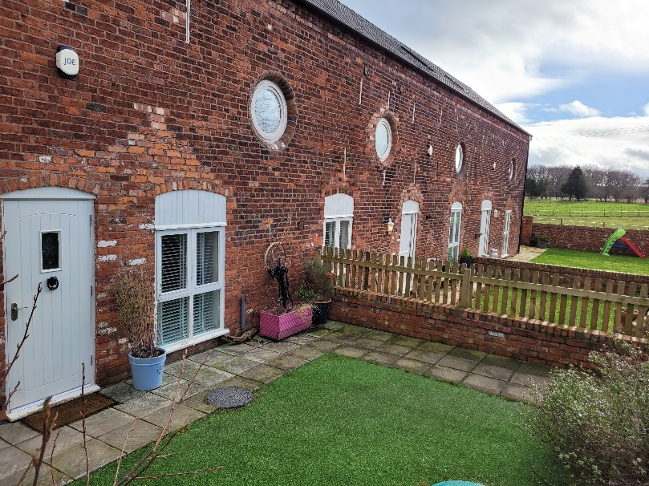
Our intention is to change the existing door to a half-glazed cottage style painted timber door as shown below. The reason for changing to a door with more glazing is to allow more light into the entrance hallway as it is currently very dark.
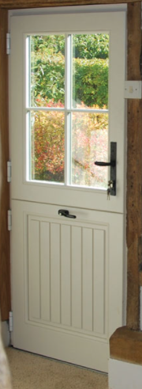
(Hallway and new door style)
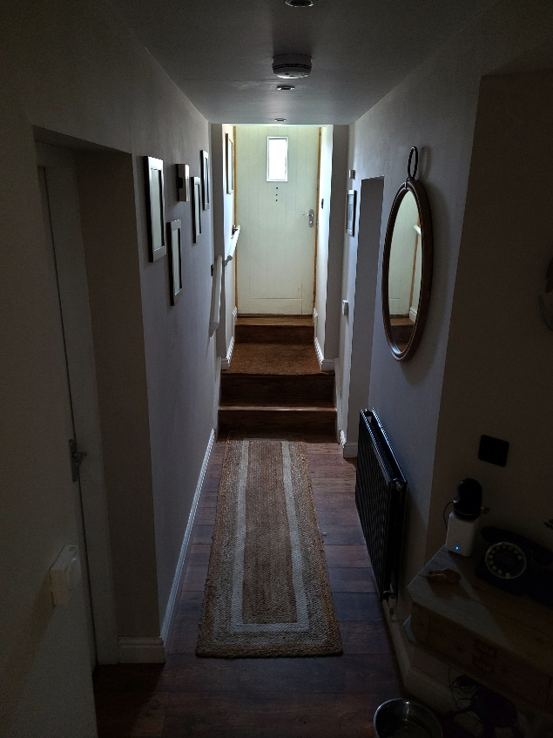

We feel that as long as the door is the same style and painted the same colour as the existing windows and neighbouring doors the impact upon the building will be minimal but the improvement in light to the hallway space will be significant.
2: We wish to install a set of patio / French doors to the rear extension to allow a free flow between the room and the enclosed rear garden. This will again allow more light into the interior space which is currently quite dark due to the single window.
(Existing elevation image)
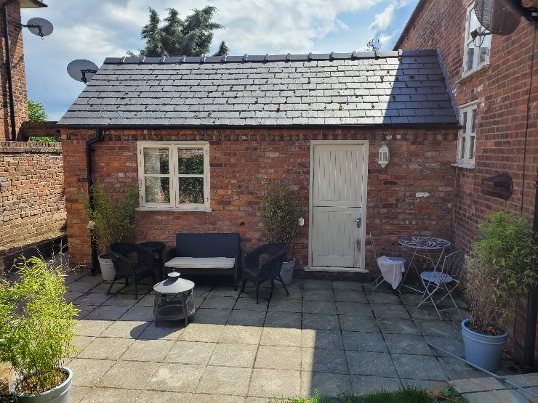
We wish to replace the existing window with a set of doors as shown below:
One of the neighbouring properties constructed a new extension in 2020 and installed similar doors to what we are proposing.
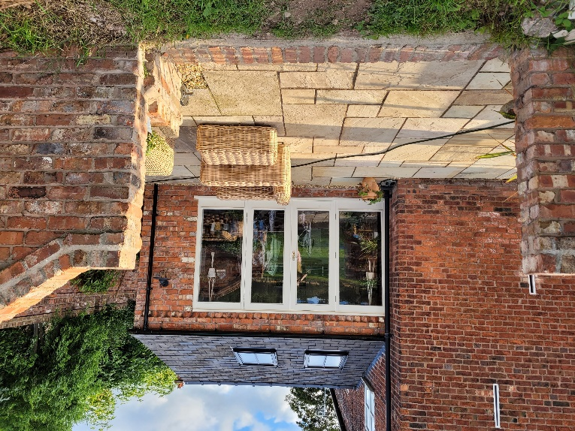
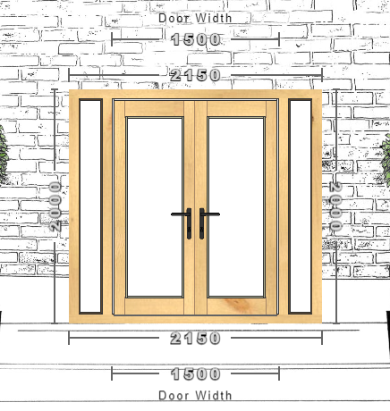
(New proposed French doors & Neighbour’s Property – Precedent)

The existing window will be reinstalled in place of the current rear door in order to allow further light into the property.
This is shown in the below proposed elevation plans.
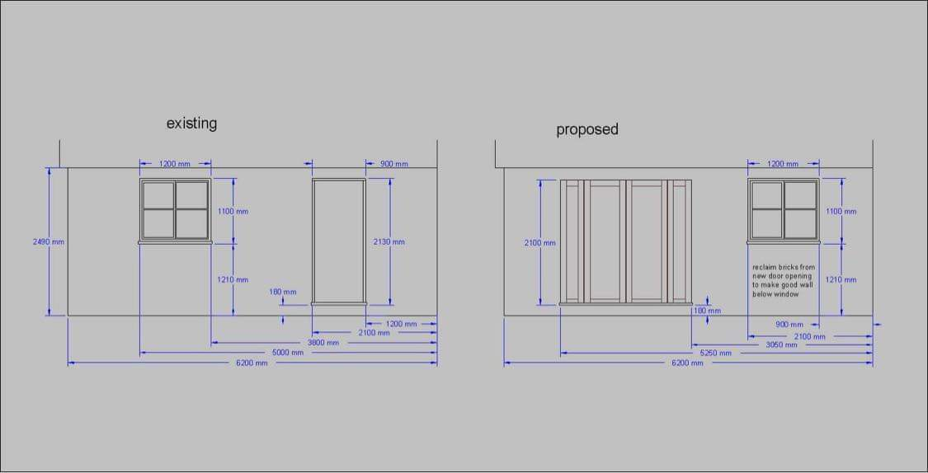
The new proposed French doors will be of timber construction and will be painted to match the existing window. We do not believe this will have an impact on the site or building as the changes are contained within the walled garden and are only to the newer extension and not the original Barn.
3: We plan to create a stud walled divide in the rear extension in order to install a downstairs WC and utility room for washing machine and dryer which the property does not currently have. As these changes are solely internal they will have no impact on the building elevations.
4: The existing window will be moved to replace the current rear door and allow light into the newly created divided space. The bricks removed for the new French doors will be utilised to brick up the current door and create the opening for the window.

Overall we do not believe the proposed changes have a detrimental impact on either the building or the site as a whole. All works will be undertaken in keeping with the existing fittings and surrounding buildings including the re-use of the existing window and bricks. The proposed changes will improve the general quality of the house with additional light to darker spaces and the addition of a downstairs WC and utility space which is currently missing.

