APPENDIX B
Woodcroft Farm

A Farm activities and site context

B Description of habitats

B1 Improved grassland
B2 Semi-improved grassland
B3 Hedges
B4 Individual Trees
B5 Scrub
B6 Ponds
B7 Watercourses

C Habitat Evaluation

C1 Improved grassland
C2 Semi-improved grass
C3 Hedges and hedgerow trees
C4 Woodland
C5 Ponds
C6 Watercourses

D Habitat enhancements

D1 Improved grass
D2 Semi-improved grass
D3 Hedges and hedgerow trees
D4 Woodland
D5 Ponds
D6 Watercourses

Maps (4 in total)

Appendix: Plants recorded whilst surveying

PART 2. Reports for Individual Farms

Woodcroft Farm

A Farm activities and site context

This is a calf rearing enterprise with a combination of grazing and indoor winterfeeding using silage and bought-in inputs. At Woodcroft 3 acres are farmed in total, and most cattle graze on rented land. The land is scattered across four sites. It all lies around 50m above sea level and is gently sloping with a landscape and soils influenced by glacial drift deposits.

Nearly all the farm is laid down to permanent grass.

Existing biological records form the farm and immediate vicinity are fairly sparse. This is partly because the area is not well recorded.

The land is intensively managed and, in common with much of the land in the “North Shropshire Plain”, the habitats on the farm have been affected by nutrient enrichment. Atmospheric nitrogen deposition from ammonia and nitrous oxide exceeds the critical limits for native habitats such as woodland and moorland.

B Description of habitats

Surveying was carried out by Peter Jackson on the 24th September 2021, 12th-13th January 2022 and 3rd February 2022. The weather was clement on all occasions.

B1 Improved Grassland

This is the predominant habitat on the farm. “Improved grass” is defined as grassland where rye grass and clover form at least 25% of the sward. The sward is dominated by perennial rye grass. There are generally few herbaceous flowering plants.

A fair amount of the Improved Grass is not of particularly high quality. It can contain a large proportion of Yorkshire Fog and Cocksfoot. Creeping Buttercup, Meadow Buttercup and White Clover and Dock can all be frequent.

In gateways with frequent traffic Annual Meadow Grass, Scentless Mayweed and Greater Plantain are common.

There is a small active badger sett in one field at Millbrook (F1)

Extent of habitat: around 50ha

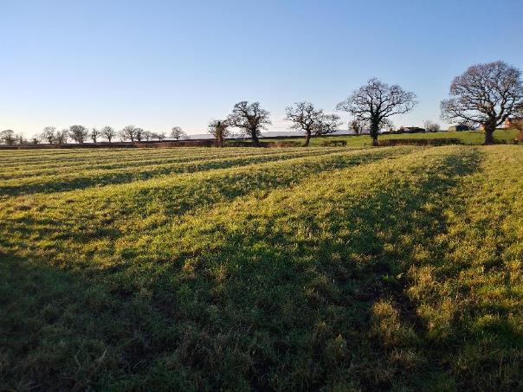
Figure 1: Improved grass at Millbrook. The ridge-and-furrow is characteristic of much of this farm.
B2 Semi-improved Grassland

There are small fragments of grassland where rye grass is almost absent. Here the sward has a more “natural” appearance and there is greater diversity. The grasses comprise species such as Common Bent, Yorkshire Fog and there are a variety of herbaceous species. These include Birds-Foot Trefoil, Meadow-Sweet, Common Knapweed, Tormentil, Lesser Celandine (and Creeping Thistle). One fragment occurs at Whitchurch Road (F13A), another at Burgess Lane (F17) Both are quite similar.

A tiny patch of more species-rich grass also occurs on one of the steeper banks at Millbrook (in F8) in a more heavily grazed situation. Herbaceous species include: Daisy, Self-Heal, Cats-Ear, Primrose, Lesser Celandine, Cuckoo Flower and Tormentil.

Extent of habitat: <0.5 ha

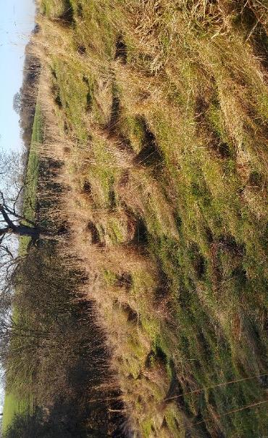
Figure 2: Sem-improved grassland at Whitchurch Road (F13A)

B3 Hedges

Nearly all the field boundaries are hedges. These are typically 1.5 to 2m height and of similar width. The main species are Blackthorn, Hawthorn, Field Maple, and Hazel, with minor amounts of Elder. Most hedges have at least four species in any 100m stretch, but there are some stretches of hedge that are almost pure Blackthorn. A few stretches of hedge have a greater variety of species. For example, the hedges H12 and H13 at Millbrook which contain Holly and English Elm.

Brambles are an abundant component of many hedges as is Ivy. Bracken only rarely occurs.

The hedge margins are typically dominated by nutrient-loving species such as Nettle, Cleavers, Creeping Thistle and Cow Parsley.

Extent of habitat: 5,900m

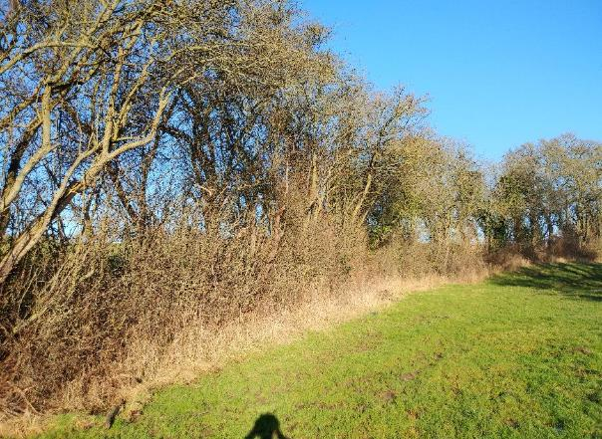
Figure 3: Overgrown hedge at Millbrook (H13)). This is ready for laying. If left unmanaged the hedge will decline further: the hawthorn will lose vigour and is likely to be damaged in gales.

B4 Individual trees

There around 80 mature trees on the farm. Most of these are at Millford, and all but handful are hedgerow trees. The few scattered in-field trees at Millford are mainly relicts of lost field boundaries. The trees are overwhelmingly Durmast Oak (Quercus robur) and are typically around 30- 50cm in diameter. There are also a few Ash, mainly at Mulsford Lane. These are showing symptoms of dieback. Mulsford Lane also has a Large Leaved Lime.

The outstanding individual tree is the old oak in F10 (See Figure 1). This is a true veteran, several hundred years old. There is evidence of a history of pollarding and possibly lightning strike. It is now in a phase, of retrenchment (possible terminal).

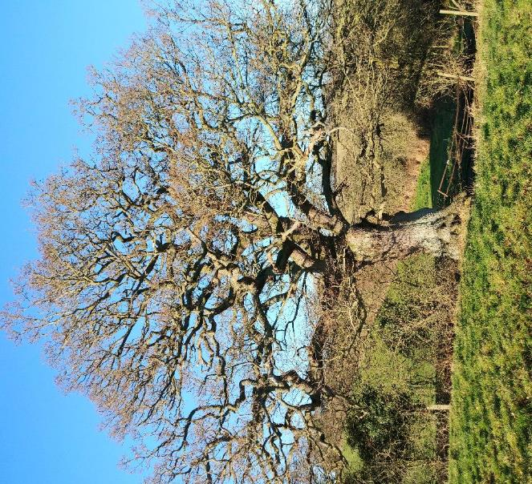
Figure 4 One of the better hedgerow oaks on the holding. Millbrook (H3)
B5 Scrub

There are several small areas of scrub or young woodland. The areas are so small that the two categories have been considered together. All owe their existence to being riparian areas which have been fenced off from grazing stock. Blackthorn thickets may be present due to expansion from hedges and hawthorn is frequent. Tree species include willows (Crack Willow and Grey Willow).

At Burgess Lane there is a patch with a fairly diverse ground flora. This includes Primrose, Dog’s Mercury, Wood Avens, Lesser Celandine, Coltsfoot, Barren Strawberry, Wood Speedwell as well as various garden escapes.

There has been some recent tree planting at Mulsford Lane.

Extent of habitat: <0.5 ha

B6 Ponds

There are around ten ponds on the holding. Some are entirely fenced off, others are unfenced.

There are various associated wetland plants such as Soft Rush, Sweet Grass, Duckweed, Pondweed, Fine leaved Water-Dropwort, Reed Canary Grass, Water Plantain. No doubt there would be quite a number of additional species that could be recorded in the summer.

Extent of habitat: 0.2 ha

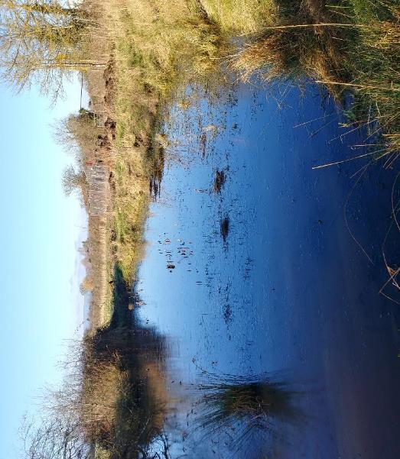
Figure 5: Unfenced pond at Whitchurch Road (W10)

B7 Watercourses

There are small brooks at Millbrook, Mulford Lane and Burgess Lane. These tend to be overshadowed by dense scrub cover or if not by Nettle or Bramble.

C Habitat evaluation

C1 Improved grassland

This is a habitat of low biodiversity. The number of species that feed on rye grass is relatively low and there is low structural diversity. The fields generally have or have had high inputs of nitrogenous fertiliser and slurry and probably have had herbicide applications to combat docks and thistles. None of these inputs improves biodiversity.

C2 Semi-improved grass

The greater diversity of plants and more complex structure of the vegetation, provides a wider range of habitats than the improved grass. None of the species recorded are uncommon.

C3 Hedges and hedgerow trees

The hedges, which have a good range of shrub species, are one of the most significant assets for biodiversity on the farm. They are rather variable in condition; several have gaps along their length or open areas at the base.

There is considerable scope to improve the condition of the hedges and to make them better habitats for wildlife by sympathetic management.

The hedgerow trees are a very important asset

C4 Scrub

The amount of scrub/woodland is low and of fairly low interest. It provides good habitat for nesting birds and cover. Botanically it is of low interest. The ground layer tends to be dominated by nettle and other eutrophic plants

C5 Ponds

These are an important wildlife habitat whose value far outweighs their area. The ponds appear to be in reasonable condition. Access by stock is potentially a problem but most ponds have some areas where the sides are too steep or have scrub. Controlled grazing within a greater buffer area around each pond would be the ideal.

C6 Water courses

The water is likely to be enriched in nutrients. The stream at Mulsford Lane has numerous records for Himalayan Balsam which is an invasive species. To make any lasting impact this would have to be controlled on a catchment basis working downstream.

D Habitat enhancements

The high nutrient levels have a large impact on the local environment. The non-planted plants on the farm are largely adapted to nutrient -rich soils (e.g., bramble and nettle) and these tend to outcompete other native plants. The air is also rich in nitrogen containing compounds. This is evident from the growth of Xanthoria parietina on twigs and branches and even barbed wire. This lichen is especially adapted to nitrogenous environments.

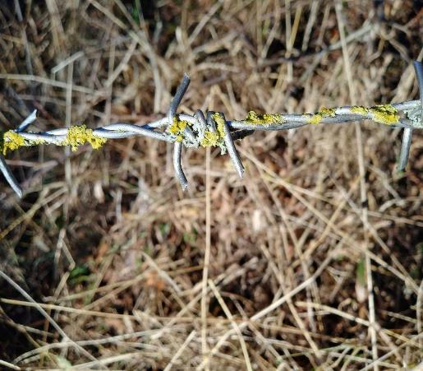
Xanthoria parietina on barbed wire at Millbrook.

A farming system that had much less in the way of nitrogen and phosphorus inputs would be beneficial for biodiversity. However, there is still a lot that could be done to improve the current situation.

Improvements are likely to be driven by the incentives in the forthcoming sustainable farming scheme. Some possible measures are outlined below

D1 Improved Grassland

- Diversify sward composition Multi-species leys have the potential to provide pollen and nectar providing the plants are allowed to flower. Additional components such as clovers, chicory and plantain have been used successfully on dairy farms. Sward management is more complex.

- Diversify sward height. Practical challenges
- Reduction in fertiliser use. Obvious conflicts with production. Last year and this year bio fertilizers have been used on trial to reduce nitrogen fertilizer usage.
- Uncut field margins.

D2 Semi-improved Grassland

- Expansion
- Avoid fertiliser inputs
- Ensure sufficient grazing to prevent scrub encroachment

D3 Hedges and field trees

- Hedgerow management – cutting regime

Current management is quite variable. Some hedges have been cut to the same height for many years. This leads to knuckled growth at the top and gappiness in the base. As part of good management, the hedges should be allowed to gradually increase in size where feasible. For conservation purposes “larger is better”: more food, more shelter, more carbon sequestration.

- Hedgerow trees

There is considerable scope for more hedgerow trees on the farm. The current number of around 70 could easily be increased. If there were an average of one tree every 30m of hedgerow, there would be space for 200 trees. There are obvious biodiversity benefits and the trees will also provide shelter, shade and act as an additional carbon sink.

- Hedgerow restoration/ planting

- Several hedges are ready for major renovation through laying or coppicing.

- A hedgerow management plan should be developed that takes into account various practical constraints.

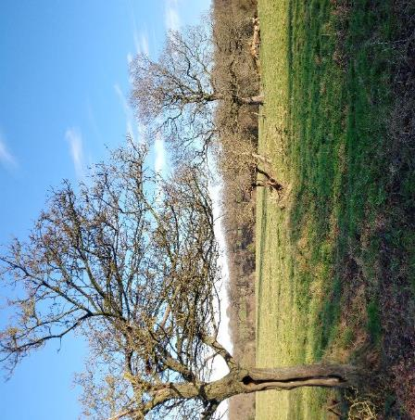
Figure 6: Very derelict hedge at Millbrook (H5)
D4 Woodland

- Woodland creation
There is scope for woodland creation but this may not be practical since most of the land is rented.

D5 Ponds

- Larger buffer area around ponds fenced out.
- Managed stock access.
- Create new ponds.

D6 Water courses

- Wider buffer area along stream corridors.

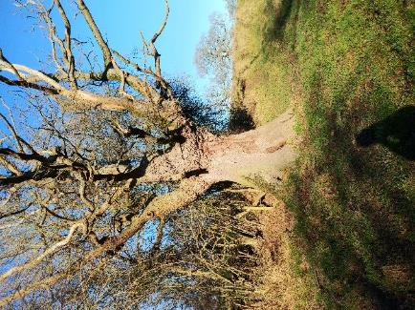
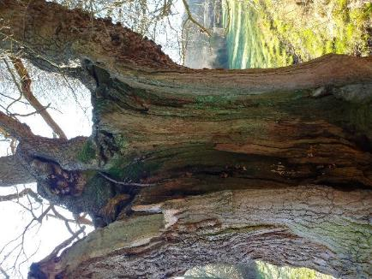
A biodiversity hotspot: Veteran pollarded oak at Millbrook (F8)

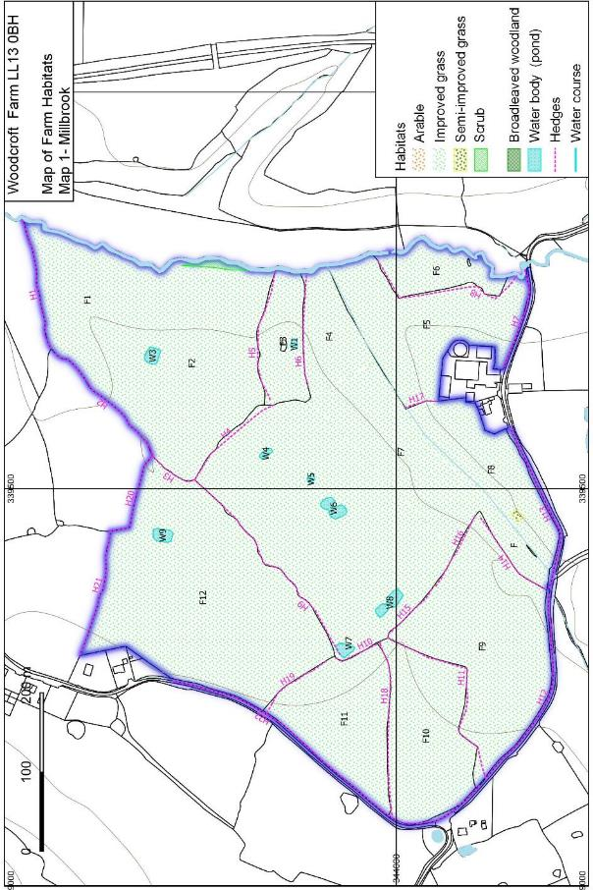

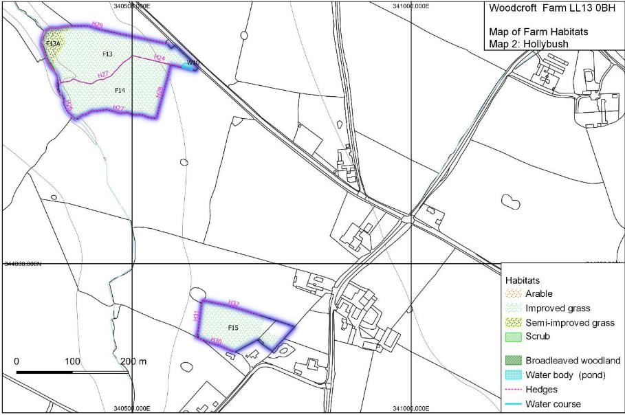

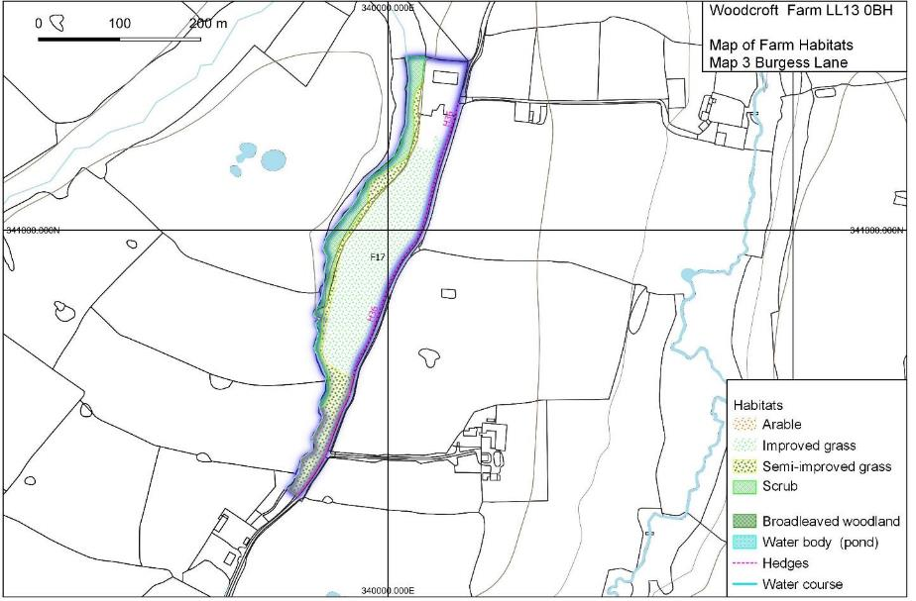

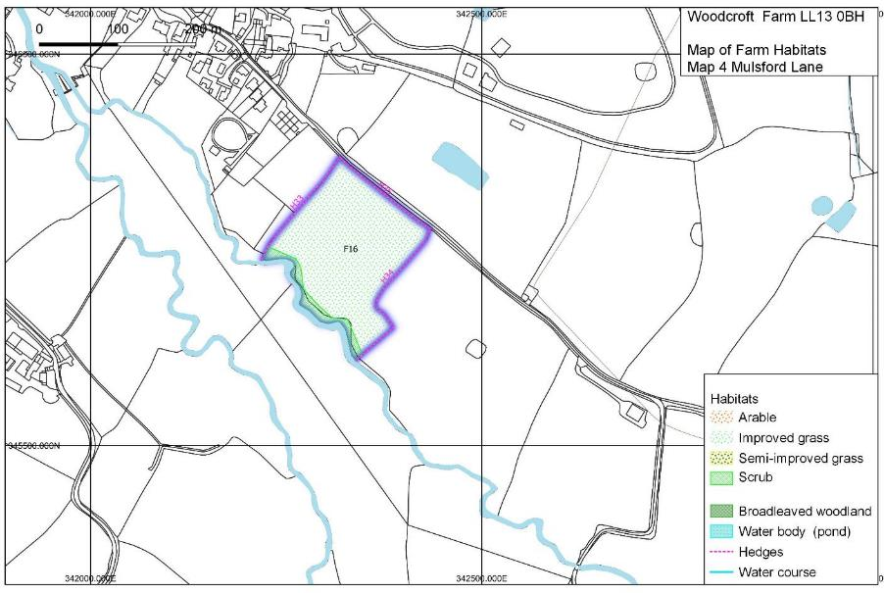

Appendix: Plant species recorded whilst surveying

English name | Latin name | Millbrook | Hollyb | Mulsford | Burgess
Annual Meadow-grass | Poa annua | * |  | *
Ash | Fraxinus excelsior | * |  |  | *
Barren Strawberry | Potentilla sterilis |  |  |  | *
Birds foot Trefoil | Lotus corniculatus |  | *
Bittersweet | Solanum dulcamara |  |  | *
Blackthorn | Prunus spinosa | * | * | * | *
Bracken | Pteridium aquilinum | *
Bramble | Rubus fruticosus agg. | * | * | * | *
Broad-leaved Dck | Rumex obtusifolius |  |  | * | *
Bugle | Ajuga reptans | *
Cats Ear | Hypochoeris radicata | * |  | * | *
Chickweed | Stellaria media | * |  | *
Cleavers | Galium aparine | * | * | * | *
Cocksfoot | Dactylis glomerata |  | * | *
Coltsfoot | Tussilago farfara |  |  |  | *
Common Bent | Agrostis capillaris |  | *
Common Knapweed | Centaurea nigra | * | * |  | *
Common Sorrel | Rumex acetosa | *
Cow Parsley | Anthriscus sylvestris | * |  | * | *
Crab Apple | Malus sp. | *
Crack Willow | Salix fragilis |  |  |  | *
Crane's Bill | Geranium sp. |  | * | *
Creeping Bent | Agrostis stolonifera | *
Creeping Buttercup | Ranunculus repens | * | *
Creeping Thistle | Cirsium arvense |  | *
Crested Dog's Tail | Cynosurus cristatus | *
Cuckoo Flower | Cardamine pratense | *
Cuckoo Pint | Arum maculatum |  |  |  | *
Daisy | Bellis perennis | *
Dandelion | Taraxacum officinal agg. | * |  | *
Dead Nettle | Lamium sp. | *
Dog Rose | Rosa canina | * | * |  | *
Dog's Mercury | Mercurialis perenne |  |  |  | *
Duckweed | Lemna sp. | *
Durmast Oak | Quercus robur | *
Elder | Sambucus nigra |  |  | * | *
English Elm | Ulmus procera |  | *
Field Maple | Acer campestre | * | * | * | *
Fine-leaved Water-dropwort | Oenanthe aquatica | *
Germander Speedwell | Veronica chamaedrys | *
Greater Plantain | Plantago major | * | *
Grey Willow | Salix cinerea | * | * | *
Ground Elder | Aegopodium podagraria |  |  | *
Ground Ivy | Glechoma hederacea | *
Hard shield fern | Polystichum aculeatum |  | *
Harts Tongue Fern | Phyllitis scolopendrium | * |  |  | *
Hawthorn | Crataegus monogyna | * | * | * | *
Hazel | Corylus avellana | * | * |  | *
Herb Robert | Geranium robertianum | *
Hogweed | Heracleum sphondylium | *
Holly | Ilex aquifolium | *
Honeysuckle | Lonicera periclymenum | *
Ivy | Hedera helix | * | * | * | *
Large Leaved Lime | Tilia platyphyllos |  |  | *
Lesser Celandine | Ficaria verna |  | * | * | *
Male Fern | Dryopteris filix-mas | *
Marsh Bedstraw | Galium palustre | *
Meadow Buttercup | Ranunculus acris |  | * |  | *
Meadowsweet | Filipendula ulmaria |  | *
Moss | Calliergon cuspidata | *
Moss | Kindbergia praelonga | *
Moss | Mnium hornum | *
Nettle | Urtica dioica | * | * | * | *
Opposite-leaved Saxifrage | Chrysosplenium oppositifolium | *
Pendulous Sedge | Carex pendula | * |  | * | *
Perennial Rye Grass | Lolium perenne | * | * | * | *
Primrose | Primula vulgaris | * |  |  | *
Red Clover | Trifolium pratensis |  | *
Reed Canary-grass | Phalaris arundinacea | * |  | *
Bulrush | Typha latifolia | *
Ribwort Plantain | Plantago lanceolata | *
Scaly Male Fern | Dryopteris affinis agg. |  |  |  | *
Scentless Mayweed | Tripleurospermum inodorum
Sharp-flowered Rush | Juncus acutiflorus |  | *
Silver Birch | Betula pendula | *
Smooth Meadow-grass | Poa pratensis | *
Snowdrop | Galanthus nivalis |  |  | *
Soft Rush | Juncus effusus | *
Sweet Grass | Glyceria sp. | * | *
Tormentil | Potentilla erecta | * | *
Tufted Hair-grass | Deschampsia cespitosa | *
Velvet Bent | Agrostis canina |  | *
Water Plantain | Alisma sp. |  | *
White Clover | Trifolium repens | * | * | * | *
Willow Herb | Epilobium sp | * |  | *
Wood Avens | Geum urbanum | * |  |  | *
Wood Speedwell | Veronica montana |  |  |  | *
Wych elm | Ulmus glabra | * |  |  | *
Yorkshire Fog | Holcus lanatus | * | * | * | *

The field margins will still need occasional cutting or blackthorn suckers lead to the hedge becoming very wide.
Trees could either be recruited from existing hedge shrubs (especially field maple) or could be planted with suitable protection.
Permanent stock exclusion is not necessarily appropriate as it would allow a dense tree cover to develop which would reduce sunlight on the water surface and shade out interesting marginal plants.

