PROPOSED ERECTION OF A PEACE STATUE IN WREXHAM

The world’s longest relay run, the Oneness-Home Peace Run, wishes to donate a Peace Statue to Wrexham. The site chosen is within Acton Park, a well-established and beautiful area for recreation and peaceful re-charging within the city.

When the Peace Run visits a community, an Olympic-style peace torch is passed from hand to hand, giving those present the opportunity to make a private wish for peace. The statue offers the same opportunity on a permanent basis, but with a bronze torch instead of the flaming original. It is therefore intended to be interactive and a bilingual explanatory information board would be positioned adjacent to the site. There is no site-specific style for information boards in Acton Park, so we are proposing one that has been tried and tested at other such sites.

Over the years, the Peace Run has offered various gifts to the communities it visits around the world. In Wales it has donated four peace statues. The first was unveiled in 2012 by the Lord Mayor of Cardiff, and stands in Cardiff Bay, on the waterfront between the Senedd and the Norwegian Church. The second was placed in the National Botanic Garden of Wales, which was unveiled by Lord Elis-Thomas and the Leader of Carmarthenshire Council in 2016. The third and fourth were in 2019, both in the north west of Wales, at Treborth Botanic Garden (part of Bangor University), and in Parc Padarn at Llanberis, close to the National Slate Museum. Photos are included in this document.

The Run would very much like to include a statue in the north east of the country as part of this peace initiative. Wrexham is an exciting place of inspiration and aspiration, with its newly bestowed city status, cultural credentials and its growing importance within Welsh life.

The proposed site within Acton Park has been chosen in consultation with local community representatives. It is close to a vantage point beside the lake, which appears already to be something of a hub for families and dog walkers to pass the time of day. In the area there are already established various benches, areas for angling and information boards about the lake and the park. Situated in the grassland alongside the walkway which surrounds the lake, a peace statue would blend in well with the existing recreational land use for those who find peace and beauty in nature. It is not anticipated that the footfall would change significantly due to the statue, so there would be no effect on existing flora or fauna, trees or animal life generally. Local schools are actively encouraged to take part in projects within the park, and it has been suggested that the children might create some planting of flowers around the site over time, and which they would maintain. The interactive nature of the statue has proved popular with children elsewhere in Wales. Stepping stones from the lakeside pathway to the statue were suggested by community representatives at the recent site visit. They are therefore shown on the site plan for illustrative purposes, though they do not form part of this planning application as they do not constitute permanent fixtures.

Gifts from the Peace Run are funded by individual supporters of it. In this case the main donors are Mr and Mrs John and Tamsin Evans, the Peace Run Coordinators in Wales, who are putting in this planning application.

There is no cost to Wrexham Council associated with the erection of the peace statue. It is a gift, and its installation would be managed as a private commission by Mr and Mrs Evans. Whilst the Council would be asked to add the statue to its existing public liability insurance, any day to day maintenance would be undertaken by the Peace Run’s local representative. Being manufactured from bronze it requires minimal maintenance – occasional washing in slightly soapy water during dry weather and regular polishing with specialist Renaissance Wax. The A1 sized information board is designed to be weatherproof and vandal resistant. The layout and wording on the information board would be agreed with the Council.

The aim is to enhance Acton Park, and Wrexham, for its residents and visitors, whilst providing ongoing interest, beauty and pride in the nation’s history of peace and international goodwill.
Supplementary information about the Peace Run

www.peacerun.org (2013 onwards)
www.worldharmonyrun.org (up to 2012)

The Peace Run is a global relay that seeks to promote international friendship and understanding. It is officially known as the Sri Chinmoy Oneness-Home Peace Run after its founder, the poet and philosopher Sri Chinmoy. Since its inception in 1987 it has traversed over 150 nations and touched the lives of millions of people. The Peace Run does not seek to raise money or highlight any political cause, but simply strives to create goodwill among peoples of all nations.

By passing the torch from one person to the next, the relay offers people from many nations the opportunity to express their hopes and dreams for a better, brighter future. People from all walks of life hold the symbolic torch to wish for a peaceful world. Passing the torch from one person to the next unites us together in our common aspiration to offer something positive to our world – together we can make a difference!

Although this is something of a grassroots initiative, it has met with approbation on many levels worldwide. The Peace Torch has been held by Nelson Mandela, Desmond Tutu, Mother Theresa, various Popes, and the Queen used the Peace Run Torch to light the first of 1800 Beacons of Peace across Great Britain as part of the 50th V.E. Day Celebrations. Perhaps more importantly, it has been passed from hand to hand by countless schoolchildren and members of the public throughout the globe.

Over the years, the Peace Run has been welcomed to Wales by various politicians, schools and organisations etc – a few highlights below:

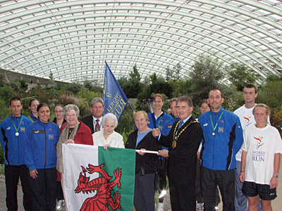
At the National Botanic Garden of Wales 2 October 2006
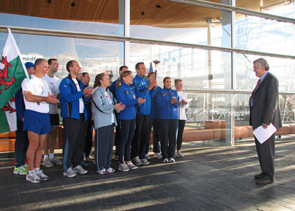
At the Senedd with the First Minister 4 October 2006
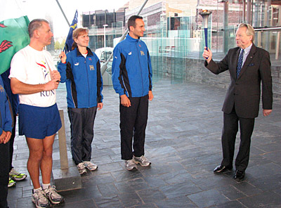
… and the Presiding Officer 4 October 2006

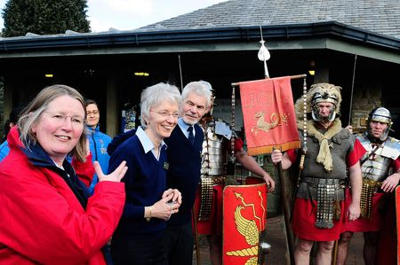
In Caerleon with Marilyn Lewis, Director of CADW, 14 March 2010
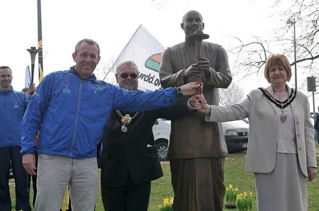
With the Lord Mayor and Lady Mayoress in Cardiff Bay, 11 March 2012

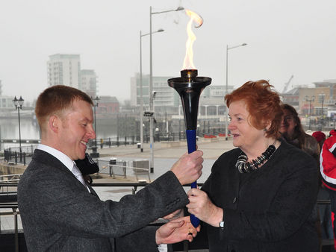
With the Presiding Officer, Rosemary Butler AM passing the peace torch to the Head Teacher of Mount Stuart Primary School in Cardiff, Peter Morris, 12 March 2012

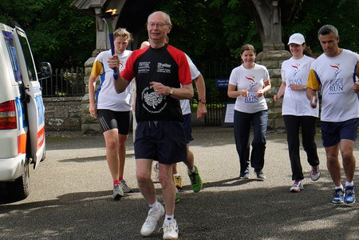
With the Dean of Brecon Cathedral 30 May 2013
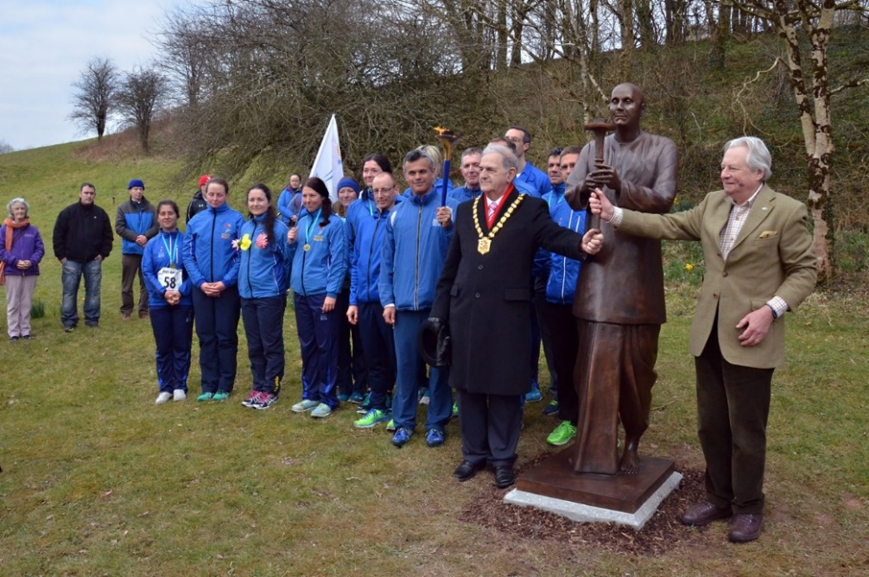
At the National Botanic Garden of Wales on 13 March 2016, after the unveiling of the peace statue by Lord Elis-Thomas and the Leader of Carmarthenshire Council
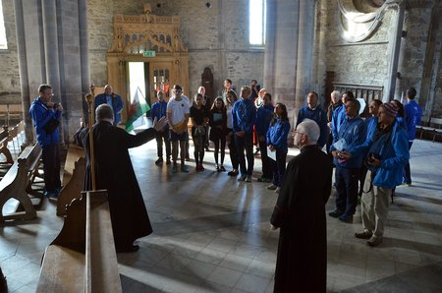
Being given a tour of St Davids Cathedral on 14 March 2016

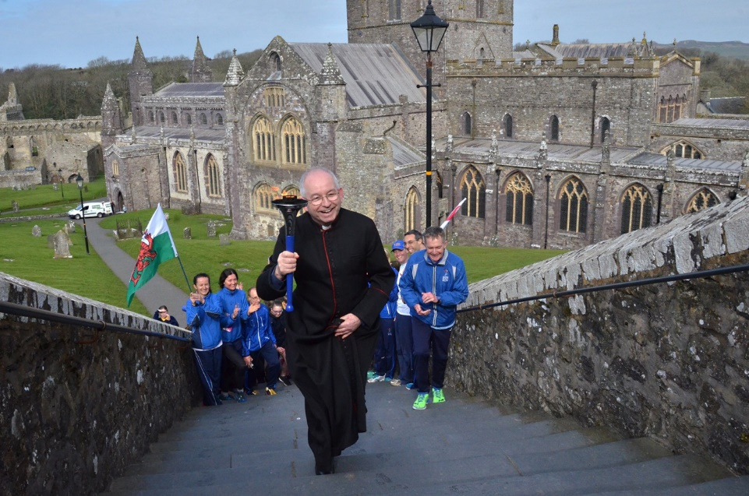
… where the Dean, David Lean, proved his running credentials!

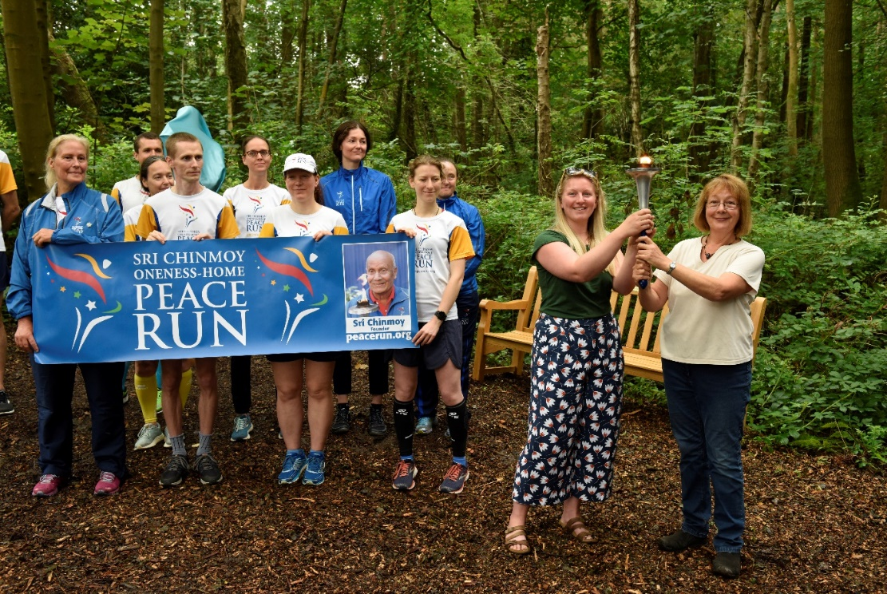
Meeting the Curator and Chair of the Friends at Treborth Botanic Garden, 4 August, 2019

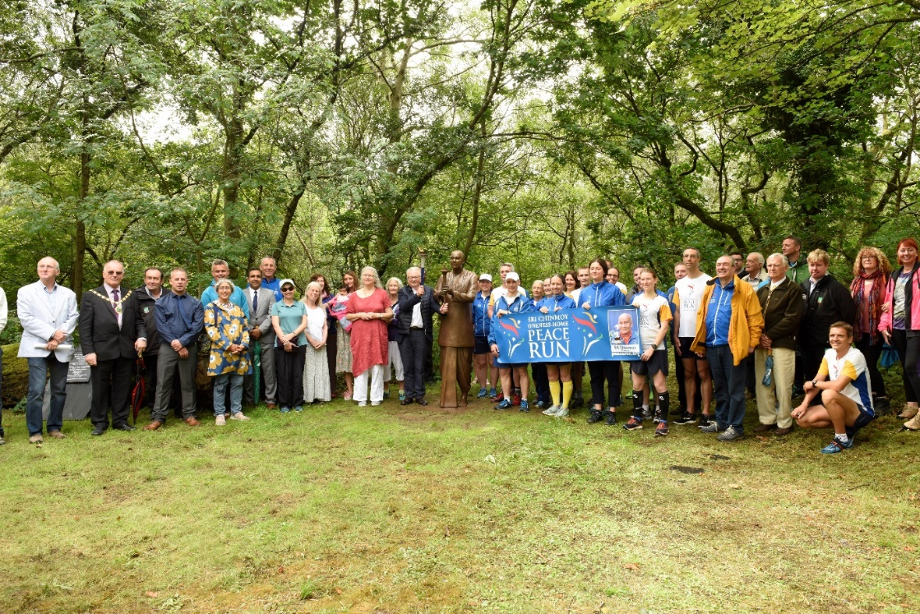
. and then a team photo at Parc Padarn, Llanberis, later the same day, 4 August 2019

The four current peace statues in Wales:

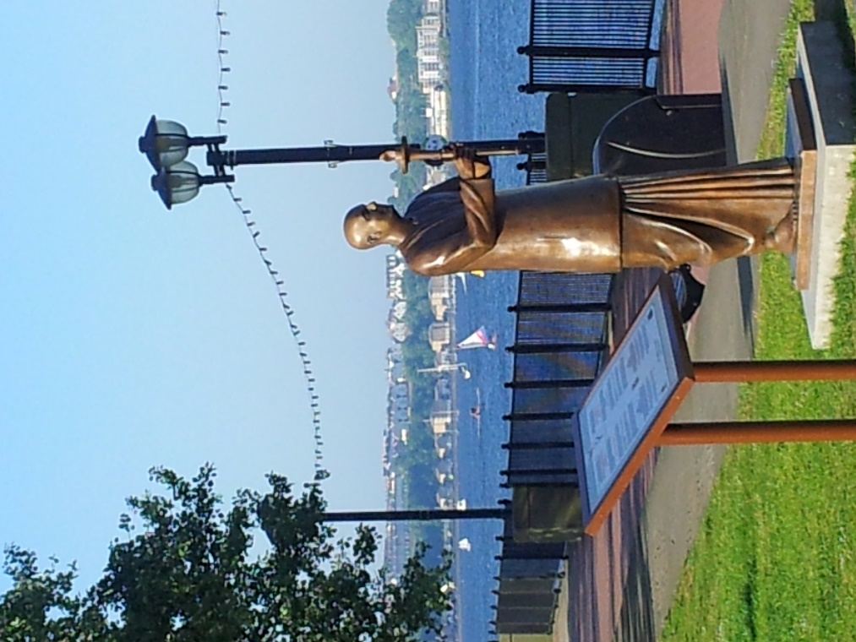

Cardiff Bay

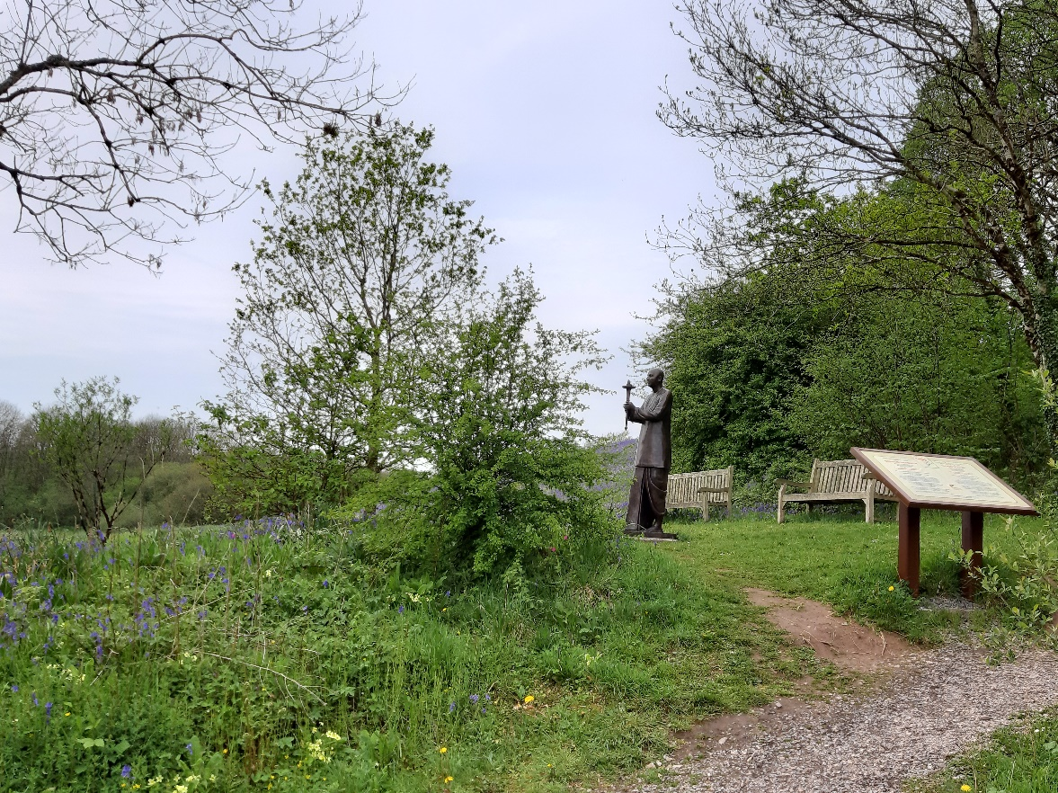
National Botanic Garden of Wales, Carmarthenshire
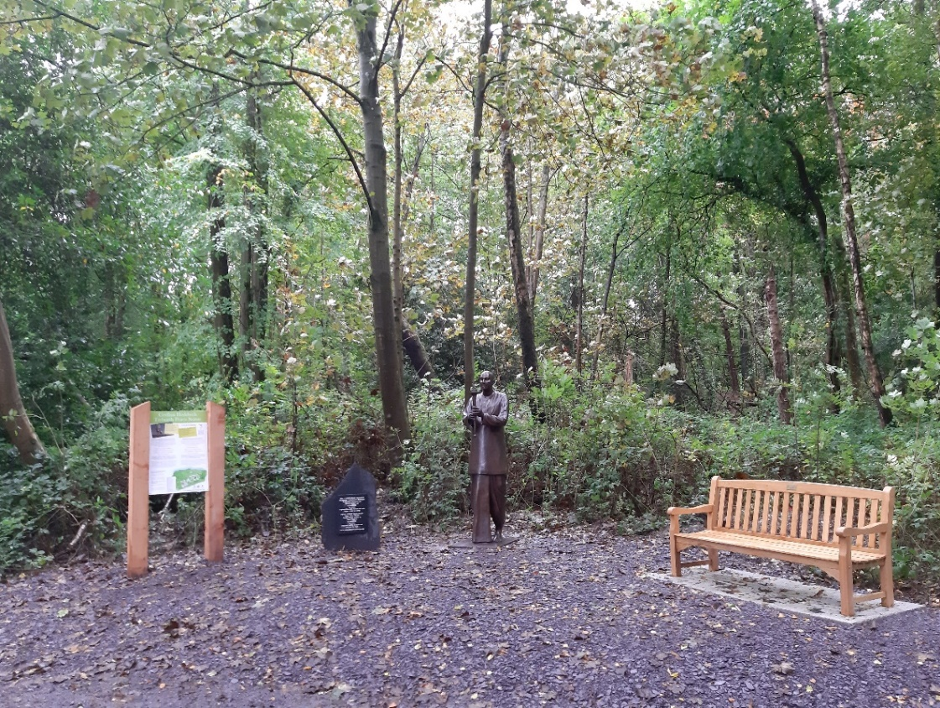
Treborth Botanic Garden, Bangor

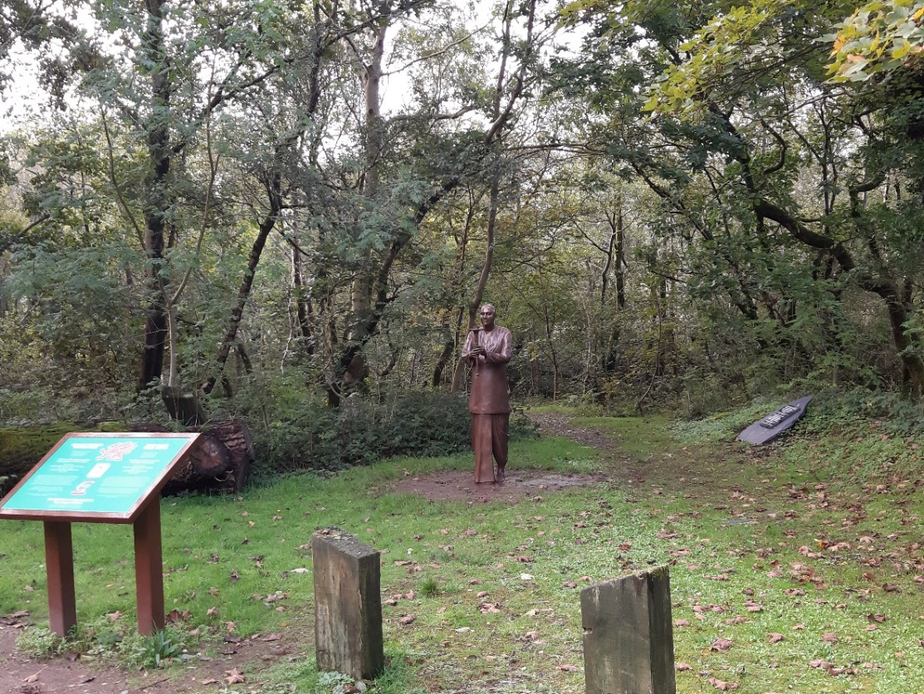
Parc Padarn, Llanberis
The proposed information board in Acton Park would be the current version of those in Cardiff, Carmarthenshire and Llanberis, seen in the photos above.

