DESIGN AND ACCESS STATEMENT
SITE AT GAMFORD HOUSE, GAMFORD LANE,
ROSSETT LL12 0EW

REDEVELOPMENT OF SITE WITH MIXED USE OF 9no. DETACHED CARBON ZERO DWELLINGS, AN OFFICE BUILDING AND ASSOCIATED LANDSCAPING WORKS

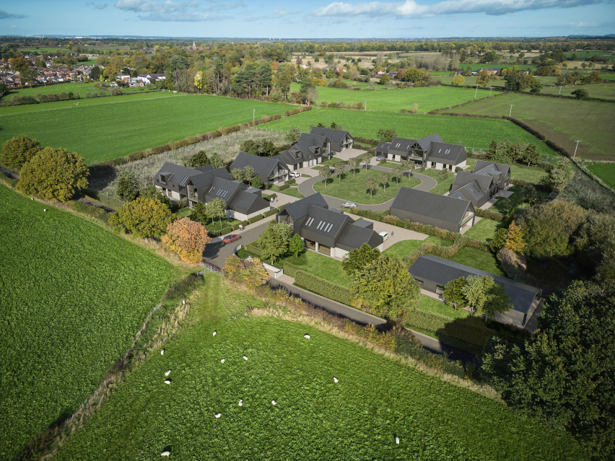


December 2022

Contents

- Introduction
- Design of Proposals
- Use /Renewable Energy
- Amount
- Layout
- Scale
- External Appearance
- Landscaping
- Access
- Assessment of Access and Inclusive Design

SITE AT GAMFORD HOUSE, GAMFORD LANE, ROSSETT LL12 0EW
REDEVELOPMENT OF SITE WITH MIXED USE OF 9no. DETACHED CARBON ZERO DWELLINGS, AN OFFICE BUILDING AND ASSOCIATED LANDSCAPING WORKS

- Introduction
1.1 The purpose of this Draft Design and Access Statement is to demonstrate that the requirements of policies within the Wrexham County Borough Council Unitary Development Plan 1996-2011 have informed the design of the proposals. In particular, policies GDP1 General development principles relating to design, and T8 Parking have been addressed and satisfied. However, of equal importance is the consideration of comments made by both the Council and the Planning Inspectorate with regard to the requirement for any scheme to have a ‘rural’ character.
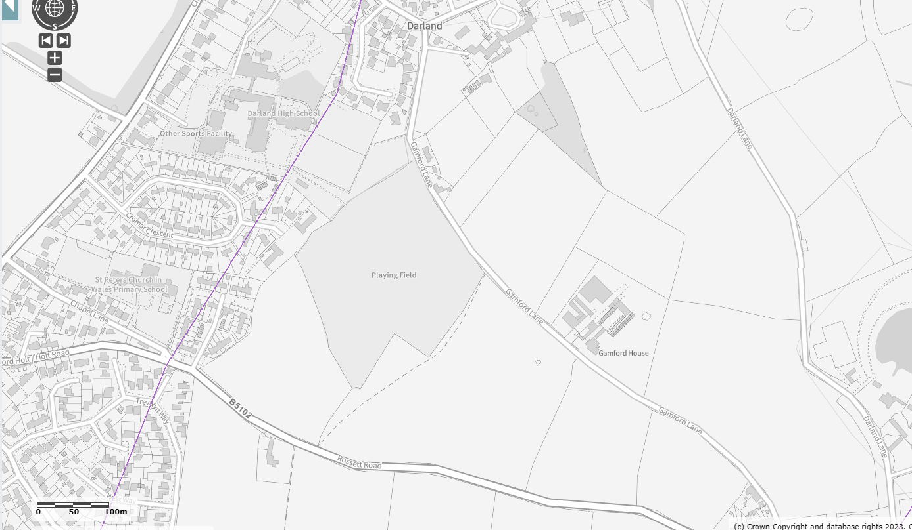
Gamford House Location Plan

- Design of Proposals
  - The scheme proposes the erection of 9no.Sustainable Carbon Zero detached properties following the demolition of Gamford House and workshop buildings across the site. In order to achieve a ‘rural’ character, the development will be gated to enclose an unadopted area where infrastructure will not be provided to adoptable highway standards but will be constructed of materials and to a design that secures and enhances a rural character to the development.
2.2 The fundamental principles that have informed the design process for these proposals are contained within Wrexham UDP 1996-2011 Development Objectives Policy GDP1:
All new development should:-
a) Ensure that built development in its scale, design and layout, and in its use of materials and landscaping, accords with the character of the site and makes a positive contribution to the appearance of the nearby locality.
b) Take account of personal and community safety and security in the design and layout of development and public / private spaces.
c) Make the best use of design techniques, siting and orientation in order to conserve energy and water resources.
d) Ensure safe and convenient pedestrian and vehicular access to and from development sites, both on site and in the nearby locality.
e) Ensure that built development is located where it has convenient access to public transport facilities, and is well related to pedestrian and cycle routes wherever possible.
f) Ensure the safety and amenity of the public and safeguard the environment from the adverse effects of pollution of water, land or air, hazards from industry and quarrying, and associated noise, odour or vibration arising from development.
g) Secure public services (e.g. gas, water, electricity) to development at minimum public cost.
h) Safeguard sites and areas of nature conservation and wildlife interest, and to provide new habitats where there is an unavoidable loss of existing habitats and areas of wildlife interest.
i) Ensure that development does not result in, or is subject to, flooding, soil erosion, landslides or contamination, either on or off the site.
j) Have regard to the need to safeguard those areas that possess a strong Welsh cultural and/or linguistic identity from development that could harm this identity.
k) Secure the development of sustainable communities, through the promotion of the economic, social and environmental well-being of the area.

2.3 The proposals before you have been designed to meet each one of the above requirements of the development objectives in Unitary Development Plan 2006-Policy GDP1. A number of variants to the proposals have been prepared but it is the scheme indicated on Proposed Plans reference ST01, PL01-09 and OF01, which is the preferred option.
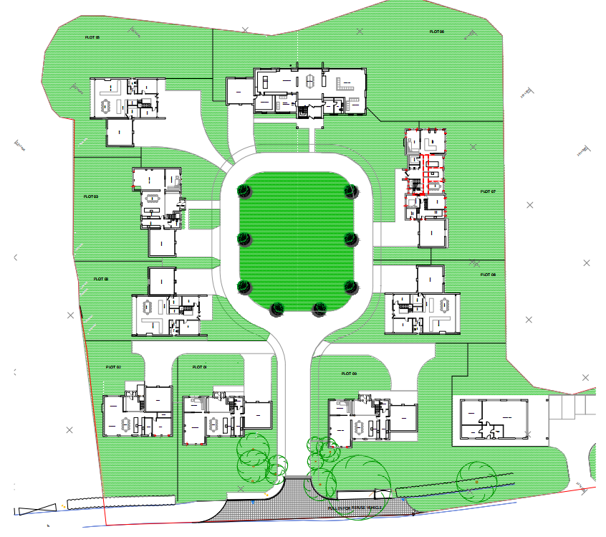
Plan ST 01
2.4 PPW11 paragraph 5.8.2 advises that the Welsh Government’s policy is to secure zero carbon buildings while continuing to promote a range of low and zero carbon technologies as a means to achieve this.
2.5 PPW11 Paragraph 5.8.3 goes further, to state that sustainable building design principles should be integral to the design of new development. Development proposals should mitigate the causes of climate change, by minimising carbon and other greenhouse gas emissions associated with the development’s location, design, construction, use and eventual demolition; and include features that provide effective adaptation to, and resilience against, the current and predicted future effects of climate change.
2.6 TAN 12: Design and Practice Guidance: Planning for Sustainable Buildings provide guidance on sustainable building design, these sustainable building design principles have been considered in the design process at Gamford House, to produce carbon zero buildings.
2.7 These targets will remain aspirational unless a scheme is permitted that will demonstrate that a carbon zero specification can be viable. Our proposals will raise design standards in the area and lead the way on sustainable design.
2.8 The provision of Net Carbon Zero homes at Gamford House is supported by three core principles: energy efficiency, low carbon heat and renewable energy. Energy efficiency relates to the use of energy for heating, hot water, ventilation, lighting, cooking and appliances. The efficient use of energy reduces running costs and carbon emissions. It also reduces a building’s impact on the wider energy supply network, which is also an important consideration.
2.9 Low carbon sources of heat are an essential feature of Net Zero carbon buildings. The new homes will be built with a low carbon heating system and will not connect to the gas network. Renewable energy generation in the new homes will be at least equal to the energy use of the building on an annual basis so that they are Net Zero carbon in operation.
2.10 Net Zero carbon homes are not only good for the planet, they will also be much cheaper to run than a standard new build house. This is due to the combined effects of a lower energy demand alongside greater flexibility of energy use during the day and of solar electricity generation and self consumption. A Net Zero carbon home in operation is very energy efficient and has an ultra low level of space heating demand. It does not use any fossil fuels on site and therefore improves air quality. It also generates renewable energy on-site and is cheap to run.
2.11 The building form will be as simple and compact as possible. This will reduce the exposed surface area for heat loss. The orientation and massing of the building will be optimised to allow useful solar gains and prevent significant overshadowing in winter. Each property will have electric vehicle charging points.
Placemaking
2.12 Placemaking is the ‘golden thread’ running through national planning guidance. Planning Policy Wales edition 11 (PPW11) reminds us that placemaking considers the context, function and relationships between a development site and its wider surroundings. This will be true for major developments creating new places as well as small developments such as this, created within a wider place.
2.13 Placemaking will require smart, multi-dimensional and innovative thinking to implement schemes that are truly placemaking. Our proposals add social, economic, environmental and cultural value to the development resulting in benefits which go beyond a physical development boundary.

- Use
3.1 The proposal is for a mixed use of residential and commercial units on a brownfield site with a lawful designation as mixed use. A landscaping scheme will form an integral part of the design in mitigating impacts upon the open countryside as well as enhancing the character of the site. New trees will highlight important vistas within the site and add separation and openness, breaking up the outline of the properties.
3.2 The scheme is proposed to remove the workshops, barns and pens and to replace them with a very low density group of dwellings and office building that meets modern standards of residential amenity, reflects local building character and allows important vistas to be established.

3.3 The provision of Net Carbon Zero homes at Gamford House is supported by three core principles: energy efficiency, low carbon heat and renewable energy. Energy efficiency relates to the use of energy for heating, hot water, ventilation, lighting, cooking and appliances. The efficient use of energy reduces running costs and carbon emissions. It also reduces a building’s impact on the wider energy supply network, which is also an important consideration.
3.4 Low carbon sources of heat are an essential feature of Net Zero carbon buildings. The new homes will be built with a low carbon heating system and will not connect to the gas network.
3.5 Renewable energy generation in the new homes will be at least equal to the energy use of the building on an annual basis so that they are Net Zero carbon in operation.
3.6 Net Zero carbon homes are not only good for the planet, they will also be much cheaper to run than a standard new build house. This is due to the combined effects of a lower energy demand alongside greater flexibility of energy use during the day and of solar electricity generation and self consumption.
3.7 A Net Zero carbon home in operation is very energy efficient and has an ultra low level of space heating demand. It does not use any fossil fuels on site and therefore improves air quality. It also generates renewable energy on-site and is cheap to run.
3.8 The building form will be as simple and compact as possible. This will reduce the exposed surface area for heat loss. The orientation and massing of the building will be optimised to allow useful solar gains and prevent significant overshadowing in winter.

- Amount
4.1 The proposal is to erect 9no. detached dwellings and a single storey office building.

The external dimensions are as follows:

Dwelling/Office | Number of Bedrooms | External floor area m²
Plot 1 | 5 | 230
Plot 2 | 5 | 205
Plot 3 | 5 | 180
Plot 4 | 5 | 170
Plot 5 | 5 | 180
Plot 6 | 5 | 260
Plot 7 | 5 | 255
Plot 8 | 5 | 180
Plot 9 | 5 | 230
Office building | - | 220

- Layout
5.1 The linear form of the workshops, sheds and pens will be replaced with 9no. interspersed detached properties that afford vistas to the open countryside and permeability. A large property would be positioned at the end of a vista into the site, with dwellings of a subservient scale arranged in clusters around a central green. The development would be gated allowing unadopted infrastructure to be constructed of materials that are more rural in character and can contribute to a courtyard feel.
5.2 The provision of a curtilage to each of the properties affords opportunities for planting and landscaping to be used to integrate the development into the landscape. The residential component to the development will be accessed from the extant main site entrance, whist the commercial use would be accessed from a separate extant access.
5.3 A single storey commercial office building would be positioned within the site but located to avoid clashes with the proposed residential uses and accessed from a bespoke driveway entrance leading to generous off street parking provision.
- Scale
6.1 The density of the development would be very low, at nine dwellings per hectare. Each dwelling will be either one and a half or two storeys in height whilst the office building will be single storey.
- External Appearance
7.1 Local Planning Guidance Note 30 has played an important role in the design process for this scheme. The dwellings will be constructed with a form and scale that is easily identifiable with rural buildings. The materials used on the elevations will also be in common with those found on rural buildings. Modern facilities such as electric vehicle charging points will be incorporated in the scheme with a similar sensitivity to the desired rural character.
7.2 Particular attention has been paid to the roofscape, which dominates the appearance of the dwellings and office, in materials that have the colour and patina of slate and in a form that reflects the local vernacular. Design cues have been taken from existing buildings in the locality of the site, at Darland and Lavister.

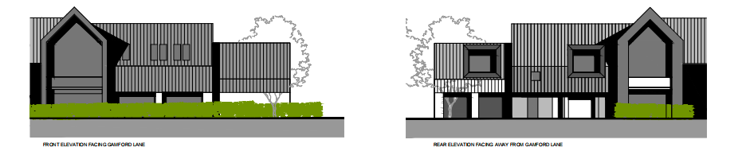
Typical elevations.
Details of external appearance are shown on plans PL 01-09, OF 01, and L 01

- Landscaping
8.1 The landscaping proposals are integral to ensuring that the proposals contribute to and enhance the character of the site in its environs. We have considered the following elements, in accordance with Local Planning Guidance Note 7:
- Existing boundaries
- The position of existing trees and whether they are to be retained or removed
- The intended uses and treatment of the external spaces
- The location of screening factors e.g. buildings, trees etc, within or outside the site
- The location of other structures
- The position and general type of planting

8.2 This submission is accompanied by a Landscape and Visual Impact Assessment, reflecting the importance we have attached to preserving and enhancing landscape character. The advice provided by Local Planning Guidance Notes: No.10 Public Open Space in New Housing Development and No. 17 Trees and Development have also informed the design of the proposals.
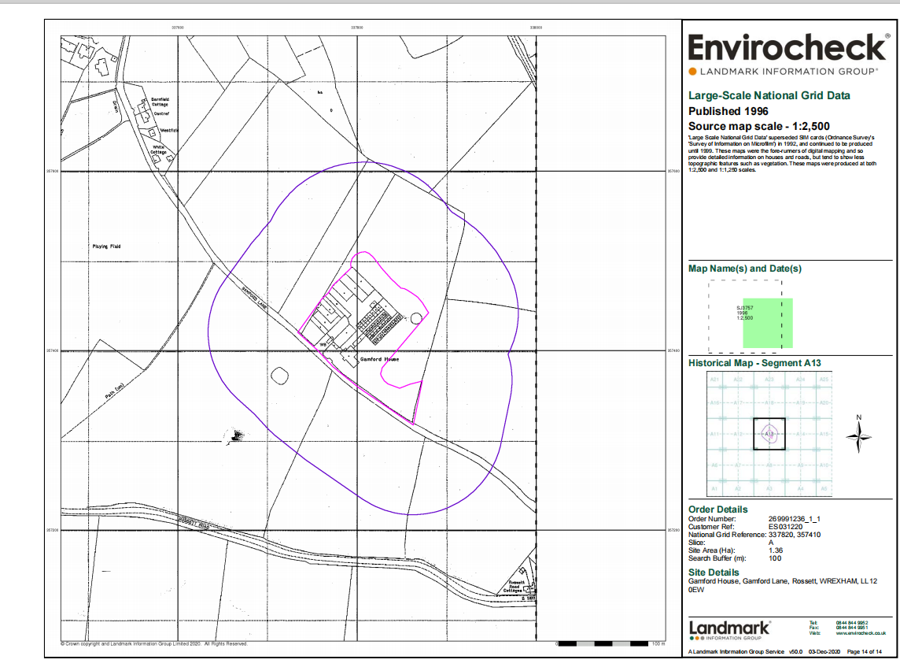

- Access
9.1 The proposals have been designed to comply with Approved Document M of The Building Regulations 2000 and British Standard 8300 and Inclusive Mobility. We are also aware of our duties under The Disability Discrimination Act including provisions which extend beyond the site, and for the provision of fire exit independent egress or fire refuges (Disability Rights Commission example Access Statements and DDA Code of practice (2002) Section 5.45) which covers more than Approved Document M. Local Planning Guidance Note 6 has been followed in detail.
9.2 PPW11 paragraph 4.1.18 states that Design and Access Statements should show how the design of the scheme has responded to the sustainable transport hierarchy.
9.3 The design of the internal access road has responded to urban design principles, including the guidance in Manual for Streets and the Active Travel Design Guidance.
9.4 The availability of public transport is an important part of ensuring a place is sustainable. The map below illustrates the sustainability of the location with services and amenities accessible on foot.
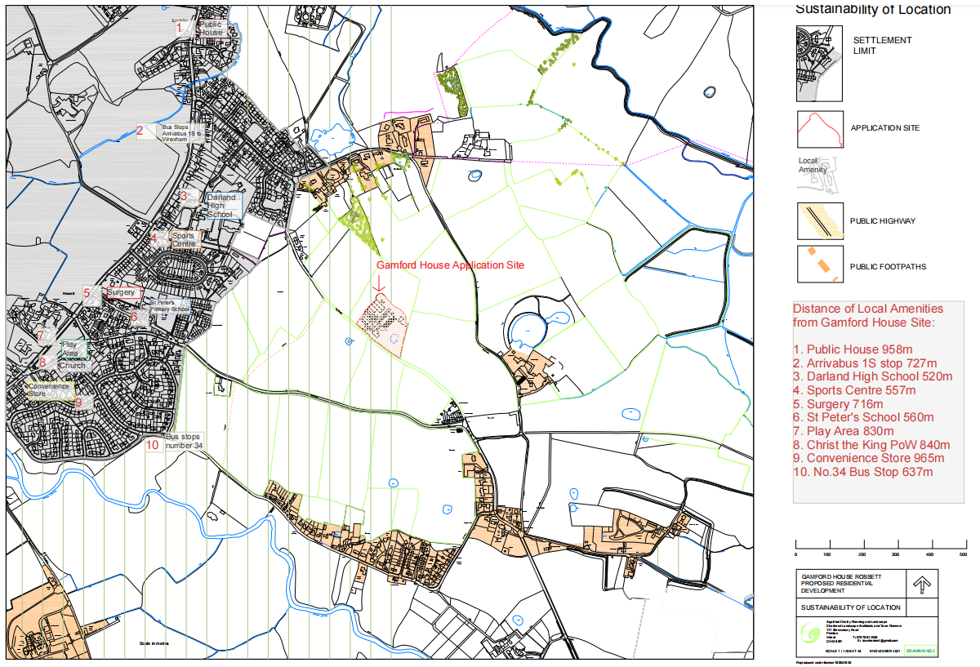

- Assessment of Access and Inclusive Design Against Planning Policies
10.1 One of the key requirements of inclusive design is the need to ensure that development is accessible to all users. This relates not only to its detailed design but also to its locational characteristics. In this case the site is accessible to all and is located within an area where its occupiers would not have to rely solely either on the private car or on public transport.
10.2 All users of the development would have equal and convenient access to the development itself and also to the local community and service facilities as those facilities are accessible by a range or means of transport.
10.3 We have met the requirements of Local Planning Guidance Note 16 with regard to parking standards, by providing four spaces per property.

DESIGN AND ACCESS STATEMENT
SITE AT GAMFORD HOUSE, GAMFORD LANE,
ROSSETT LL12 0EW
REDEVELOPMENT OF SITE WITH MIXED USE OF 9no. DETACHED CARBON ZERO DWELLINGS, AN OFFICE BUILDING AND ASSOCIATED LANDSCAPING WORKS

December 2022

