HERITAGE IMPACT STATEMENT
FOR PROPOSED WORKS AT:
67 Acton Gate, Wrexham

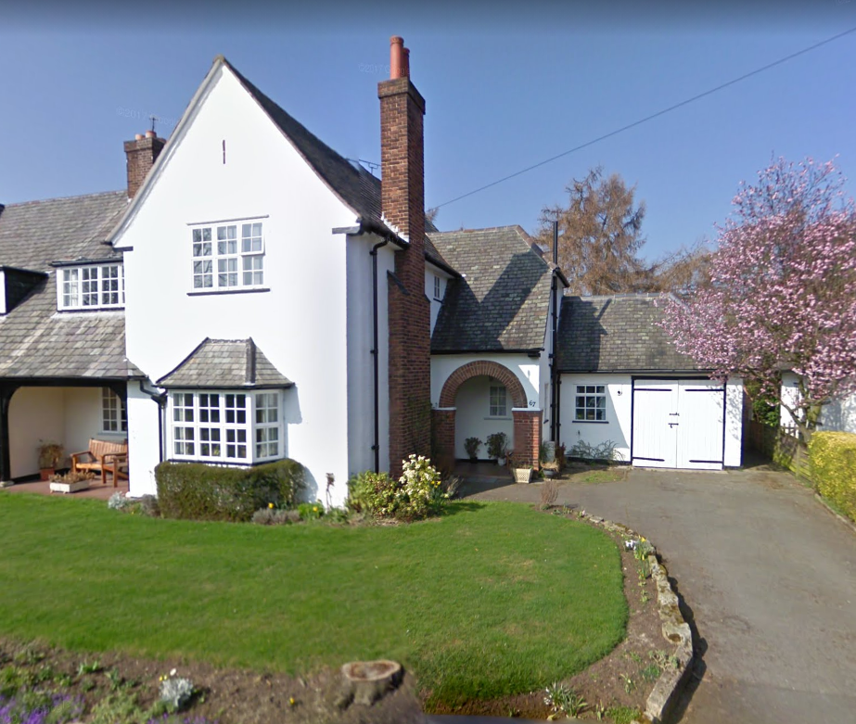

Contents

- Introduction and Objectives
- Historic and Architectural Significance
- Justification for Proposed Works
- Impact of Proposed Works
- Setting of the Listed Building
- Legislation and Policy
- Evaluation of the scheme in the context of the Conservation Principles
- Assessing the changes to in the context of the Conservation Principles
- Conclusion

Appendices
Appendix A - CADW Listing
Appendix B - Map from CADW website showing the listed properties on Acton Gate
Appendix C - Ordnance Survey Map - Denbighshire - Revised 1938

Introduction and Objectives

1.1 - This heritage statement has been prepared to accompany the listed building application for proposed works at 67 Acton Gate, Garden Village, Wrexham, LL11 2PW, namely the removal of the interconnecting wall separating the kitchen from the sitting room to create a large a kitchen-dining room which is more suitable for modern-day living. This report draws on the guidance on the statutory requirement to prepare a heritage impact statement in tandem with an application for listed building consent. The guidance is complementary to the Historic Environment (Wales) Act 2016 and is underpinned by the modern conservation philosophy of CADW’s Conservation Principles for the Sustainable Management of the Historic Environment in Wales (2011)
1.2 - 67 Acton Gate is a Grade II listed property, designated as such on 31st January 1994. The listed building description as detailed on the CADW website is attached in Appendix A.
1.3 - Appendix B shows the Ordnance Survey map detailing the location of the property, also from the CADW website.
1.4 - The listing covers a number of houses designed by Architect G. L. Sutcliffe, the group of four semi-detached houses on Acton Gate along with one larger detached house, were among the first to be built within the ambitious Garden Village Development. Sutcliffe was also responsible for the layout of the estate and also designed many of the other buildings within the estate. A copy of the plan for the 5 houses, taken from the deeds is shown below
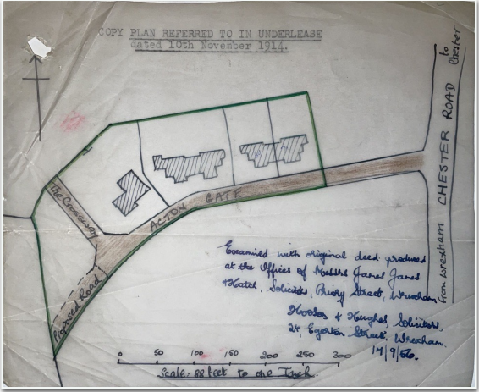

1.5 - 67 Acton Gate is a roughcast render over brick, bay fronted semi-detached house. Built around 1913 as part of the Wrexham Garden Village.

1.6 - The proposal comprises the creation of a modern kitchen / dining and upgrading the utilities throughout. A summary of the proposal is detailed below:

• Removal of interconnecting wall between the kitchen & sitting room to created one large kitchen Diner.
• Installation & modernisation of Kitchen / dining room.
• Improvements to the utilities (throughout)
• Installation & re-instatement of 3 traditional fireplaces on the ground floor.

Historical and architectural significance

2.1 - Historical Context. There is little recorded history about the house however there is some history in relation to the area that the house is located and the housing development that it formed part of. Garden Village is a suburb of the town of Wrexham and an electoral division (ward) in the community of Rhosddu in Wrexham County Borough, North Wales. At the start of the 20th century, the housing supply in many areas of Wrexham was of poor quality and, with the increase in industry locally, in short supply. The development of Garden Village began with the purchase of some 200 acres (81 hectares) of land from Sir Foster Cunliffe near to the estate of Acton by the Welsh Town Planning and Housing Trust Limited. The intention was to provide affordable housing to workers coming to Wrexham to work in the expanding industries of coal and iron. Gresford Colliery had recently been opened where it was expected that approximately 3,000 men would be employed in the next two years. A Co-partnership Housing Society was set up in 1913 called Wrexham Tenants Limited, with Lord Kenyon, Mr. David Davies, M.P., and others as Directors to build the houses, while the Trust would build the roads and supervise the development of the estate. The Architect chosen for the project was G.L Sutcliffe, who has become well known for his work on Brentham and Hampstead Garden Suburbs in London. Sutcliffe was keen to improve the living conditions of ordinary working people, and saw garden suburbs on the edge of existing cities as a more practical solution than free-standing Garden Cities on the Letchworth model. Sutcliffe had designed several large houses in the Surrey and Buckinghamshire commuter belt, in an attractive 'arts and crafts' style with gables and steeply-pitched tiled roofs. These features characterised the cottages and houses he designed within the various garden suburbs. Even when commissioned to plan a garden suburb for a northern city like Liverpool, he kept to the same style. An original artwork from the Hampstead Garden Suburb designed by the architect G.L. Sutcliffe is shown below

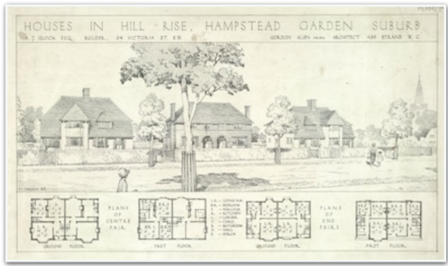
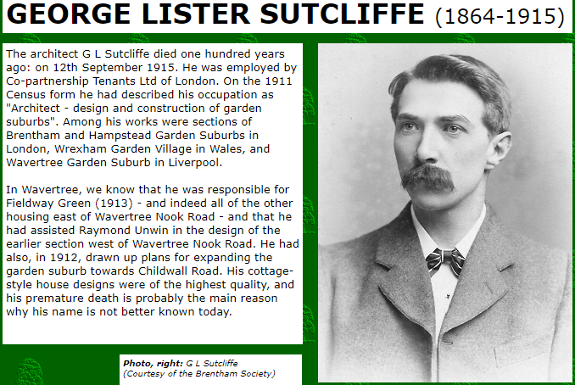

2.2 - Sutcliffe's original plan for Garden Village in Wrexham was to provide a village institute, two places of worship, a school and plenty of open spaces and recreation grounds. The design was inspired by the Garden City Movement and was planned as a ‘Garden Suburb’. In the first year, 44 properties were completed; numbers 63-71 Acton Gate, numbers 149-167, Chester Road (originally called Bryn Acton) and Cunliffe Walk. These first house were designed by Sutcliffe and the remaining 205 by Thomas Alwyn Lloyd, architect to the trust. One of the pioneering features of the development was that the tenants were also investors in the Company 5 of 22 Heritage Impact Statement - 67 Acton Gate, Wrexham - February 2021 thus ensuring control of future development. The picture below shows the plan for Garden Village as referred to in the Conveyance of September 1923. Appendix C shows the Ordnance Survey map for the area from 1938 which shows the early development of Garden Village and the row of listed houses within Acton Gate.

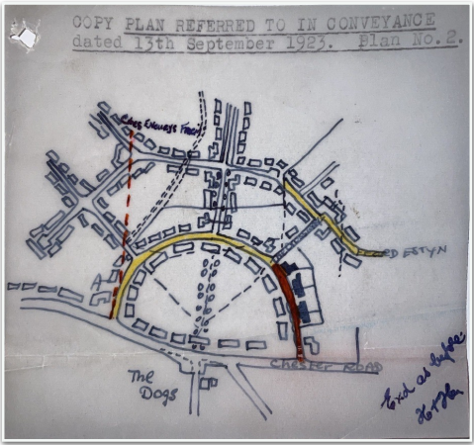

Unfortunately, with the advent of World War I, the development lost impetus and no further development was undertaken by Wrexham Tenants Limited. The planned shops, churches, institute and school were never built, although St Margaret's church was built in 1928, partly to the original design of Thomas Alwyn Lloyd. In 1955, Wrexham Tenants Limited was wound up and the properties sold to the tenants at greatly reduced prices of between £250 and £450. Analysis of the deeds (shown to the right) confirm that the house was first owned by Wrexham Tenants Limited as outlined above. It is believed that the houses on Acton Gate were occupied by the managers of the Gresford mine, with the workers from the mine occupying the houses in the remainder of the village.

2.2 - Aesthetic Context. 67 Acton Gate is a well-preserved example of a neo-vernacular style house, constructed with roughcast render over brick with grey slate roofs and brick axial and end wall stacks. Set over 2 storeys the house is a symmetrically planned 4-window range with advanced outer gables. The property's doorways are recessed in porches with round-arched entrances and the roof above swept down from the hipped gable. Gabled ranges have canted bay windows with slate roofs to the lower storey, and 3-light casement windows (renewed in original openings) above.

The Central range between the gables has roof swept down and carried on chamfered and braced timber posts over a veranda, with French doors in return of gabled cross wing, and casement windows in main range. There is also a long dormer window of 4-lights in the roof above. Linked to the entrance blocks at either side, are hipped roofed garage extensions, which may be adapted from original outbuildings, and are similar in detail to the main building. The image above shows the current view of the property from the South East.
  - - Communal Value. 67 Acton Gate does not hold any significant local status.

  - - Evidential Context. The structural history of the house is reasonably straightforward, and its major phases may be outlined as follows:-

• Phase 1. circa 1916, construction of the house
• Phase 2. circa 1980, extension of the utility room to the rear of the property with the installation of a flat roof.
• (Listing of 67 Acton Gate - 31/01/1994)
• Phase 5, circa 2017, installation of combination style gas boiler as an upgrade to the existing heating and hot water system.

2.5 - Remove, replace and update dated kitchen with a fresh but traditional kitchen which is in more up keeping with the character of the property.
Due to the compact size of the kitchen, we propose to remove the wall between the kitchen and sitting room installing an RSJ to make one large open plan kitchen. As per the structural engineering report & drawing.
Below is the current Kitchen design with the highlighted wall that we would like to remove.
The 2 rooms have an overall difference in height by around 6 inches, with the shorter ceiling being in the kitchen. We propose to keep the ceiling the same height in each room which will delineate between the 2 original floor spaces, showing that they use to be 2 separate rooms.

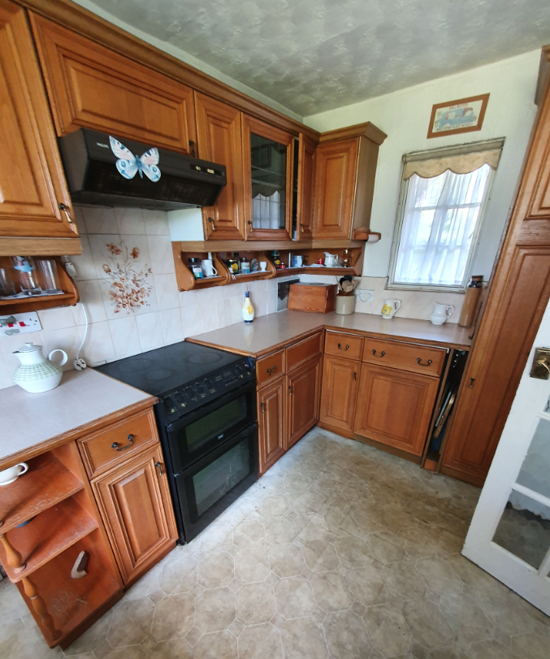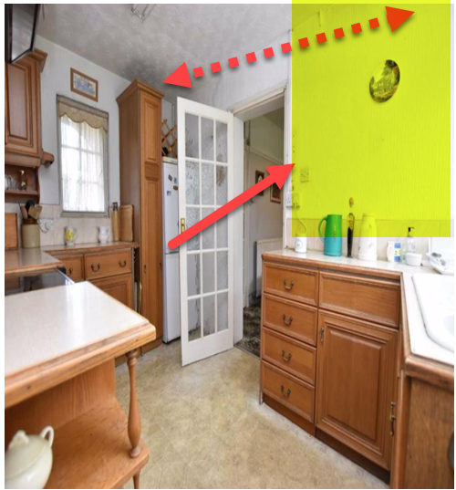

Sitting room –
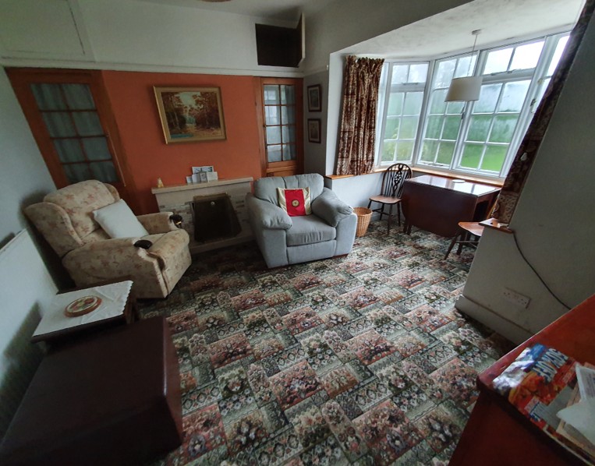
Current Layout with the proposed highlighted wall that we would like to remove –

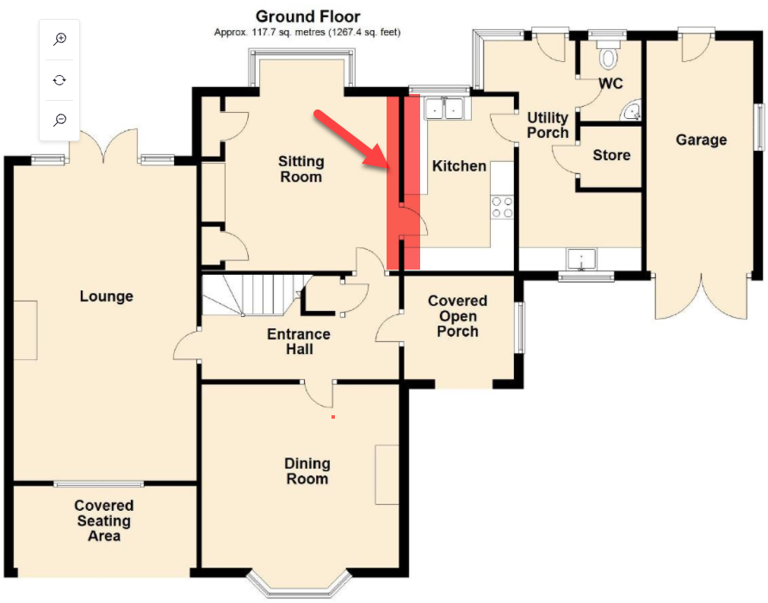

Below is the projected Kitchen design & layout, with the difference in ceiling heights highlighted.
#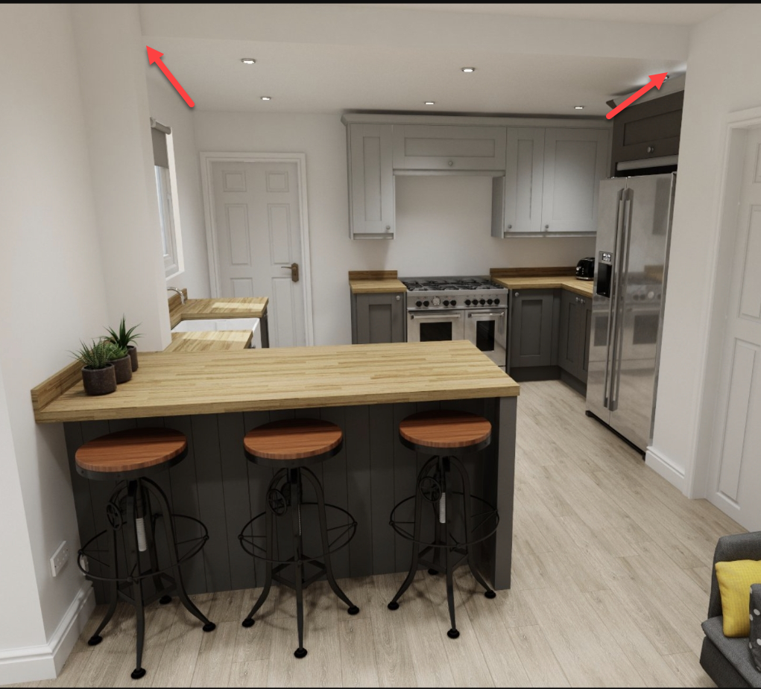

- Structural Engineer Drawing / layout -
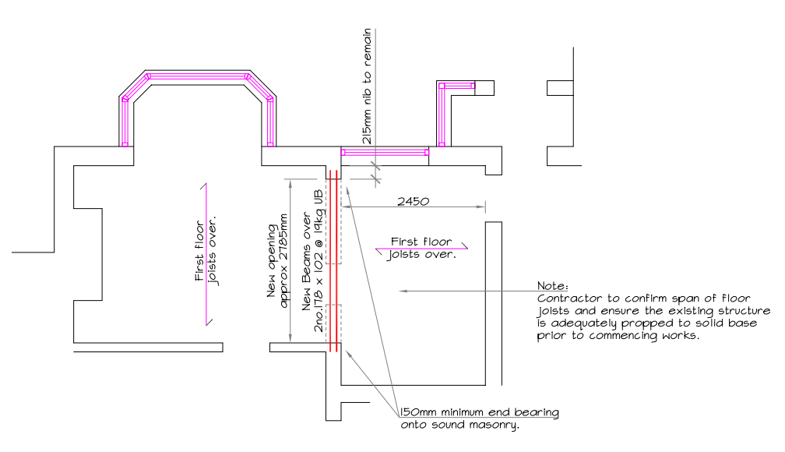

2.6 - The property currently has 3 fireplaces on the ground floor level.
Fireplace 1 in the living room has been converted to a dated non original gas fire & surround.
Living room -
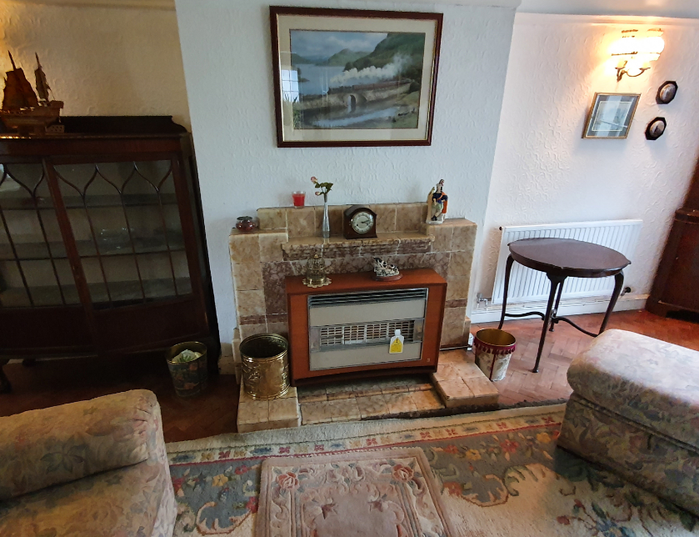

Dining Room –
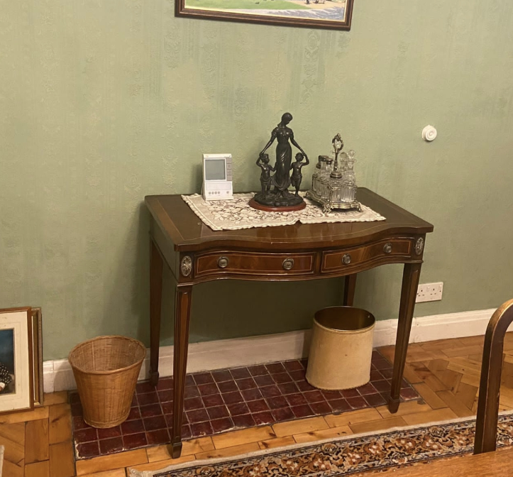
At present the dining room fireplace is boarded up, we plan to re-instate the fireplace with a traditional log burner.
Sitting room –
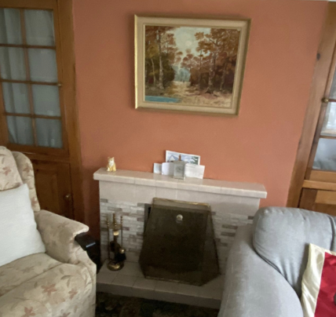

The fireplace in the sitting room is an open fire place with a dated non-original fire surround.
Two side cupboards have been fitted to either side of the chimney which currently hide the chimney breast. We would like to remove these 2 cupboards and expose the chimney breast, and install a traditional period fireplace which will be the main focal point of the family home (example picture below)
This style will be the same for the Dining & living room.
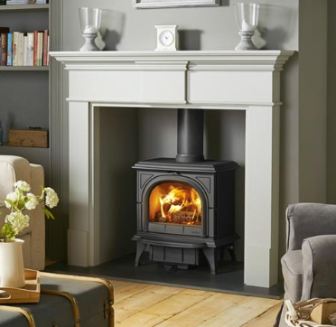
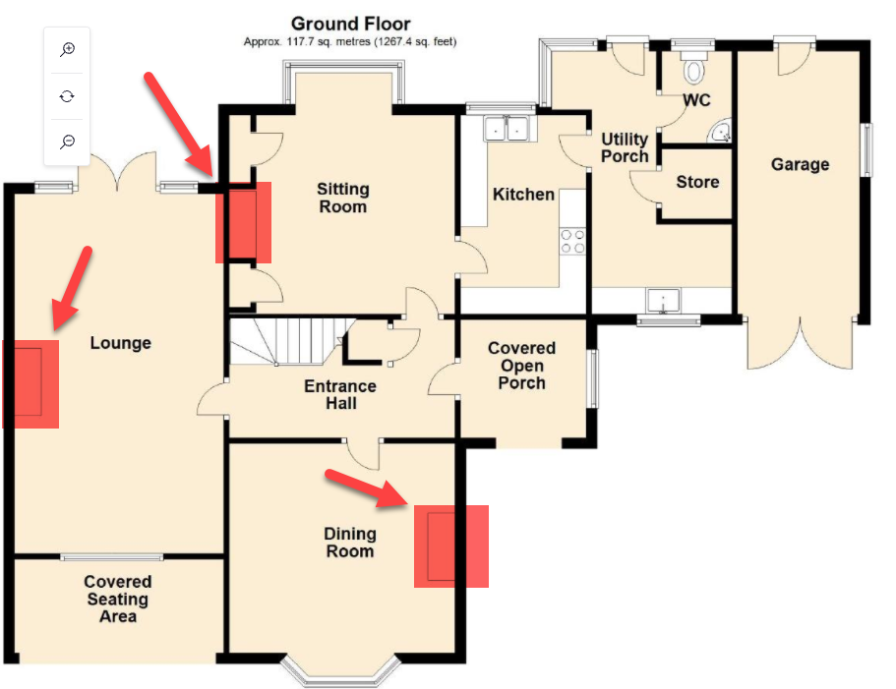

2.7 – Installation of new radiators
We would like to install new energy efficient double panel convector radiators.
As the boiler was replaced in 2017 there will be no new water pipes fitted as the previous & current locations are fit for purpose.

New energy efficient radiator - Current radiators –
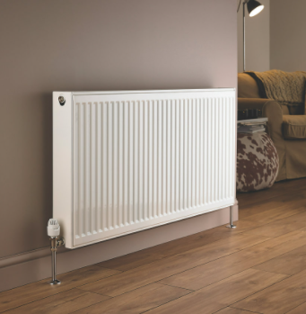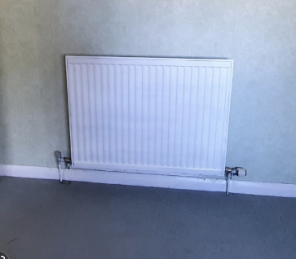

The pipework on one wall in the Kitchen is hidden by plastic conduit. We would like to chase the pipe into the wall and fill with Lime plaster, specification below –

Technical Data – Lime plaster Non-Hydraulic
Specification | BS EN 998-1:2016
Texture | Coarse
Binder | Lime Putty
 | BS EN 459-1:2015
Aggregate | BS EN 13139-1:2015
Grading | Gc85/20
Density | 1,525 kg/m³ ± (at 91 days)
Vapour permeability | 0.92 grams / 100mm² / 24hrs ±
Compressive strength | 0.75 N/mm² ± (at 91 days)
Flexural strength | 0.74 N/mm² ± (at 91 days)
Resistance to freeze thaw | Low
 | (10 cycles)
Resistance to sulphate exposure | High
 | (26-50 cycles)
Resistance to freeze thaw in sulphate conditions | Low
 | 10 cycles
Capillary rise | Very high
 | (126-150mm in 6 hours)
Mortar durability class | 1 to 2
Carbonation rate | High
Initial set | Overnight ±
Curing | 2mm per calendar month ±

3.0 – Chimney breast cupboards
The current cupboards are hiding the chimney breast, and we would like to remove them to fully expose the chimney and restore it back to its original standard.
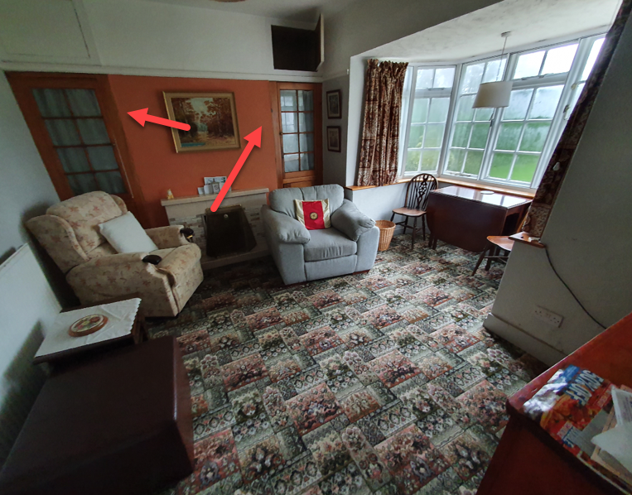
When opening the cupboard, you can see that the inside of the cupboard is wall papered in the same paper as outside the cupboard. This suggests that the cupboards were placed on top of the wall paper at a later date. It also appears the cupboards were installed to hide some old central heating pipes.
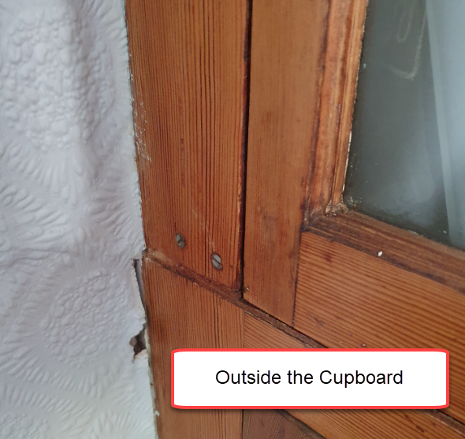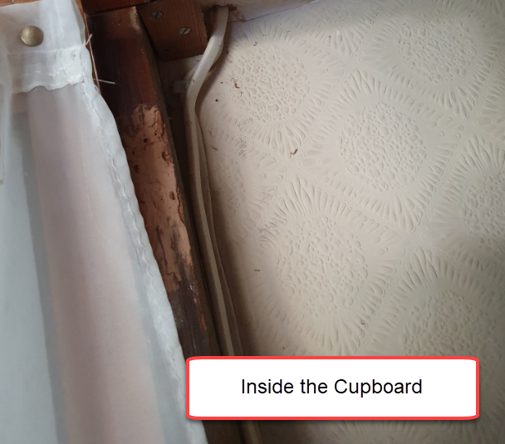

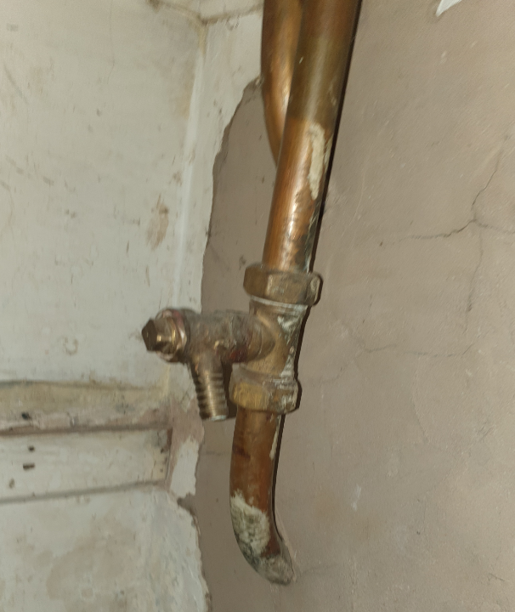

In our pre-application we also included the following significant requests which we no longer require –

- Re-positioning of bathroom door –
We are now installing a new bathroom suite using the current layout.

- New secondary glazing –
The current secondary glazing will now be remaining in the property.

- Extend current Drive –
No plan to extend anymore.

- Extend Garden Patio -
No plan to extend anymore.

4. Impact of the Proposed Works

4.1 By increasing the energy efficiency of the property via improvements to plumbing and heating systems the energy rating of the property will be significantly increased resulting in a lower carbon footprint.

4.2 The proposed changes allow for the vast majority of the property to be preserved or restored to its original format, with only sympathetic restoration and improvements carried out.

4.3 Proposed Exterior works may be described as: - The refurbishment of the original windows, with original materials will not only bring the property back to its original standing & character, but will make the property more energy efficient. The outside of the property will be fully re-painted with the correct materials, which will aesthetically bring the property back to its original standing. Over the past several years the exterior of the property has been neglected.

4.4 Proposed Interior works may be described as: - Upgrading of central heating system - Re-instating (opening out) three fireplaces – Removal of wall between the kitchen and sitting room to create a large kitchen diner - Installation of kitchen in the newly created kitchen / dining / living area.

4.5 The proposed scheme has the following merits: - The exterior of the property will remain unchanged from all aspects - The environmental impact of running and maintaining the property is significantly reduced

5. Setting of the Listed Building

5.1 The setting of a listed building is the surroundings in which it is understood, experienced and appreciated, embracing present and past relationships to the surrounding landscape. Views to, from and across a historic asset are an obvious form of evaluation, but other sensory elements may be relevant too, including topography, layout, use, noise, and light pollution, as well as historic, artistic, literary, cultural or scenic associations, tranquillity and remoteness. When assessing proposals, local planning authorities are required to pay special regard to the desirability of preserving the building or its setting or any other features of special architectural or historic interest which it possesses. This is set out in section 66 of the 1990 Act Listed Buildings and Conservation Areas Act.

5.2 In terms of its historic setting, 67 Acton Gate is a semi-detached property within the small village of Garden Village. The proposal will have no appreciable impact on this, as none of the exterior is being changed while the interior changes within the property will have no impact on the setting.

6. Legislation and Policy

6.1 Legislation and Policy – The legislative and policy context includes the following:- - 1990 Planning (Listed Buildings and Conservation Areas) Act, section 66 - 2016 Historic Environment (Wales) Act 2016 - Technical Advice Note 24 (The Historic Environment) 2017 including annex 1 (Historic Impact Assessment in Wales), 2 (Managing Change to Listed Buildings in Wales) and 6 (Setting of Historic Assets in Wales) - Planning Policy Wales Edition 9 (November 2016), Section 6 - Pembrokeshire County Council Local Development Plan (2013), Policy GN.38 - Conservation Principles for the Sustainable Management of the Historic Environment in Wales’, Cadw, 2010.

6.2 Evaluation of the proposed scheme in the context of national policy

6.21 The main material policy document is Technical Advice Note 24 (The Historic Environment) 2017. Paragraph 5.13 requires consideration of a number of issues when determining a listed building consent application.
These include:-

• The importance and grade of the building and its intrinsic architectural or historic interest.
• The physical features of the building which justify its listing and contribute to its significance, (for example its form and layout, materials, construction and detail) including any features of importance such as the interior, which may have come to light after the building’s inclusion on the list.
• The contribution of curtilage and setting to the significance of the building, as well as its contribution to its local scene • The impact of the proposed works on the significance of the building.
• The extent to which the proposed works would bring substantial community benefits for example, by contributing to the area’s economy or the enhancement of its local environment. The first four points comprise the crux of listed building legislation and it is considered that this statement addresses the relevant issues. In terms of the fifth point, it is certain that the proposal will enhance the local environment and highly likely that the renovated building will contribute to the area's economy through the ability to be used as comfortable work-from-home premises 6.22 Paragraph 5.14 states that 'Many listed buildings can sustain a degree of sensitive alteration and extension to accommodate continuing or new uses. Past changes that reflect the history of use and ownership may themselves be aspects of the special interest of the listed building'. It advises that ' when applicants and the local planning authority assess the heritage values and significance of a listed building, which is the subject of a consent application, they must consider the sensitivity of that building to the proposed changes. Sustaining the special interest and significance of a listed building through the process of alteration, extension or re-use is exacting, and should always be based on specialist knowledge and skill in order to realise the benefits that well-designed interventions can bring’.

It is considered that 67 Acton Gate is capable of sustaining the degree of alteration proposed to sustain its ongoing use as a family home with modern-day requirements and that a careful balance has been made against the heritage values of the building.

6.23 From the Welsh Assembly Government publication; ‘Conservation Principles for the sustainable management of the historic environment in Wales’, it is considered that the work being proposed for 67 Acton Gate do meet the criteria for justification of new work or alternations which are listed below:

a. the need for the work is fully justified; and
b. there is sufficient information comprehensively to understand the impacts of the proposal on the significance of the asset; and
c. the proposal would not materially harm the values of that asset, which, where appropriate, would be reinforced or further revealed; and
d. the quality of design and execution must add value to the existing asset; and e. the long-term consequences of the proposals can, from experience, be demonstrated to b

7. Evaluation of the proposed scheme in the context of the

Conservation Principles

Principal 1 – Historic Assets will be managed to sustain their values
Changes in the historic environment are inevitable and conservation of historic buildings is about the careful management of change, having special regard to the desirability of preserving the building or its setting or any features of special architectural or historic interest which it possesses.

The proposed works at 67 Acton Gate are perceived as conserving the special character of the house whilst upgrading its facilities for modern-day residential use. The works of alteration mainly centres on the removal of a wall between the kitchen and sitting room and improvements to the internal efficiencies of the house. The character of 71 Acton Gate, as an example of an early house built in Garden Village and designed by G. L. Sutcliffe remains unaltered.

Principle 2 – Understanding the significance of historic assets is vital
In evidential terms, the structural history of 67 Acton Gate is very straightforward, as examined above. In terms of communal value, to the historian, 67 Acton Gate is a well-preserved semi-detached house, the proposed scheme has no impact on any of this.

Principle 3 – The historic environment is a shared resource
Although 67 Acton Gate is a private house, along with the other listed properties on the road, it has formed an important part of Garden Village. In terms of public interest, the legal procedures needed to obtain listed building consent provide the mechanisms for arbitrating between private and public interests.

Principle 4 – Everyone will be able to participate in sustaining the historic environment
It is hoped that this document will assist ensuring that decisions about 67 Acton Gate are taken in an open and transparent manner, as well as sharing what is known about the house to date, raising people’s awareness and understanding of their heritage.

Principle 5 – Decisions about change must be reasonable, transparent and consistent
It is hoped that this document will underpin this principle and provide a clear justification for proposed changes to the building.

Principle 6 – Documenting and learning from decisions is essential
The information and documentation gathered as a result of the proposed scheme will be retained by the owners, with a copy provided to the Wrexham Borough Councils public archive.

8. Assessing the changes to 67 Acton Gate in the context of the Conservation Principles

Changes to the building may be categorised as new work or alteration, including: New work or alteration

• Re-instating / Opening out of boarded up / non-original fireplaces in three rooms.
• Removal of wall dividing the kitchen & sitting room to create a larger Kitchen / Diner.
• Modernisation of the various utilities within the property including central heating & plumbing.
• Removal of non-original cupboards either side of the chimney breast in the sitting room.

9. Conclusion

9.1 This Heritage Impact Statement has been completed in line with current CADW guidance (CADW 2017a).

9.2 Completion of the works will allow the property to become a fully functioning family home once again.

9.3 The removal of the wall diving the kitchen & sitting to create a larger kitchen space, which will be the focal point of the family home.

9.4 The proposal has been carefully planned to preserve and restore as much of the original house as possible.

9.5 The property will receive significant investment to sympathetically modernise to today’s living standards whilst maintaining and restoring many original features, protecting the property for many generations to come.

9.6 Taken as a whole, it is concluded that the proposed development would at least ‘preserve’ the character and appearance of 67 Acton Gate. This is determined on the basis that all of those elements of the property which make a positive contribution to the listing are maintained.

9.7 It is hoped that this report adequately addresses the impact of the proposal on the character and setting of the 67 Acton Gate, balancing the statutory requirement to preserve the listed building with government and local policy to retain it in suitable use and condition.

Appendix A - CADW - Full Report for Listed Building –

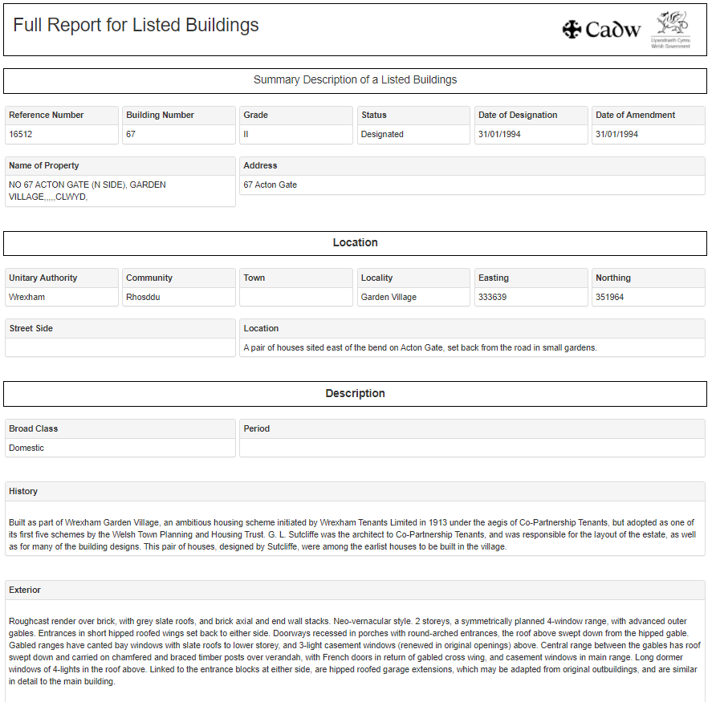
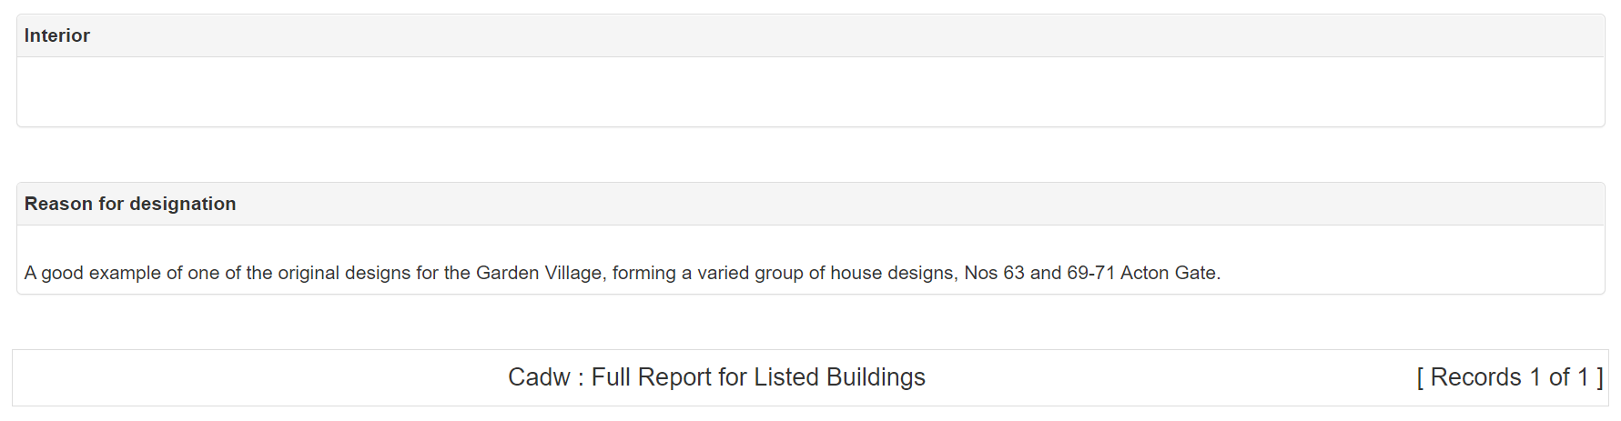

Appendix B - Map from CADW website showing the listed properties on Acton Gate

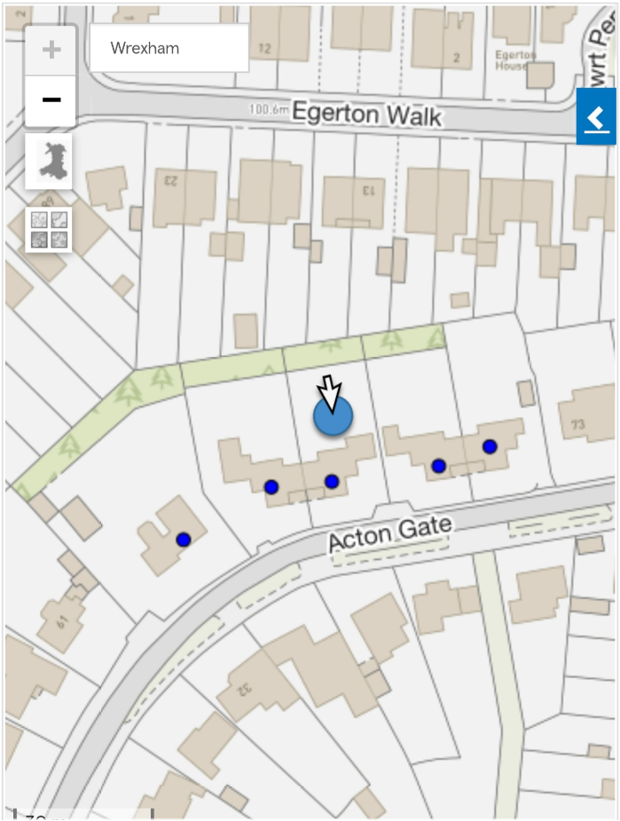
Appendix C - Ordnance Survey Map Denbighshire XXVII.NE. Series: Ordnance Survey. Six-inch to the mile Revised: 1938 Published: ca. 1944

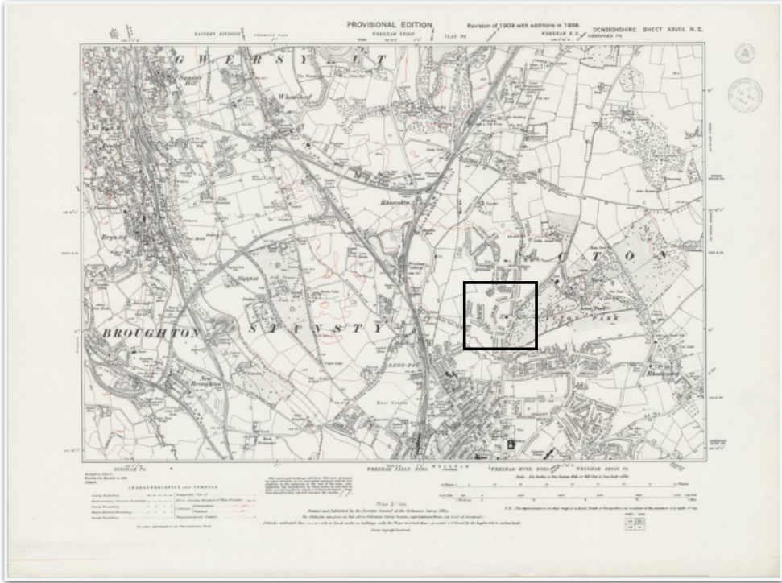

Enlarged area from 1938 map showing Acton Gate Houses
