SUPPORTING, DESIGN AND ACCESS STATEMENT

AGRICULTURAL PRODUCE & GENERAL STORAGE BUILDING
(REMODELLING AND MODERNISATION OF EXISTING FACILITIES)

MR AND MRS LLOYD

OF

CLOY BANK FARM
OVERTON
WREXHAM
LL13 0HR

OCTOBER 2022

- BACKGROUND
Cloy Bank Farm is a family run agricultural holding on the outskirts of Overton, accessed off Cloy Lane within an open countryside location. The holding farms approximately 37.5 acres of grassland which was purchased in 2018
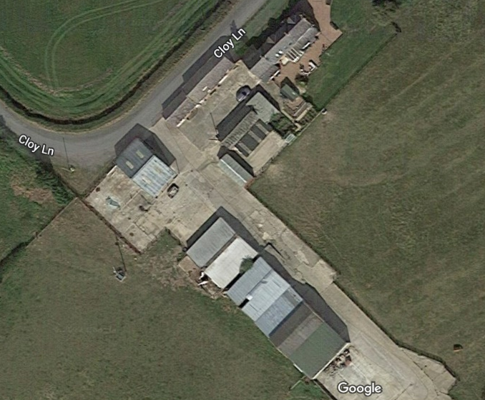
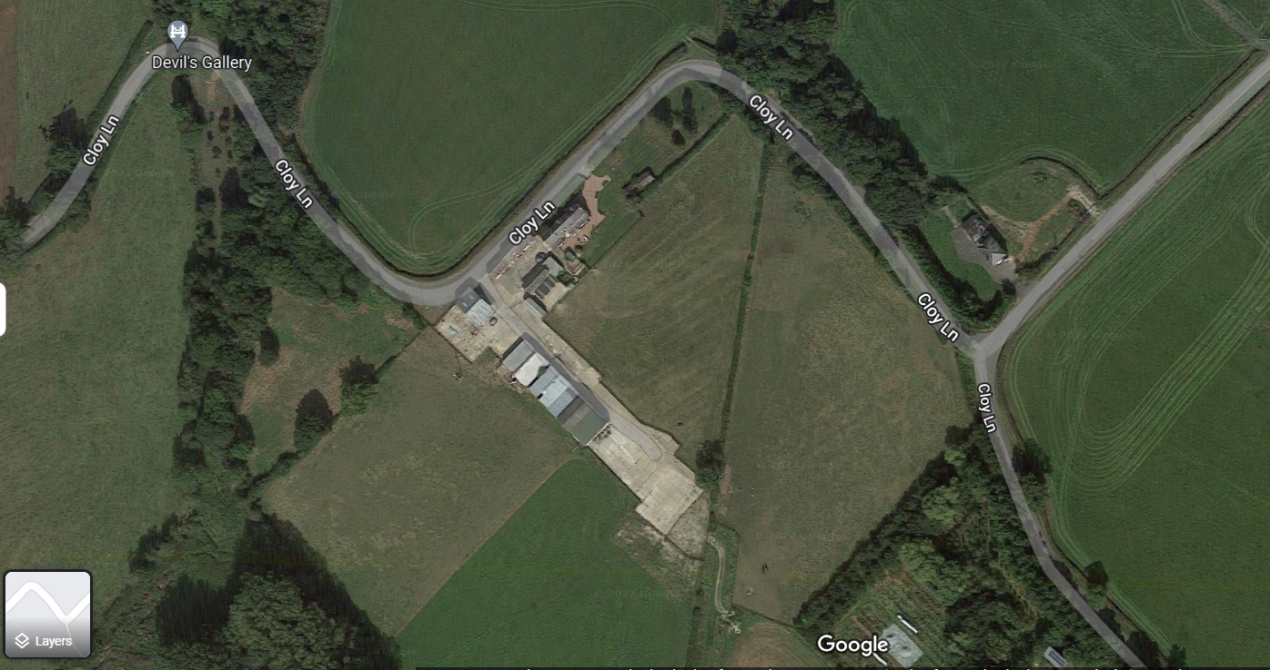

The land is equally used as grazing and/or to produce hay. The applicants have a flock of pedigree Poll Dorset sheep which lamb March April with males sold and females retained to increase the flock size. At present the applicants have a flock size of 32 ewes. This is expanding yearly, a closed flock to enhance genetics and prevent disease.
Currently on site there are a range of steel portal framed buildings, which were utilised historically with the former dairy unit that operated from the site, however since the applicants purchase of the farmhouse, buildings, and land via auction, they have spent significant time and money in modernising the facilities, which has led to the subject application. The buildings on site are outdated to modern farming practices, restricted in scale and design notwithstanding they were cubicle sheds which do not allow the height to accommodate the storage of produce of access of modern farm machinery. As shown in the following images
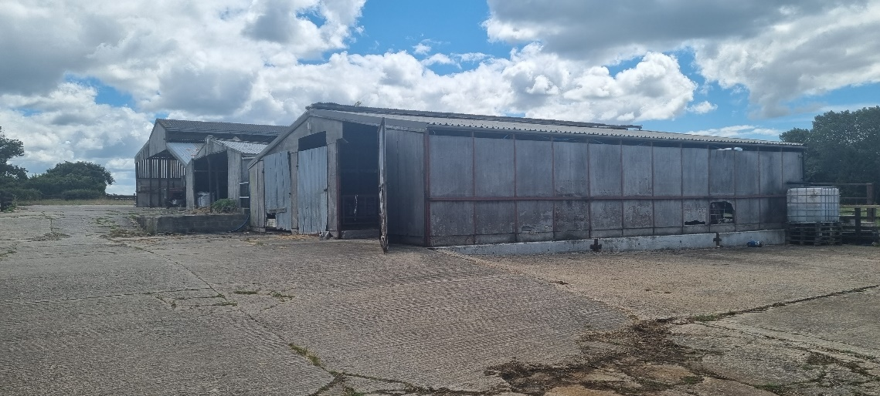
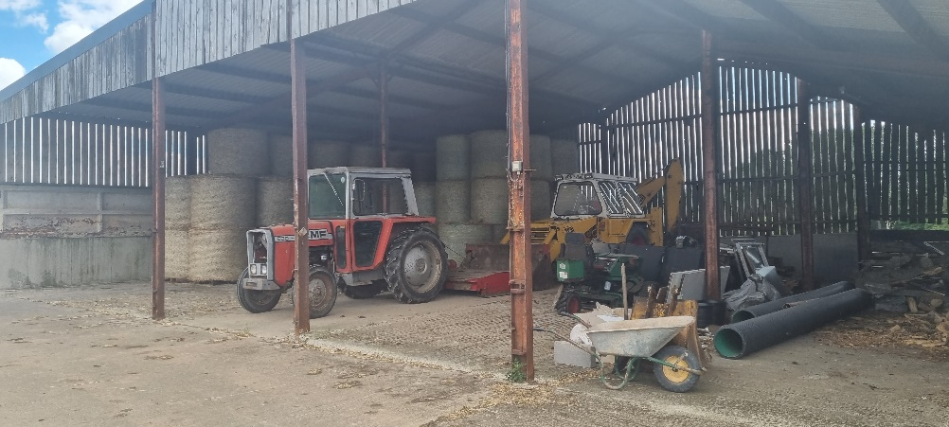
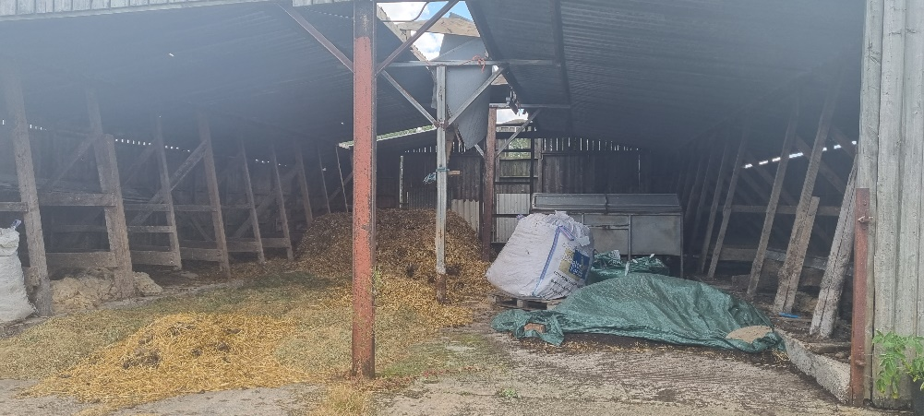
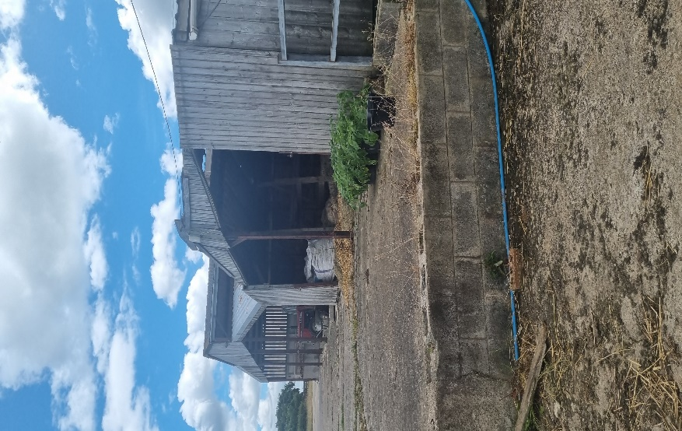

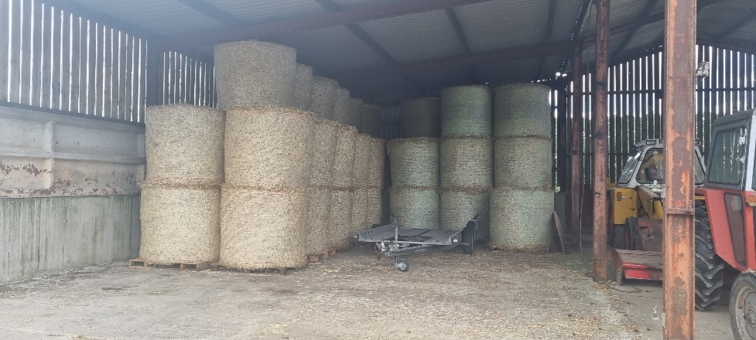

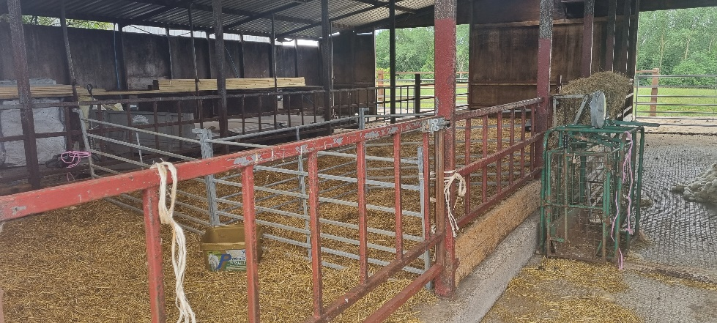

The proposed building will require the demolition of the extant structures and the construction of a new Steel portal framed structures upon the footprint including an existing building to be remodelled. The use of the site will remain agricultural a mixed produce, machinery, and temporary welfare facilities for the flock during lambing only. The proposed site is as shown below. Full elevation, floor plans and site layout drawings accompany this submission:
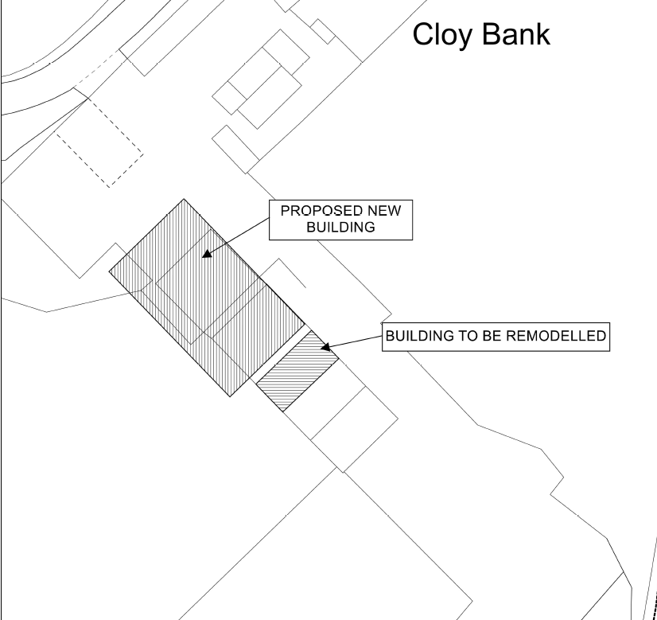

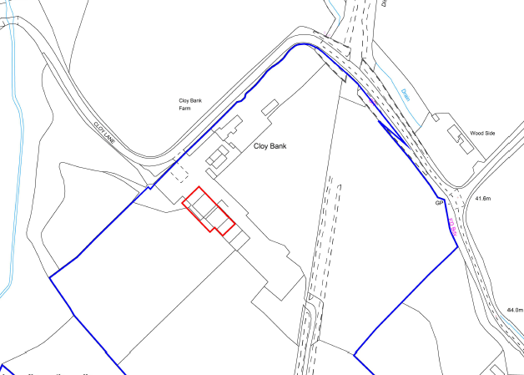

Being contained “under one roof” enhances the site security especially with small tools, fuel and workshop equipment also being stored on site. Furthermore, It is essential to uphold the quality of the produce and expensive machinery it is important for such items not to be left outside in the weather. The weather critically causes the agricultural produce to waste which means it is not able to be fed to the livestock or used for bedding which results in decrease profitability and in most cases, an additional expense replacing this produce.
The applicants also produce haylage for animal feed especially during the winter when there is less grass. Whereby it is essential that all haylage has sufficient indoor storage space. Produce needs to be stored out of direct sunlight to prevent it from heating and deteriorating. Should the produce deteriorate then it will be unsuitable for consumption.
The business is also looking to reduce carbon emissions and waste and requires dry storage of the hay it produces. Additional shed space will reduce the reliance on having to use plastic bale wrap. Unwrapped indoor storage will reduce the dependency on plastic will help the business meet net zero.
The building will also store fertiliser applied to the land, which needs to be stored out of sight and in a secure and safe location. Fertiliser needs to legally be stored in a cool/dry place to prevent large blocks/ lumps from forming, this will stop it being spread and its effectiveness.
- PROPOSAL
Remodelling of existing activities with new purpose-built agricultural buildings through the construction of a steel portal framed agricultural produce and general storage building on the footprint of the extant facilities
- PLANNING POLICY
The application has been prepared taking the national planning guidance into consideration contained within the Planning Policy Wales.
Cloy Bank Farm is located in Wrexham County Borough Council and therefore the application will be considered against Wrexham Unitary Development Plan. The principal policies are:
• GDP1 Development Objectives

Criteria of the above policy:

- Ensure that built development in its scale, design and layout, and in its use of materials and landscaping, accords with the character of the site and makes a positive contribution to the appearance of the nearby locality.
- Take account of personal and community safety and security in the design and layout of development and public / private spaces.
- Make the best use of design techniques, siting and orientation in order to conserve energy and water resources.
- Ensure safe and convenient pedestrian and vehicular access to and from development sites, both on site and in the nearby locality.
- Ensure that built development is located where it has convenient access to public transport facilities, and is well related to pedestrian and cycle routes wherever possible.
- Ensure the safety and amenity of the public and safeguard the environment from the adverse effects of pollution of water, land or air, hazards from industry and quarrying, and associated noise, odour or vibration arising from development.
- Secure public services (e.g. gas, water, electricity) to development at minimum public cost.
- Safeguard sites and areas of nature conservation and wildlife interest, and to provide new habitats where there is an unavoidable loss of existing habitats and areas of wildlife interest.
- Ensure that development does not result in, or is subject to, flooding, soil erosion, landslides or contamination, either on or off the site.
- Have regard to the need to safeguard those areas that possess a strong Welsh cultural and/or linguistic identity from development that could harm this identity.
- Secure the development of sustainable communities, through the promotion of the economic, social and environmental well-being of the area.

• EC3 Agricultural Buildings

The construction of new agricultural buildings will be permitted unless the development is materially detrimental in terms of its impact on the environment or surrounding landscape. The development should form part of an existing farm complex and take advantage of topography and other landscape features for screening. Isolated buildings will only be permitted in exceptional circumstances where there is an essential agricultural need, and no reasonable alternative location for the development.
The proposed building is a replacement scheme for the extant structures, no increase in floor area. No encroachment to key agricultural land. The scheme provides a purpose-built agricultural building of modern construction to replace the outdated structures on site at present therefore there will be no detrimentally impact on the surrounding environment or landscape. The proposal appears to comply with this main policy regarding the construction of agricultural buildings.
It is felt that the proposed development has taken both the local and national planning policy guidelines into consideration when preparing this application, includes its design, location, function and appearance.
- DESIGN

  - USE

The use of the site is agricultural. The proposed use is to remain agricultural, produce, machinery and general agricultural storage building (as coloured red on plan).

  - AMOUNT

The proposed new building to area of the new build would 557.48m² and has an eaves height of 6m and a ridge height of 8.55m - length of 30.48m, a width of 18.29m. Full detail can be seen on the enclosed scale plan. Whilst the building to be remodelled extends to 6.35m x 14.1m currently mono pitched 4.40m to lowest and 5m to highest roof height. In terms of the remodelling, the only variation is to lift the roof line. No increase in existing floor area.

  - LAYOUT & LANDSCAPING

The proposal is to be constructed on the established complex, it technically is a project of remodelling and modernising existing facilities therefore there will be no requirements to carry out any major engineering works. The access and yard area are already in existence, no encroachment on key agricultural land or need for expansion to existing hardstanding.

  - SCALE

The proposed building together with the remodelled structure have been designed provide modern agricultural storage buildings essential to the operations of the unit. The change from a dairy farm to a pedigree sheep and grassland-based unit.

  - APPEARANCE

The building is as shown on the enclosed elevation drawings. There are appropriate separation distances, and it is not considered that the development would have a detrimental impact upon neighbouring residential amenity. No trees or boundary hedges will be altered. The site and yard are enclosed by post and rail. The building is enclosed will be of clad on the sides and roof with dark grey box profile sheets

  - ACCESS

There will be no changes to the existing access arrangements.

