For the Attention of: Sharon Holman – Case Officer
Wrexham County Borough Council

[By Email: planning@wrexham.gov.uk]

22nd September 2022

Dear Ms Holman

PLANNING APPLICATION: P/2022/0733

DEMOLITION OF EXISTING DWELLING AND ERECTION OF REPLACEMENT DWELLING; The Mount, Tower Hill, Acrefair, Wrexham

Thank you for your consultation notification of 06 September 2022 seeking the views of The Coal Authority on the above planning application.

The Coal Authority is a non-departmental public body sponsored by the Department of Business, Energy & Industrial Strategy. As a statutory consultee, The Coal Authority has a duty to respond to planning applications and development plans in order to protect the public and the environment in mining areas.

The Coal Authority Response: Material Consideration

I have reviewed the site location plans and the proposals and supporting information available to view on the LPA website and can confirm that part of the site falls within the defined Development High Risk Area.

The Coal Authority records indicate that there is a recorded mine entry within 20m of the southern site boundary. We hold no treatment details for this feature and its recorded position may be subject to significant departure. Untreated mine entries also pose a potential risk to surface stability and public safety.

However, the parts of the site where the erection of the replacement dwelling and detached double garage are proposed lies outside of the defined High Risk Area. Therefore we do not consider that a Coal Mining Risk Assessment is necessary to support this proposal and we do not object to this planning application.

The Coal Authority notes that as the site lies within an area where coal mining activity has taken place it is requested that the following wording is included as an Informative Note on any planning permission granted:

The proposed development lies within a coal mining area which may contain unrecorded coal mining related hazards. If any coal mining feature is encountered during development, this should be reported immediately to the Coal Authority on 0345 762 6848.

Further information is also available on the Coal Authority website at:
www.gov.uk/coalauthority

Please do not hesitate to contact me if you would like to discuss this matter further.

Yours sincerely,
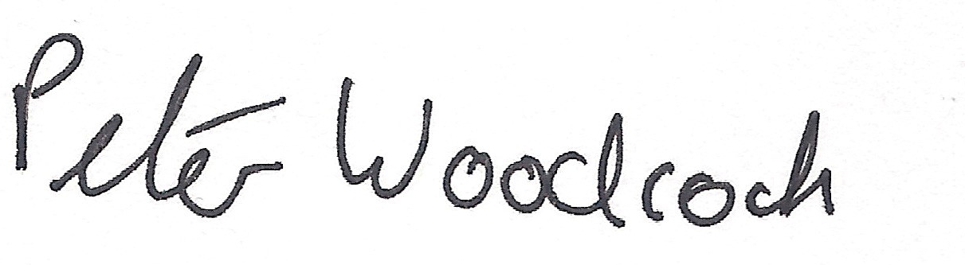
Peter Woodcock | BSc (Hons)
Trainee Planning Manager

Disclaimer

The above consultation response is provided by The Coal Authority as a Statutory Consultee and is based upon the latest available data on the date of the response, and electronic consultation records held by The Coal Authority since 1 April 2013. The comments made are also based upon only the information provided to The Coal Authority by the Local Planning Authority and/or has been published on the Council's website for consultation purposes in relation to this specific planning application. The views and conclusions contained in this response may be subject to review and amendment by The Coal Authority if additional or new data/information (such as a revised Coal Mining Risk Assessment) is provided by the Local Planning Authority or the Applicant for consultation purposes.

