HERITAGE IMPACT STATEMENT
IN RELATION TO

INSTALLATION OF REPLACEMENT WINDOWS
AT
UNIT 6
ST GILES HOUSE
RHOSNESNI LANE
WREXHAM
LL12 7NJ

BY

IAN STOCKDALE
RIBA
07725555715

REASON FOR STATEMENT

UNIT 6 IS PART OF A CONVERTED GRADE 2 LISTED BUILDING
WHICH IS CONSIDERED TO BE THE FIRST BESPOKE CHILDREN’S HOME IN WALES.

THE PROPOSAL IS TO RECONFIGURE THE INTERIOR LAYOUT OF THE LOUNGE AREA TO NUMBER 6 BY RESTORING IT BACK TO IT’S ORIGINAL LAYOUT AND PROFILE AS A FORMER SCHOOL ROOM/CHAPEL.
THIS WILL ALLOW US TO REPLACE THE WINDOWS TO THE FRONT ELEVATION ONTO RHOSNESNI LANE BACK TO THERE ORIGINAL CONFIGURATION.

THIS MOVE WOULD RESTORE THE SYMMETRY OF THE FRONT ELEVATION WHICH WAS ADJUSTED IN THE ORIGINAL CONVERSION OF THE PROPERTY SOME YEARS AGO.

TO ASSIST ATTACHED ARE PHOTOGRAPHS OF THE EXISTING WINDOWS AND A PHOTOGRAPH OF THE ORIGINAL WINDOW STYLE WHICH IS FOUND ON THE OTHER GABLE WING OF THE BUILDING.

THIS AMENDMENT WOULD HAVE POSITIVE IMPACT ON THE APPEARANCE OF THE PROPERTY WHICH MAY NOT BE OBVIOUS TO THE PUBLIC IN GENERAL BUT WOULD RESTORE THIS ELEMENT OF THE ORIGINAL FACADE TO IT’S ORIGINAL STATUS AND REBALANCE THE MAIN ELEVATION TO RHOSNESNI LANE.

THE NEW WINDOWS WILL BE A REPLICA IN PROFILE AND SIZE OF THE ORIGINALS AND A SPECIALIST MANUFACTURER IS TO BE APPOINTED TO MEASURE UP, DETAIL, SUPPLY AND FIT.

WE BELIEVE THE AMENDMENTS PROPOSED WILL BE ACCEPTABLE AND BENEFIT THE PROPERTY AS A WHOLE, RESTORING IT BACK TO IT’S ORIGINAL DESIGN.

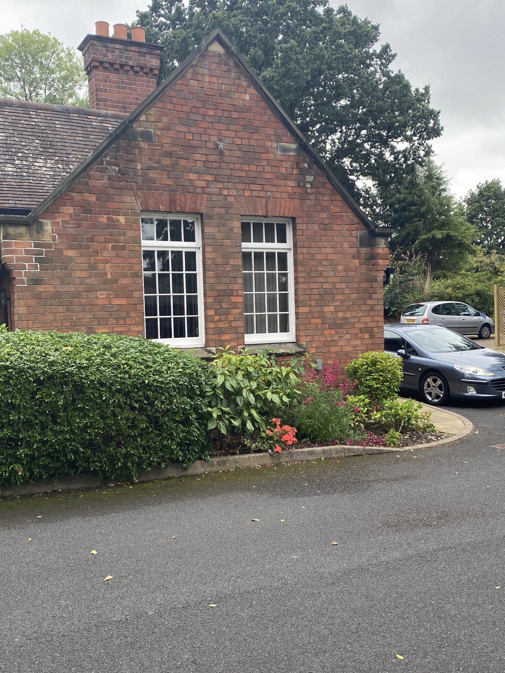
Caption

PREPARED BY
IAN STOCKDALE
RIBA

2/11/2022

