Additional information for Cobham Cottage LL139RY

Post and rail stock fencing

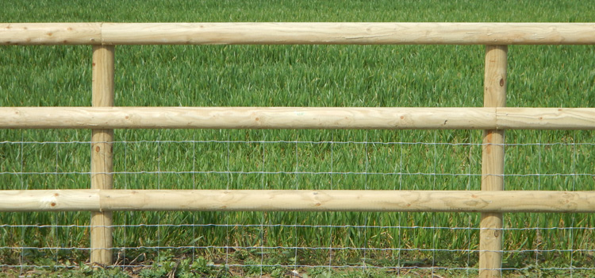

1.2m high Post & Rail Fencing supported on 125mm x 75mm posts @ 1.8m centres set in concrete footing 600mm down. 38mm x 88mm post rails.

With a native hedge planted inside the fence, to match the hedging plants currently surrounding the field.

Mix of hedging plants:-

Crataegus monogyna (hawthorn) 50%
Prunus spinosa (blackthorn) 20%
Acer campestre (field maple). 20%
Quercus rubus (oak). 10%

We propose also to plant in the area: -

Corylus avellana (hazel tree)
Quercus rubus (oak)
Cratageus monogyna (hawthorn)
Sorbus aucuparia (rowan)

We are passionate about the environment and would like to support the local wildlife, by converting this small inefficient part of the field to a wildlife friendly area. We have already added 8 trees to the existing garden.

