For the Attention of: Amy Brittain – Case Officer
Wrexham County Borough Council

[By Email: planning@wrexham.gov.uk]

19 January 2023

Dear Amy

PLANNING APPLICATION: P/2022/0277

RESERVED MATTERS PERSUANT TO OUTLINE PLANNING PERMISSION P/2019/0829 (ACCESS, APPEARANCE, LANDSCAPING, LAYOUT AND SCALE) ERECTION OF DWELLING; Hillcroft, Wrexham Road, Pentre Bychan, Wrexham – FURTHER INFORMATION RECEIVED

Thank you for your consultation letter of 12 January 2023 seeking the views of the Coal Authority on the further information submitted in support of the above planning application.

The Coal Authority Response: Substantive Concern

Condition 10 requires that:

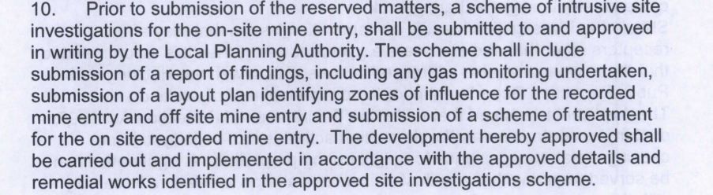

You will note the Coal Authority’s previous ongoing concerns, which were most recently conveyed in our letter dated 31 October 2022. These concerns were specific to the layout constraints presented by the mine entry (shaft) within the planning boundary.

The Coal Authority is therefore now pleased to note the amended layout drawing, which clearly shows the proposed building outside the zone of influence of the mine entry. Consequently, the Coal Authority is now able to withdraw its objection to the proposed layout.

Notwithstanding the above, and whilst this would normally enable us to withdraw our objection to the planning application and to consider the outstanding coal mining related issue (i.e. the remediation of the shaft) as part of a discharge of condition application, no detailed scheme of remediation for the shaft has been presented, as required by the condition. Consequently, the Coal Authority is still unable to withdraw its objection to this planning application.

Please do not hesitate to contact me if you would like to discuss this matter further.

Yours sincerely

Chris MacArthur
Chris MacArthur B.Sc.(Hons), DipTP, MRTPI
Planning Liaison Manager

General Information for the Applicant

Under the Coal Industry Act 1994 any intrusive activities, including initial site investigation boreholes, and/or any subsequent treatment of coal mine workings/coal mine entries for ground stability purposes require the prior written permission of The Coal Authority, since such activities can have serious public health and safety implications. Failure to obtain permission will result in trespass, with the potential for court action. In the event that you are proposing to undertake such work in the Forest of Dean local authority area our permission may not be required; it is recommended that you check with us prior to commencing any works. Application forms for Coal Authority permission and further guidance can be obtained from The Coal Authority’s website at:
https://www.gov.uk/get-a-permit-to-deal-with-a-coal-mine-on-your-property

Disclaimer

The above consultation response is provided by The Coal Authority as a Statutory Consultee and is based upon the latest available data on the date of the response, and electronic consultation records held by The Coal Authority since 1 April 2013. The comments made are also based upon only the information provided to The Coal Authority by the Local Planning Authority and/or has been published on the Council's website for consultation purposes in relation to this specific planning application. The views and conclusions contained in this response may be subject to review and amendment by The Coal Authority if additional or new data/information (such as a revised Coal Mining Risk Assessment) is provided by the Local Planning Authority or the Applicant for consultation purposes.

In formulating this response The Coal Authority has taken full account of the professional conclusions reached by the competent person who has prepared the Coal Mining Risk Assessment or other similar report. In the event that any future claim for liability arises in relation to this development The Coal Authority will take full account of the views, conclusions and mitigation previously expressed by the professional advisers for this development in relation to ground conditions and the acceptability of development.

