VAL/2022/0260 -CLOY BANK FARM, CLOY LANE, OVERTON
Existing Mixed Livestock and Produce Building
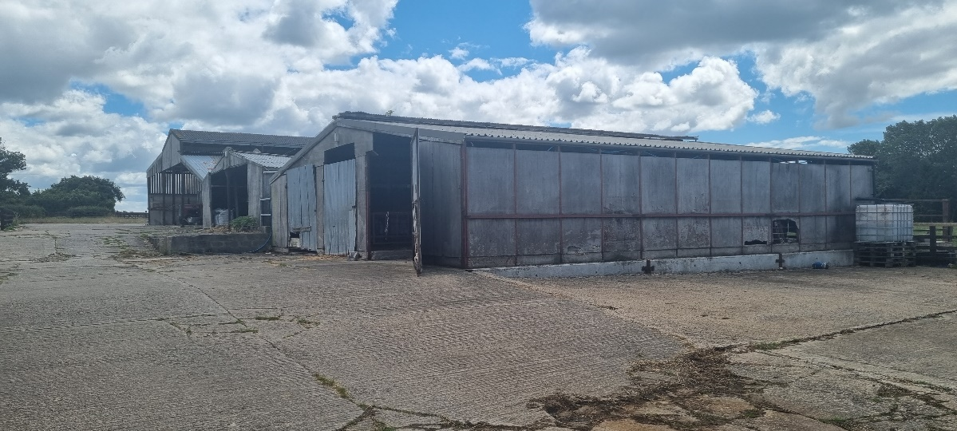
Internal
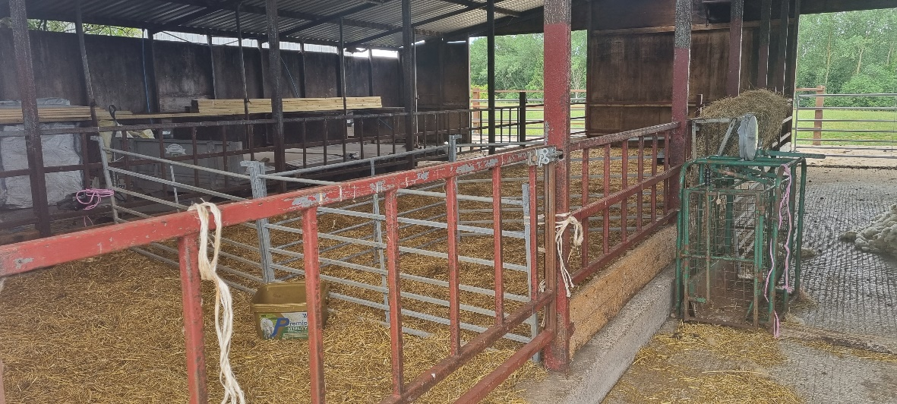
External (Top yard)
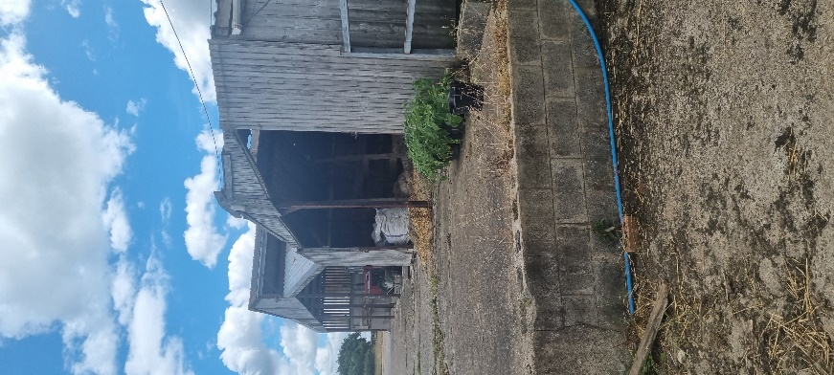

Internal of top yard buildings
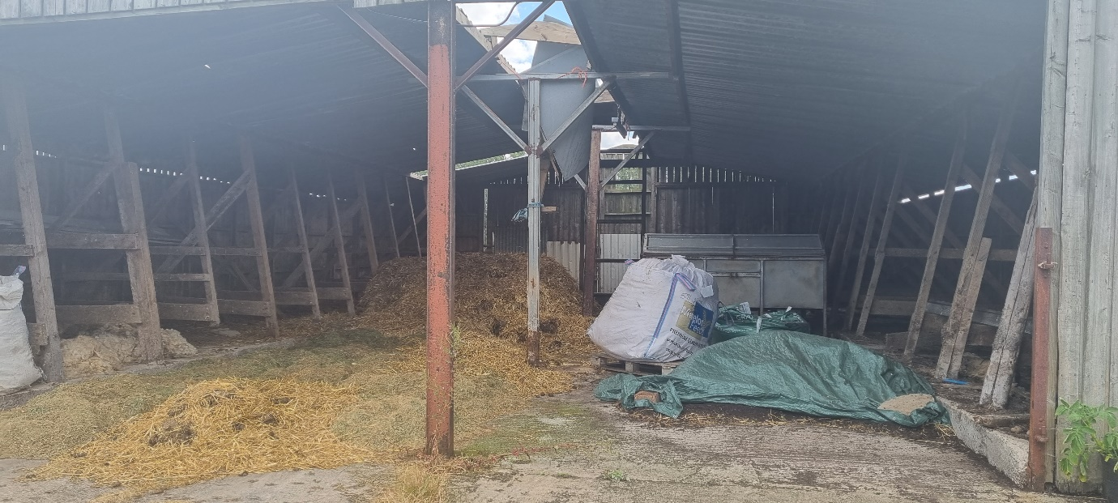
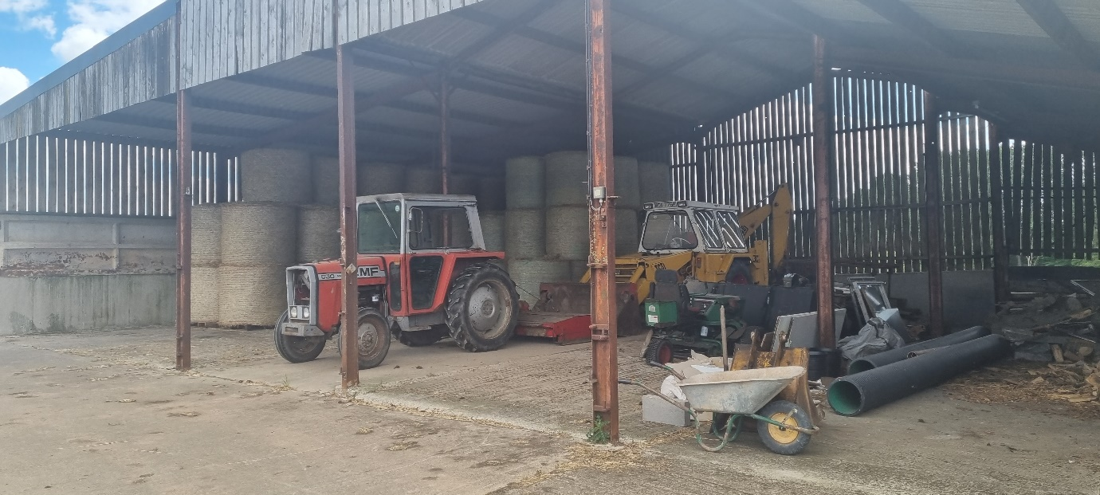
Open Yard ( Top of site)
