Wrexham County Borough Council Planning Committee Briefing Document

Hwb Yr Orsedd - P/2022/0008 and 009

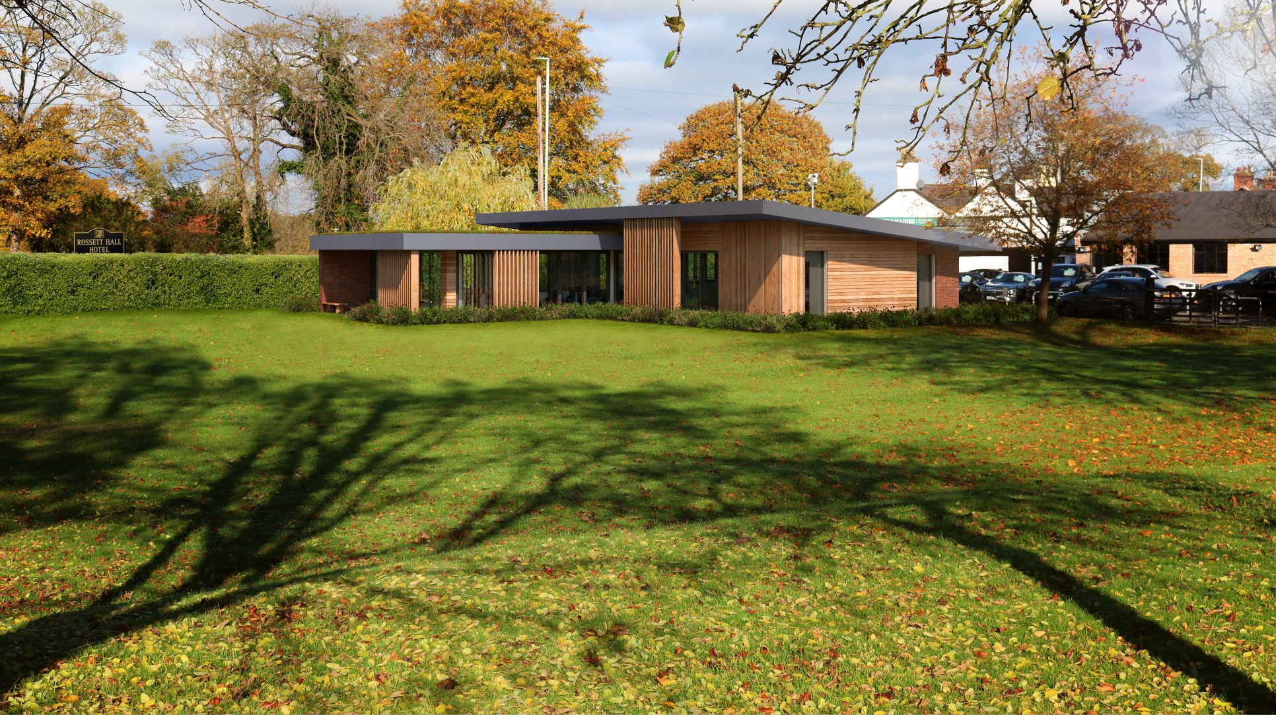
Background

What is Hwb Yr Orsedd?
In brief this is a project set up by Rossett Community Council to redevelop the disused public toilets in Rossett Park to create a community hub.
A "not for profit" company, called Hwb Yr Orsedd Ltd (HYOL), has been established. The company board is a group of local volunteers, who are working with Rossett Community Council and the wider community to develop the hub which will provide a shared space enabling local people to undertake various activities.
Social Business Wales have provided invaluable advice and support from the outset of the project.

How long has the toilet block remained out of daily use and why?
It is approximately 6 years since the toilets were open daily. The facilities were subject to misuse which added to the cost of upkeep and made continued use unsustainable. Obviously it is intended that the new Hwb will have toilets open to the public.

Is there a need/demand for a Hub?
There was a public consultation between March – May 2018. The outcome was a high level of support for the council’s vision for the Hwb.
In December 2021 a consultation event was held in the village attended by around 100 people. The response received at the event was overwhelmingly in support of the Hwb.
Rossett Community Council employ a Community Agent who works with various groups in the community, particularly the elderly, she has clearly identified a need and demand for such a facility.
A petition in support of the project with over 200 signatories was submitted with the application and we are also aware a significant number of comments were submitted by the public in support of the application.
The business community have also indicated their support for the project.
Both our MP and MS have met the project team on site and pledged their full support for the proposals.
Provided we can secure the funding this offers an unmissable opportunity to enhance the park and the community as a whole.

The Project

What kind of activities would be held at the Hub?
The whole ethos of the Hwb is to provide a resource for the local community which is currently absent from any one site in the village. The vision for the Hwb is that it will be:

- A shared community space for groups of different ages and interests to meet, socialize and participate in shared activities e.g. choir, baking, crafts, chess, bridge, book club or anything else the community decided they want
- Somewhere for families to meet up with friends and grab a coffee while the children use the park facilities.
- A place that brings people of all ages together, reduces isolation and helps them form new relationships and support networks.
- A central base for the outreach Post Office, Library, Bank etc.
- A place to provide advice on utility transfer, nutrition, well-being; a place for activity groups to meet
- A place where people (including students from Darland School) could volunteer and receive training.

How would the Hwb impact on the trees and play area?
One basket swing would need to be removed/relocated and potentially one willow tree would need to be removed but it would be replaced with new plantings.

Why is the Hwb bigger than the existing building?
In order to provide the services that the community say they would find beneficial there will need to be some increase in the footprint of the new building compared to the existing toilet block. However the absence of parking will lessen the overall impact considerably and is key to striking a balance in providing the desired services without overreaching too far into the existing green space.
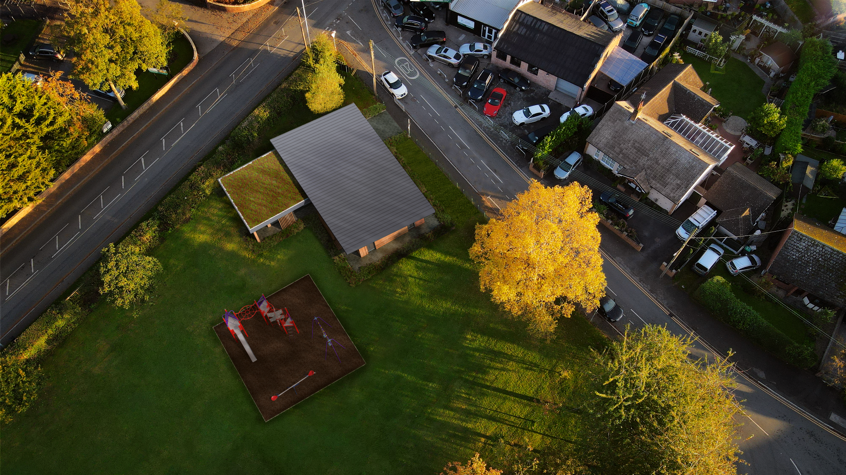

Car Parking
It is the overwhelming view of most residents that there should be no parking on the green area. This position is supported by the Community Council, HYOL and the application is submitted accordingly.
To make it clear, all options have been considered and this position has been arrived at taking into account local parking availability and the likely demand for parking. The salient points in support of the application are set out below:

- Overwhelming opposition from the community for any green space to be taken up by parking provision, this is also the view of the Hwb board and Community Council.

- Historic use and covenant to maintain land as a playground, bowling green or public area for adults and by implication free of vehicles.

- The concentration of users of the park and the proposed Hwb facility/ offering live close enough to make it accessible without transport. This was supported by travel survey undertaken at consultation event held in December which showed that over 90% of potential hub users would not use cars to get there.

- There is existing on street parking provision on two adjacent roads, 25 spaces in total.

- The ‘pinch points’ twice per day during school term time are short and by their very nature transient. Overall for most of the day there is ample parking around the green.

No parking means that ‘splays’ (for safe entry and egress from the Hwb) would not be needed. i.e there is no reduction in current on street parking.
- No parking provision contributes to national and local targets for carbon reduction and 2050 net zero and in addressing the climate emergency declared by both the Welsh Government and Wrexham Council.

- Contribution to achieving the local and national goals as set out in the Wellbeing of Future Generations Act

Planning Officers’ Support
The Community Council and Hwb Board are grateful for the help, advice and support we have received from the Council’s Planning Officers in designing the community hub.
Aside from the parking issue we have addressed all the issues raised and recommendations made by them in coming to our final design proposals.
We believe that we now have a building that is attractive, energy efficient, sustainable and in keeping with the Rossett conservation area plan.

Summary
This application is submitted by Rossett Community Council with the people of Rossett very much at the centre of the project.
This is an opportunity to change a disused toilet block into a vibrant local building which people will want to use and provide local people of all ages a focal point which is hitherto absent.
It is our view that this vision can be delivered without the on site parking required by the Local Authority Highways officers.
We urge you to give your support to the application.

