Landscape Scheme

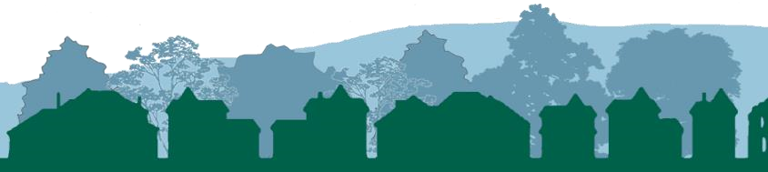

REAL PLANNING
Dunmore, Church Street, Penycae,
Wrexham. LL14 2RL info@realplanning.co.uk Tel: 01978 840651
Mob: 07930103090

Landscape Scheme V3 K Edwards August 17th 2022 (amends in red)

Contents

- Introduction
- The Site
- The Proposed Development
- Extract from Submitted Planning, Design and Access Statement
- Landscape Comment from Natural Resource Wales
- General Description of Landscape Works
- Planting Preparation and Methodology
- Implementation and Maintenance Plan
- Conclusion

Appendices

- Schedule of Tree Planting
- Specification of Native Hedge Planting
- Drawing – Landscape Proposals

v2

1. Introduction

The purpose of this Landscape Scheme is to improve the quality of the design of the proposed stables immediately adjacent to the property known as Bryer, Trevor Hall Road, close to the village of Garth and located between the towns of Wrexham and Llangollen. It is also required to ensure that new development fits into its rural location, the landscape located within an Area of Special Landscape [UDP Policy EC5 refers] as identified in the adopted Wrexham Unitary Development [see extract from the UDP Proposals Map – Inset 13 in Section 6 to the submitted Supporting Statement] and close to the Clwydian Range and Dee Valley Area of Outstanding Natural Beauty [AONB]. The Scheme considers every aspect of the proposed building and its site.
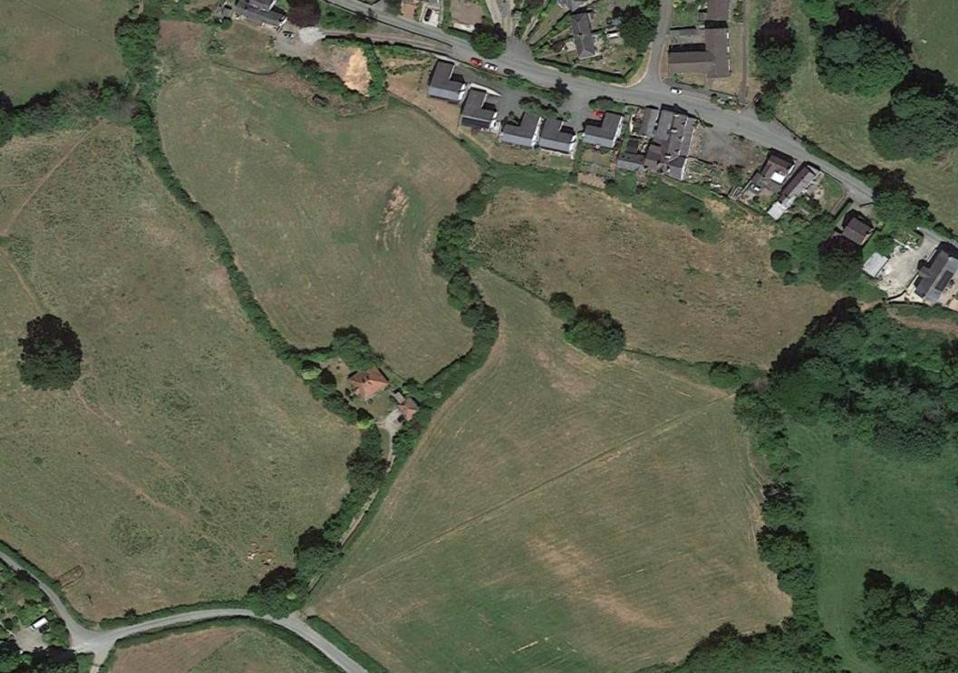

Photo 1

–

Aerial

photo of site location

2. The Site

The location of “The Site” is shown above and within the red line boundary shown in the submitted Site Plan which defines its full extent.

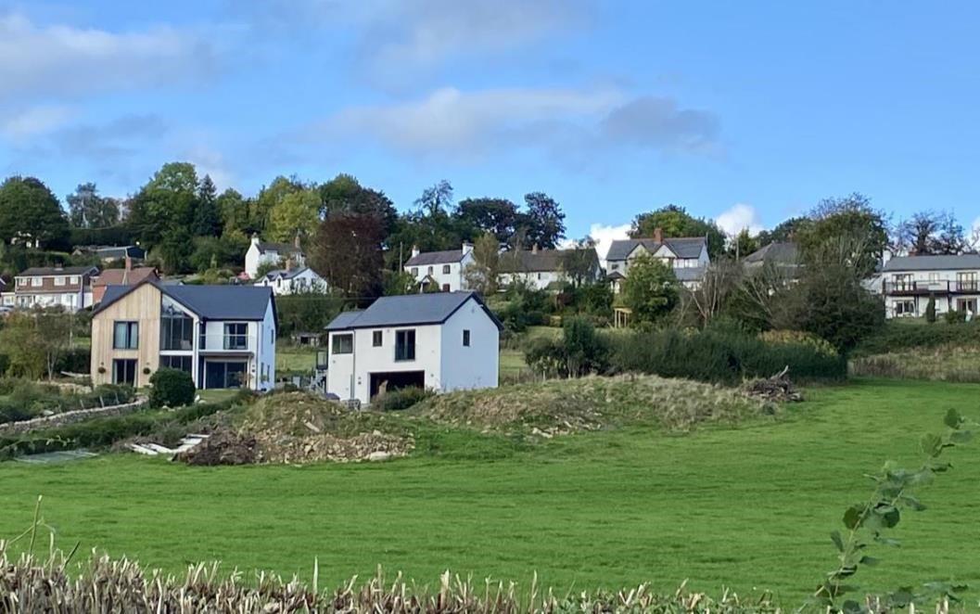

Photo 2 – Site relationship to the property known as Bryer

The property known as Bryer [in which the applicant lives] is located off Trevor Hall Road just beneath and south of the village of Garth, 8 miles west of the town of Wrexham and 4 miles east of Llangollen. The Site is accessed from the top end of the unadopted access road to Bryer, immediately to the southeast and located within the adjacent field, which is currently in the ownership of the applicant’s mother. The Site is situated within the open countryside and outside any settlement limits as identified within the Wrexham Unitary Development Plan and within an Area of Special Landscape as detailed above. It is also located within a buffer zone around the Pontcysyllte World Heritage Site and close to the Clwydian Range and Dee Valley AONB. There is further policy explanation in Section 5 to the submitted Supporting Planning Statement. There are no trees affected by the proposed development.

3. Proposed Development

The proposed development is described in detail in the submitted Supporting Planning Statement¹ together with the applicant’s identified need.

¹ Supporting Planning Statement – Bryer Stable v2 [Real Planning dated September, 2021]

Section 3 states that the proposed scheme will consist of the following:

─ | immediate access from the unadopted road to Bryer.
─ | stable building which includes four stables, two feed rooms and large open area for the treatment of animals and secure storage of physiotherapy equipment and trailer.
─ | walls consisting of vertical timber boarding over concrete panels.
─ | box profile sheeting to roof.
─ | metal windows in profiled roof panels and steel double doors to main entrance.
─ | parking and turning facility with compacted gravel over consolidated hardcore.
─ | the Site will be bounded by a timber post and rail fence together with hedging
of native species.

4. Extract from Submitted Supporting Planning Statement

As a foundation to this Landscape Scheme, it is important to note the consideration already given to the proposal in relation to landscape issues, extract from the submitted Supporting Planning Statement as follows:

“Both national and local planning policies direct new development to within existing defined settlement limits [UDP Policy PS1 refers]. While there are certain exceptions to this [such as the submitted proposal], UDP Policy PS2 states that:

“Development must not materially detrimentally affect countryside, landscape / townscape character, open space, or the quality of the natural environment.”

UDP Policy GDP1 also ensures that any proposal in its scale, design and in its use of materials, together with the provision of adequate access, accords with the character of the site and the surrounding area.

Landscaping
The application site is also located within an Area of Special Landscape [UDP Policy EC5 refers] as identified in the adopted Wrexham Unitary Development [see extract from the UDP Proposals Map – Inset 13 in Section 6 to this Statement]. However, it is important to note that development is not necessarily precluded within such designations although the final siting, design and use of materials must ensure that the important characteristics of the setting of the Special Landscape Area are not compromised. UDP Policy EC5 states that:

“Within Special Landscape Areas, priority will be given to the conservation and enhancement of the landscape. Development, other than for agriculture, smallscale farm-based and other rural enterprises, and essential operational development by utility service providers, will be strictly controlled. Development will be required to conform to a high standard of design and landscaping, and special attention will be paid to minimising its visual impact both from nearby and distant viewpoints.”

This matter has been given full consideration in relation to the final design of the proposed scheme and it is considered that the proposal will not only maintain but will enhance the landscape quality in the area.

Pontcysyllte Aqueduct and Canal World Heritage Site
It is also acknowledged that the development proposal is sited within the buffer zone of the Pontcysyllte Aqueduct and Canal World Heritage Site - a fact that is an important material consideration to be taken into account in the determination of this planning application. The design process has considered the impact of the proposal upon the World Heritage Site, on views both inwards and outwards. It is considered that the design quality of the proposed development and the sympathetic use of appropriate materials both contribute to the integrity and authenticity of the World Heritage Site.

Scale, Siting and Design
The total area of the Site is approximately 1160 square metres and comprises the elements outlined in Para 3.3 in this Statement. The stable block is nearly 21 metres long and close to 11 metres in width with a pitched roof over. The building is set into the ground at the rear, so heights given are not true values above ground. Only to the front of the stable building is all of the elevation above ground level.

The proposed scheme is set immediately adjacent to the existing hedging at the point the unadopted access road arrives at the properties Bryer and Claremont. In relation to the Site’s field position, it is considered to be the best location in that it, the proposed stable block and parking and turning area, clearly become part of a complex of buildings in association with the two existing residential properties. Consequently, in terms of siting and scale, the proposed development will be in accord with UDP Policy GDP 1 – General Development Principles.

Appearance
The structure mainly sits below ground level, with the highest point below the form of the land. The stable block is to be constructed of concrete block up to a metre above ground level with the rest of the elevations continuing in naturally stained wood and the colour to be agreed with the Local Planning Authority. The roof will be a dark grey / black Bitumen Corrugated Sheet taking account of the Council’s planning guidance reference that darker coloured roof materials assist in reducing the scale and mass of a building and, therefore, this is used as opposed to clear or transparent material. This also involves introducing a series of small rooflights.

The proposed parking and turning area will be surfaced in dark grey gravel over consolidated hardcore.

All areas are set within a Site boundary of timber post and rail fence with new hedging utilising native species and associated planting as shown on Drawing PD218/02.”

5. Landscape Comment from Natural Resource Wales

As explained earlier, the application site lies outside the nearby Clwydian Range and Dee Valley AONB and landscape concerns² were expressed by Natural Resource Wales [NRW] around any potential resultant impact of the proposal. Real Planning agreed to the provision of cross sections to demonstrate if the proposal can be ameliorated through naturalised landforms together with a Landscape Proposals Plan.

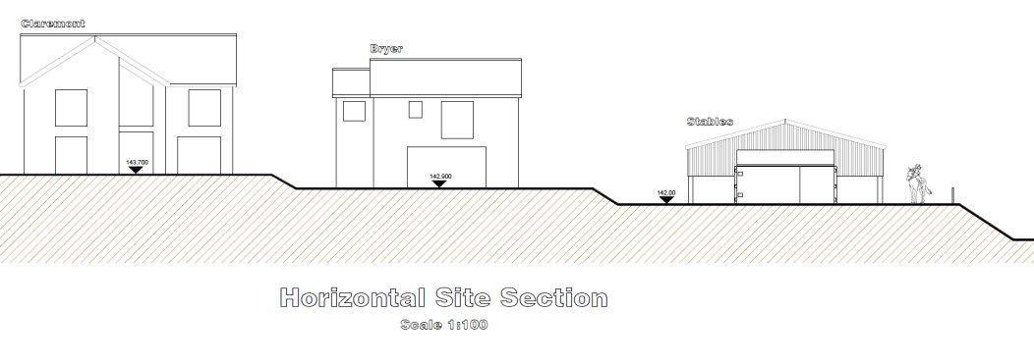

In April 2022, Real Planning submitted the requested Cross Section [see above and below] to the NRW Landscape Officer subject to the additional need to:

─ Introduce more naturalised landforms.
─ Provide hedgerow / tree planting scheme along the edges of the proposed development and between it and Bryer.
─ Provide a Landscape Proposals Plan.

² Consultation response to WCBC Planning from Natural Resource Wales dated 13th October, 2021

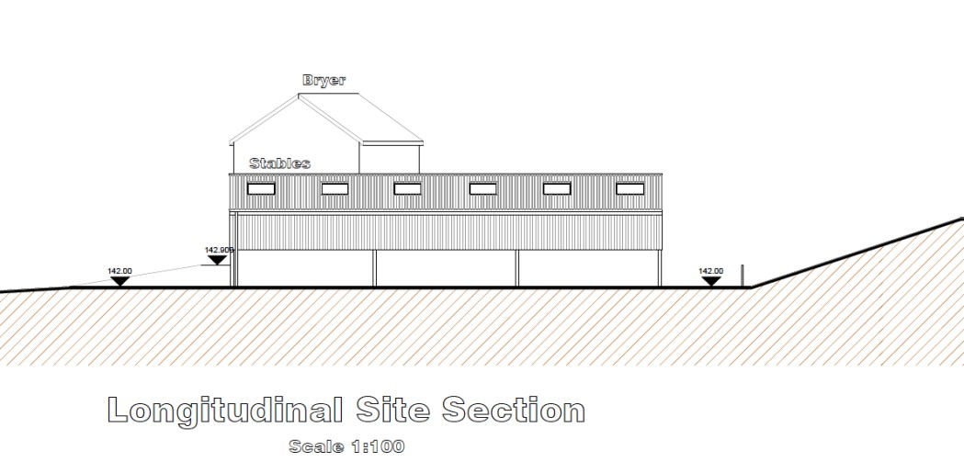

The NRW Landscape Officer responded by email dated 22nd April stating:

“The section drawing helps explain the relationship between buildings and their relative scale and position in the landscape. Cut and fill to set the new building into the hillside looks appropriate. The sections and/or landscape plan will need to confirm where cut spoil is reused. As discussed previously the planting of native species shrub and tree species to separate the residential and agricultural elements, define the edges of gardens, and enclose the parking area would all help settle the previous and current development proposals into the landscape.”

6. General Description of Landscape Works

In accord with the sentiments identified, in particular the above response to the submitted cross sections by the NRW Landscape Officer, the following landscape works are proposed and detailed in this Landscape Scheme and also shown on the attached Landscape Proposals drawing [Appendix 3 to this Statement]:

─ supplementary planting along the hedgerow between the proposed stables development and the adjacent property known as Bryer.
─ compacted gravel to the site access / ingress and stables parking area.

much reduced car parking area – now 70% of the original submission [see revised Proposed site plan together with the submitted Landscape Proposals Drawing].
─ post and rail fence on the east, north and south boundaries to the site.
─ seeding to all proposed grassed areas within the proposed site; and
─ native hedge and hedgerow tree planting to east, north and south boundaries to the proposed site.

7. Planting Preparation and Methodology

Prior to laying topsoil, ensure all areas for soft landscaping, turfing or planting are ripped thoroughly to alleviate compaction caused by the building works. All building rubble, wood, plastic, large stones and debris from the site to be removed from the site. All ground preparation and planting operations shall comply with BS4428 (1989) Code of Practice for General Landscape
Operations). Contractor should be aware of the root protection areas and should not raise soil levels in these areas and allow for hand operations.
• Response to NRW question - preparation of the compacted areas of soil prior to grass-seeding of the earthworks;
The site has been cleared of the small amount of rubble and the compacted subsoil (native) is to be levelled to the proposed elevations to enable level access from the driveway and to form a gentle sloping area as per the side elevations previously submitted and detailed in the landscape plan. Any topsoil stripped with be reinstated, using the “loose tipping method” to prevent compaction. The soil has been analysed and tested and will be fertilised in accordance with the results. Decompaction and aeration will be achieved by using a verti-drain, slit or spike in the topsiol to break up any panning and compaction, therefore improving aeration, drainage and root function

Topsoil
─ to be medium textured loam slightly acidic–neutral, free from perennial weed, roots, and stones over 50mm.
─ it should be fertile and contain an adequate humus and fibre content.
─ imported topsoil shall conform to BS 3882, general purpose grade. ─ depth of topsoil to be generally as follows:-
- Shrub planted area – 450mm depth
- Tree pits – 1.2m x 1.2m x 750mm deep
- Turf area – 150mm topsoil
- New native hedging – minimum 300mm depth of existing site topsoils.

Trees
─ trees should be planted in areas previously cleared of all weeds, grass and vegetation.
─ bare-root trees and container grown trees to be planted between October and March.

the trees are to be of ‘Selected Standard’ size, 10-12 cm girth, 2.75-3.0 metres tall, bare-root or root-balled and healthy and vigorous.
─ trees with a girth greater than 8cm shall be planted in prepared tree pits 1.2m x 1.2m x 750mm deep, base of pit broken up by a further 150mm to alleviate drainage, backfilled with a mix of topsoil and proprietary tree and shrub planting compost at a ratio of 1:1.
─ fix tree stake into firm ground below pit before planting, backfill in 150mm lightly consolidated layers after planting.
─ lay a 75mm perforated irrigation pipe on top of root system to facilitate watering, prior to final backfill.
─ cut-end of pipe needs to be finished just above ground level.
─ stake trees with a single low stake [third height of stem] secured by rubber Tom ties located at top of stake.
─ water thoroughly upon completion.
─ ensure the tree ties are not so tight that they damage the stems.
─ check regularly and loosen to allow growth.
─ trees should be able to be self-supporting by the third year when the stakes and ties should be removed to avoid damage to the tree and making it dependent on support.
─ check regularly that the tree guards are sound and secure, and replace as necessary.
─ maintain a metre wide strip in a weed free condition for at least three years, to reduce competition from grass and weeds for moisture and nutrients.

Native Hedging
Additional information in response to NRW questions - The proposed grass/wildflower seed mix, or tree species if proposed;
Tree Species:Purple Birch [Betula Pendula 'Purpurea'];Common Spindle [Euonymus Europaeus]; Rowan [Sorbus Aucuparia]; Field Maple [Acer Campestre]; Sugar maple [Acer Saccharum]
Specification of Native Hedge Planting
Mixed Native Hedge – species mix to be as follows:-
Main Matrix (Transplants / Quicks) 70% of planting stock
─ Hawthorn [Crataegus Monogyna]
─ Blackthorn [Prunus Spinosa]
─ Hazel [Corylus Avellana]
Interplant (Whips / Transplants) 30% of planting stock
─ Holly [Ilex Aquifolium]
─ Dog Rose [Rosa Canina]
─ Dogwood [Cornus Sanguinea]
─ Wild Privet [Ligustrum Vulgare]
─ Honeysuckle [Lonicera]
─ Guelder Rose [Viburnum Opulus]
Planting to include additional climbers / shrubs in the hedgerow as these will increase the value to wildlife and attractiveness of the hedge at a ratio of 1 plant per 10 metres.
Grass seed
No Ryegrass Horse & Pony Herb Grass Seed Mix; Comer Timothy; Meadow Fescue; Strong Creeping Red Fescue; Tall Fescue; Crested Dogs Tail; Smooth Stalked Meadow Grass; Brown Top Bent; Perennial Chicory; Sheeps Burnet; Sheeps Parsley; Ribgrass; Yarrow; Sainfoin

Information in original scheme detailing the establishment method
─ clear a metre wide strip of vegetation from the proposed hedge planting site using a Glyphosate based systemic herbicide – strictly in accordance with manufacturer’s instructions.
─ allow the ground to recover from any chemical treatment before planting.
─ take great care to avoid drift and hence damage to nearby vegetation.

use mulch to reduce weed control operations, spread a geotextile membrane / black polythene over the planting site and peg at sufficiently regular intervals to keep in place. Straw can also be used as mulch.
─ through the plastic, plant the hedging transplants and pit plant the container grown stock in pits larger than the root ball, having first gently teased out any roots from the root ball of any container grown stock.
─ planting is to be carried out during the planting season [October to March] – ideally in November, before the ground gets too cold, otherwise up to March except when there is a ground frost or soil is waterlogged.
─ avoid planting in very cold or wet weather.
─ hedging plants are to be 60-80 cm high, 1+1, bare-root, healthy and vigorous transplants to be planted in a double staggered row, at a density of not less than 7 per meter with approximately 450mm between plants in the same row, and 300-400mm between rows.
─ all plants need to be well heeled-in after planting and watered-in during dry weather.
─ all transplants shall be protected with a 400mm high plastic spiral rabbit guard supported by a 750mm stake or cane, which can be removed once the plants are well established (approx 3-5 years).
─ temporary stock-proof fencing should be erected to protect hedging from grazing if required.

8. Implementation and Maintenance Plan

Response to NRW questions – long term management of restore areas included in the original scheme

Upon approval by the local planning authority, the above landscape scheme shall be implemented within the planting period October 2022 to March 2023 or the planting season immediately following occupation of the permitted development, whichever is the soonest. The approved landscape scheme shall be maintained for a period of five years from the date of implementation. Within that timescale, any planting becoming severely damaged or seriously diseased, or is in poor physiological condition and / or are removed shall be replace with trees and shrubs. Long-term management is proposed, to ensure that the planting remains healthy and in-keeping with the original design.

Tree Planting
─ ensure the tree ties are not so tight that they damage the stems.
─ check regularly and loosen to allow growth.
─ trees should be able to be self-supporting by the third year when the stakes and ties should be removed to avoid damage to the tree and making it dependent on support.
─ check regularly that the shrub guards are sound and secure, and replace as necessary.
─ ensure adequate watering and fertilising is carried out to ensure good establishment and that all dead, diseased or damaged plants are replaced.
─ replace dead, dying or damaged stock with the same species as soon as practicable in the first planting season following failure.

Hedge Planting
─ in the first spring after planting trim all lateral branches back by 50% (not Holly).
─ prune damaged, diseased or dead wood immediately after first leaf break.
─ follow with a light trim every second or third year, allowing the hedge to increase in size each time.
─ ensure adequate watering and fertilising is carried out to ensure good establishment and that all dead, diseased or damaged plants are replaced.
─ replace dead, dying or damaged stock with the same species as soon as practicable in the first planting season following failure.
─ in the spring and after severe frosts and winds firm-in around the base of each plant and ensure that tree stakes and ties and shelters are secure.

The approval of this Landscape Scheme dated May, 2022 will ensure the applicant will be responsible for the health and condition of the plants for at least 5 years after they are planted, and this means that any which die during this period must be replaced.

9. Conclusion

The submitted landscape scheme is comprehensive. Great care has been taken in ensuring the proposals soften the impact of the proposed development and that it will not look out of place in this rural location. It has taken account of the
Local Planning Authority’s development policies, national and local planning guidance, and best practice. In particular, the proposed hard and soft landscape treatment is in accord with the Council’s local planning guidance³ and Wrexham Unitary Development Plan Policies GDP1 and EC4 and will be secured by condition. It is considered that the retention and management of the adjacent existing hedging and the introduction of supplementary planting will add to the character of the Area of Special Landscape [UDP Policy EC5 refers] and nearby Clwydian Range and Dee Valley Area of Outstanding Natural Beauty.

To secure the implementation of the proposed Landscape Scheme the following conditions can be attached to the decision:

─ The submitted and approved Landscape Scheme [RP – Bryer Stables dated May, 2022] shall be fully implemented in all respects within the agreed timescale and in strict accordance with the approved scheme.
─ The landscaping scheme as carried out in connection with condition no. ? shall be permanently retained. Any planting becoming severely damaged or seriously diseased or is in poor physiological condition and / or are removed without the written permission of the Local Planning Authority shall be replaced in accord with the approved Landscape Scheme.
─ The landscaping scheme as carried out in connection with condition no. ? shall be maintained in strict accordance with the five year Maintenance Plan as detailed in the approved Landscape Scheme.

³ Local Planning Guidance Note 7 - Landscape and Development - Wrexham County Borough Council

Appendix 1 – Schedule of Tree Planting

Species | Specification | Root
Purple Birch [Betula Pendula 'Purpurea'] | Selected standard | White fabric container
Common Spindle [Euonymus Europaeus] | Selected standard | White fabric container
Rowan [Sorbus Aucuparia] | Selected standard | White fabric container
Field Maple [Acer Campestre] | Selected standard | White fabric container
Sugar maple [Acer Saccharum] | Selected standard | White fabric container

Appendix 2 - Specification of Native Hedge Planting

Mixed Native Hedge – species mix to be as follows:-

Main Matrix (Transplants / Quicks) 70% of planting stock
─ Hawthorn [Crataegus Monogyna]
─ Blackthorn [Prunus Spinosa]
─ Hazel [Corylus Avellana]

Interplant (Whips / Transplants) 30% of planting stock
─ Holly [Ilex Aquifolium]
─ Dog Rose [Rosa Canina]
─ Dogwood [Cornus Sanguinea]
─ Wild Privet [Ligustrum Vulgare]
─ Honeysuckle [Lonicera]
─ Guelder Rose [Viburnum Opulus]

Planting to include additional climbers / shrubs in the hedgerow as these will increase the value to wildlife and attractiveness of the hedge at a ratio of 1 plant per 10 metres.

