
Bob Dewey

PLANNING

SUPPORTING STATEMENT AND

ADDITIONAL INFORMATION
RETENTION OF PARKING AREA
GLEBE FARM. BRONINGTON

Background: Glebe Farm has been operated as a livery yard and in 2006 (ref P/2006/0686) its use was authorised.
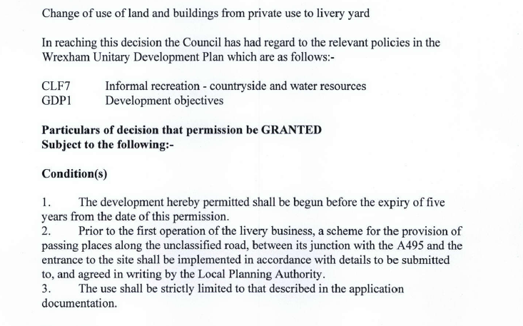
Subsequently a new (replacement) manège was constructed in 2018 with the benefit of planning permission (ref P/2018/0657).

This replaced a smaller area adjacent to the farm house on which there were no planning controls. Conditions were imposed which limited to private use in connection with the dwelling.

Extract from the permission:-
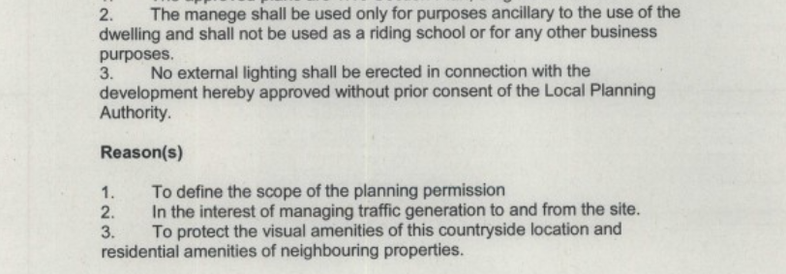

So far as we are aware, no discussion occurred prior to the imposition of condition 2 which presents some confusion in that the whole site has long established planning permission as a livery. It is understood that Highway Officers raised no objections to the proposal.

Following the refusal to issue a certificate of lawfulness for the parking area, this new application is made to seek to obtain planning permission for the parking area shown on the plan (below). is lawful. This is hoped to will allow permission for the continued use of the manège for wider use to be granted.

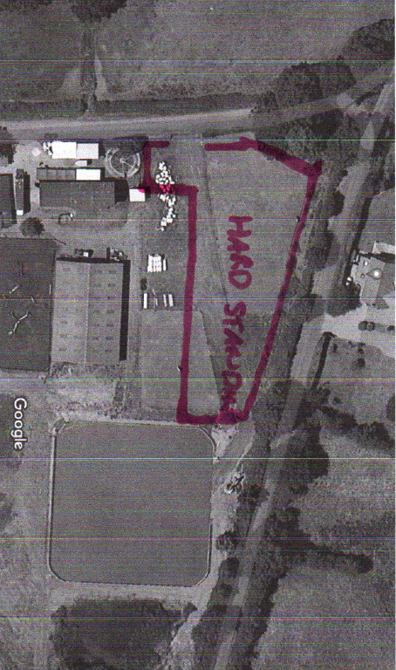

INFORMATION

The following information is provided to assist the Council in determining this application.

It was believed that the grant of permission for the use of the whole site as a livery yard, authorises ancillary uses. Use of part of site for the parking of owners’ cars and horse boxes/trailers must therefore be permitted. The refusal to issue a Certificate refers solely to operational development. However it is considered that it should not be unreasonable to expect visitors to have parking available and usable in all weather conditions. The laying down of a porous hard surface is a sensible way of ensuring that vehicles can park and turn off the highway and do not result safety issues on the road by mud being deposited there. The surfacing was undertaken in Spring 2011 and a letter from the contractor was provided with the Certificate application. In an email, Ms Penny confirmed she has parked there for some 6 years and similarly Ms Turner stated that the area in question has been used as hard surfaced parking since 2011/2012.

The choice of materials was particularly designed to reflect the rural location and photos show that It had rapidly grassed over (see google earth pictures). Any impact it may have had on the appearance of the area was substantially diminished.

Subsequently, as a natural routine, the surfacing was later renewed in similar material. The Council has argued that this resurfacing was an engineering operation, and hence that an explicit planning permission is necessary. Whilst the applicant is strongly of the view that the operations (limited as they were) they were a natural part of maintaining the site. This application has been made (without prejudice) to ensure that the surfacing (and resurfacing as necessary) of the land is beyond any future challenge.

It also allows the applicant to seek to allay any fears from the adjoining resident about the future appearance or use of the land.

.

The use of the parking area is strictly associated with the manège and is intended to serve the existing livery users. Only from time to time will it be used for special equestrian events. If the usage is on rare occasions extended to permit other owners to bring ponies/horses for competitions/displays this will only be at weekends and limited to mornings and early afternoons. No evening events are envisaged. Occasionally, it may be hired out to individuals and local riding and pony clubs. The parking area will therefore only be used on rare occasions and if (as the applicant claims he has shown) it has been so used for more than ten years, it clearly has had a minimal impact upon the area or the neighbour.

The intention is to erect a post and wire fence (or similar) approximately two metres from the site boundary and to remove any hard surface material from that area. There are a number of substantial mature trees along this boundary and these appear to be in good health. Any gaps in the boundary hedge will be planted with hawthorn or blackthorn to ensure that the views into the site are secured. The remainder of the 2 metre strip will be allowed to naturally regenerate or will be sown with wildflowers ro enhance the area.

Conclusion:

The Council is urged to grant permission for the surfacing of the area to remain..

Robert A Dewey BA(Hons) MBA Dipl Est mgmt., Dipl TP, Dipl Transp Std,.
May 4 2022
Rev3

The Gables, Llanfynydd WREXHAM. LL11 5HG

tel: 01978 761315 (m) 07947 186 777

e mail bobdeweyplanning@gmail.com

