Code No: RHO P/2020/0669
Decision Date: 05/03/2021
Applicant: Mr Ian Warren
Location: Pant Y Garn, Plas Drain Road, Pen Y Cae, Wrexham, LL14 1UH

Reserved matters:
Condition(s)
- Approval of the following details shall be obtained from the Local Planning Authority before any part of the development is commenced:
  - The scale of the building(s)
  - The appearance of the building(s)
  - The landscaping of the site

- As part of the reserved matters application, an external bat friendly lighting scheme shall be submitted to and approved in writing by the Local Planning Authority. The scheme shall be fully implemented in accordance with the approved details prior to first use / occupation of the development.

Response for approval:
- a. The scale of the building(s)
Following detailed site investigation, structural design and in order to meet the highest DEFRA standards for animal welfare the design has been laid out in 211236-101 Structural Arrangement.

The proposed dimensions are L-25612, W-13375, H-3000.
The significant variation from the approved outline in the reduction in height from 4m to 3m based on this structural design. It is hoped this change helps further reduce the impact of the building in the existing landscape.



- b. The appearance of the building(s)
The proposed appearance of the building is in accordance with the Supplementary Planning Guidance Note (Clwydian Range and Dee Valley Area of Outstanding Natural Beauty (AONB)).

To maintain the local distinctive-ness it is proposed the building will utilise whitewashed, blockwork walls in keeping with a predominant agricultural style within the AONB (SPG 8.31).

Roof colours are generally of blue/black and the proposal is to harmonise with surrounding settlements by utilising a slate blue/grey/black coloured roofing sheet (SPG 8.31). Darker coloured roofs also produce less glare and are less visible from greater distances or surrounding higher ground (SPG 8.35).

Window openings will be vertical and appropriate frame colours (wood colours/effect) will be utilised (SPG8.34).

- c. The landscaping of the site
The building design includes a split level (see 211236-101 Structural Arrangement) to minimise the required cut and fill in accordance with SPG 8.54.

Existing mature planting adjacent to the site will be retained, providing good screening to the west (SPG 8.51). The slope generated by the cut and fill, which helps lower the building in the surrounding landscape, will be laid to grass with patches planted with shrubs and wildflowers to support pollenating insects.

The north face of the building is the only side adjacent to the property boundary. It is an old patchy hedgerow, which will be retained and enhanced with infill planting of indigenous species (predominantly blackthorn and hazel) at a minimum density of 7 whips per meter (SPG 8.52).

To the east the orchard will be retained along with the existing grass bank between the building and trees, in accordance with the requirements of the Ecological Survey (PLN Ecological Report - Web - Pant y Garn EcIA – 5th November 2020).

The south facing aspect accommodates the parking and access road which will avoid the use of brick/paviours in preference for stone in keeping with the existing farm track (SPG 8.53).

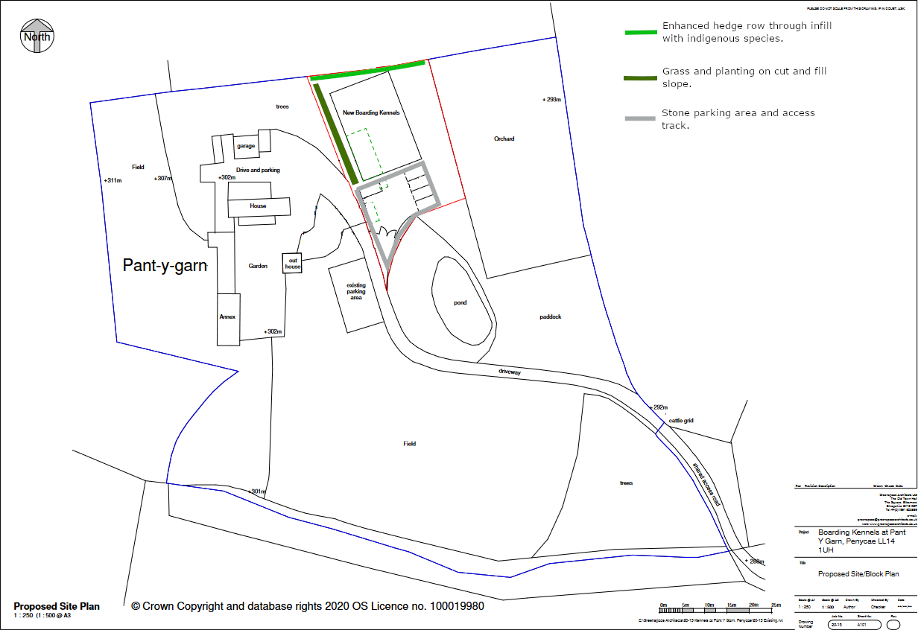

- Bat friendly lighting scheme
The proposed external lighting scheme is based on the Bat Conservation Trust Guidance Note (BCTGN).

External lighting will be separated into two independently controlled systems, a standard bat friendly lighting scheme and an emergency lighting scheme to aid evacuation and emergency actions. All lighting will utilise LED luminaires <2700 Kelvin (BCTGN Step 4).

The agricultural land to the north and the orchard to the east are both potential foraging grounds for bats, as such only emergency lighting will be in place meeting BCTGN Step 3. To the west the standard lighting scheme will be limited to the southern half of the building, providing lighting up to the main access point.

To the south and south-west sides of the building external lighting will be directional, targeting pedestrian routes. Where possible lighting will be placed directly under the eaves, or include additional cowling to further reduce any upward light spill (BCTGN Step 4).

All internal lighting will be recessed minimising light spill (BCTGN Step 4).

