Date | 11 November 2022
Our ref
LPA refs
Contact us | 01827 946411 / info@neptuneplanning.co.uk

PLANNING, DESIGN AND ACCESS STATEMENT
RE: ERECTION OF GROUND MOUNTED WAREHOUSE UNIT
LOCATION: BROTHER INDUSTIRES LTD, VAUXHALL INDUSTRIAL ESTATE, RUABON, LL14 6HA

INTRODUCTION

This supporting planning statement accompanies planning application forms and documents seeking planning permission for a warehouse unit.

The applicant is known as Smart Space Instant Buildings. The company provides fast and cost-effective solutions for a whole range of industrial and commercial applications. Smart-Space is the trading name of the Portable Venues (Group) Ltd, which was incorporated in 1987. Since this time Smart Space looks to provide a ‘one stop shop’ for its commercial clients seeking additional space. This can include a range of applications from storage, refrigeration, office accommodation and even sporting use in some past examples. The business takes client’s from their initial contact through the planning and design phases through to completion on the site.

The proposals in this case seek planning permission for the erection of a warehouse unit to an existing hard surfaced yard area. The unit will provide additional warehouse capacity at Brother Industries, a manufacturer of a range of products, who operate in an industrial area to the south west of Wrexham. The supplier is currently facing issues with storage within their existing building. The proposals seek to provide greater flexibility to remedy this issue.

This statement considers national and local planning policies, guidance and relevant legislation. It concludes that the proposals comply with the adopted development plan and planning permission should be approved, subject to appropriate conditions.

SITE DESCRIPTION

The application site is located to the North of Ruabon, approximately 3.5 miles south west of Wrexham. The site has access to a good quality road network (A483) and sits within Vauxhall Industrial Estate, an industrial area north of Ruabon. The site is situated just off a main bus route which runs directly into Wrexham, and has decent footpath connections to the nearby residential estates.

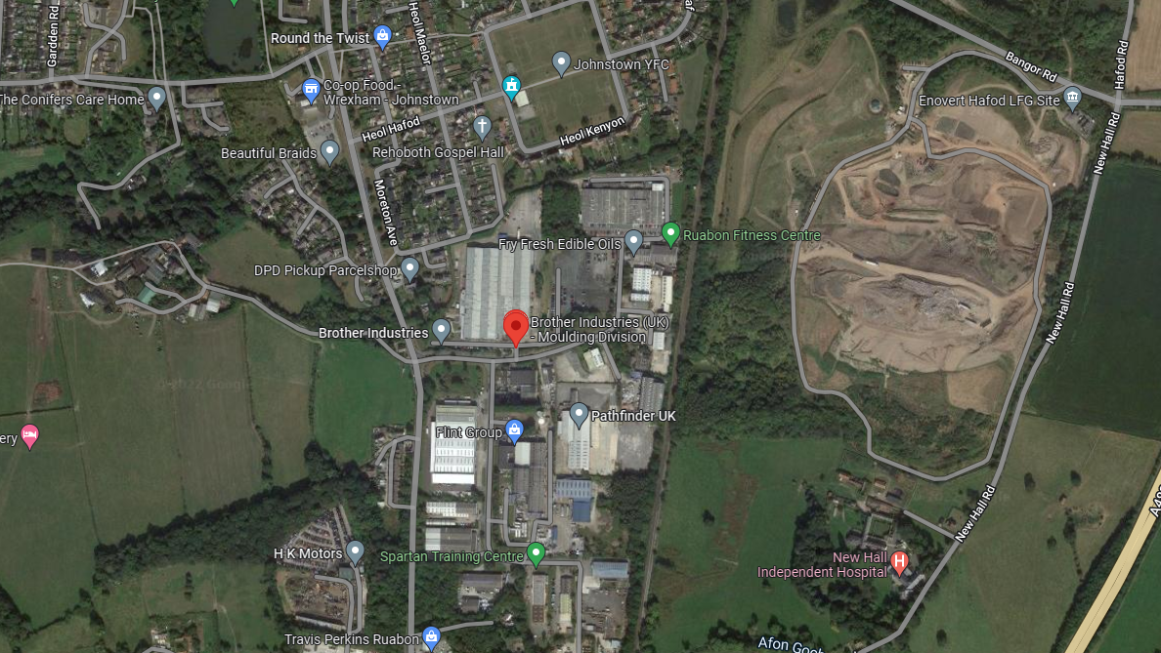
Figure 1: Wider location of site in Redditch (c) Google Earth

The site is currently used for moulding by Brother Industries, as traditional B8 and B2 use. The existing main building on site is a large scale steel portal frame type unit. The building has large open floor area, some office space ancillary to the function of the main use.

Planning history

We have found no relevant historic planning applications for the site listed on the Wrexham Planning website.

DESCRIPTION OF DEVELOPMENT

Planning permission is sought for the erection of a ground mounted warehouse within the existing yard area of the premises.

The applicant provides structures of this type for a range of commercial clients across the UK under their trading business known as Smart Space. In this case Brother Industries, the occupiers of the site seek the erection of the warehouse unit to assist with storage on the current site.

The proposed covered area will be 25m by 15m in area, 7.4m in overall height and 5.4m to eaves level. The proposed structure will have a Twin Layer Insulated PVC Roof, composite wall panels panels and will essentially bolt down to the existing yard surface. The building does not have traditional foundations and is ground mounted. The fixings to the existing surface are ‘Pull Tested’ to assure structural stability in that the building will remain anchored to the existing surface.

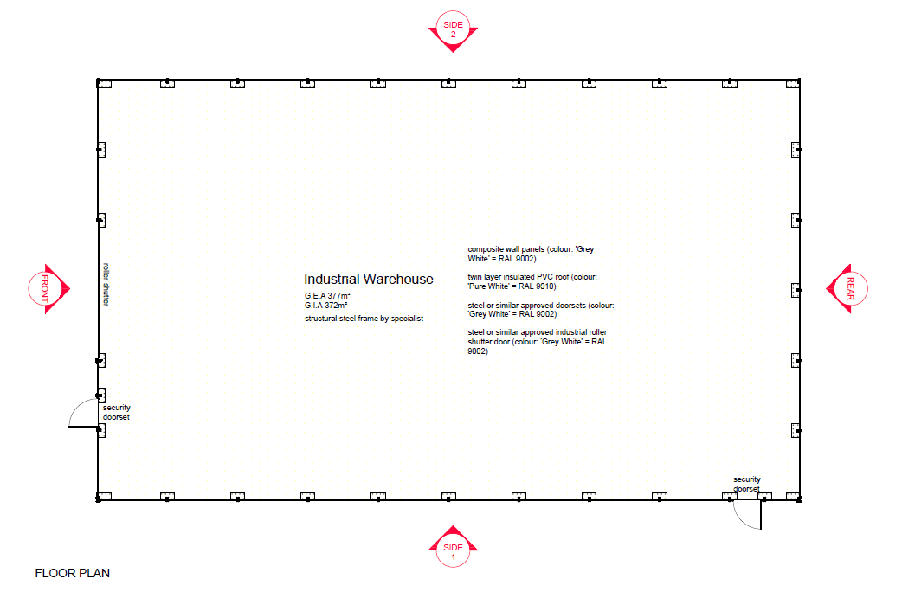
Figure 2: Extract from Proposed floor plan Not to scale

PLANNING POLICY CONTEXT

Section 70(2) and Section 38(6) of the Planning Acts requires that decisions on planning applications must be made in accordance with the development plan unless material considerations indicate otherwise. Whilst noting the primacy of the development plan, the decision must also take into account government policies within the National Planning Policy Framework (NPPF) and guidance in the National Planning Practice Guidance (NPPG) which are material considerations in decision making.

Under Section 15 of the Planning and Compulsory Purchase Act 2004 (as amended by the Localism Act 2011) Local Authorities are required to prepare a Local Development Scheme (LDS) which explains the documents which form part of their Development Plan Documents for governing development in their area. We could not find a relevant LDS for Wrexham, so looking at the councils “Development Plans and other Planning Policy” and found

Wrexham Unitary Development Plan 1996 - 2011

Proposals Map

National Planning policies

The following section summarises the relevant paragraphs and chapters in Planning Policy Wales (PPW). Within PPW, para 1.2 states that “The primary objective of PPW is to ensure that the planning system contributes towards the delivery of sustainable development” and then goes on further at the top of page 7 to define that sustainable development is:

“Sustainable Development” means the process of improving the economic, social, environmental and cultural well-being of Wales by taking action, in accordance with the sustainable development principle, aimed at achieving the well-being goals.

Acting in accordance with the sustainable development principle means that a body must act in a manner which seeks to ensure that the needs of the present are met without compromising the ability of future generations to meet their own needs.

PPW page 17 – Key Planning Principles, talks about growing the Welsh economy in a sustainable manor, it states that the planning system should enable development which contributes to long term economic well-being, making the best use of existing infrastructure. We believe that this statement supports developments to already existing businesses, allowing them the potential to grow, whilst also supporting sustainable development.

PPW para 3.55 states that “Previously developed (also referred to as brownfield) land (see definition overleaf) should, wherever possible, be used in preference to greenfield sites where it is suitable for development.” It goes on further to state in para 3.56 “Planning authorities should work with landowners to ensure that suitably located previously developed sites are bought forward for development and to secure a coherent approach to their development” These statements go on to support the principle of sustainable development, whilst also supporting the proposed developments.

PPW para 5.0.1 and 5.0.2, in Productive & Enterprising Places states that “The productive and Enterprising Places theme of planning policy topics covers economic development, physical infrastructure, energy and the efficient use of resources” and “It includes the development of land necessary for economic activity including traditional office, and industrial Development” respectfully. Para 5.4.1, Economic Development, mentions that “The planning system should ensure that the growth of output and employment in Wales as a whole is not constrained by a shortage of land for economic uses.”

In our view the proposed development is fully supported by PPW.

Key Considerations

The key considerations of relevance to the current application and as considered within this report are as follows:

Policy principle of development

Character, Appearance and Amenity Considerations

Highways Considerations

Overall Conclusions

principle of development

We have examined the Wrexham Unitary Development Plan (1996 to 2011) and the Associated Proposals map. We note that the site is not within any land designations from within the proposals map, however within the UDP (Unitary Development Plan) the site is relevant within Policy E1, E4, and GDP1.

Policy E1 talks about allocating employment land, and lists a number of sites. No. 24 is Vauxhall Industrial Estate which has been allocated 2.5 hectares of employment land. Policy E1 goes on further to state that “The plan identifies sufficient fully serviced and easily accessible employment land to cater for the sustained economic development of the County Borough. All new employment development will be directed to the above locations and to sites with planning permission for employment use”. This implies that acceptable developments would be supported on these sites.

Policy E4 states “Employment development on unannotated land within settlement limits will be permitted subject to Policy GDP1.” The site sits within Vauxhall Industrial Estate, which is within Johnstown/Rhosllanerchrugog settlement boundary.

Policy GPD1 provides a list that all new developments need to adhere to, the most relevant to this application being A) Ensure that built development in its scale, design and layout, and in its use of materials and landscaping, accords with the character of the site and makes a positive contribution to the appearance of the nearby locality. And E) ) Ensure that built development is located where it has convenient access to public transport facilities, and is well related to pedestrian and cycle routes wherever possible. We believe that the proposals adhere to all of the points made within Policy GDP1.

We assess that as the proposed development site is within a large industrialised area and is a warehouse unit to support B8 use, it would support the range of employment opportunities on offer from the employer to its employees. Regarding levels of traffic generation, the proposed changes will not cause an increase to the amount of employees within the business it is solely to be used for additional storage space, and would not cause an uplift in traffic to and from the site.

Accordingly, we asses there is in principle support in Local Policies as identified above for the expansion of the existing premises. The wider principle of providing for additional storage space which fulfils an essential purpose within a supply chain in order to promote business continuity within a substantial employer, is considered to fully accord with the emphasis set out in National Policy.

Character, Appearance and amenity

The proposed building will be within Vauxhall Industrial Estate, which can be accessed just off of Ruabon Road.

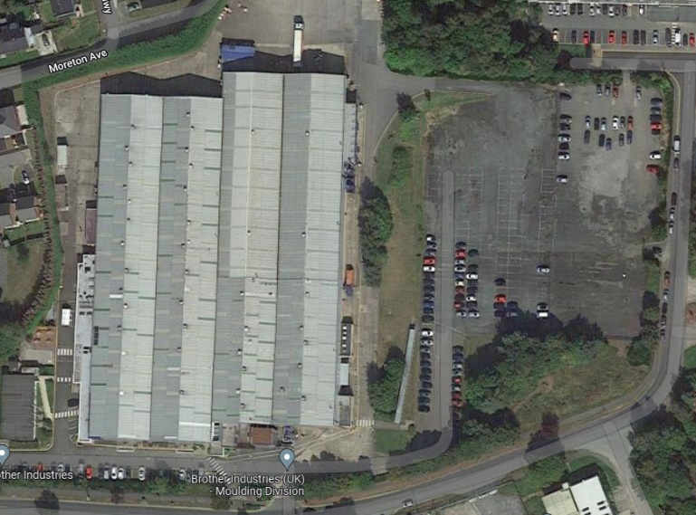
Figure 3: Extract from Google Earth (c) showing immediate surroundings of premises.

Large tree cover screens views of the site from the residential properties to the north, and the existing building and trees screen views from the industrial estate to the south and west. The east and south side of the site, are industrial areas, and as the proposed unit will not exceed the existing building in height, the addition of a warehouse unit would have minimal effects on the surrounding views. Accordingly, we assess the building proposed is appropriate in the context of the established premises and would have no wider landscape impacts.

Highways Considerations

There will be no net change in the scale of the operation or number of employees proposed for the business. The warehouse unit is solely to ease the current issues with storage and will be placed over an existing hard surfaced area that is currently unused. The area will not hinder existing vehicle manoeuvring or parking and leads to net loss of parking.

There will be no change in the surface water approach to dealing with rainfall that already falls onto the hard surfaced yard. Hence existing drainage capacity is sufficient and unaffected by the ‘bolt down’ structure proposed.

CIL Considerations

The CIL is a local charge on new development. CIL receipts are required to be spent on ‘infrastructure’. A ‘meaningful proportion’ is also required to be passed back to local communities.

The Community Infrastructure Levy Regulations (2010) can be found at http://www.legislation.gov.uk/ukdsi/2010/9780111492390/contents. These have been updated and revised over many years.

In the case of Wrexham, there is no current CIL Charging Schedule published, and looking through the Unitary Development Plan (1996 to 2011) and we could not see that S106 agreements would be justified for this site.

CONCLUSIONS

The application site is an established manufacturer for Brother Industries, who are facing difficulty in terms of storage within their current site, and are in need of greater flexibility in order to rectify this issue. The application proposed a remedy to this issue in the form of a warehouse unit that effectively bolts onto the existing yard area.

Accordingly the proposal is considered to accord with the Council’s adopted Local Plan, the Emerging Local Plan and PPW policies more broadly.

In conclusion, planning permission should be approved without delay.

