Materials proposal for Brunnett and Blossom Barn.
Brickwork.
External brick work will be re using existing bricks where required. Lime and sand mix to be used for rebuilding ( where required ) wet lime mix to be used for pointing once all works are completed. Mix to be confirmed by CADW
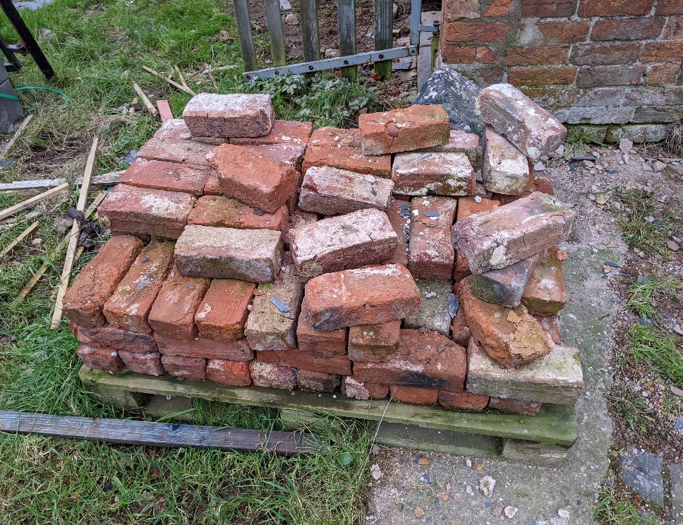

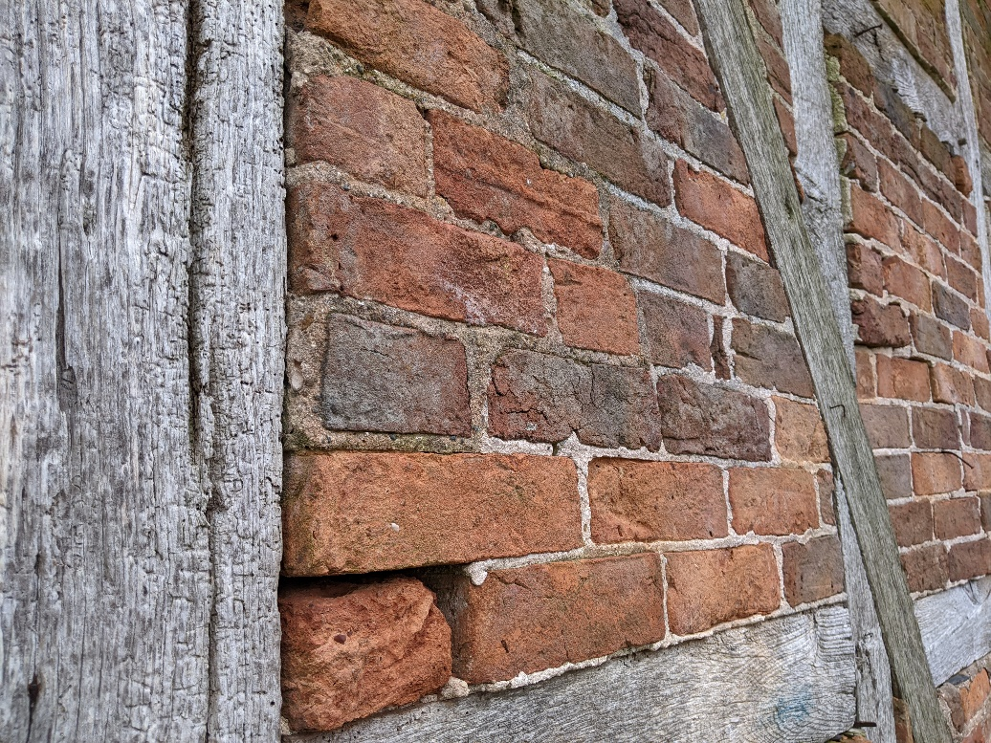

Oak framework.
Most of the external oak framework will remain in place. Any repairs will be done using air dried oak from north Shropshire timber in a traditional style. Any missing timbers will be replaced with air dried oak and will be fitted by using mortice and tennon joints, or splicing.
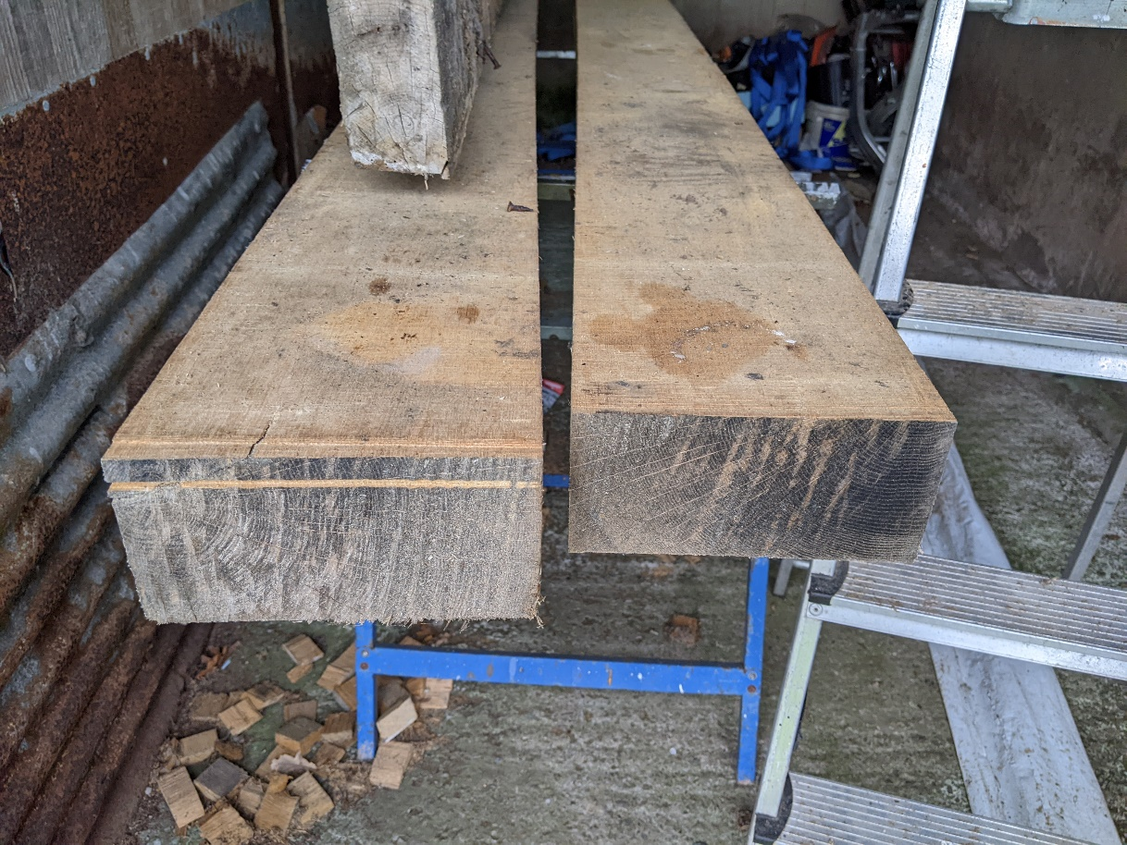

Roofing
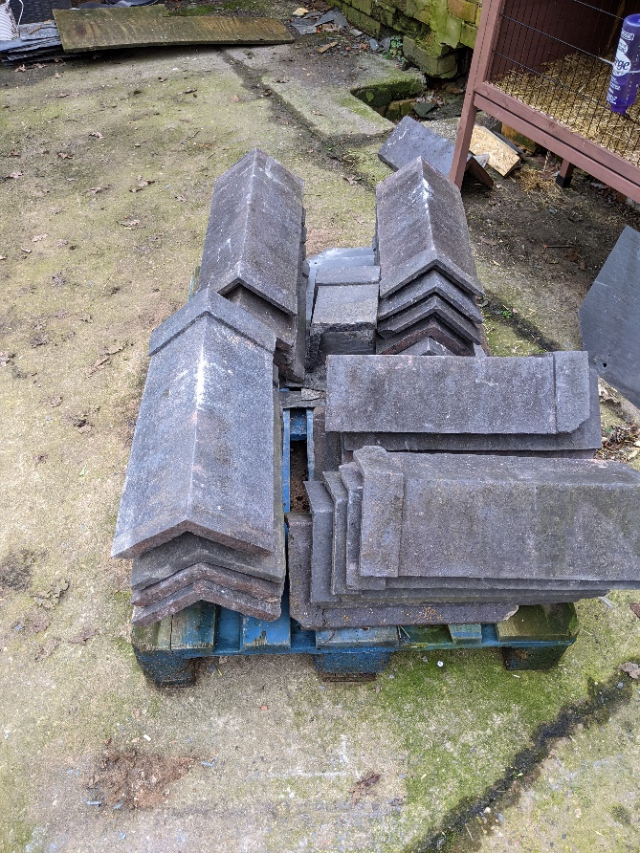
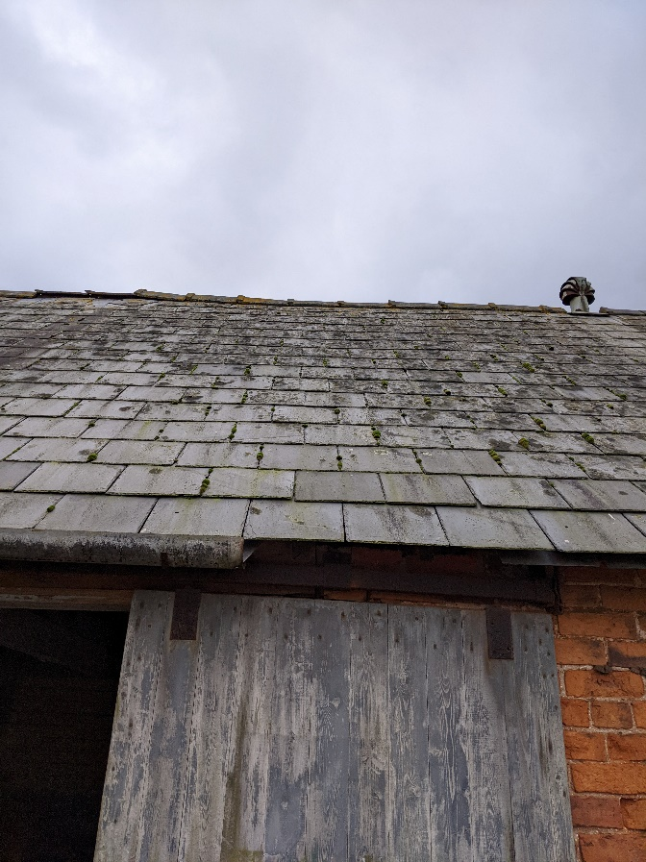
Traditional grey 24”x12” and 24”x14” welsh slates and grey pot ridge tiles to be used on the main barn, as per existing roof on adjoining barn.
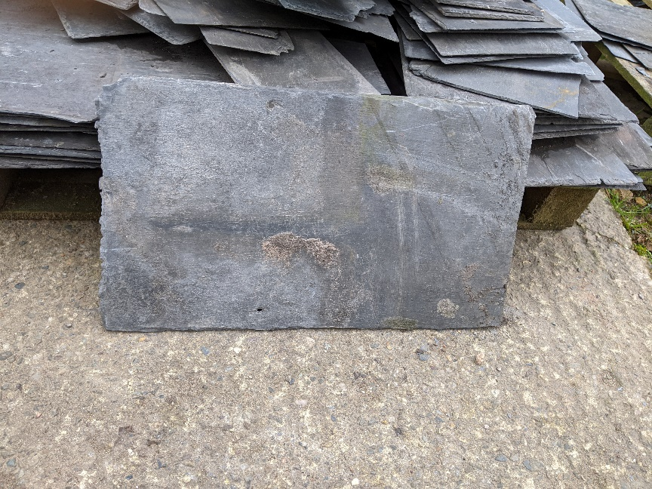

Guttering and downpipes
A mixture of Aluminium – cast iron style – downpipes and black deepflow upvc half round guttering fixed to the rafter ends and 75mm round downpipes to be used.
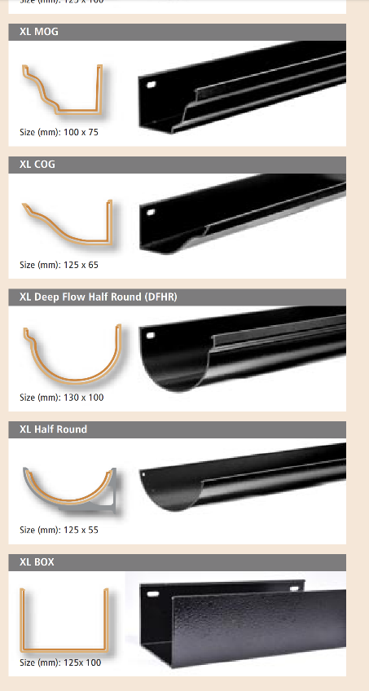
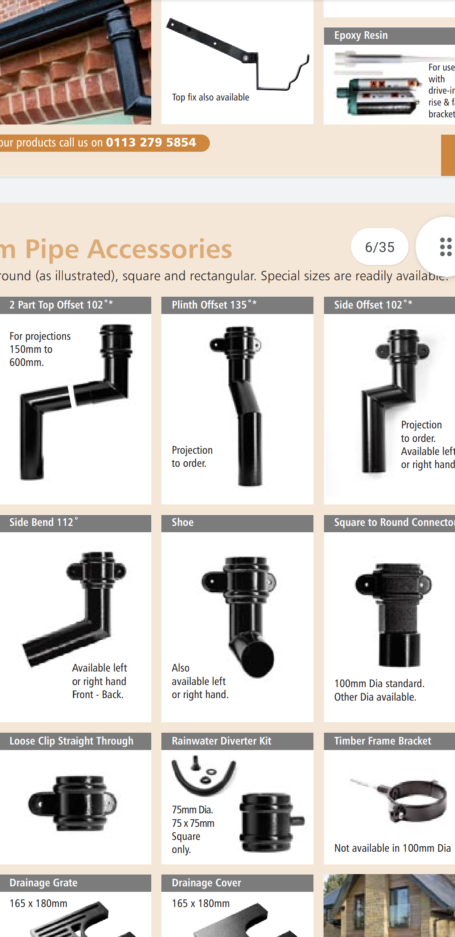
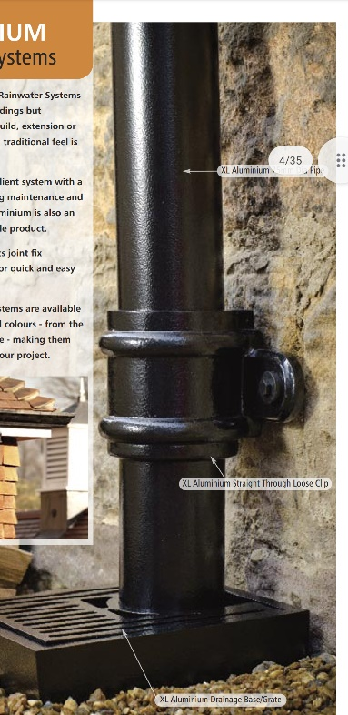

External windows and doors
All windows and doors will be constructed of oak and all glass will be doble glazing.
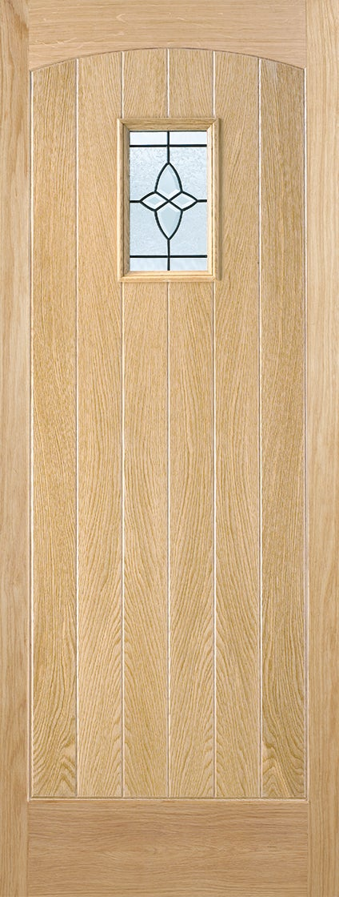
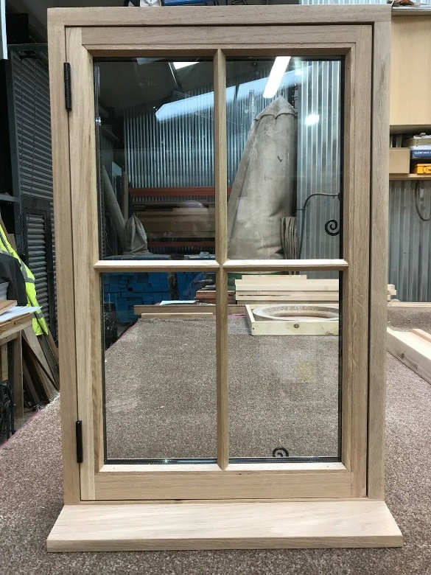
Doors will be built from oak planks and will look like existing barn doors. Windows will all have pieces of double glazed glass and additional vertical bar to look like a traditional Georgian bar window.

Extractors and ventilation.
Brick coloured vent and extractor grilles will be used, mostly at the rear of the buildings- so not to spoil the frontal view of the building.
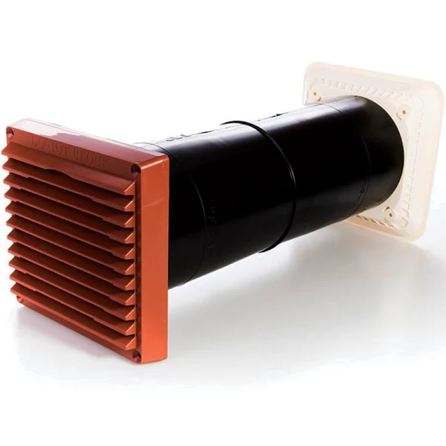
Log burner chimney pipes to be black and traditional. Fixed to existing brick work.
