RUABON STATION HOUSE RUABON WREXHAM

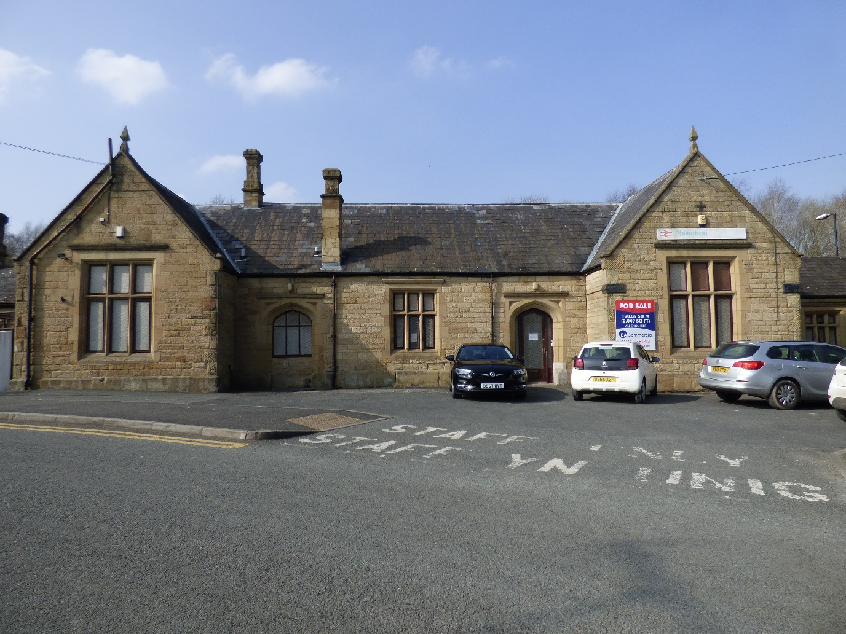

DESIGN AND ACCESS STATEMENT
INCLUDING HERITAGE IMPACT STATEMENT

MAY 2022

Anne Netherwood B.Arch BD RIBA

Anne Netherwood B.Arch BD RIBA

Chartered Architect

11 Cottage Fields
St Martins
Oswestry
Shropshire SY11 3EJ
01691 778495

RUABON STATION HOUSE, RUABON, LL14 6DL

I. INTRODUCTION
This document is produced in support of an application for Change of Use and Listed Building Consent for converting the former station building from offices to a domestic dwelling.
2. BACKGROUND

The building is listed Grade II (CADW listing reference number 1719). The list entry states that it was designed in the Tudor-Gothic Revival style by Henry Robertson in the 1860s, and replaced the original Shrewsbury and Chester Railway Station by T.M. Penson. It is constructed in sandstone ashlar with a slate roofs. It was converted to offices in the 1910s, when the platform canopy was removed. The reason given for its listing is:

“Listed for its special interest as good example of an 1860s station in a style popular for rural railway architecture”.

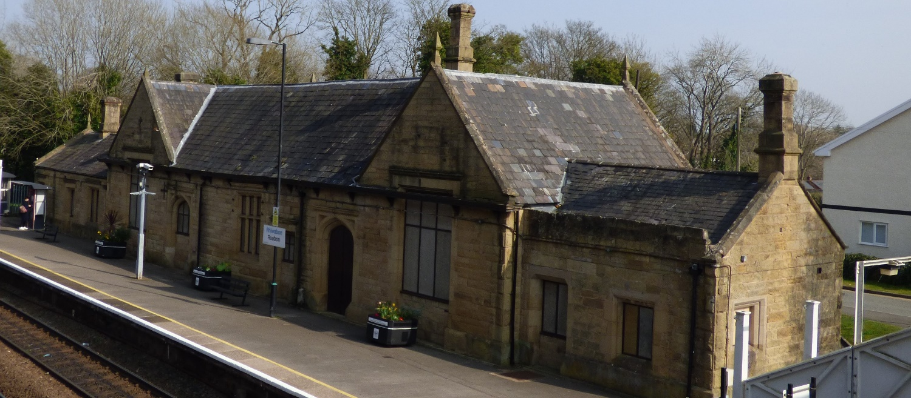

Ruabon Station House also sits within the Ruabon Conservation Area. The Ruabon Conservation Area Assessment and Management Plan notes that the trees surrounding the station provide a rural setting to the building.

3. DESIGN PRINCIPLES

The design principle discussed with the Conservation Officer and adopted by the client is “minimum intervention”, keeping external and internal openings as existing. The only external change, discussed with the Conservation Officer, is to convert one of the window openings on the street side to a glazed door to match the design of the existing entrance door. The window glazing inserts are not original and will be replaced with toughened obscured glass and double glazed on the platform side, with a gap for sound insulation from the railway. Glazing on the street elevation will be clear double-glazed units, all within the existing openings.

Environmental Sustainability

Adding insulation to a traditionally constructed building can have unforeseen consequences unless the insulation is compatible with the construction. The building is traditionally constructed, with walls of stone bedded in lime mortar and possible a rubble core. This requires a compatible, vapour-open type of insulation. We propose that the existing panelling and gypsum plaster is removed, and the walls finished with cork insulating lime plaster. Wood fibre insulation will be added above the new ceilings. Both lime plaster and wood fibre have moisture-buffering properties, which will help mitigate condensation and damp.

Damp in the building appears to be localised and may relate to leakage from the rainwater disposal system rather than rising from the ground. We propose that the entire rainwater disposal system should be investigated and overhauled with all the gulleys and underground drains checked.

Site

At present the forecourt is open and covered with tarmac. We propose that this should be removed and replaced with permeable brick paving in the car parking area, while the rest of the forecourt becomes a private garden surrounded by a stone wall 1.2 mm high. Stone walls are noted in the Ruabon Conservation Area Assessment and Management Plan as contributing to the special character of the area:

“Sandstone walls are the most prevalent form of boundary treatment within the Conservation Area. They range in heights and display a mixture of capping styles, including flat stone copings, 'cock and hen' and pyramidal copings. Within High Street and Church Street, low stone plinths or dwarf walls surmounted with iron railings are evident, defining the boundaries of the more prestigious properties within the area. The stone walls are important character features within the area that not only provide a means of enclosure and give an indication of status but provide continuity to the street frontage. Constructed from the principal local building material, they provide a strong sense of cohesion within the Conservation Area”

4. HERITAGE IMPACT STATEMENT

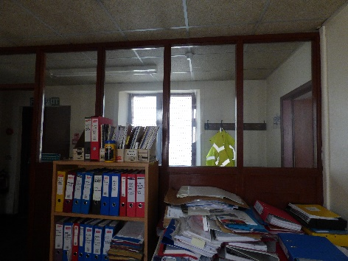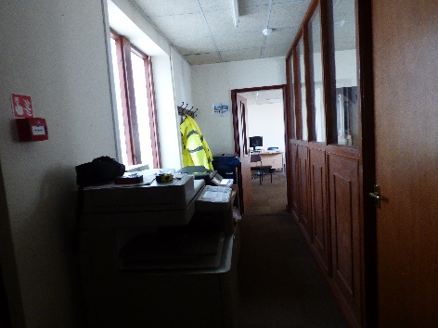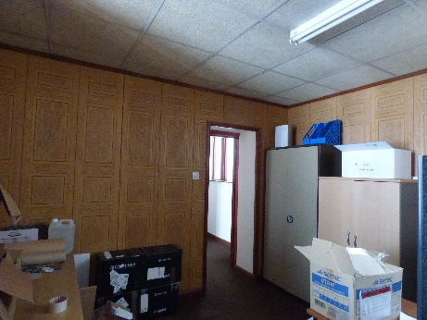

Interior of offices

The existing ceilings will be removed, and new ceilings installed at the original ceiling level. This, together with the replacement of office partitions by plastered stud walls will simplify the appearance of the interior. We believe that the conversion will restore the building to something more similar to the original, and enhance its heritage value. It will certainly ensure a viable use of the building for the foreseeable future.

5. ACCESS

The proposals do not affect the position of the existing access from the road, but narrow the entrance and close the opening with double timber gates. There is level access throughout the single storey building.

6. PROTECTED SPECIES
There is no evidence of bats in the existing building, and the client has not been advised that an ecological report is required.

7. PLANS (not to scale)

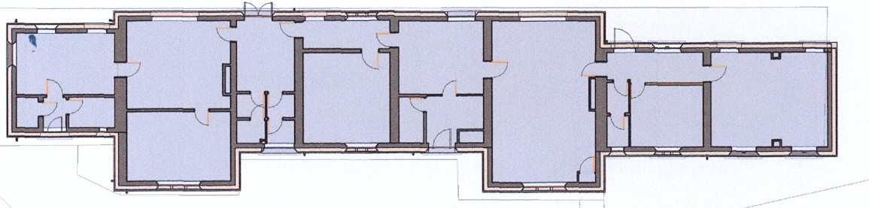

Existing Ground Floor Plan

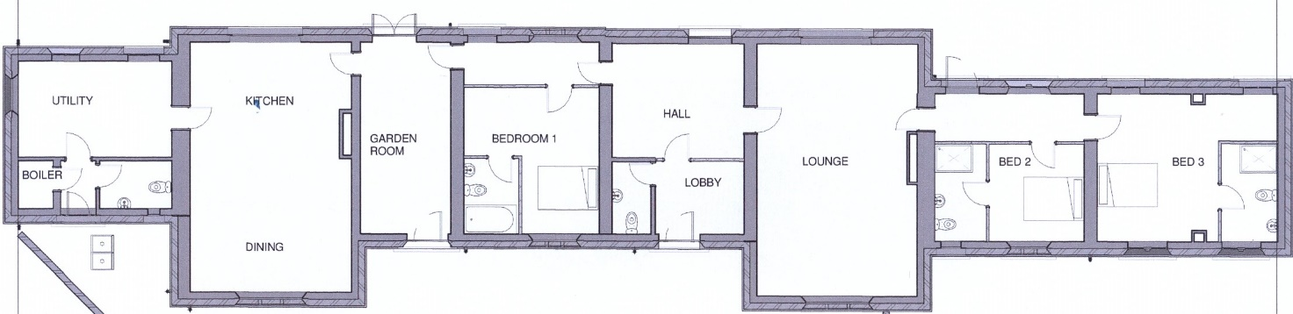

Proposed Ground Floor Plan

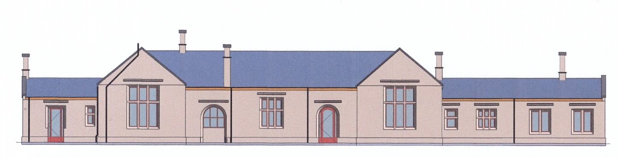

Existing South Elevation

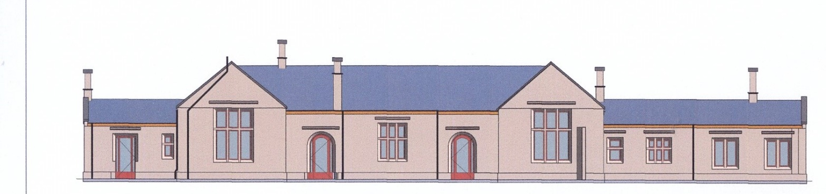

Proposed South Elevation

East, West and North Elevations remain unchanged

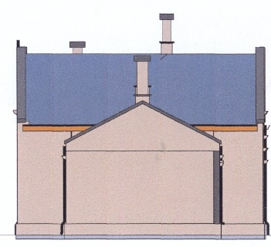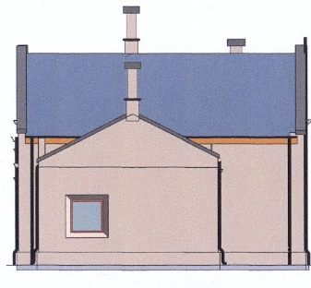

East Elevation West Elevation

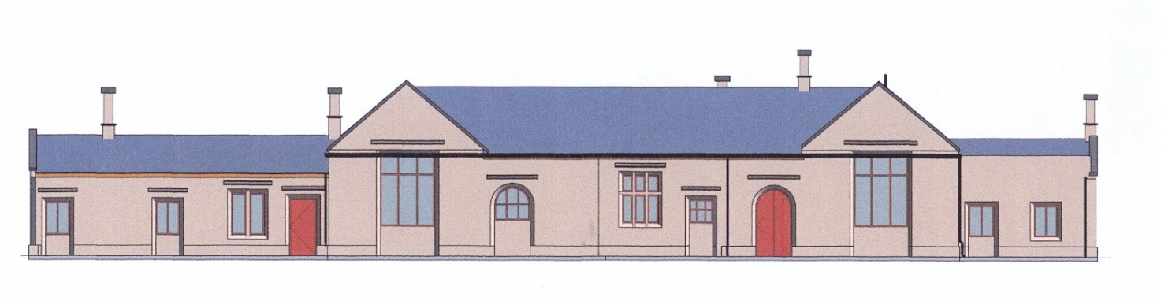

North Elevation

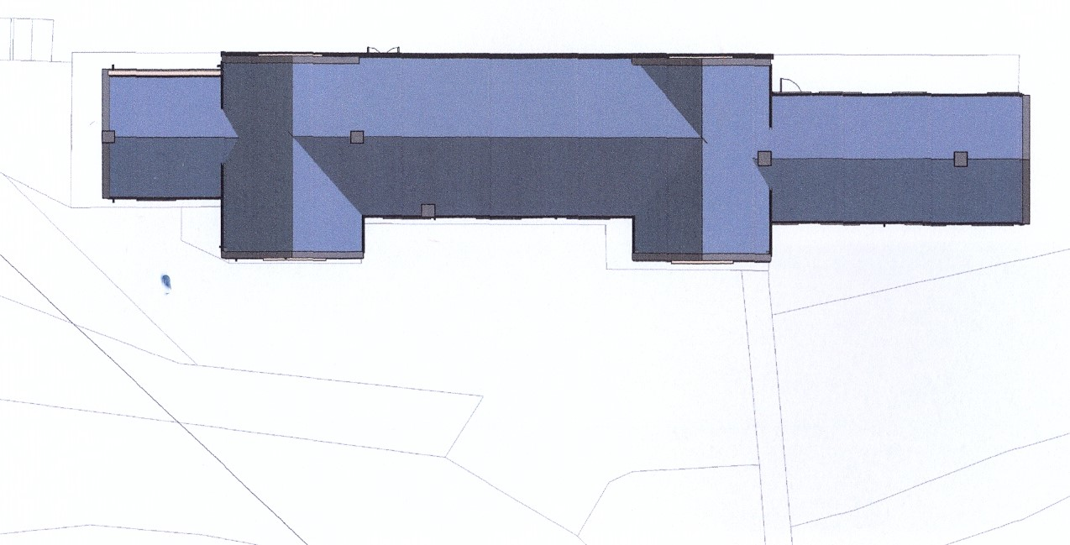
Existing Site Plan

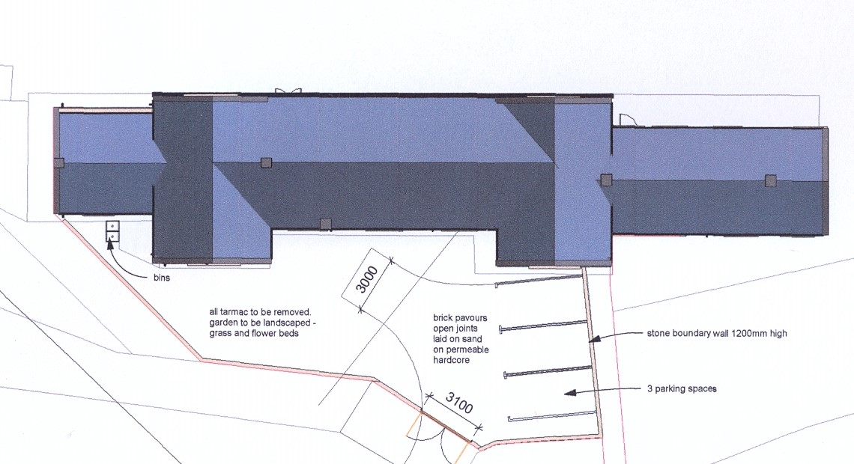
Proposed Site Plan

8. PHOTOGRAPHS 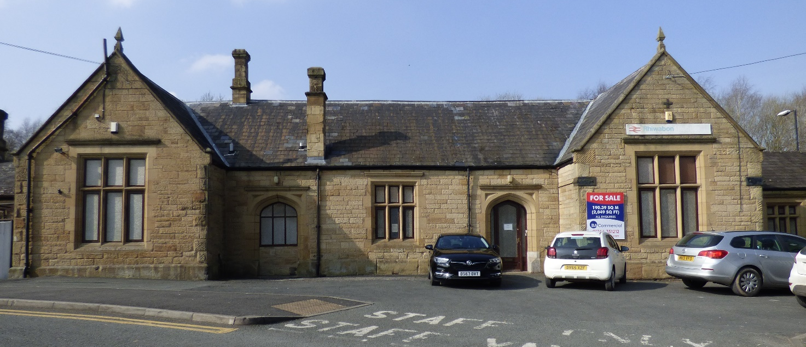

South Elevation

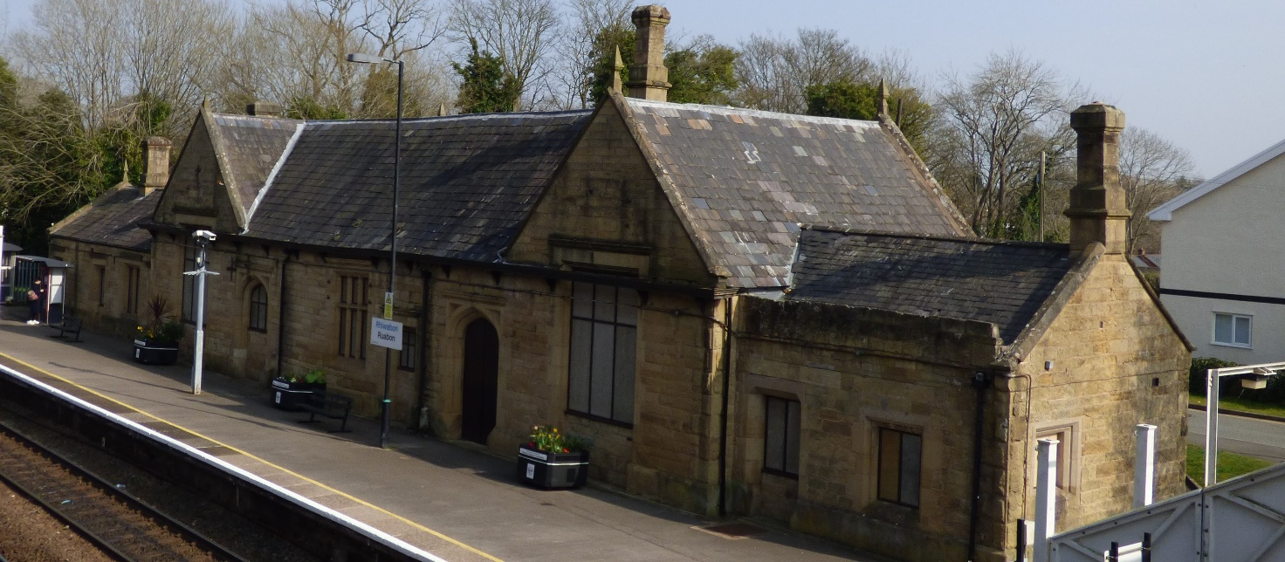

North Elevation

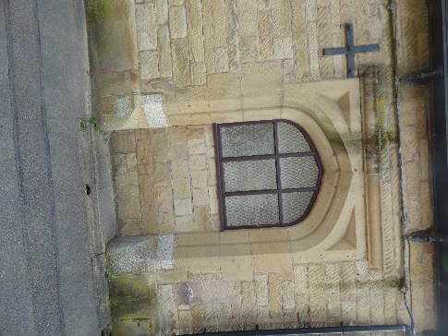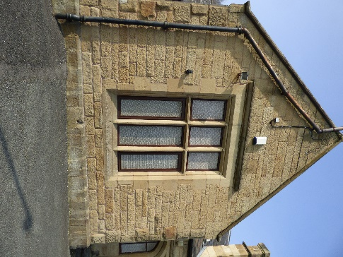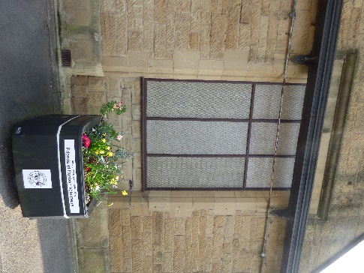

Window to be Stone mullions New timber frames to

changed to door to remain same proportions as existing

