RUABON STATION HOUSE HERITAGE IMPACT STATEMENT

External Elevations

There is only one change to the external elevations: we are proposing to replace a window in the south elevation with a glazed door. The window appears to have been inserted into an original door opening, and a stone panel installed below. The stone panel will be removed and a new glazed door inserted to match the existing entrance door.

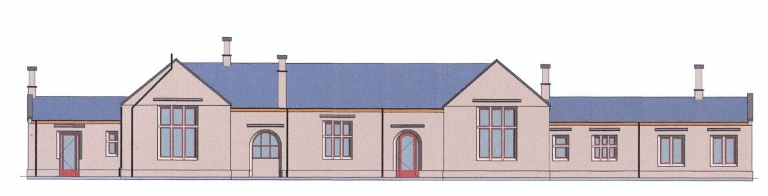

South Elevation Existing

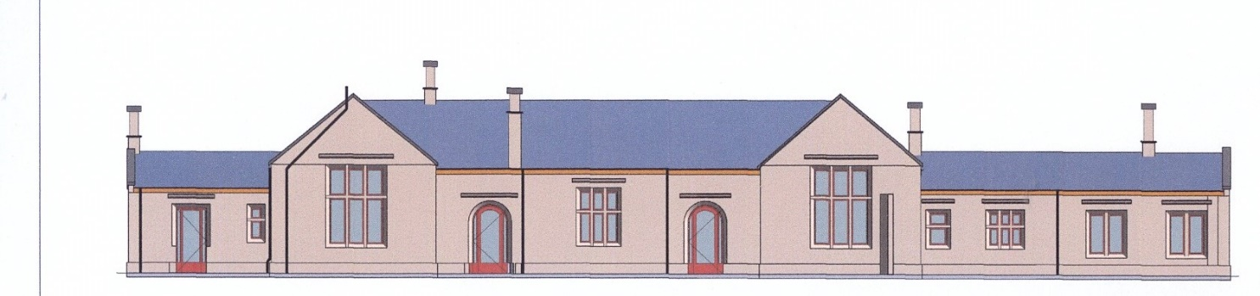

South Elevation Proposed

Interior Appearance

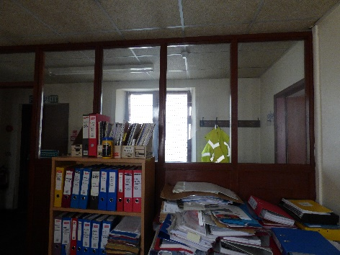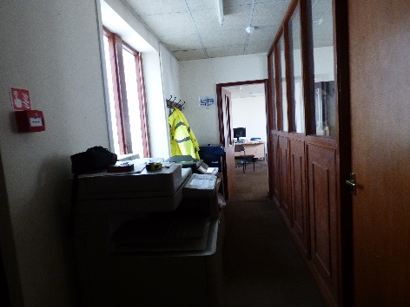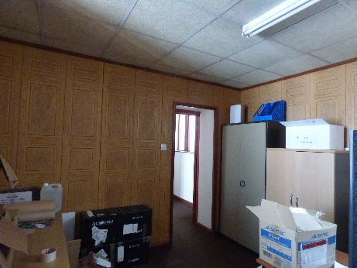

Interior of offices

The existing ceilings will be removed, and new ceilings installed at the original ceiling level. This, together with the replacement of office partitions by plastered stud walls will simplify the appearance of the interior.

Site

The existing forecourt is tarmac and used for car parking. We propose to replace the tarmac with brick paving for the car parking area, and the rest of the forecourt to be landscaped as a private garden. A stone boundary wall 1.2m high will give privacy and is in keeping with the existing stone boundary walls within the Conservation Area.

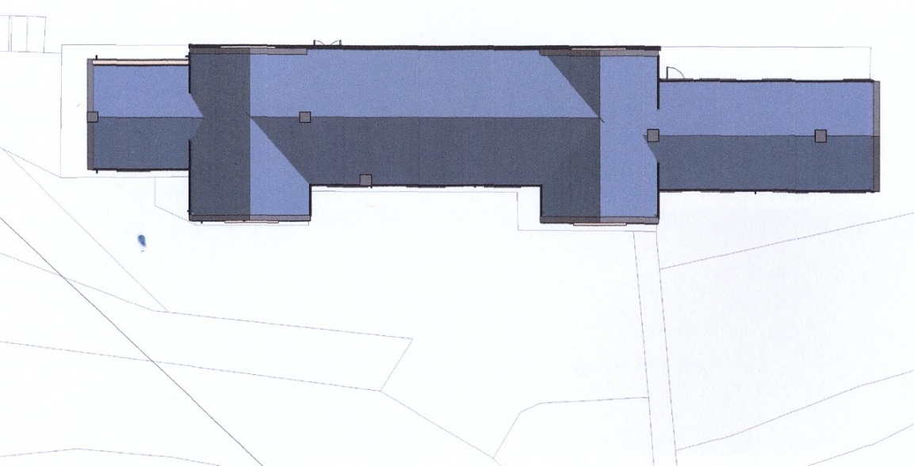

Existing Site Plan

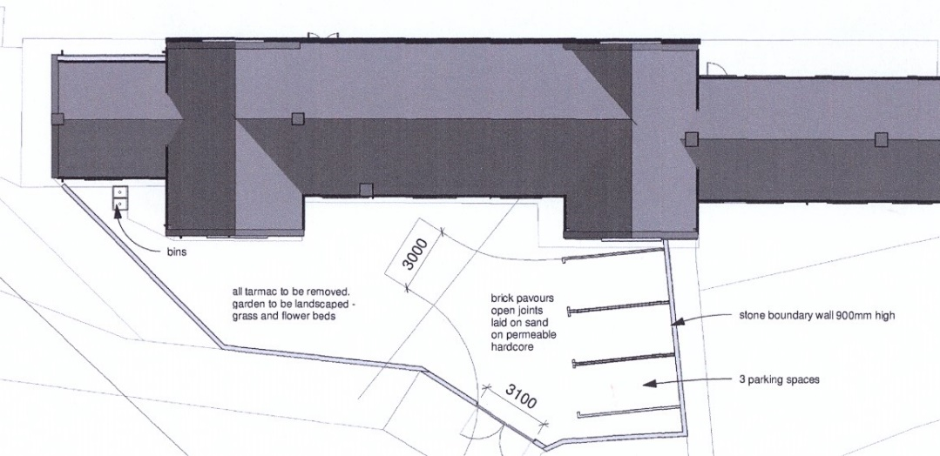

Proposed Site Plan

Heritage Impact

We believe that the conversion will have a positive impact. It will restore the building to something more similar to the original, and enhance its heritage value. It will certainly ensure a viable use of the building for the foreseeable future.

