HERITAGE IMPACT STATEMENT
The proposed development is concerning Westview House, Hanmer SY13 3BS.

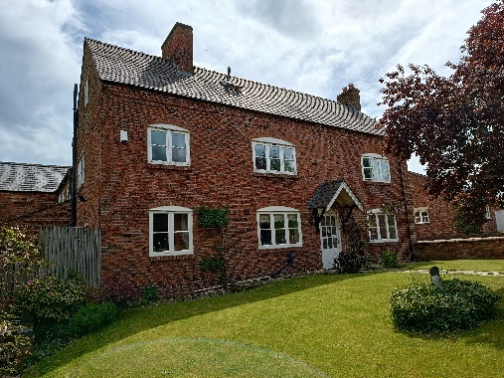
This is a Grade 2 listed building. The following information has been copied from the British Listed Buildings website.

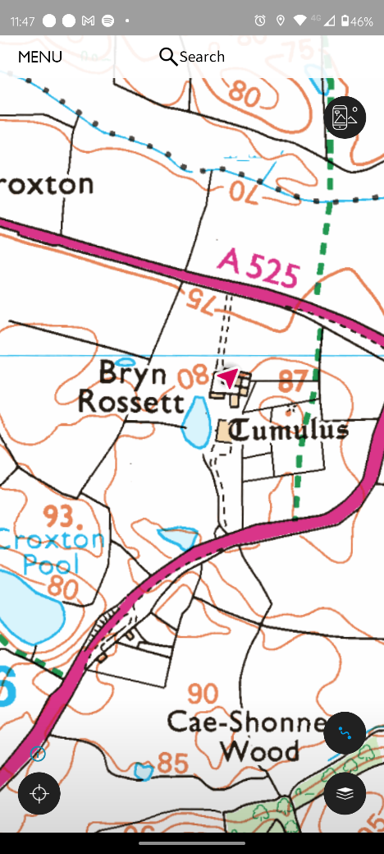
Coordinates
Latitude: 52.9634 / 52°57'48"N
Longitude: -2.7997 / 2°47'58"W
OS Grid: SJ463409

Entry Name: Bryn Rossett (West View House)
Listing Date: 16 November 1962
Last Amended: 15 November 2005
Grade: II
Source: Cadw
Source ID: 1663
Building Class: Domestic
Location: Reached by private drive on the S side of the A525, approximately 1.5km NNE of Hanmer.
County: Wrexham
Community: Hanmer
Community: Hanmer
Locality: Croxton
Traditional County: Flintshire

History
An C18 house shown on the 1839 Tithe map. It was extensively and liberally restored, with replacement roof, windows and doors, in the first decade of the C21, including partial rebuilding of the front wall.

Exterior
A 2½-storey 3-window brick house with slate roof on sawtooth eaves, and rebuilt brick stack to the L of center and external stack to the R, the upper part of which is also rebuilt. The front slope has one skylight, the rear slope 5. The entrance is R of center, a new half-glazed door in an original opening, under a new gabled canopy. It is flanked by 3-light casement windows under original segmental heads, with similar 2-light window further L. In the L gable end is an inserted half-glazed door in the lower storey, a 3-light window in the upper storey and 2-light attic window. The rear has a 2-light window in the lower storey and 1-light window above.

Reasons for Listing
Listed, notwithstanding alteration, as an estate farmhouse of local C19 character.

My Proposal
I would like to insert two small new windows into the south facing wall of my property.

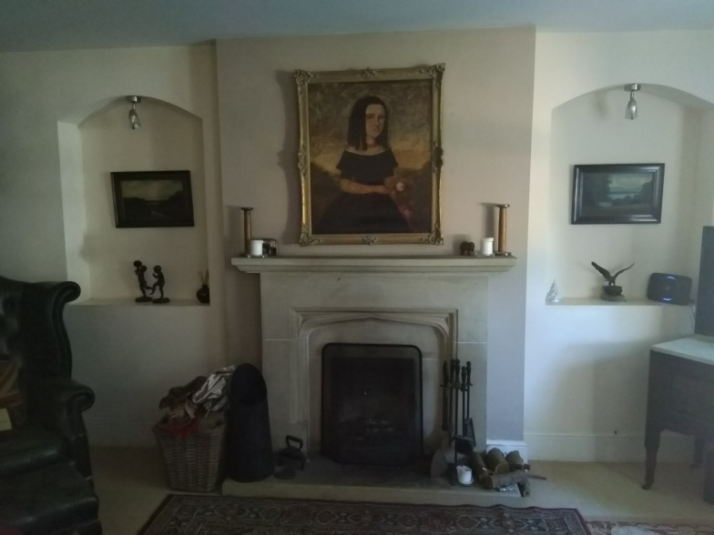
PIC 1
My sitting room is currently very dark, cold, and dismal and consequently rarely used. See pic1.
I would like to install 2 small windows to light the room and make it warmer, without the need to tun on lights and the heating.

The position of the windows would be in the alcoves either side of the fireplace. The alcoves suggest windows may have been present there at some point. See pic 1
The property was extensively renovated and partially rebuilt about 10-15 years ago.
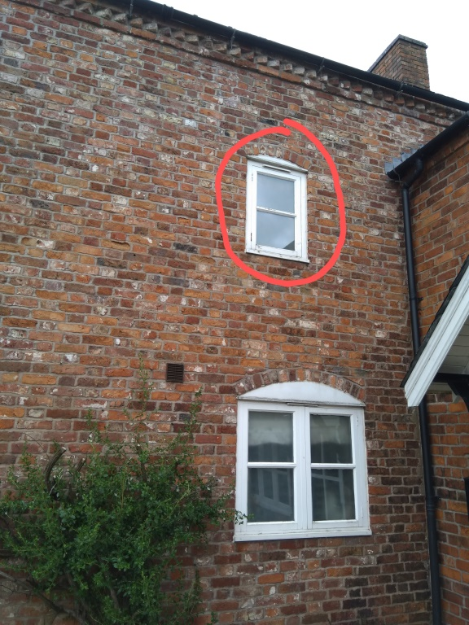
PIC 2
The design of the widows would be to fit into the alcoves (see pic 1) and to match the window that is currently in the 1st story east facing rear wall, this is a 2ft by 3ft timber framed window.
See window outlined in red on pic 2

PIC3
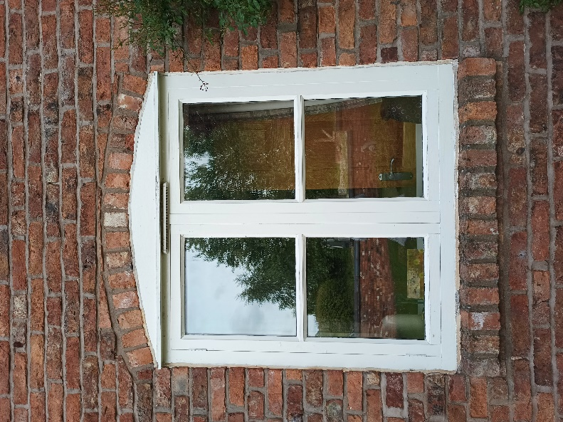

However we would copy the header and footer brick detail of the windows on the front (East facing) elevation. PIC 3

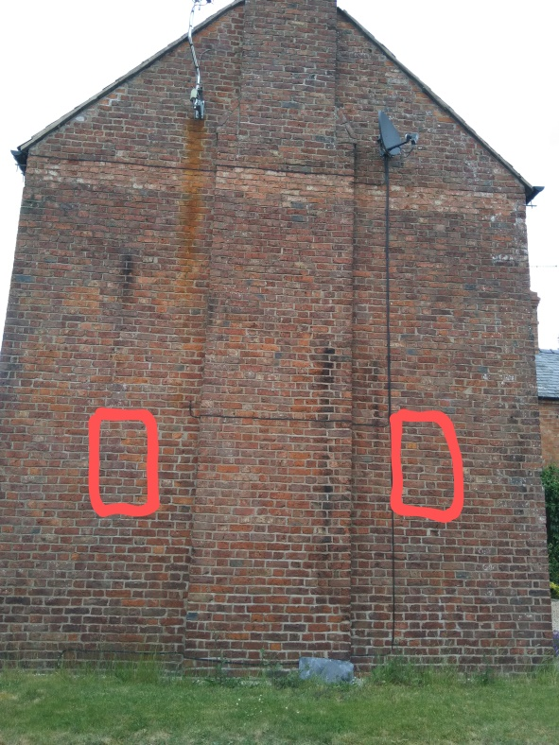
PIC 4
The position of the windows illustrated on the exterior south facing wall is illustrated by the red lines in pic 4

In having regard for the historical value of this property as an estate farmhouse of local C19 character, I do not think that this proposal will negatively affect the appearance or historical value of the property, I believe it will match the attractive appearance of West (front) elevation.

