

Gareth Buckley
Arboricultural Surveyor
Treehogs
5/23/2022
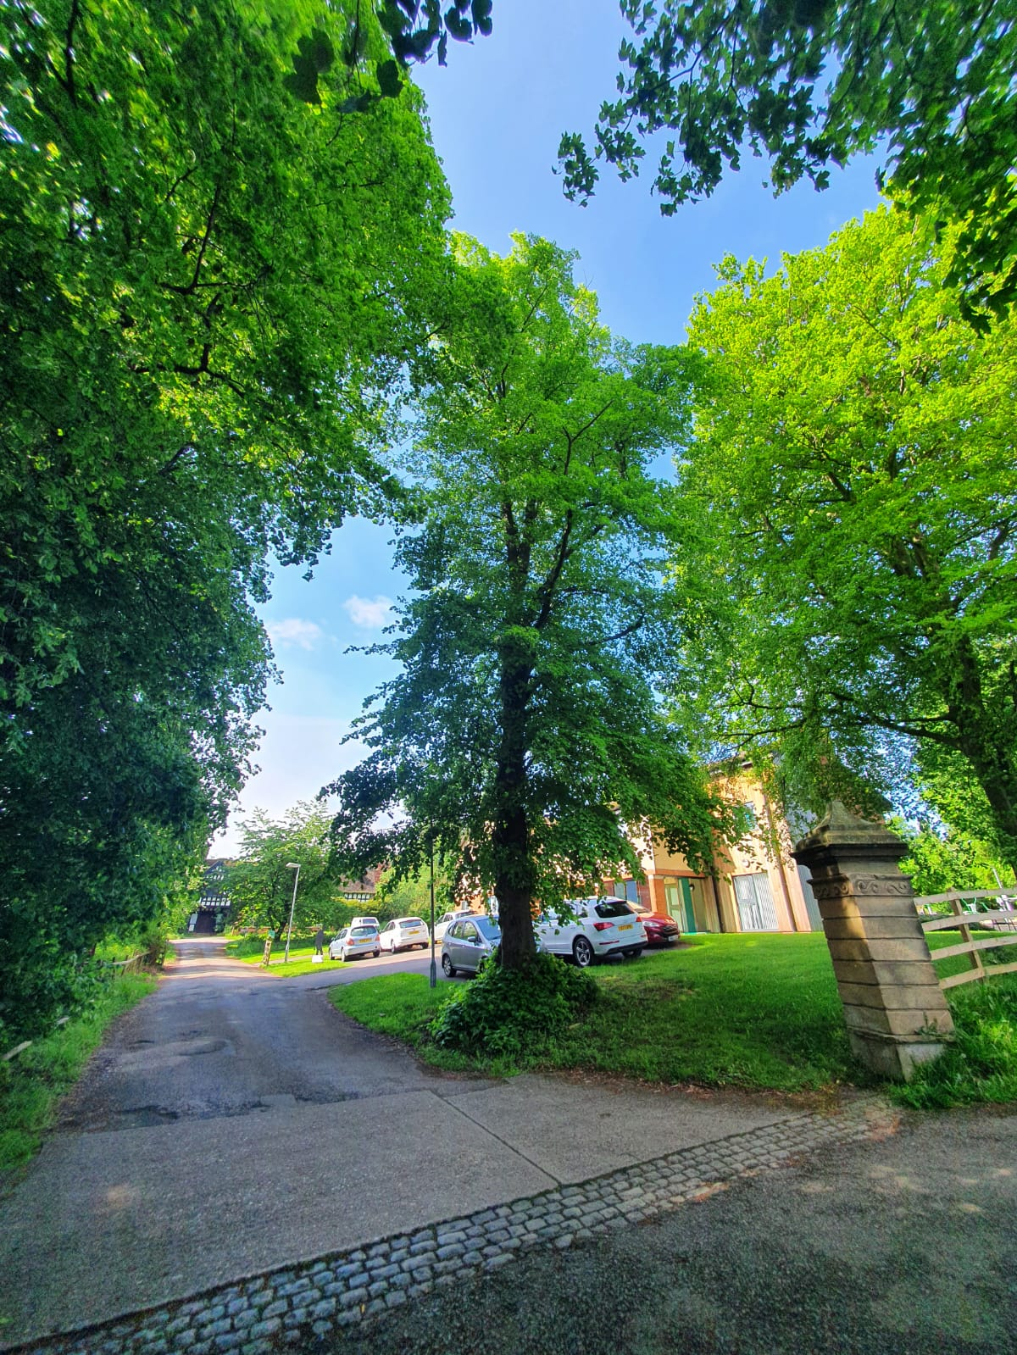
Arboricultural Survey of Ty Dewr, Wrexham

Scope

The scope of this survey and report is to provide a baseline inspection of the trees on or adjacent to the property at Ty Dewr, Bryn Estyn Road, Wrexham LL13 9TY, focusing on risk assessment and mediation, as well as improvement of the amenity value provided by the trees. The onsite inspection was undertaken by Gareth Buckley on 18th May 2022, using the Visual Tree Assessment (VTA) method of inspection.

Survey Observations & Recommendations

There are 5 trees either on the property or within falling distance of the property (T1 to T5), comprising semi-mature to mature lime, English oak, and Common beech trees. All surveyed trees are in good overall condition with no serious defects of concern for risk assessment purposes.

T3 (English oak) has dense ivy cover on the main stem and limbs to a height of approximately 8m, which prevents the visual inspection of the timber beneath. This means that any structural defects that may be present in the timber beneath the ivy cannot be identified. Removing the ivy in a 2-stage process of severing at the stem base and then returning in 9 to 12 months to strip the dead ivy from the tree would enable a detailed aerial inspection of the tree, thus ensuring the tree is in as good condition as it appears to be.

T5 is a third-party tree likely to be owned by Wrexham Borough Council. There are several branches that put substantial pressure against the overhead BT cables running between Bryn Estyn Road and neighbouring properties.

All other recommended work is of a relatively minor nature with the aim of enhancing the high amenity value provided by T1 to T5, and is outlined in the table overleaf, along with photos for visual identification of trees. Given the good condition of all trees surveyed, it is recommended that the survey be repeated every 2 years. This survey schedule can be amended if any of the trees begin to show symptoms of structural or physiological deformity.

Tree ID | Species | DBH @ 1.5m (mm) | Height (approx m.) | Crown spread (m from stem) | Condition | Recommended works
T1 | Lime | 680 | 20 | 5 to 6 | Good canopy cover, minor dead wood but no major defects overall. | Crown lift to 6m above ground including basal epicormic growth, crown clean to remove dead wood.
T2 | Common Beech | 860 | 19 | 10 | Well balanced crown with good foliage cover, no major defects | Crown lift to approx. 5m above ground; prune for 3 to 4m from building and 1 to 2m from BT lines - one to building and 1 along Bryn Estyn Rd
T3 | English Oak | 1100 | 17 | 7 to 10 | Ivy clad stem and main limbs to 8m, ivy obscures inspection for structural defects. Canopy slightly over-extended above BT cables, but not drastically so. | Sever ivy at base, and strip from stem once the ivy is dead. Crown lift above BT cables for 1.5m clearance.
T4 | Common Beech | 950 | 23 | 10 to 12 | Well formed mature beech tree with good canopy cover and no major defects. Dead stub at 6m. | Crown lift to 5m, remove dead stub and prune for 1.5m from BT cables.
T5 | English Oak | 480 | 12 | 9 | 3rd party tree with a broad, spreading crown and good foliage cover. Branches overhang property to 1.5m above ground, and put substantial pressure on BT cables running between Bryn Estyn Road and neighbouring properties. | Crown lift by approx. 1.5m removing only minor branches less than 50mm in diameter. Prune back from BT lines for 1m clearance

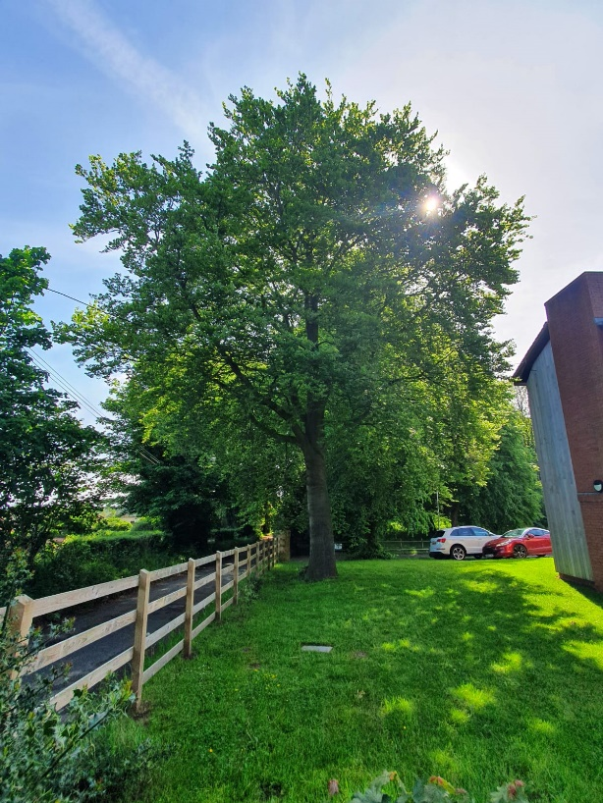
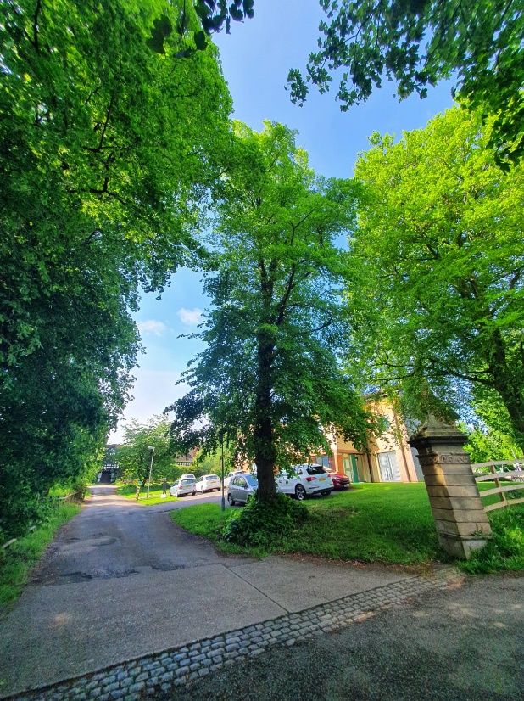
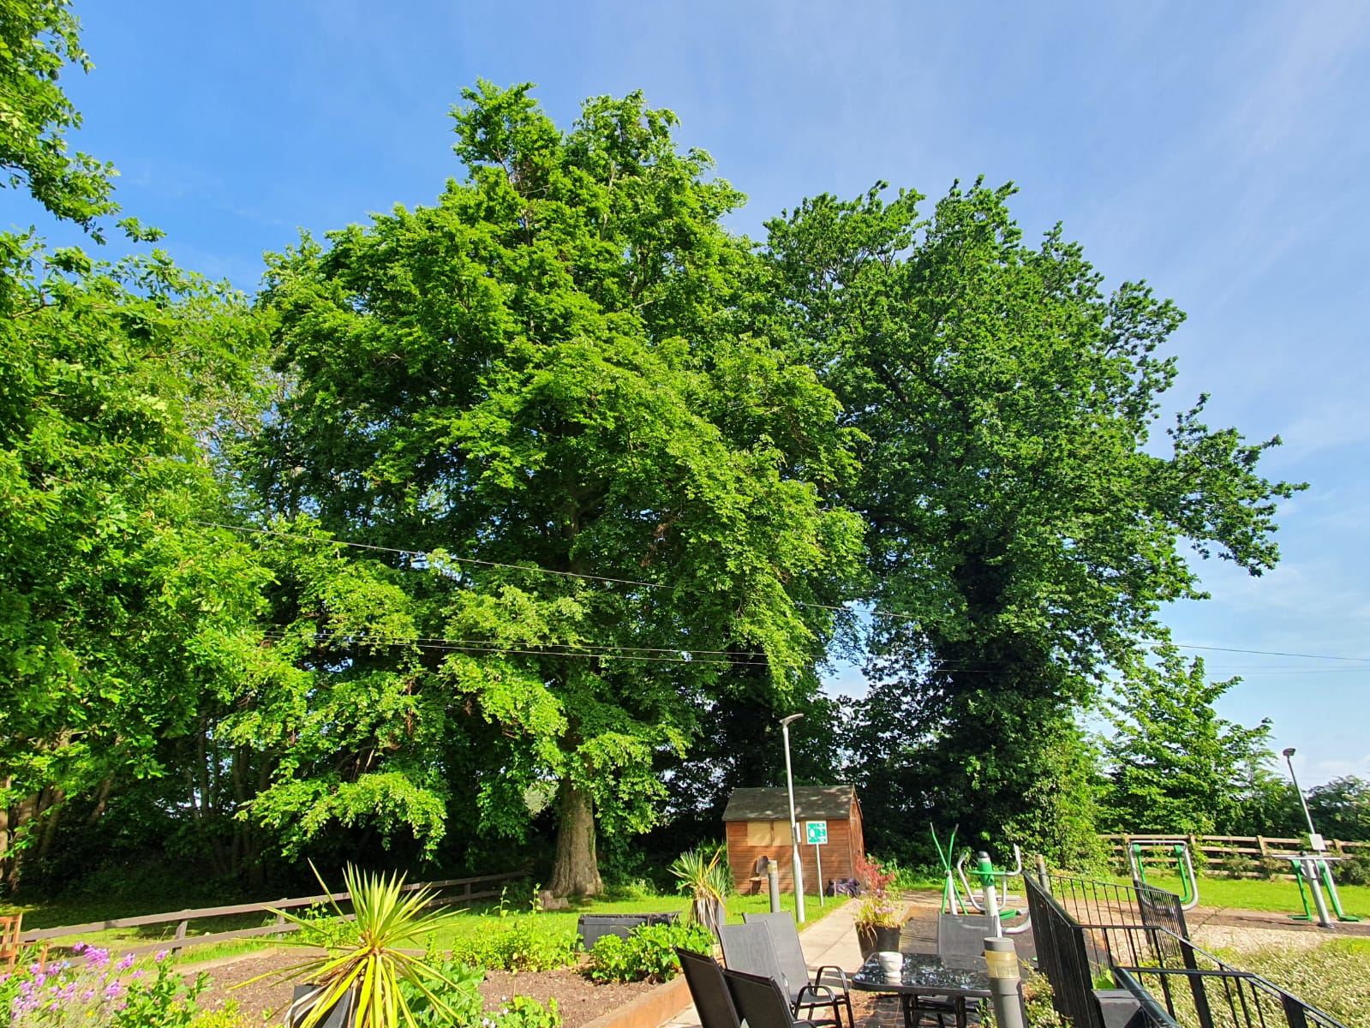

T2
T1

T4
T3

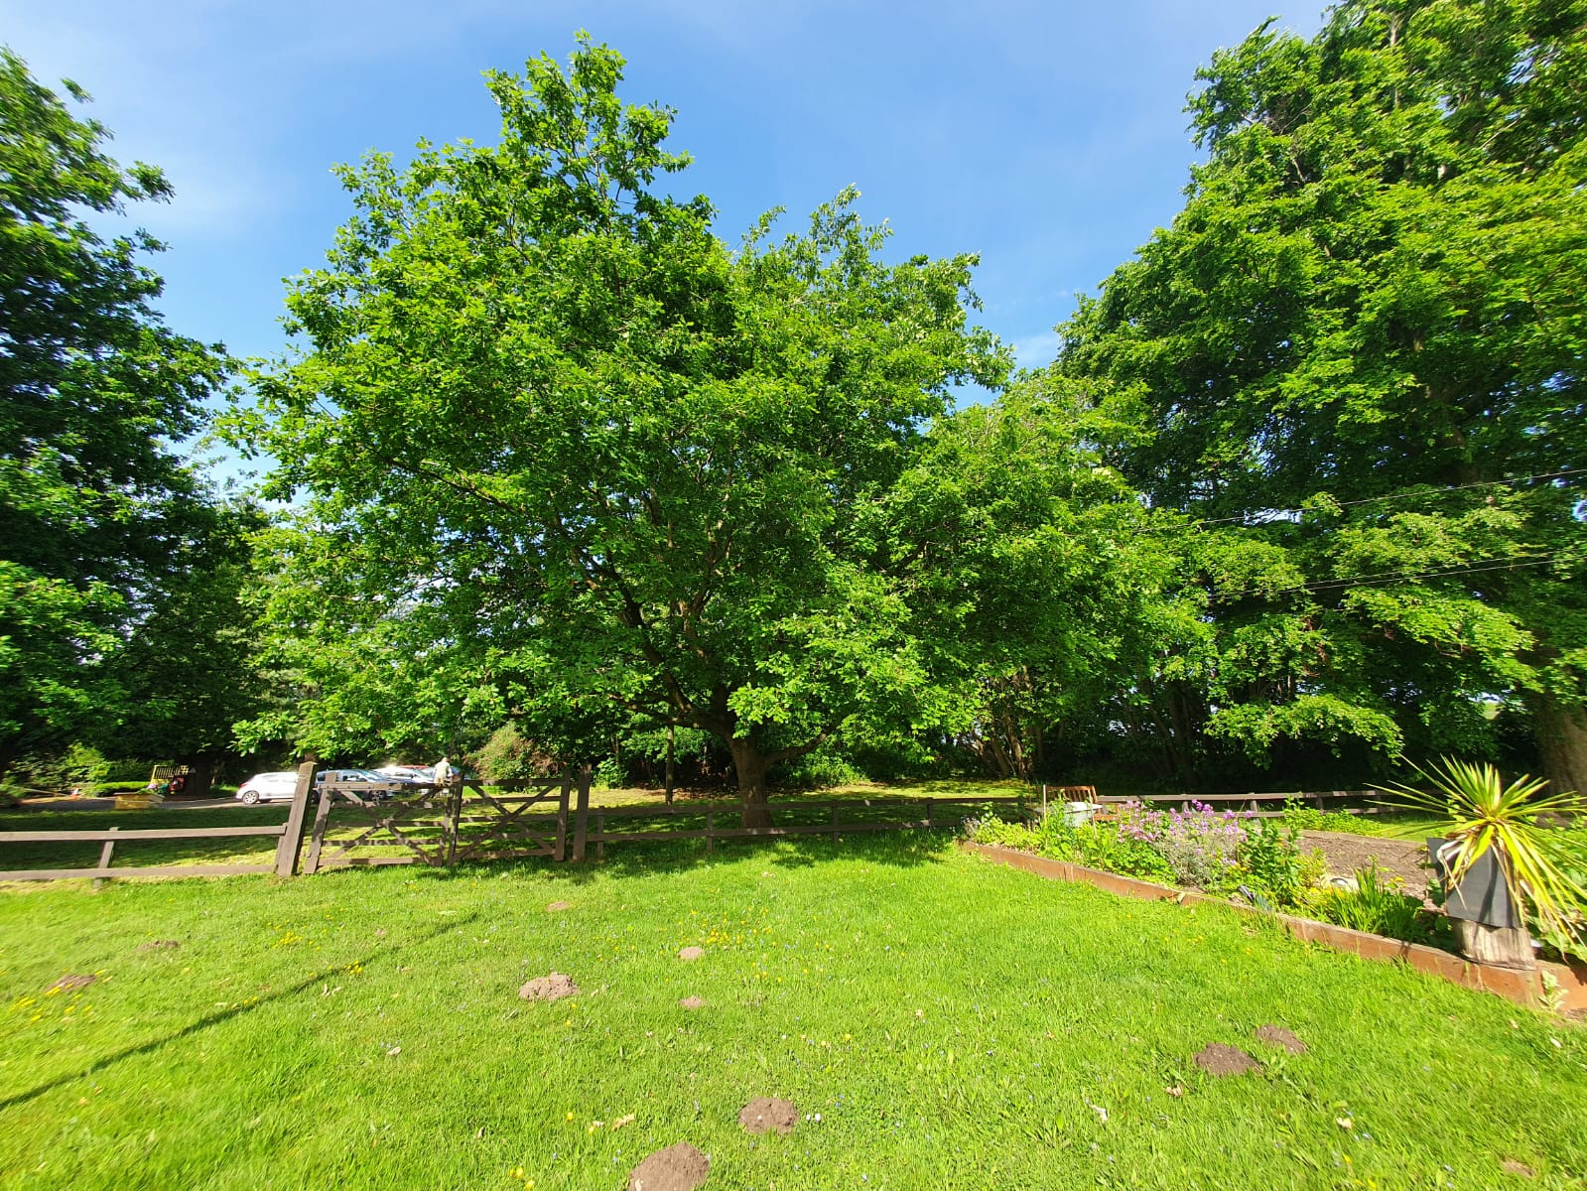
T5

