Application No. | Application Type | Date Valid | Expiry Date | Extension of Time Date
P/2022/0462 | Householder Planning Application | 13/05/2022 | 08/07/2022

Applicant | Agent Name and Address
MR AND MRS MORRIS  7 ROSSETT PARK  ROSSETT  WREXHAM  LL12 0FB | EDW ARCHITECTURE  EDWARD WEBB  THE RECTORY MEWS  WREXHAM ROAD  PULFORD  CHESTER  CH4 9DG
Description of Development | Location of Development
ESTYNIAD UNLLAWR I GEFN YR EIDDO / SINGLE STOREY REAR EXTENSION | 7  ROSSETT PARK  ROSSET  WREXHAM  LL12 0FB

Relevant History | N/A

Constraints | Applicable | Acceptable | Not Acceptable
Outside settlement
Inside settlement

Conservation Area
Listed Building/ setting
Green Barrier

Special Landscape Area
Flood Risk
Within Buffer Zone or affecting SAC*
World Heritage Site
AONB
Phosphates
Other

Local Planning Guidance | Acceptable | Not Acceptable
LPGN20: House extensions
LPGN21: Space around dwellings

UDP Policies to be considered:
PS1: Location of development
GDP1: Development objectives
Key Issues |  | Acceptable | Not acceptable | Observations Below | N/A
Residential Amenity
Design
Highway safety
Parking
Conservation/LB
Ecology
Trees
Other

KEY PLANS AND PHOTOGRAPHS (All plans and photos on Civica file)

None – see Civica for details
Yes – see below

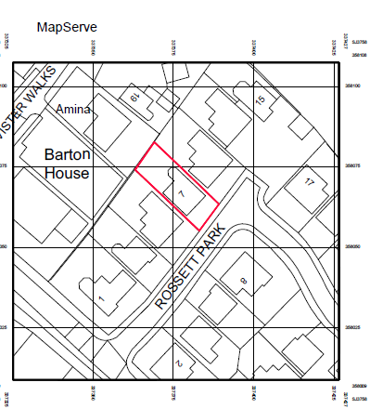
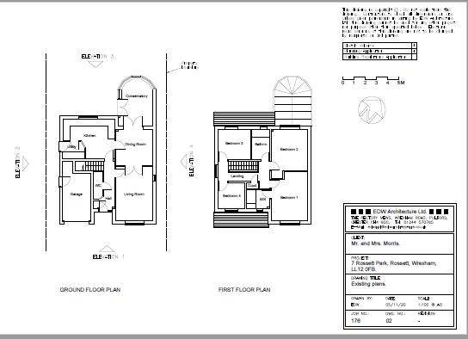
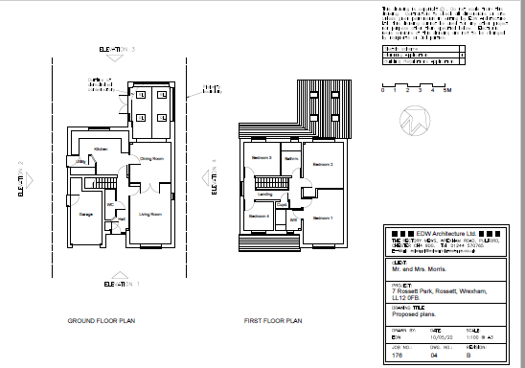
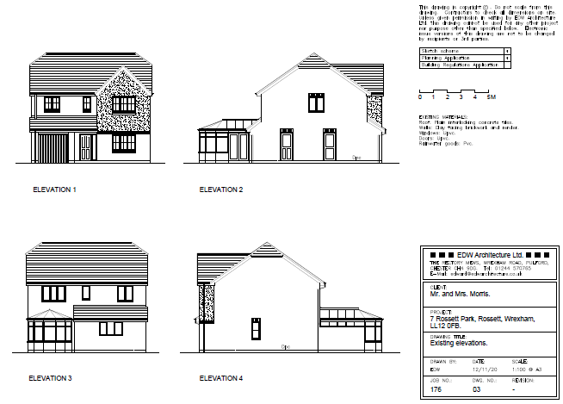
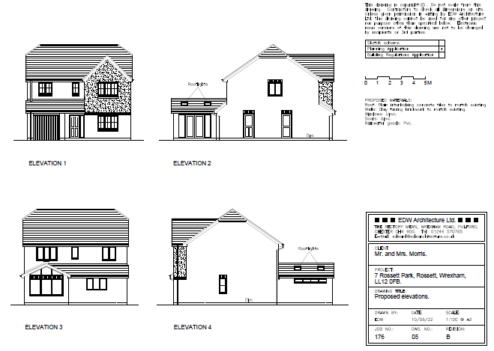

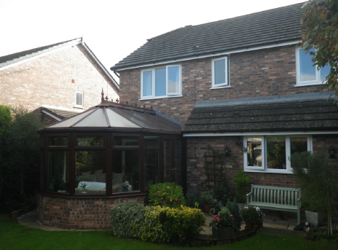
APPLICANTS SUPPORTING STATEMENT: N/A

CONSULTATION  RESPONSES | Consulted | Supports | Comments | Objects | No objection/ no comments | No response
Community Council
Local member(s)
Highways
Public Protection
Natural Resources Wales
Welsh Water
Other
Neighbours

KEY COMMENTS MADE IF APPLICABLE

Community Council and Local Member: No comments

Consultees: N/A

Neighbours: No response

Others: N/A

OFFICERS OBSERVATIONS
The proposal involves the removal of an existing conservatory and replacement with a single storey extension on the same footprint, projecting 4.5m from the rear elevation of the dwelling. The extension would be 1m from the boundary with 9 Rossett Park which has 1.8m high close boarded fencing as boundary treatment. It would be 6m from the boundary with 5 Rossett Park which has 1m high close boarded fencing as boundary treatment, existing vegetation in excess of 2m in height and a blank wall on the side of the rear single storey projection at the property.

MAIN ISSUES
The existing conservatory, on the north-eastern elevation adjacent to 9 Rossett Park has a blank elevation with the exception of a small portion of glazing 1.8m from ground level. The proposed extension would have a blank wall on the same elevation with a small strip of glazing at the same height. Along with the existing boundary treatment this would negate any harm to the adjoining property by virtue of loss of privacy or overshadowing. The elevation facing 5 Rossett Park would be almost fully glazed. However, the existing vegetation on the boundary and the blank elevation on the rear single storey projection on that property would negate any loss of privacy or overshadowing.

The extension would be 19m from the rear elevation of the property to the north-west of the site. While this is slightly below the require 22m outlined in LPGN20 and LPGN21, the existing conservatory has a fully glazed elevation at the same distance therefore there would be no further harm to the neighbouring property.

The design of the extension would reflect the character of the existing dwelling and is considered to be acceptable.

CONCLUSION
The proposal complies with adopted policies and Local Planning Guidance.

RECOMMENDATION
GRANT
REFUSE
S106 Required
Cadw/ WG Referral Required
Is application EIA Development?

CONDITIONS OR REASONS
- ZB01
5 year commencement

- ZA01
The development shall only be carried out in strict accordance with the details shown on the approved drawing(s) numbered:
- Job no: 176, Dwg no: 04 Revision B
- Job no: 176, Dwg no: 05 Revision B
- Job no: 176, Dwg no: 06
and contained within the application documentation.
- ZC13
Matching materials

INFORMATIVES

Planning Manager | Date Signed

