MAES LEWIS MOBILE HOME
KNOLTON
WREXHAM

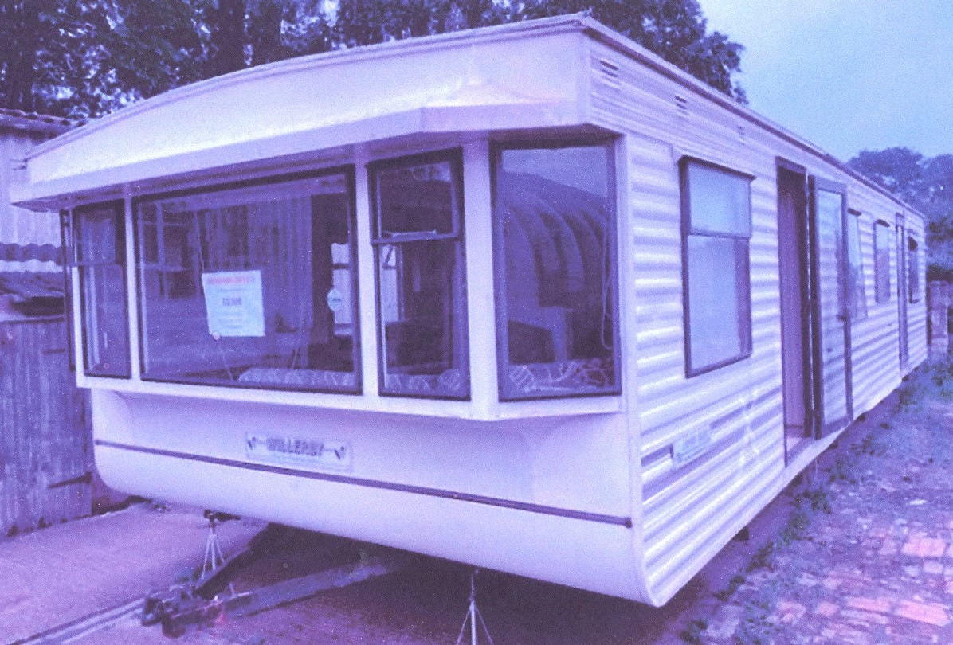

DESIGN STATEMENT

October 2021

Anne Netherwood B.Arch BD RIBA

Anne Netherwood B.Arch BD RIBA

Chartered Architect

11 Cottage Fields
St Martins
Oswestry
Shropshire SY11 3EJ
01691 778495

MAES LEWIS, KNOLTON

WREXHAM

I. INTRODUCTION
This document is produced in support of an application for Planning Permission for a mobile home in the grounds of the house owned by Mr and Mrs Moore.

2. OBJECTIVE

The owner's wife suffers from osteoporosis and has limited mobility. She underwent surgery for breast cancer in March 2021 and is currently being treated with chemotherapy and radiotherapy. Her GP has recommended that she moves into a smaller home on one level, and the family has decided to apply for permission to site a mobile home in the grounds of the house. If permission is granted, Mr and Mrs Moore will move into the mobile home and their son and daughter-in-law will move into the house in order to care for her.

A letter from her GP is attached to the planning application.

3. DESIGN
The design is for a mobile home, of a similar type to the one illustrated.
Suggested type of mobile home

It will only be in place for the lifetime of Mr and Mrs Moore senior. There is an existing double gate on the south of the site which is set back from the road line, and this can serve the mobile home if a separate access is needed. The existing access to the house is via an entry to the north.

Foul drainage from the house is taken by an “onion” type of septic tank. Mr Moore proposes to install a new septic tank for the mobile home. This will be the newer rectangular type which does not require concrete weighting. It will therefore be possible to remove it when the mobile home is no longer in use.

PROPOSE SITE PLAN
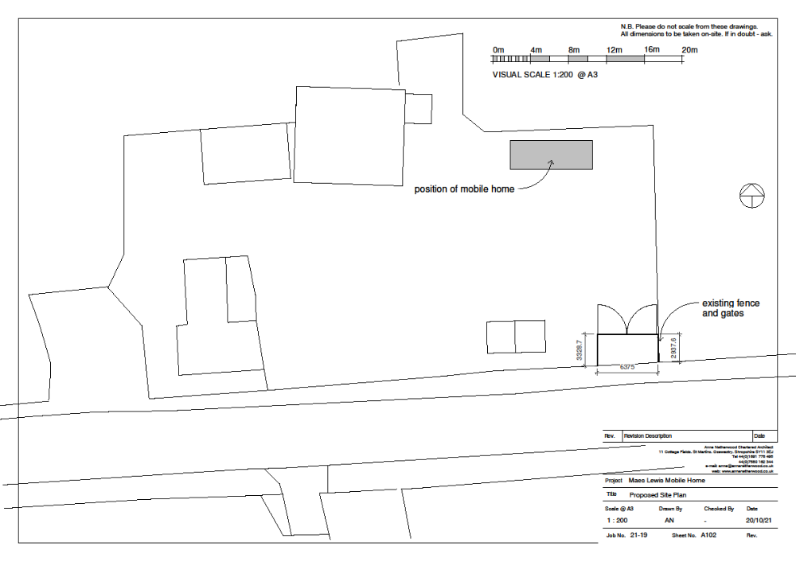
The mobile home will be located by the rear boundary. At present this area is a chicken run.

CONCLUSION
Mr Moore has had an informal discussion with Simon Goodacre who advised him to ask Mrs Moore’s GP for a letter in support of the proposal and apply for planning permission. However, Mr Moore found the application form rather daunting, and was then advised to engage an architect. I do hope that this planning application will be granted as it will certainly enable Mrs Moore to stay in her familiar surroundings and be cared for by her family.
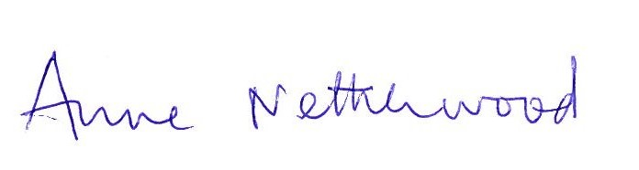
October 20th 2021

