Tree Preservation Order Tree Works Application
Bryn-Y-Groes, Chester Road, Gresford, LL12 8TZ
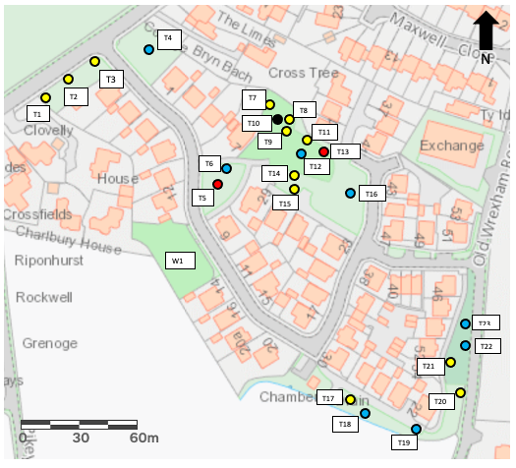
Site Plan 1

