A Heritage Impact Assessment for the Church of St Ffraid, Gyn Ceiriog, in support of the proposed works as detailed in Application No. PP-10175151

1. Brief Description of the Church
The small Grade II listed former Church of St Ffraid is situated just to the north of the village of Glyn Ceiriog. It sits within a roughly circular wooded churchyard on a steeply sloping site overlooking open fields to the south. There are a few scattered dwellings to the west and a band of trees to the north which give way to open farmland a little further on. The church is built from grey rubblestone with sandstone dressings around the doors and windows. It consists of a single chamber for the nave and chancel, a west tower, south porch and north vestry. The original medieval church was rebuilt circa 1790 but remodelled during a Victorian restoration in 1839-9, paid for by Viscount Dungannon of the Brynkinalt Estate. New windows were inserted in the nave and chancel and a porch added. The arch-braced roof and west gallery may also have been replaced at this time. Many of the furnishings date from 1887 when further work was undertaken and the panelled sanctuary ceiling added. The Cadw listed building report has been included in Appendix II.

2. Background Information
The Church was made redundant on 11th March 2019 and came out of Ecclesiastical Exemption on this date. The moveable contents have been relocated but all fixtures and fittings remain. Following redundancy, the Representative Body of the Church in Wales (the owners of the building) were contacted by the Trevor family of the Brynkinalt Estate asking if they could remove a 19C marble wall mounted memorial tablet dedicated to members of the Dungannon family (a branch of the Trevor family) and a family hatchment, both located on the north chancel wall above the choir stalls (see photographs in Appendix I). The Trevor family would like to place the memorial tablet in their family mausoleum in the churchyard of St Mary’s Church, Chirk. The hatchment will be placed in a prominent place in the Great Hall at Brynkinalt.
Although both these items are included in the listed building description, it is felt that the family connection to them should be preserved, especially since the church will shortly be offered for sale. Their relocation will also ensure their long term future in the well maintained family mausoleum and Brynkinalt House (a family home and events venue).

3. The Impact of the Works
The removal of the memorial tablet will be carried out by a professional stonemason who will ensure that minimal damage is caused to the historic fabric of the chancel wall. The underlying stonework will be checked and any cavities filled. It is understood that the wall in this area has been plastered and painted and these materials will be used to “make good” the affected area as required. This will also ensure minimal visual impact on the interior setting of the church.
The family hatchment appears to have been attached to the wall at a single point (eg. a bracket). This will enable it to be lifted off its fixing with no damage to the wall underneath. The bracket will be left in situ to prevent any loss of historic fabric.
The following table summarises the impact of the works on the Church of St Ffraid:
Proposed Work | Remove marble memorial tablet from the north chancel wall and “make good” any damage to the historic fabric underneath. Remove the hatchment by lifting it away from its fixing point. Leave the fixing bracket in situ to prevent damage to the historic fabric.
Objective | To ensure minimal damage to the historic fabric of the north chancel wall and the visual impact on the church interior.
Significance of affected fabric | The fabric of the north chancel wall most probably dates to the time of the church rebuild (c1790). It therefore forms part of the pre-Victorian restoration of the church.
Beneficial impact assessment | The works are minimal and any damage to the historic fabric will be repaired using materials to match the existing historic fabric and decorations.
Harmful impact assessment | Very minor loss of historic wall fabric.
Proposed Solution | The reinstatement works following the removal of the memorial tablet will use materials that are appropriate to the historic building fabric of the north chancel wall. Thy will also be in keeping visually with the internal character of the church. The memorial tablet will be placed in the Trevor family mausoleum and the hatchment in the Great Hall at Brynkinalt. This will preserve their family connection for future generations and ensure they are well maintained.

Appendix I – Part 1: Photographs of the Memorial Tablet and Hatchment

Wall mounted memorial tablet dedicated to members of the Dungannon family in St Ffraid’s Church
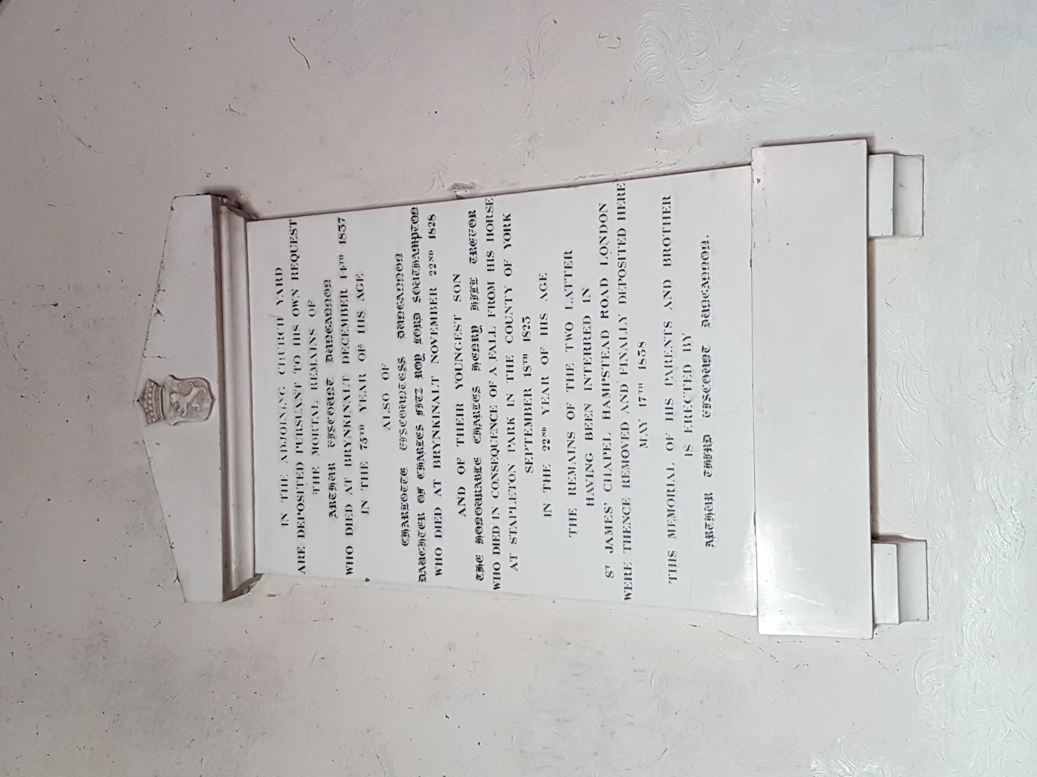
Hatchment of the Dungannon family in in St Ffraid’s Church
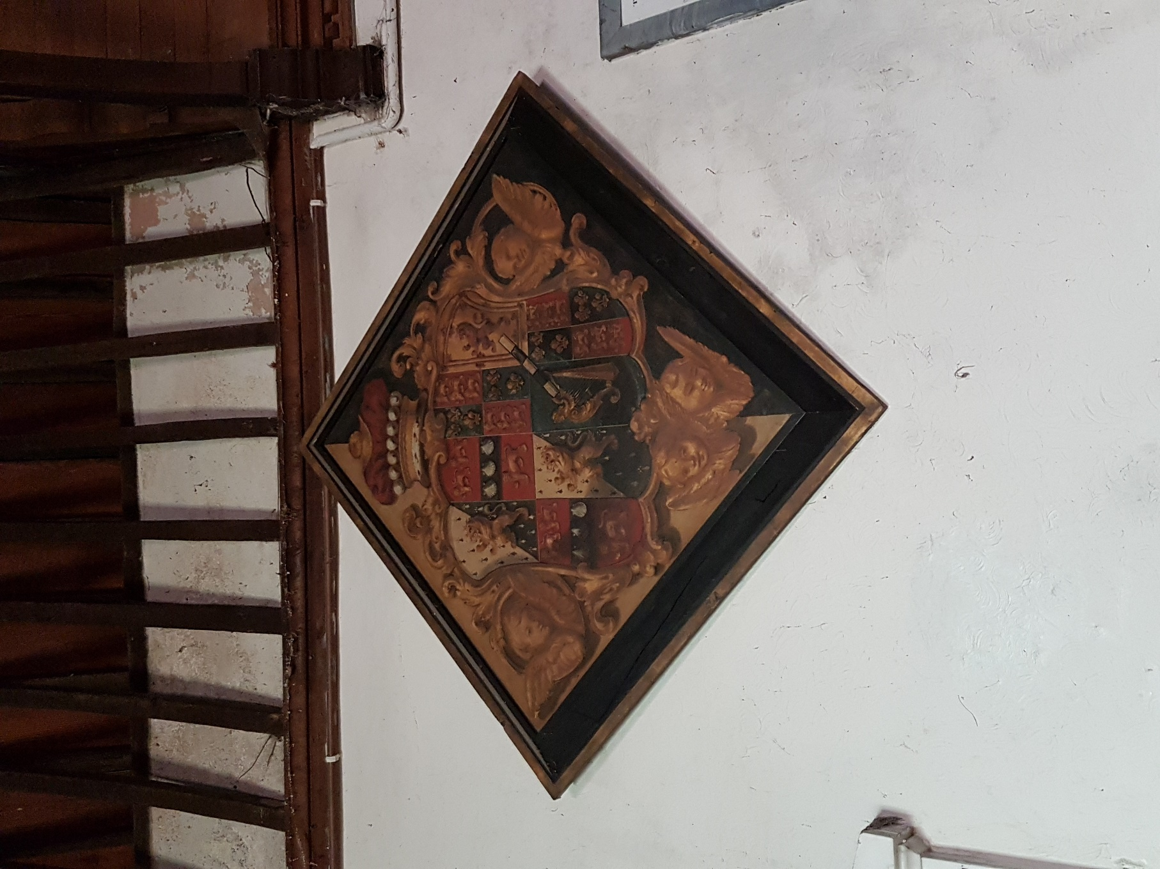

Showing the position of the memorial tablet and hatchment in relation to the north nave and chancel wall in St Ffraid’s Church
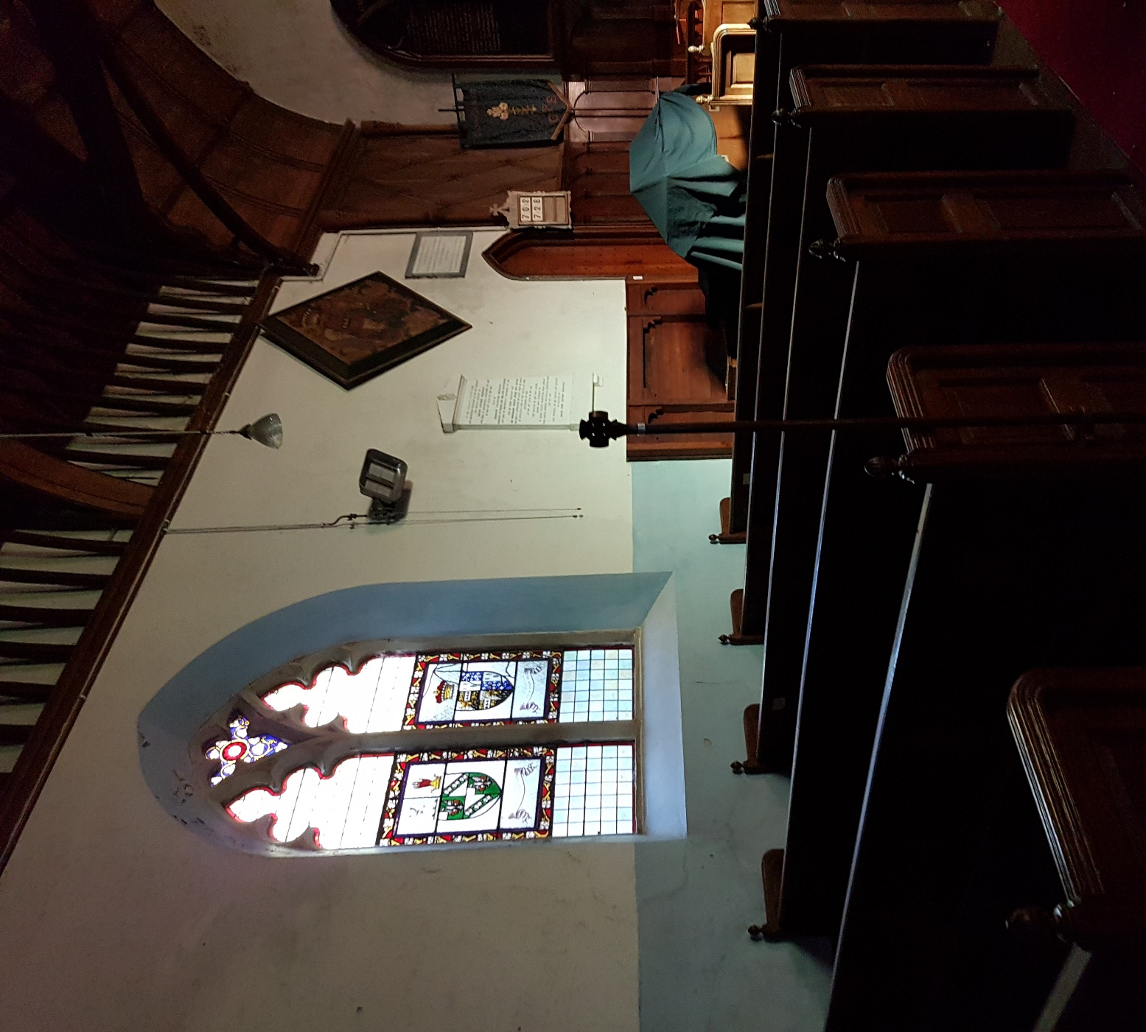

Proposed location of memorial tablet (Trevor family mausoleum at St Mary’s Church, Chirk)
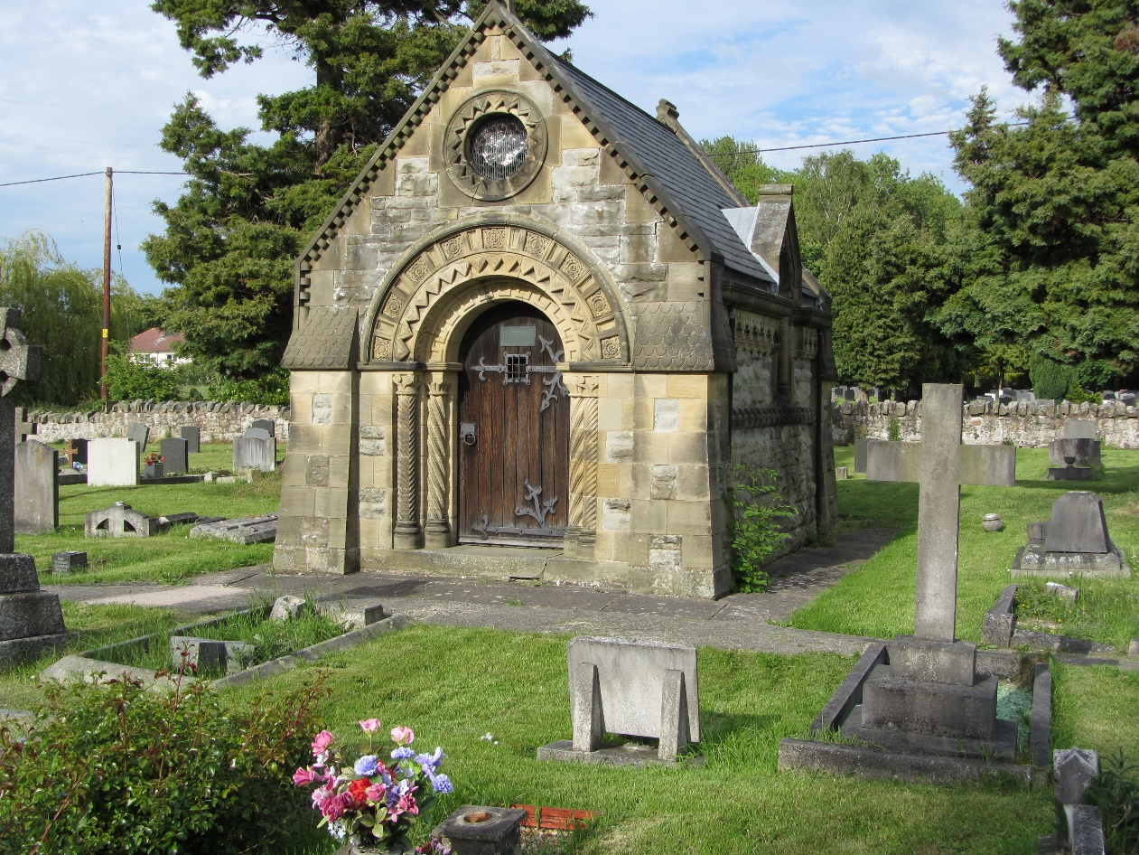
Proposed location of family hatchment in the Great Hall, Brynkinalt
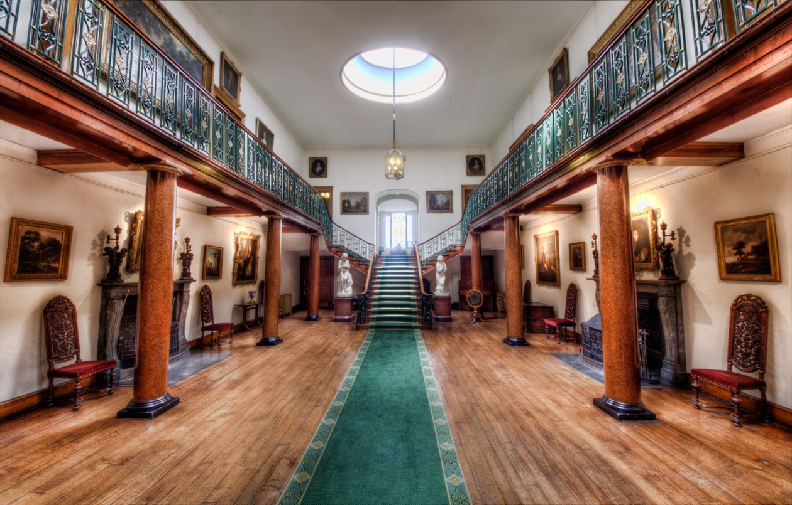

Appendix II


Full Report for Listed Buildings

Summary Description of a Listed Buildings

Reference Number
81287
Building Number

Grade
II
Status
Designated
Date of Designation
08/07/2003
Date of Amendment
08/07/2003
Name of Property
Church of St Ffraid
Address

Location

Unitary Authority
Wrexham
Community
Llansantffraid Glyn Ceiriog
Town
Llangollen
Locality
Glyn Ceiriog
Easting
320469
Northing
338440
Street Side

Location
On the E side of a lane which runs N from the centre of Glyn Ceiriog. The lane rises steeply and the church is in a prominent position on the hillside.

Description

Broad Class
Religious, Ritual and Funerary
Period

History
On an ancient site, originally with a circular churchyard. The medieval church was rebuilt c1790; the tower with its round-headed openings and the layout of the interior are characteristic of this period. A Victorian restoration was undertaken at the expense of Arthur, Viscount Dungannon in 1838-9, which included the insertion of new windows to the nave and chancel and the addition of a porch. The arched-brace roof and gallery may have been replaced at this time. Many of the furnishings are of 1887, along with the sanctuary ceiling.

Exterior
West tower, wide single chamber nave and chancel, S porch and N vestry. The church is constructed of rubble stone, the roof covered by small slates with tile cresting; shallow plinth. Heavy sandstone dressings to C19 openings. Narrow 3-stage tower with battlemented parapets above moulded string course. S side has narrow doorway to R with round-arched head and continuous chamfered stone moulding, containing a boarded door. To its L is a small pointed lancet with coloured glass. The W end has a large round-arched window to the middle stage with hollow moulding and a stone sill; diamond quarry glazing. Belfry openings to S, E, and W sides, all with heavy C19-style surrounds, with shallow pointed-arched heads and hoodmoulds. To W end of nave flanking the tower, are single cinquefoiled lights; that to R replacing an earlier taller window. The S side of the nave and chancel has a porch to L of centre, single window to its L and 2 windows to R. Gabled porch with kneelers and raised copings, diagonal buttresses with offsets. Pointed-arched entrance with several orders of roll mouldings and hoodmould. Diamond-shaped stone tablet to gable, dated 1838. Lancet to each side of porch, the glass with coloured margin glazing. Inside porch are narrow benches. A shallow pointed-arched doorway with chamfered surround containing double boarded doors leads into the nave. The 3 windows lighting the nave and chancel are 2-light with pointed-arched heads, roll mouldings and hoodmoulds. The lights have cinquefoiled heads. Butt joints for earlier taller windows survive, probably C18. East gable is roughcast with kneelers and raised copings, and is surmounted by a cross. Four-light E window in Perpendicular style, with cinquefoiled lights and quatrefoil to apex; hoodmould. The N side of the church is cut into a steep bank. Gabled vestry to far L has single pointed-arched light to its E side with hollow moulding. Area of brickwork to N, possibly relating to a former chimney. One window to R of vestry, in similar style to front.

Interior
Nave and chancel of high and wide proportions with gallery to W end. Nave has 4-bay arched-brace roof, the posts resting on a rail below wall plate level; roof panelled to underside, between exposed rafters. Ornate cusped rood beam, probably inserted later; King-post truss with struts, supported on braces. Short chancel and sanctuary with wood-panelled wagon roof. Gallery to W end with wood-panelled front supported on 2 wooden posts with chamfered angles and moulded caps. Royal arms attached to front. Underneath gallery is a panelled door with traceried tympanum under a Tudor arch leading to tower and gallery stairs. To the rear of the gallery are 2 panelled doors under a moulded round arch with cusped Y-tracery and head bosses: that to R leads to stairs to ground level; that to L to a landing, from which a ladder ascends to the bell chamber. Four-tier gallery with benches and a box-pew to S side. The nave has a central aisle flanked by open panelled pews. Wood panelled vestibule to entrance, half-lit with coloured margin glazing. Nearby is an octagonal stone font with foliage decoration, probably C19. Square wood-panelled pulpit with chamfered angles, to SE corner. One step up to chancel; further step up to altar and C18 wooden altar rails. Half-height blind wooden panelling to walls flanking altar, the panels with arched heads. Above are wooden commandment boards with Y-tracery. The panelling continues to N and S walls, with diamond panelling above. Doorway with pointed-arched head to N leads to vestry. Hatchments above to L. North wall has white marble tablet with pedimented head to members of the Dungannon family, mainly C19. Further small tablets on S wall. Stained glass: East window showing Last Supper, in memory of Sir Thomas Storey (d 1898) of Plas Nantyr, and his wife, dedicated by Alfred Edwards, Archbishop of Wales. Three windows attributable to David Evans to N and S walls, including one near porch showing coat of arms of Archbishop of Canterbury and Victoria Royal Arms. World War I memorial to central window of S wall.

Reason for designation
Listed as a church retaining C18 and early C19 form and character, notable for its liturgical interest as a church in the Georgian ecclesiastical tradition,

