DESIGN AND ACCESS STATEMENT

The proposal is to insert two small (2ft x 3ft) wood framed windows into the existing alcoves either side of the fireplace,
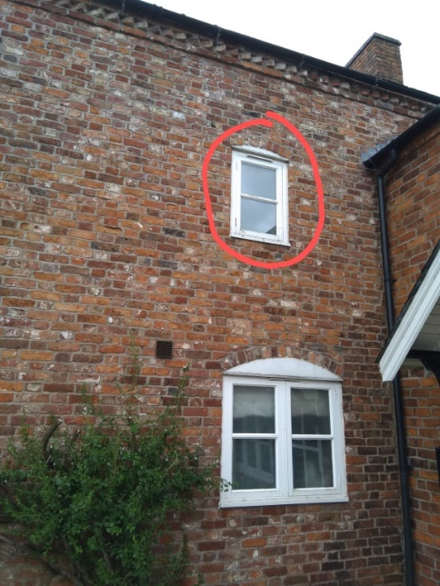

These windows will match in style and size the existing window (outlined in red on the picture) on the first-floor East elevation.

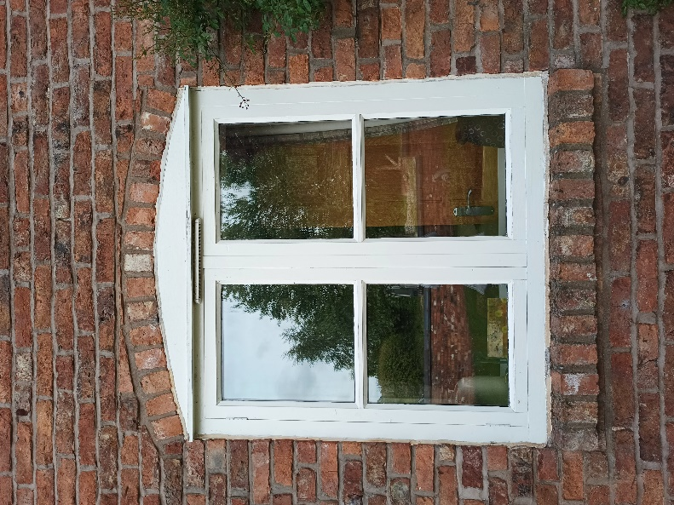
However we would copy the header and footer brick detail of the windows on the front (East facing) elevation.

