
Bob Dewey

PLANNING

SUPPORTING STATEMENT
PROPOSED REVERSION OF USE OF PROPERTY TO DWELLING
DEE COURT , BANGOR ON DEE.

Background: This report seeks to explain and support a proposal for the reuse of a property originally built as a dwelling but temporarily used as an office. No planning permission was ever sought for the use as an office. Initially the change of use took place to manage developments in the immediate area but on their completion, the office remained to support developments in the wider Wrexham area.

Proposal: The dwelling would be within a part of the village which is almost entirely residential in character and is attached to a part of the same building which would remain in commercial use by a dentists.

The change of use would create a single two bed room dwelling for which, we understand, three is significant demand in the village.

Planning Policy: The site is within the area covered by the Wrexham Unitary Development Plan adopted in 2005. It is shown as within the village boundary. It is within the floodplain of the River Dee. It adjoins the boundary of the village Conservation Area.

Policies PS1, PS2, EC12 and GDP1 are relevant. .

The Council’s overall strategy is that new development should normally only take place within settlement limits and that any development should not materially detrimentally affect the countryside.

Planning Policy Wales 11 is also important. This clearly stresses the need to ensure communities are cohesive, attractive and viable. It focusses particularly on the need to minimise travel especially by cars

PLANNING HISTORY:

An application for change of use (in identical terms to this)( ref: P/2018/1041) was refused 13 September 2019. However the refusal was made solely on the grounds of perceived flood risk

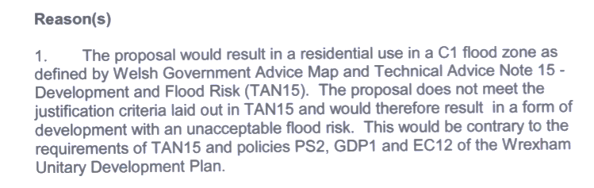
No flood assessment was provided as part of that application submission. That is now remedied.

SUPPORTING INFORMATION:

Planning policy at local national level requires that developments should as far as possible be located within settlement limits. That avoids unnecessary encroachment into open countryside and ensures that developments are accessible as possible to the communities they serve.

The fact that the previous refusal was made solely on the grounds of flood concerns, confirms that otherwise the development would be fully in accordance with local and national planning policies.

Whilst the concerns about flood risk are very real, they must be tempered by the reality of the situation.

The village is protected by substantial flood defences which significant reduce ant danger to the population. This proposal is to create a two bed dwelling which would increase the population allegedly at risk by about 0.1%.

The office, if continued would bring additional personnel into the building (almost certainly more than would live in the dwelling and most likely coming from outside the village – increasing the risk. Such people coming into the village would threrfore be potentially more at risk though their lack of familiarity with the emergency procedures.

If the Council had enforced planning control and taken action to remove the unauthorised commercial use, then the requirement would have had to be to re-instate the residential use.

TAN 15 is not an absolute bar to any new residential development in areas at risk. It imposes a duty on the LPA to consider whether there are reasons to justify the development. It is our submission that a building designed as a dwelling and occupied as such previously, which will increase the area’s population by an insignificant amount is unlikely to impose and additional risk on the community. Occupiers of the dwelling can (and would) be provided with very clear advice as to how to deal with any emergencies

In any event, the ground floor is already raised up by three steps from the pavement and there is a further rise from the carriageway. In absolute worst flooding incidents, the upper floor would provide a safe refuge.

Conclusion:

The site is in an extremely sustainable location and the increase in population at risk would be miniscule. With the presence of the well-maintained flood defences and the additional rise in the ground floor level the chance of any persons being put to any danger would be insignificant.

The alternative of a commercial office use occupied by people from outside the area unfamiliar with the emergencies plan would be worse.

The alternative is likely to leave a vacant building within the heart of the village.

The council is urged to grant planning permission.

Robert A Dewey BA(hons) MBA
Bobdeweyplanning
January 10 2022
Rev 2
The Gables, Llanfynydd WREXHAM. LL11 5HG tel: 01978 761315 (m) 07947 186 777
e mail bobdeweyplanning@gmail.com

