CHAIN BANK
CHIRK
WREXHAM

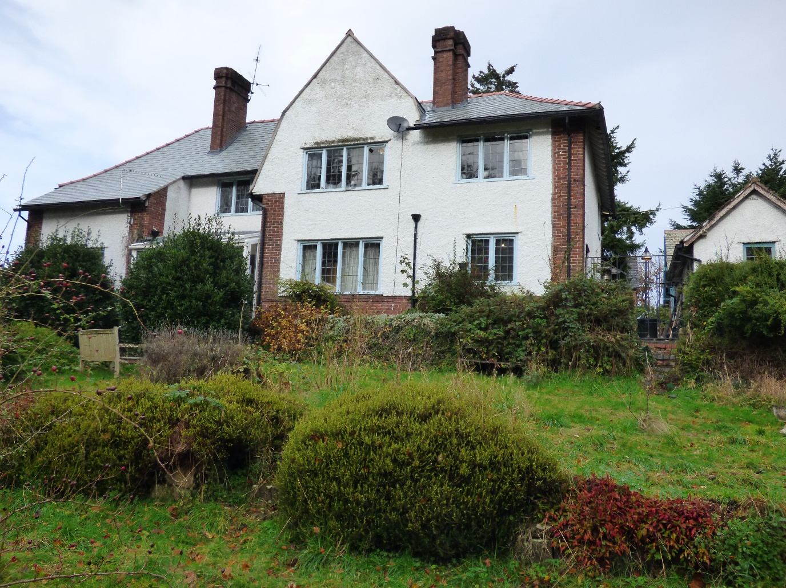

DESIGN AND ACCESS STATEMENT

November 2021

Anne Netherwood B.Arch BD RIBA

Anne Netherwood B.Arch BD RIBA

Chartered Architect

11 Cottage Fields
St Martins
Oswestry
Shropshire SY11 3EJ
01691 778495

CHAIN BANK CHIRK

WREXHAM

I. INTRODUCTION
This document is produced in support of an application for Planning Permission for a new garage and a deck on the south side of the detached house. The existing house is cavity wall construction with facing brick to the outer leaf. It has metal windows in timber frames and a slate roof. The ground within the property boundary slopes steeply down to the south, Outside the boundary on the west side there is a public footpath leading to the Chirk Aqueduct, part of the Llangollen Canal World Heritage Site.

2. OBJECTIVE
The owner purchased the house this year in order to provide accommodation and home care for his father-in-law, Kevin, who has been wheelchair bound for twenty years following a stroke and heart surgery. He is unable to walk or move his left side, and relies on carers coming in three times a day. Kevin has now accepted it is not safe for him to live alone and he intends to move in with his daughter and son in law at Chain Bank as soon as the
accommodation has been adapted for him to provide some independence and safe space while having company to also support him.
The owners of Chain Bank intend to make some alterations to the interior of the house so Kevin can have his own suite of rooms accessed with a through the floor lift. They also wish to erect a deck to the south side of the house in order to provide level access for Kevin to enjoy the outside fresh air and views of the garden and also able to attend family gatherings at this home.

The existing garage is difficult to access and too small for most modern cars.

This will be converted to a small wheelchair accessible workshop for the Kevin’s use. The owners want to erect a double garage to the west of the house which will accommodate a car and a camper van. Because of the slope of the land there will be room on the south side to install a workshop at a lower level. Part of the workshop will be under the garage and part outside; the roof of the external part will be a terrace accessed from the garage.

3. DESIGN
The Deck design intends to be made to last with steel frame and block and beam structure topped with a stone / concrete paving. Subject to engineer’s recommendations the existing walkway at the rear will be reinforced as a retaining wall with the deck built over it and extending a further two meters to the south.
The garage will be oak framed with vertical timber cladding and a slate roof at 30° pitch.

There are a few minor alterations to the south elevation of the house itself – particularly the replacement of an existing sunroom on a similar footprint, and the cutting back of a roof at the west end to provide a balcony to the main bedroom and the dressing room.

4. SITE
The north boundary is the edge of Castle Road. At present this is marked by a hedge which is very overgrown. The owner plans to remove the hedge and erect a 1m high stone wall similar to one on the boundary of a neighbouring property. This will be topped with metal railings. New timber gates will be fitted at both ends of the drive, hung on 340mm square stone piers.
The garden to the south is also very overgrown, with self-seeded trees competing with some planted mature species. The owner is in discussion with the Llangollen Canal Trust in relation to thinning the trees on both sides of his boundary – something that the Trust will welcome. However, this does not form part of the current application.
Access to the new garage will be from the west end of the drive, retaining as much of the beech hedge as possible.

5. PHOTOGRAPHS
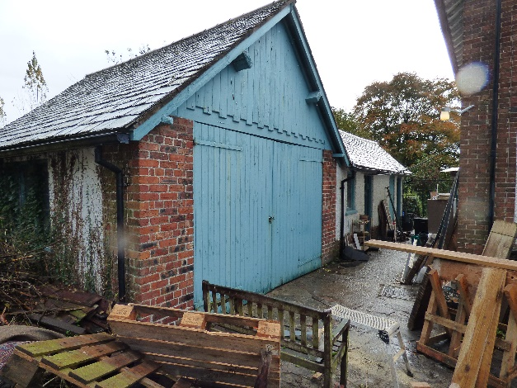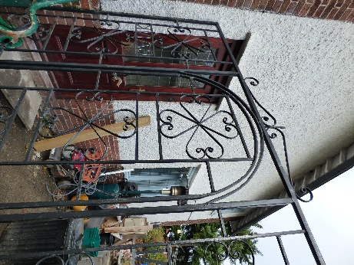
Existing garage and outbuildings East side of house
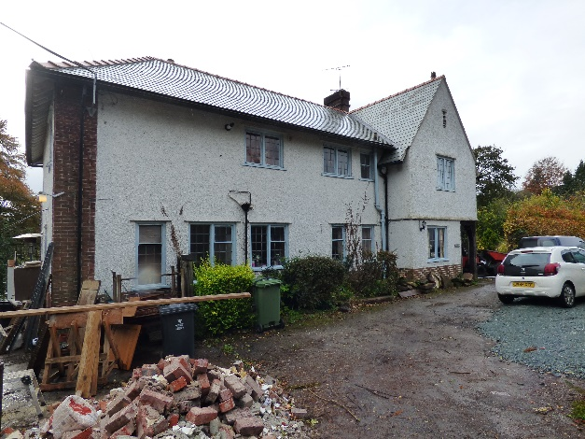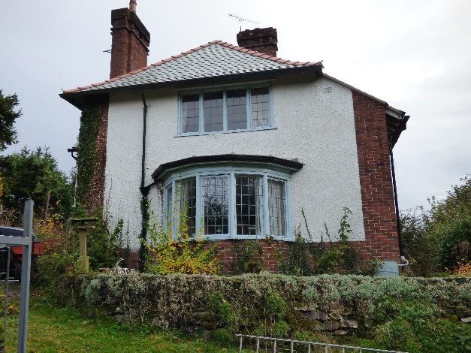
North elevation and drive West elevation and walkway
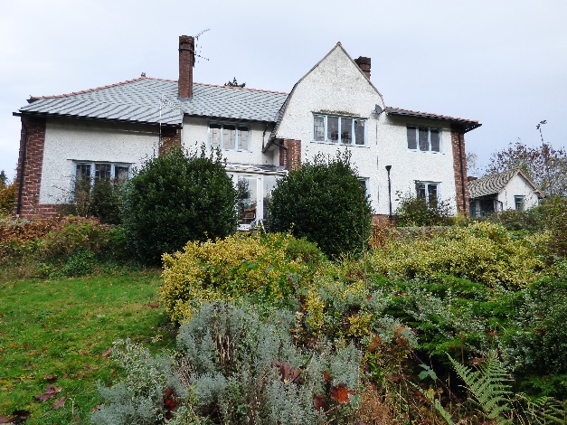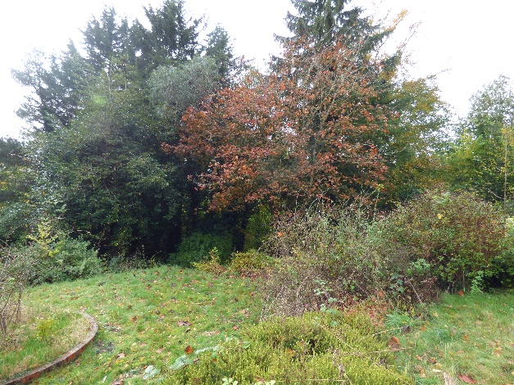
South elevation and garden Mature trees in garden
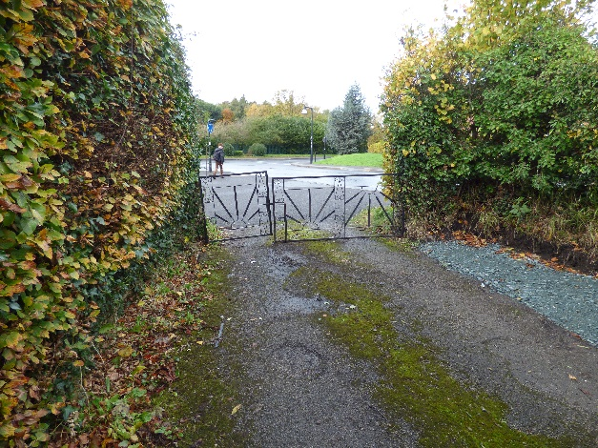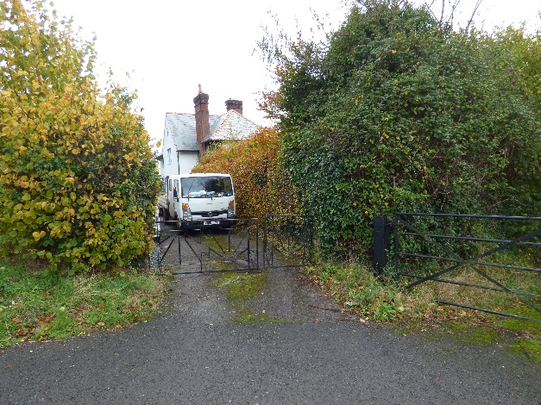
West end of drive with beech hedge West end of drive looking east
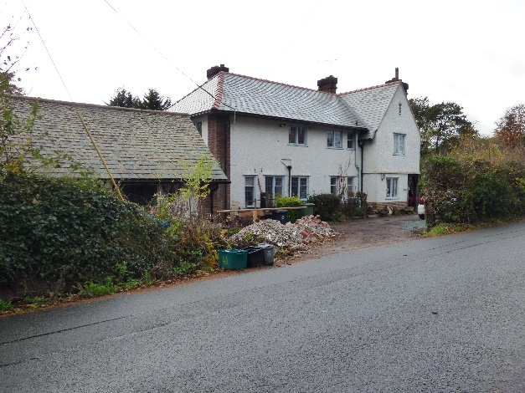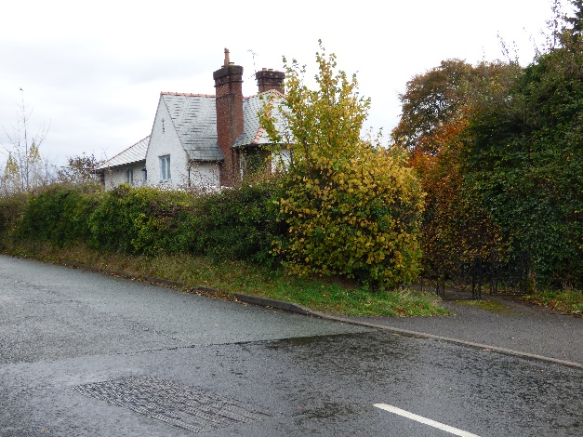
East end of drive and road Hedge on north boundary
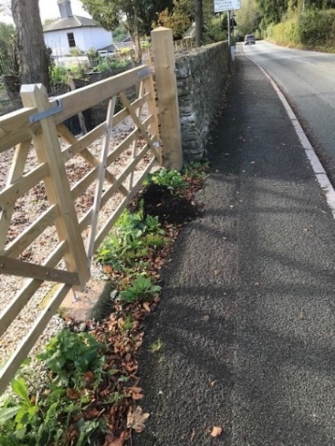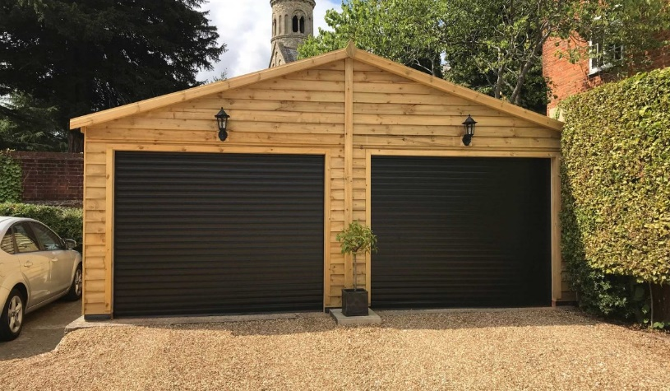
Neighbouring boundary Garage similar to that proposed
wall and gates

