Application Statement
Change of Use

Proposed conversion of the ground floor shop (Class A1) and ground floor of the associated dwelling and rear garden (Class C3) to a restaurant/coffee shop (Class A3) together with internal alterations to the existing residential use on the first floor at The Old Post Office, Station Road, Rossett, Wrexham, LL12 0HE.

- Introduction

1.0 This planning statement has been provided to accompany an application for a Change of Use in relation to an existing shop and associated dwelling to a Restaurant/Coffee Shop.
The statement considers the issues surrounding the proposed development and includes information as set out by the Town and Country Planning (Development Management Procedure) (Wales) Order 2012 and Design Technical Advice Note 12 (Design and Access statement) 2014.

1.2 The content of this statement is commensurate with the complexity of the proposal.

2.0 The site.

2. 1 The Old Post Office (most recently the Spar Shop) is a property located on Station Road and is within easy walking distance of the public car park on Station Road. To the right of the building there is an attached hairdressers (A1) shop.

2.2 The existing premises are situated in excess of 600m from Darland School.

2.3 The site is shown to be in a LOW risk flooding area from the NRA mapping system.

2.4 The site is within 60m of the Wrexham to Chester bus route and bus stops.

3.0 Background

3.1 The shop was formally a family run Spar shop with a Post Office and includes a single residential dwelling with accommodation above and to the rear of the shop. The shop business ceased operation in approximately 2017and together with the attached dwelling has been vacant since that time. Since closure the building and retail shop front has deteriorated and is in need of replacement/refurbishment.

3.2 The building is not listed for planning purposes.

4.0 Planning Policies

4.1 In preparing this submission full regard of the Wrexham Borough Council Development Plan has been considered.

GEN1 - General Requirements for Development

LPGN 9 - Hot Food Takeaways, Restaurants and Cafes

LPGN 12. Shop fronts.

4.2 In general proposals for new establishments or for the change of use of existing establishments to sell hot food for the consumption both on or off the premises will be permitted where they meet the following criteria:
- the amenity of local residents, including residents living above the property, is not unduly harmed;
- on-site provision is to be made for the disposal of casual litter and wastes; and
- the use will not result in traffic hazards or disturbance arising from street parking.
3.2 Restaurants are appropriate uses within village centres complementing existing uses and enhancing the service choice available to the public. Such uses are also important to the evening economies of existing village centres complementing the range of public houses and other shops present in the locality. While proposals for these uses will be encouraged, it will be important to ensure they do not jeopardise the health and viability of the area. In particular it will be important for proposals to consider their impact on residents in upper floor dwellings. As such, it is intended that the existing first floor flat, immediately above the restaurant, will be occupied by a person who is to be employed within the restaurant below.

4.0 Proposal.

4.1 It is proposed to change the use of the existing ground floor shop area (Class A1) situated at the front of the building and the rear residential area (Class C3) into a restaurant (Class A3)for a maximum of 46 seated customers.

4.2 It will be necessary to provide a commercial kitchen and also suitable toilets accommodation for the use of the customers. To facilitate this and also provide an economically viable restaurant business it is considered necessary to incorporate the existing ground floor residential facilities into the commercial premises, thus forming a first floor flat. The existing independent ground floor access to the ‘flat’ will be retained. The occupancy of the flat will be limited to a staff member/s of the restaurant below.

4.3 It is also intended to incorporate the rear garden of the former house in conjunction with the restaurant. This will provide a pleasant external sitting/dining/drinking area adjacent to river, similar to the adjacent beer garden serving the adjacent Public House. The estimated number of tables will be 5 x 4 persons equaling 20 persons.

4.4 To provide suitable and sufficient toilet accommodation, without reducing the useful floor area of restaurant, it will be deemed necessary to demolish the existing timber and translucent sheet structure to the front of the existing workshop/storage building and, construct a small extension and convert the front section of workshop to provide the requisite toilets. As part of the refurbishment of this area, the existing poor sub standard covered access to the rear garden, toilets and access to the first floor flat will be replaced with a fully insulated flat roof construction.

4.5 It is envisaged that if planning permission were to be granted for the proposed change of use, then to fulfill the service provision, it would be necessary to recruit at least 18 persons, all being full time employees on a shift basis.

4.6 With regard to customer opening hours the client has suggested opening times are to be 8:30am -22:30pm. Although the opening hours for the garden area will be the same as the restaurant, it is likely that the garden area will tend not to be used during the winter months but may be a little more popular during the summer months.

5.0 Layout and Scale.

5.1 As a change of use the scale of the existing building will not alter however, these are the approximate floor areas within the existing building and their proposed usage:
a) Restaurant - 85m2
b) Bar and servery and wine cellar - 36m2
c) Toilets - 14m2
d) Kitchen and storage - 45m2

6.0 Appearance.

6.1 The applicant (being the owner of the building) is very keen to improve the appearance of the existing building which is very prominent on Station Road, as the building currently does not present a prosperous appearance, especially with a possible very long term vacant accommodation on the ground floor frontage to Station Road.

6.2 If planning permission were to be granted then it would be likely that a new traditional timber shop front would be provided with the new entrance door set back from the rear edge of the pavement, as it is contended that the shop front in its present unkempt condition actually detracts from the current ambience of the area.

6.3 It is considered that the new shop front will considerably enhance the street scene to Station Road and neighbouring properties through the use of appropriate materials and by virtue of its design, proportion, style and scale. This will be assured as any new shop front will meet the requirements of LPGN 12 and will be the subject of a future requisite planning application.

6.4 Due to the existing single storey roof being constructed using different corrugated sheeting materials it is considered necessary to replace the single storey roof in its entirety. The roof will be a modern ‘ruberoid’ flat roof construction incorporating a lantern light over an area of the restaurant.
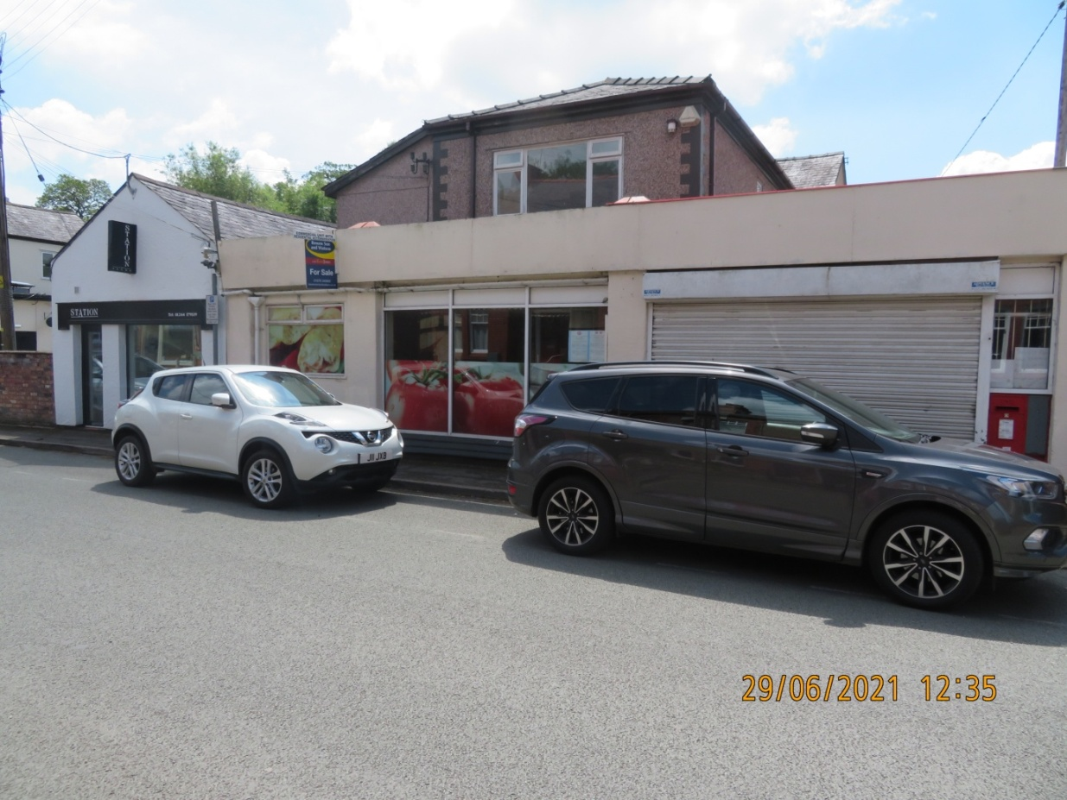
Photograph 1 – showing the existing entrance and shop front to Station Road.

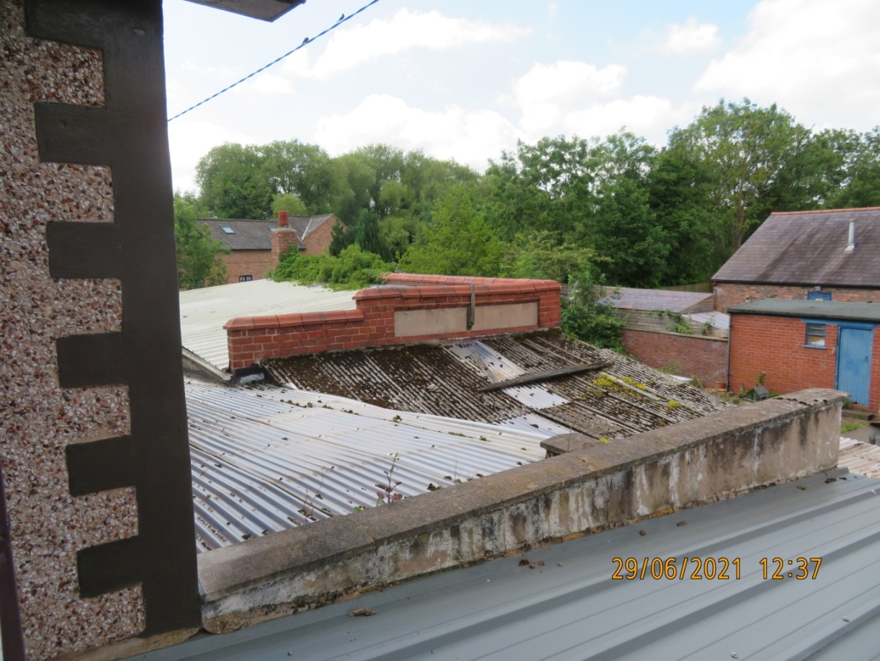
Photograph 2 – showing the existing ‘flat roofs’ which would be replaced.

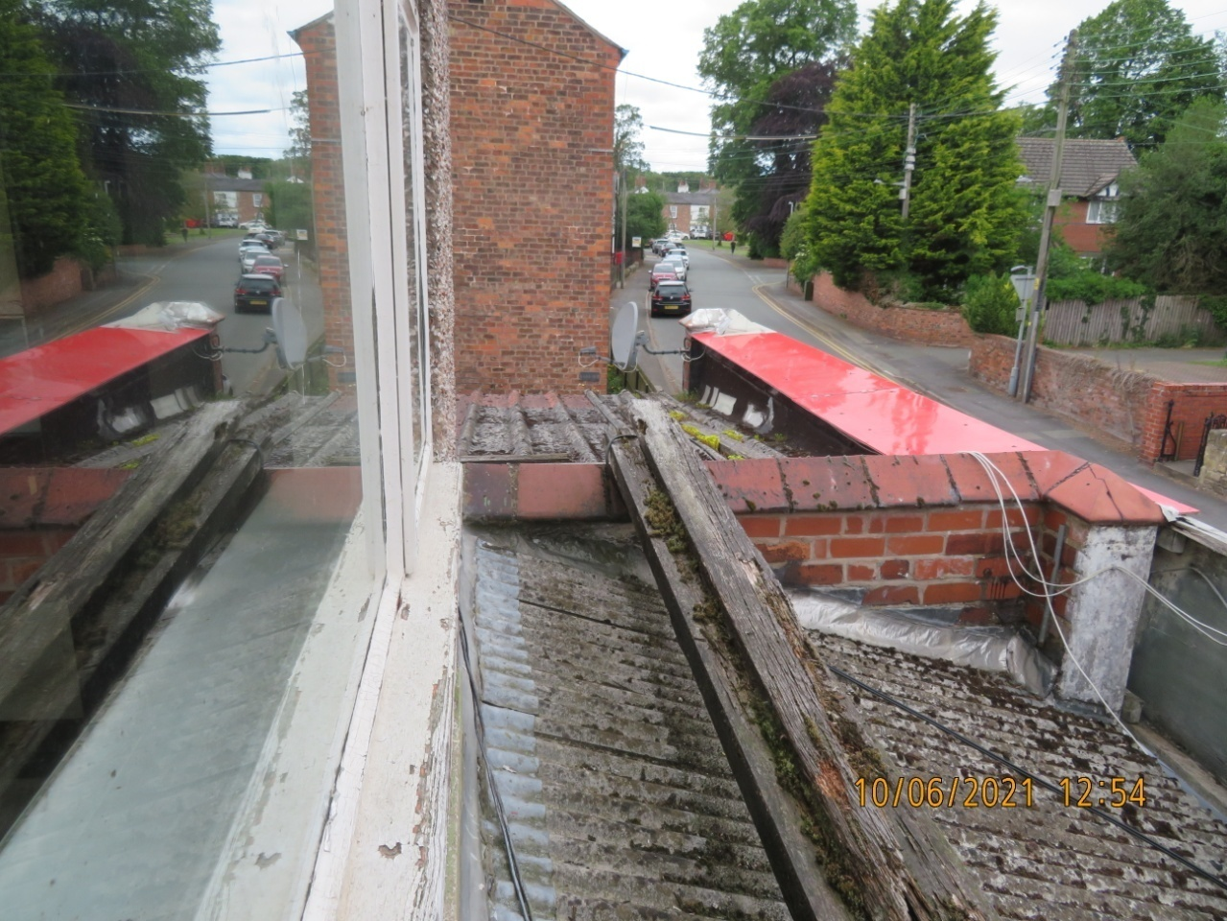
Photograph 3 – showing the existing roofs over the shop entrance which are to be replaced.

7.0 Accessibility.

7.1 Again as stated in 6.1if planning permission were to be granted the restaurant will still be accessed from the Station Road frontage as at present, however, to ensure that a level access to the premises is provided the entrance will need to be set back from the rear of the pavement.

7.2 The staff, kitchen and storage areas will be accessed via the side door already serving the existing storage building and existing dwelling. The proposed flat will be accessed from using the existing access to the rear of the original building as existing.

7.2 Vehicle, cycle and pedestrian access within the site will be provided to the side of the building via the existing concreted hardstanding and footpath. Parking for two vehicles will be provided within the site for the use of the flat occupants and servicing. A public car park is situated within 60m of the site.

7.3 Within the restaurant, a section of the counter/server/display unit will be at low level and table service assistance will be made available to all patrons/customers who are unable to safely carry/collect goods from the counter and transport them from the building or to the proposed tables.
Staff will be trained to ensure loose furniture is moved to maintain clear and safe access routes.
7.4 Should a disabled person be employed at the premises the owners will have a documented policy identifying individual needs and undertaken reasonable adjustments, as identified in Part II of the DDA 1995.
7.5 Access to the first floor flat will utilize the existing entrance to the original dwelling.
8.0 Refuse and Recycling Storage.

8.1 A nominated licensed contractor will be engaged to remove rubbish, waste materials and re-cycling, on a regular/daily basis as required from a the specified storage area within the curtilage of the building, as shown on the drawings

8.2 The siting shown will give easy access to the recycling operatives and their vehicles.

9.0 Consulation.

9.1 No formal public or neighbouring consultation has been undertaken.

10.0 Overall Conclusions.

10.1 If planning permission were to be granted it is considered that the proposed change of use together with the intended alterations will not cause any adverse visual or detrimental impact on the surrounding area or the setting of the existing building.

10.2 It is also considered that whilst the change of use (with its substantial economic investment) will possibly duplicate other nearby similar establishments, may lead to concerns with regards to sustainability of existing businesses due to the patronage of the restaurant, economic competition between similar businesses, is not a material planning consideration and is thus a consideration outside the remit of planning.
It is contended that it is very likely that the use as a restaurant will retain commercial activity on Station Road and would occupy a potentially perpetually vacant and unviable shop unit, and as a result of this ‘change of use’ will enable the remaining businesses to benefit from the increased public presence and foot fall within the area.

~*~

