Site and Other Plans

`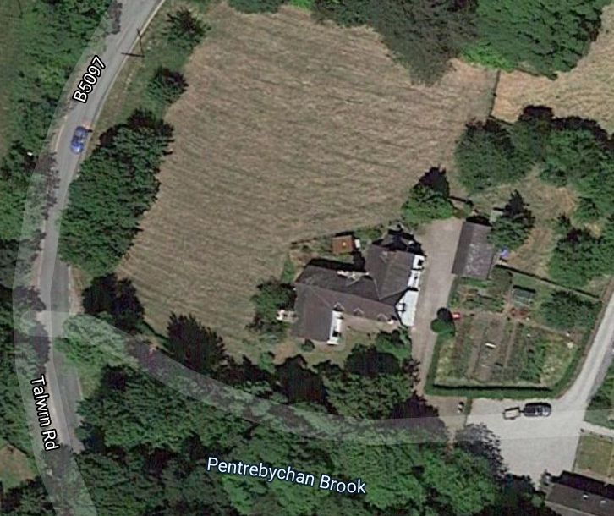
Chimney here

