- Applicant Details
Applicant Name and Address
Title and Name |  | Mr and Mrs E Chantler
Company
Suffix (unit/name/number)
Address line 1 |  | Knolton Hall
Address line 2 |  | Oswestry Road
Address line 3 |  | Knolton, Overton
Town |  | Wrexham
Postcode |  | LL13 0LG
Phone number | Mobile
Phone number | Works
Phone number | Home
e-mail address |  | echantler@strettonproperty.co.uk
Agent Name and Address
Title and Name |  | JG Moss
Company |  | Moss Co LLP
Suffix (unit/name/number)
Address line 1 |  | Brookgate Hall
Address line 2 |  | Plealey
Address line 3
Town |  | Shrewsbury
County |  | Shropshire
Postcode |  | SY5 0UY
Phone number | Mobile
Phone number | Works | 01743 588230
Phone number | Home
e-mail address |  | info@mosscompany.co.uk

Preferred contact | Applicant | Agent ✓
- Site Details
A general description of site location supported by a plan specifying the construction area and the extent of the drainage system should be submitted. Plans shall be at a scale of 1:2500. All plans should show the direction of North.

Name of proposed development | Revision to replacement stable range at Knolton Hall
Grid Reference (E/N) | Easting | Northing
Suffix (unit/name/number)
Address line 1 | Knolton Hall
Address line 2 | Oswestry Road
Address line 3 | Knolton, Overton
Town | Wrexham
County
Postcode | LL13 0LG
Description of proposed development | Revision to replacement stable range
Total application site area (Ha) | 7,892m² / 7.8ha
Is the site currently developed i.e. Brownfield, or is it currently undeveloped i.e. Greenfield? | brownfield
Existing land use | domestic curtilage
Proposed land use | domestic

- Application

Has any prior advice been sought from the SuDS Approving Body (SAB) about this application? |  |  | Yes ☐ |  | No x
If Yes, please complete the following information about the advice you were given. This will help the SAB to deal with this application more efficiently.
Officer Name
Reference |  | Date

Does this application relate to any other SAB application already made? | Yes ☐ | No ☒
If “Yes”, please provide SAB Reference number

Is this application part of a phased approach to development of the site, or one of multiple applications for the same site? |  | Yes ☐ | No ☒
If “Yes”, please provide brief details

- Environmental Impact Assessment (EiA) Statement

Does this application relate to a development that is the subject of an EiA application under the Town & Country Planning (Environmental Impact Assessment) (Wales) Regulations 2017(1)? | Yes ☐ | No ☒

- Compliance with Statutory National Standards for Sustainable Drainage Systems (SuDS)
All sustainable drainage systems MUST comply with the Statutory National Standards for Sustainable Drainage Systems (SuDS) for Wales. You are advised to refer to the detailed text in the Standards that relate to the information required below. The Standards are re-produced, in the Guidance to assist in completing this application form.

Standard Principles
The Principles listed below will underpin the design of surface water management schemes to meet the Statutory National Standards. Where possible, please provide a brief summary in each of the boxes below relating to each of the bulleted Standard Principles and itemised Standards 1 to 6, showing how your proposed surface water drainage scheme complies with this statutory requirement.
Compliance with Standard Principles
My proposed surface water drainage scheme will comply in the following way/s:
The proposed development is on existing hardstanding with no new non permeable surface created as part of the proposal.

A review of the National Resource Wales indicates that Knolton Hall and the outbuildings within its curtilage are located within Flood Zone 1: ie with an area assessed as having a less than 1 in 1000 annual probability of the risk of river flooding. Therefore, a Flood Risk Assessment is not applicable for this application.
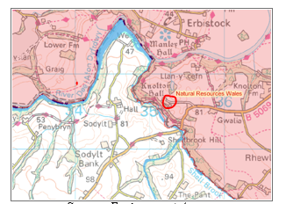

The site area is unlikely to increase future pressures on flood risk, the environment and water resources due to the isolated location of the site.

The applicants own all of the land including the run off destination.

The applicant will look to incorporate the use of water butts, to collect run-off from the roofs, for stable and outdoor use.

There is no likelihood of pollution at source or through dispersal.
Where possible, relevant items of supporting information (e.g. evidence, technical documents, plans and drawings etc.), as shown in Table A and Table B of this Guidance should be listed below and all relevant material submitted.
https://flood-map-for-planning.service.gov.uk Post code: LL13 0LG

Standards 1 to 6
Compliance with Standard S1 - Surface water runoff destination
My proposed surface water drainage scheme will comply in the following way/s:
The proposed development does not result in an increase in hard standing however appropriate drainage measures in accordance with the relevant regulations will be provided. Surface water runoff from the replacement stables will be directed into soakaways. Percolation tests will be carried out on site to determine the size of soakaways required. The soakaways will be designed in accordance with BRE Digest 365 to cater for a 1 in 10 year return storm event.
Where possible, relevant items of supporting information (e.g. evidence, technical documents, plans and drawings etc.), as shown in Table A and Table B of this Guidance should be listed below and all relevant material submitted.
1140.32B 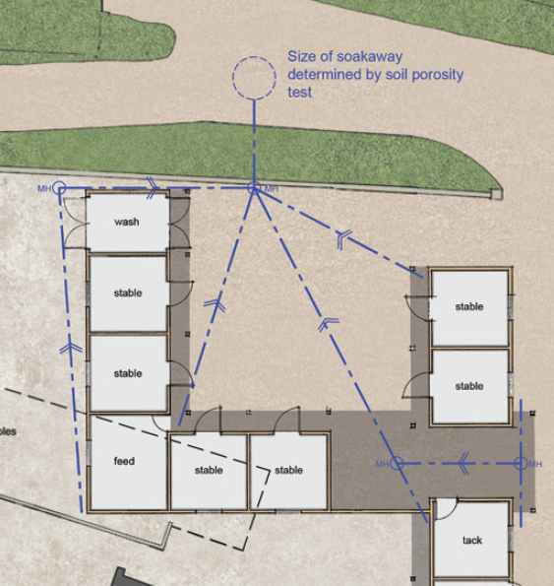
The proposal is not considered to have a negative impact on flood risk, the morphology and water quality of receiving waters and the associated ecology.
The proposed system will provide surface water runoff destination under
Priority Level 1, where surface water runoff is collected for re use on the site and
Priority Level 2, where surface water runoff is infiltrated to ground

Compliance with Standard S2 - Surface water runoff hydraulic control
My proposed surface water drainage scheme will comply in the following way/s:
It is not considered any increased flood risk to people and property downstream of the site will result from the development, https://maps.cyfoethnaturiolcymru.gov.uk post code LL13 0LG , below confirms no risk of flooding from rivers.
The site is not within an area of geological conservation importance.
Where possible, relevant items of supporting information (e.g. evidence, technical documents, plans and drawings etc.), as shown in Table A and Table B of this Guidance should be listed below and all relevant material submitted.

Compliance with Standard S3 – Water Quality
My proposed surface water drainage scheme will comply in the following way/s:
The water collected will be natural rainwater.
The applicant will look to incorporate the use of water butts, to collect run-off from the roofs, for horse and outdoor use.
The proposal does not involve the need to dispose of trade effluents or trade waste.
There are no known hazardous wastes within the study area.
It is not considered the surface water run off design will provide any negative impacts on the receiving water quality in any near by systems due to its location and the site isolation.
Where possible, relevant items of supporting information (e.g. evidence, technical documents, plans and drawings etc.), as shown in Table A and Table B of this Guidance should be listed below and all relevant material submitted.
https://magic.defra.gov.uk/ has been studied and the site confirmed as little impact to biodiversity.

The site is not within a designated nature conservation, heritage (curtilage only) or landscape sites.
An ecology survey was commissioned by Arbore Vitae on 28th February 2019 and refers to the stables, to be demolished as part of this application as Building 4. No other building is affected by this application. The conclusion was that building had no evidence of bats. Probable low to moderate suitability as a route and had former use by swallows.

Compliance with Standard S4 – Amenity
My proposed surface water drainage scheme will comply in the following way/s:
The proposed surface water system for the replacement stables ensures the amenity to the site and does not contribute adversely to climate resilience or health and wellbeing of the occupiers of the dwelling.
The site is privately owned with no access to the public.
Where possible, relevant items of supporting information (e.g. evidence, technical documents, plans and drawings etc.), as shown in Table A and Table B of this Guidance should be listed below and all relevant material submitted.

Compliance with Standard S5 – Biodiversity
My proposed surface water drainage scheme will comply in the following way/s:
The proposed surface water system retains the biodiversity, retaining networks, habitat and ecosystems together, and ensures this is not disturbed whilst maintaining the existing benefits.
There is no known contamination or pollution impact with the proposed system or its location.
The site is not within an area of geological conservation importance.
The site is not within an area of special habitats or other biodiversity features.
The proposal does not involve the need to dispose of trade effluents or trade waste.
There are no known hazardous wastes within the study area.
Where possible, relevant items of supporting information (e.g. evidence, technical documents, plans and drawings etc.), as shown in Table A and Table B of this Guidance should be listed below and all relevant material submitted.
https://magic.defra.gov.uk/ has been studied and the site confirmed as little impact to biodiversity.

Where appropriate, planting will provide key habitats for wildlife, maximising opportunities for biodiversity benefits from the scheme.

Invasive species will not be introduced.

Compliance with Standard S6 – Design of drainage for Construction and Maintenance and Structural Integrity
My proposed surface water drainage scheme will comply in the following way/s:
To perform safely, reliably and effectively over the design life of the development, taking into account the need for reasonable levels of maintenance.
The estate yard is level and laid with concrete.
Where possible, relevant items of supporting information (e.g. evidence, technical documents, plans and drawings etc.), as shown in Table A and Table B of this Guidance should be listed below and all relevant material submitted.
The proposals will be built to meet current standards required by Building Regulations.

All materials and components will have a minimum design life equivalent to the design life of the development, including an appropriate factor of safety, Operation and Maintenance and structural integrity

6. Initial Assessment of Flood Risk

Is the site within an area at risk of flooding? Refer to Natural Resources Wales Development Advice maps. (Natural Resources Wales / Development and flood risk) | Yes ☐ | No ☒
If the proposed development is within the area at risk of flooding, you will need to consider whether it is appropriate to submit a flood consequences assessment. (Refer to Technical Advice Note 15 (TAN15).
Is the site located within an area susceptible to surface water flooding? Refer to NRW Surface Water Flood Maps. | Yes ☐ | No ☒
Is the site located within an area susceptible to groundwater flooding? | Yes ☐ | No ☒
Is there a watercourse (as defined under Section 72 Land Drainage Act 1991) located within 20m of the proposed development? | Yes ☐ | No ☒

- SuDS Scheme Application - Checklist
Please complete the following checklist and make sure you have read the Guidance on Making SuDS Applications for SAB Approval, the Guidance on completing the Pre-Application Form, and provided all the necessary information in support of your application:
Pre-Application fee (where required) | Yes ☐
Completed, signed and dated Pre-Application Form. | Yes ☒
Considered further questions and technical information in the Guidance, required to help assess your Pre-Application and assist your Full Application proposals at a later date. | Yes ☒

- Declaration
I/ we hereby apply for SuDS Pre-Application Advice as described in this form and the accompanying plans/drawings and additional information. I confirm that, to the best of my knowledge, any facts stated are true and accurate and any opinions given are the genuine opinions of the persons giving them.
This form is completed using accurate information and can be used as a summary of concept of the surface water drainage strategy on this site.

Form completed by | Moss Co LLP
Signature | 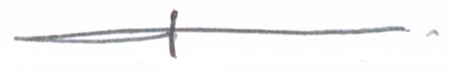
Qualification of person responsible for signing off this application | Architect
Company | Moss Co LLP
On behalf of (Client’s details) | Mr Edward Chantler
Date | 21.11.20

