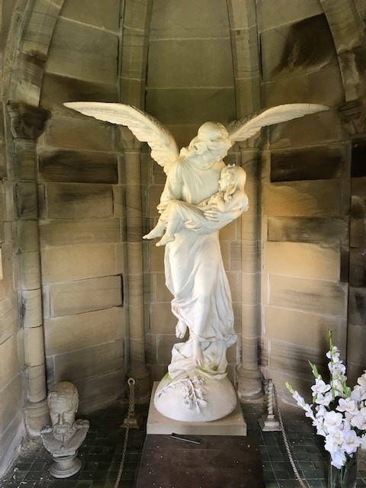
Marble Memorial – within the Trevor Mausoleum set in the churchyard of St Marys Church, Chirk
