PROPOSED ALTERATIONS AT
KNOLTON HALL

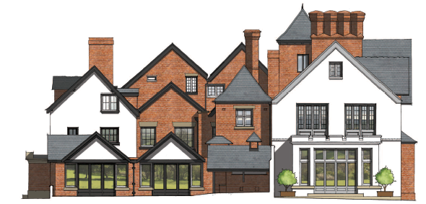
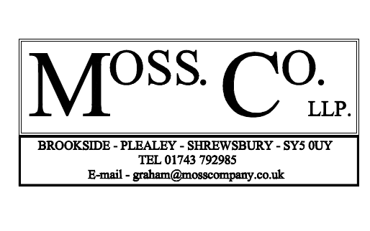
HERITAGE STATEMENT

PROPOSED ALTERATIONS AT
KNOLTON HALL
HERITAGE STATEMENT

SECTION 1
- Introduction And Background

SECTION 2
- Historical Impact Assessment

SECTION 3
- Design Concept And Proposals
- Materials

SECTION 4
- Method Of Construction

SECTION 5
- National And Local Planning Policies

SECTION 6
- Conclusions

SECTION 7
- References

SECTION 1

Introduction & Background

This Heritage and Planning Statement has been prepared by Moss Co LLP on behalf of Mr and Mrs Edward Chantler in support of a listed building application for internal alterations at Knolton Hall, Oswestry Road, Overton WREXHAM Powys LL13 0LG.

Knolton Hall is a grade II* listed building.

The current owner and applicants purchased the property in 2016 with a view to restore the property and reside there as their family home.

A full and listed building application for the alterations and a single storey extension at Knolton Hall, Oswestry Road, Overton WREXHAM Powys LL13 0LG, reference numbers : P2017 0691 and 0692 was granted on 2nd November 2017. This application makes minor internal changes to the approved application.
In addition to this Planning Design and Access Statement, the application is supported by the following information:

- Existing Location Plan
- Proposed Site Plan
- Approved Plans and Elevations
- Proposed Plans and Elevations

LOCATION
Knolton Hall, Oswestry Road, Overton WREXHAM Powys LL13 0LG

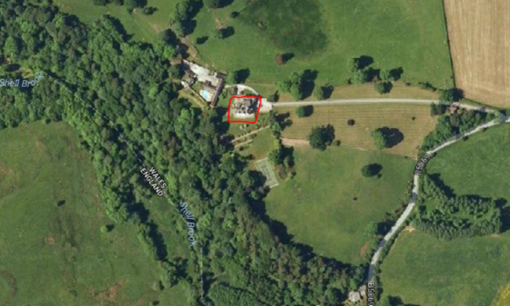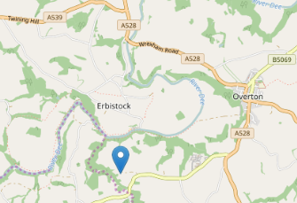
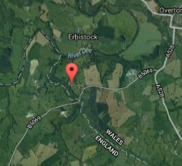
The application site lies close to the Wales/England border.
SECTION 2

HERITAGE IMPACT ASSESSMENT

The purpose of this Heritage Impact Assessment is to consider the proposals against the policy context outlined below and is not concerned with any other planning issues. It investigates the potential impact of the proposals on the nearby listed buildings following the criteria/definitions set out below.

Significance
Current national policy guidance relating to the protection and enhancement of the Historic Environment is contained within the National Planning Policy Framework. (NPPF). The purpose of this assessment is to

“…describe the significance of any heritage assets affected, including any contribution made by their setting. The level of detail should be proportionate to the assets’ importance and no more than is sufficient to understand the potential impact of the proposal on their significance. The NPPF, as a general rule, “recommends approval of development unless any adverse impacts of doing so would significantly and demonstrably outweigh the benefits”.

Significance is defined within the glossary to the NPPF, Annex 2: Glossary, National Planning Policy Framework, Department of Communities and Local Government, 2012 as:

“The value of a heritage asset to this and future generations because of its heritage interest. That interest may be archaeological, architectural, artistic or historic. Significance derives not only from a heritage asset's physical presence, but also from its setting."

LISTED BUILDING STATUS
Entry Name: Knolton Hall
Location: On the western edge of the Community, approached by a drive which leaves the main road at the top of Barton’s Bank.
County: Wrexham
Community: Overton
Locality: Knolton
Traditional County: Flintshire
Lieutenancy Area (Ceremonial County): Shropshire
Listing Date: 16 November 1962
Last Amended: 15 March 1994
Grade: II* Source: Cadw Building Class: Domestic Source ID: 1691

The origins of the present house are in a house of c1600, which has been successively extended and remodelled, principally in the C18, apparently in 2 distinct phases, and then, c1857-68 by John Cunningham of Liverpool, for Mr R C Cotton of the Combermere family.

Exterior
The earliest form of the building is apparent in the layout of the entrance front, which comprises a central hall range flanked by 2 advanced gabled wings, both of which have lateral stacks. Left-hand wing is partially timber framed, the framing surviving in the gable end and in part of the return wall to the garden front: small panels with cusped quatrefoils. The rest of the building is painted brick, with heavy slate roofs throughout. In the C19 remodelling, the front gables at least were painted with mock framing which has since disappeared. Fenestration of left hand wing entirely of the C19, with carved mullioned and transomed windows, some with decorative leading. Towards the rear of this wing, a pavilion roofed tower is a C19 addition over the staircase. The entrance hall is itself gabled, and was probably raised in height with the addition of its gabled upper storey during the C19 remodelling: the upper storey is jetted in brick. Central doorway in porch flanked by C19 carved wood mullioned and transomed windows of 2-lights. 6-light mullioned window above the doorway is also a C19 insertion, and there is a 4-light mullioned window in similar style in the attic, which has carved wood entablature bearing an inscription ‘every house is builded by some man but he that built all things is God’. Right hand gable is also almost certainly part of the original layout of the house, although the external structure appears to be no earlier than the C18. Upper windows have the carved mullions that characterise the C19 work, but there is possibly one original opening surviving to the ground floor. This wing is partially wrapped round by a later wing which seems to be mid C18: fenestration belongs to the C19 remodelling, but brickwork, which includes part bands in the return elevation, is C18. It appears to have been extended by a single bay to the rear, probably during the major C19 remodelling. Ornately panelled bargeboards throughout, all added in the C19.

Garden front: The garden front is entirely a mid C19 addition to the house, and may itself have been extended by one bay to the right (E). It comprises a 2-storeyed, 3 window range, with 2 gables over left hand windows, and a steeper gable over the narrower right hand bay, which seems to be of the newer brickwork. 4-light mullioned and transomed rectangular bay window in centre, with similar window to left; 3-light mullioned and transomed window to left above, and 2-light sashes above the bay window, and in the right hand bay. Axial stack.
Rear elevation: Gables over hall range and cross wing, with subsidiary gables of less height built against them, representing an extension of the original plan in the C19. N gables is an extension of the C18 wing, probably late C18 or early C19, and pre-dating the major C19 remodelling. Wide return gable of C19 wing to right, itself extended along its rear elevation in the early C20.

Interior
Plan comprises entrance hall with flanking wings and staircase; corridor running to rear of hall added in C19, connecting the C19 garden front wing with the back stairs (at rear of N cross wing of hall) and C18 wing to N. Entrance hall was opened out through 2 storeys in the C19 remodelling: gallery runs along E wall: with C18 ornate cast iron rail, said to have come from Overton church. Dado panelling may partly pre-date the remodelling (perhaps C17) and can be clearly distinguished from the C19 pine panelling which forms architraves to doorways; and which frames the stairs which foliate fretwork; pine panelled pediment overmantle is dated 1868, with initials ‘CMARC’ on scrollwork.
Staircase opens off the hall towards the rear left (S): early C18, with turned balusters, 3 per tread, carved tread ends, fluted newel and swept rail. Dado panelling made from smooth planks of timber. Decorative plasterwork over doorway to S room has dado panelling similar in style to that in the hall; simpler moulded full-height panelling, C17 in style but almost certainly late C19 in date, in N room which has plaster moulding to beams which panel the ceiling, and a corner fireplace. The room formerly extended further towards the rear of the house, where small service rooms have been created. ‘Cromwell Road’ in C18 N wing also appears to have been remodelled in the C19: graining over oak dado panelling, and ornate carved surround to corner fireplace. Upper rooms in this wing have chamfered ceiling beams and bolection moulded fireplaces, one of which retains a rectangular hob-grate of the late C18. Double ogee grate also survives in first floor of N cross wing of hall.

Reasons for Listing
Listed at II* as a substantial, complex country house with some external and internal parts of considerable quality.

Source: British Listing
- Knolton Hall is a wonderful, if eccentric layout of a building. A full and listed building application for alterations and a single storey extension has been previously granted in November 2017 (reference numbers: P2017 0691 and 0692). This application seeks to make minor alterations, some of which are a reversion to the original layout, thereby retaining more of the original fabric.
Setting
Setting is clearly defined within the NPPF Annex 2: Glossary, National Planning Policy Framework, Department for Communities and Local Government, March 2012, as

"The surroundings in which a heritage asset is experienced. Its extent is not fixed and may change as the asset and its surroundings evolve. Elements of a setting may make a positive or negative contribution to the significance of the asset, may affect the ability to appreciate that significance or may be neutral."

Historic England guidance https://historicengland.org.uk/advice/hpg/has/setting/ adds to the understanding of setting by stating the following:

“The setting itself is not designated. Every heritage asset, whether designated or not has a setting. Its importance, and therefore the degree of protection it is offered in planning decisions, depends entirely on the contribution it makes to the significance of the heritage asset or its appreciation.”

- The setting is in open countryside, some distance from a public road. The proposals would not have a greater impact on the green belt.

- There are no neighbours on either side and therefore no loss of amenity or sense of overshadowing or overlooking caused by the proposals

- It is considered that the proposals will not result in a significant visual impact on the setting or character of the heritage asset.
Harm
The NPPF effectively identifies two distinct levels of harm that may be caused to heritage assets, substantial and less than substantial. These are not explicitly defined, but the application of each term may be inferred by paragraphs 133 and 134 of the NPPF.

“Substantial harm is considered to be serious to the significance of the heritage asset, e.g. the total or partial loss of a designated heritage asset.

Less than substantial harm is not as onerous and more varied in scope, but still a material consideration in assessing planning applications.”

- It is considered that the internal proposals will not result in any significant visual impact on the setting, character or significance of the surroundings or listed building.

- The proposals are sympathetic and the alterations are internal and not considered to result in an adverse impact upon appearance of the heritage asset.

- The proposals will further improve the character, functionality and future life of Knolton Hall, by creating a suitable and appropriate function, within the fabric of the original structure. The footprint remains as approved.

- The works will be carried out sensitively using appropriate construction techniques and materials sympathetic to the structure and fabric of the building.

- All existing features of architectural and historic interest are intended to be retained in-situ and fully protected during the approved works.

- The proposals will not affect or increase pressure on the existing natural features, tranquillity or noise to the surrounding area.

- Several of the modified proposed retain more of the original fabric than was previously approved.

Mitigation
All existing features of architectural and historic interest (e.g. windows, doors,
ornamental plaster, joinery, staircases) shall be retained in-situ and fully
protected during the approved works.

Conclusion
For the reasons outlined above, it is considered that the proposal will have little or no impact on the character, significance and setting of the designated heritage asset.

The proposals are largely internal and will not result in harm, as defined by the NPPF to the setting, significance or character of the Knolton Hall.

SECTION 3

PLANNING STATEMENT

USE
The existing and proposed use is for domestic use only.
The proposals will provide for better modern family living.

Design Principles and Concept

A full and listed building application for the alterations and a single storey extension at Knolton Hall, Oswestry Road, Overton WREXHAM Powys LL13 0LG, reference numbers : P2017 0691 and 0692 was granted on 2nd November 2017 and this application seeks to make further revisions.
Proposals
- Internal alterations, largely formation or closing of openings
- Formation of a single window on the east elevation, to match those adjacent
There are no neighbours on either side and therefore no loss of amenity or sense of overshadowing or overlooking caused by the proposals.

AMOUNT
The existing house is on 3 floors.

There are no extensions intended in this application.

Approved and proposed floor areas
- Ground Floor Plan – 440m$²$
- First Floor Plan – 344m²
- Second Floor Plan – 153m²
- TOTAL – 937m²
Site Area – 7892m²

SCALE
No extensions are proposed. The scale remains that as approved.

Appearance
There are no changes to the approved north, south and west elevations.
The below proposal to the east elevation is to be omitted.
East elevation
It is proposed to form a single window opening, on the ground floor in the parlour, to match those adjacent. However with the existing hedging this is unseen from the main approach.

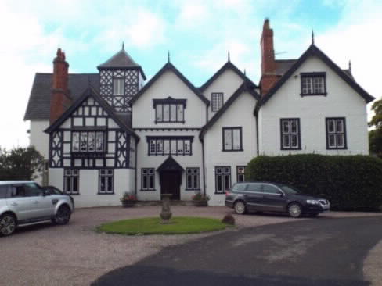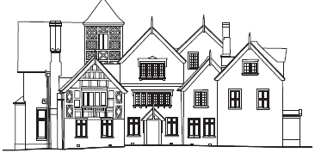
Existing east elevation Approved east elevation (showing porch hidden by landscaping)

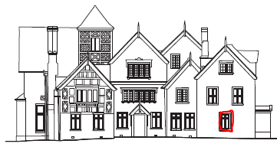
Formation of new single opening in the parlour

Proposed east elevation

LAYOUT
GROUND FLOOR

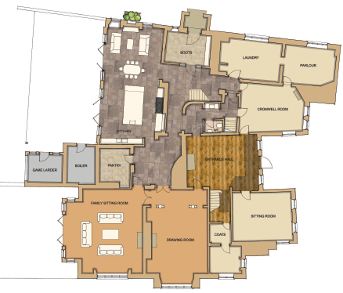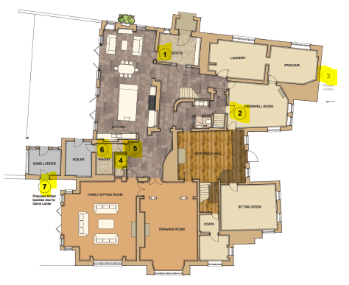

Approved ground floor plan Proposed ground floor plan
annotated with changes

ALTERATIONS OVER THE PREVIOUSLY APPROVED PLANS

Ground floor
1. Form an opening on the west side of the proposed boot room. This wall is constructed of brick and dates to the mid C19th. The opening is to be formed where the jamb of the existing C20th porch intercepts and so the original work has already been altered in this vicinity. The door opening is proposed to provide a more direct access to the new kitchen. Drawings correct

2. Opening into the Cromwell Room is to have the existing door fixed in the closed position.

3. A new window opening is proposed to the east elevation. The window type is to match those used above and the opening will be formed to clear the chimney breast. Aesthetically the proposed window will form a balance with those on the opposite cross wing. The parlour is currently north lit and the proposed window will improve the quality of light in the room and allow a view of the drive. The wall is constructed of brickwork and is of mid C18th date. The opening will be carefully dressed, using the existing bricks to match the other similar openings in every detail. Omitted

4. A studwork partition is proposed to be formed within the pantry to allow for a bottle store, separate to the pantry. As it is in studwork this would be reversible.

5. The existing door opening to the pantry is proposed to be made wider to allow for three doors, giving access to the pantry and bottle store. The wall is constructed of brickwork and dates to mid C19th.

6. A doorway is proposed to allow internal access to the boiler house. The wall is constructed of brick and dates to the mid C 19th.

7. An external door on the south side of the game larder is proposed so that this space may be used in conjunction with the terrace, for storage of outdoor furniture etc in conjunction with the terrace. The wall is of brickwork constructed in the mid C19th. A simple boarded and ledged door will be used to suit the status of the outbuilding.

First floor

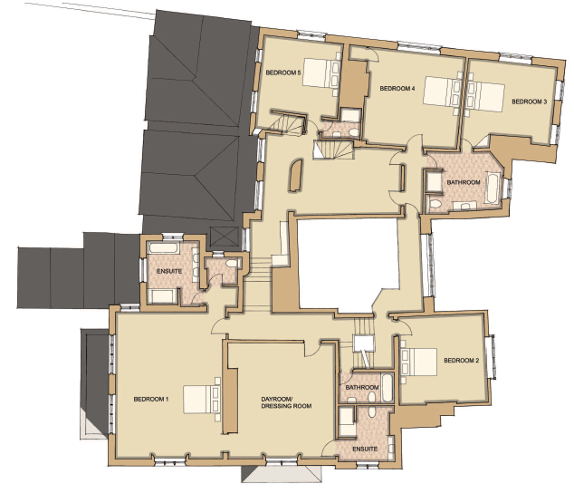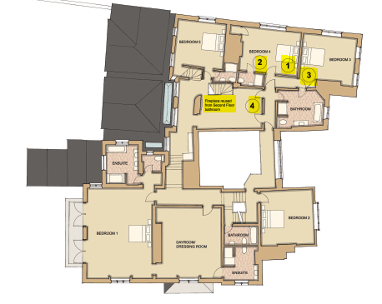

Approved first floor plan Proposed first floor plan
annotated with changes

1. The south wall of bedroom 4 was approved to be removed and is now to be retained.

2. A new door opening is proposed in the partition described above and an ensuite bathroom created in the space. The drainage and water supply for this will come from the approved ensuite adjacent.

3. The existing door to bedroom 3 which was removed on the previously approved plan is now to be retained.

4. A new inserted cupboard previously approved is now to be discarded.

5. Fireplace relocated from second floor bathroom

Second floor

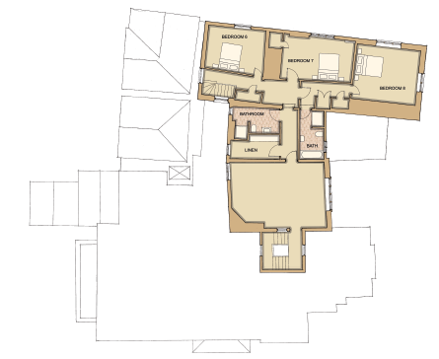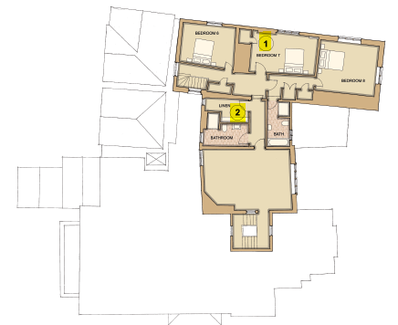

Approved second floor plan Proposed second floor plan
annotated with changes

1. The storage access between bedrooms is proposed to be altered with the access now serving bedroom 6 rather than bedroom 7. The existing door in bedroom 7 will be retained but fixed closed and a new opening formed in bedroom 6. The wall is constructed of brickwork and dates to the construction of this wing in the mid C18th. The opening is to be a small a possible to allow for occasional access only. The original opening is to remain into bedroom 7

2. The roles of bathroom and linen room as previously approved are to be reversed with the bathroom now to the north. This allow for more convenient drainage and the bathroom is to take advantage of the larger window.

ACCESS
There are no changes to the access from that approved on consents P2017 069 and 0692.

LANDSCAPING
There are no changes to landscape from that approved on consents P2017 069 and 0692.

ENVIRONMENTAL
The proposals will be built to meet current energy and thermal efficiency standards required by Building Regulations.

Where possible materials required for the construction will be from local, sustainable and renewable sources.

There is no work to the roof intended. We do not believe that the works will require an ecology report as there is no loss of habitat of significant value and without the loss of favourable conservation status of any protected species.

Access for emergency vehicles to the site remains as approved on consents P2017 069 and 0692.

There are no public footpaths within the development site.

DRAINAGE
The scheme has been designed to connect to the existing drainage system thereby causing little or no loss of fabric to accommodate the proposals.

The creation of an ensuite for Bedroom 4 will connect to the adjoining bathroom.

There is no change to the approved surface water run-off.

FLOOD RISK
The site is not located in an area designated as a Flood Zone and thus at negligible risk from flooding, as confirmed by the Environment Agency flood maps.

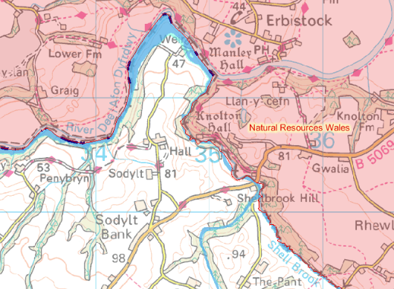
Source: Environment Agency

COMMUNITY
The layout of the site remains as existing. There are no public areas, car parks or footpaths that cross the site.

MOVEMENT TO, FROM & WITHIN THE DEVELOPMENT
The parking facilities on the site remain as existing, having a very large open area which allows for parking and turning of delivery vehicles.

The drive is existing and is privately owned.

PLANNING HISTORY
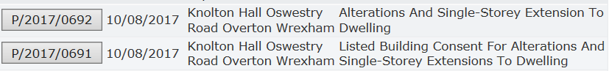
Source: Wrexham planning access
The Site & Its Surroundings
Standing in an elevated position with glorious far-reaching views, Knolton Hall is surrounded by beautiful unspoilt countryside on the Shropshire/Welsh Border, close to the Cheshire Border. Situated to the edge of a small rural hamlet, the house is close to good amenities in the nearby village of Overton-on-Dee and the town of Ellesmere. In an area known as the Wynnstay country, it is noted for its superb riding opportunities and close proximity to a number of equestrian venues.

CONSULTATION
There are no neighbours on either side and therefore no loss of amenity or sense of overshadowing or overlooking is caused by the proposals.

JUSTIFICATION FOR THE WORKS
The works will be carried out sympathetically using appropriate construction techniques and materials sympathetic to the structure and fabric of the building.

All existing features of architectural and historic interest (e.g. windows, doors,
ornamental plaster, joinery, staircases, fireplaces) shall be retained in-situ and fully
protected during the approved works.

Partitions will be constructed from studwork and plasterboard and the work is reversible.

SECTION 4

CONSTRUCTION METHOD STATEMENT

Introduction
This statement considers the issues surrounding the development during the construction works to ensure that neighbouring properties, residents and local amenities as well as the general public are not adversely affected by the construction works and site operations that may be taking place.

Some of the issues and suitable solutions to ensure the well-being, safety and to protect the people named above are as follows:

- Site traffic and deliveries including parking of vehicles for visitors and site operatives
- Storage of plant and materials used in constructing the development
- Material use, waste and recycling
- Impact to neighbours

Site Traffic and Deliveries
Construction works will take place between 7.30am and 6pm Monday to Friday and 8am and 1pm on Saturday, unless otherwise agreed. No construction work on Sunday or Bank Holidays.

All deliveries shall take place in the dedicated location as agreed on site. To prevent traffic back log on the road deliveries shall be arranged to be at suitable times when least impact will be caused to neighbouring residents.

Site traffic will due to the nature of the site be within the development boundaries and therefore have little risk to the general public.

Storage of plant and materials
Materials shall be stored in the designated area as agreed on site.

Material use, waste and recycling
All materials used in the construction shall be sources as environmentally friendly and
economically as possible i.e. from the local area.

All waste shall be sorted into the appropriate skips for either preferably re-use, recycling or as a last resort disposal.

Hazardous wastes shall be dealt with by an appropriately qualified and competent person as shall be disposed of in the correct manor at a registered disposal plant for the particular waste; receipts of disposal shall be kept in the site office as proof of the correct disposal.

Impact to neighbours
There are no neighbours on either side and therefore no loss of amenity or likely disturbance.
SECTION 5

PLANNING POLICY

NATIONAL PLANNING POLICY
The National Planning Policy Framework (NPPF) seeks to promote economic, social and environmental development which contributes to building a vibrant and healthy community. Paragraph 7 states there are three dimensions to sustainable development that give rise to the need for planning system to perform a number of roles:

an economic role – contributing to building a strong, responsive and
competitive economy, by ensuring that sufficient land of the right type is
available in the right places and at the right time to support growth and
innovation; and by identifying and coordinating development
requirements, including the provision of infrastructure;

a social role – supporting strong, vibrant and healthy communities, by
providing the supply of housing required to meet the needs of present and
future generations; and by creating a high quality built environment, with
accessible local services that reflect the community’s needs and support its
health, social and cultural well-being; and

an environmental role – contributing to protecting and enhancing our
natural, built and historic environment; and, as part of this, helping to
improve biodiversity, use natural resources prudently, minimise waste and
pollution.

Following the NPPF guidelines pursuing sustainable development involves seeking positive improvement in the quality of the build, natural and historic environment.

Central Government Guidance:
National Planning Policy Framework
National Planning Practice Guidance

We believe the proposals are in line with the NPPF namely but not limited to the following:-
Paragraph 9. Pursuing sustainable development involves seeking positive improvements in the quality of the built, natural and historic environment, as well as in people’s quality of life, including (but not limited to):
- making it easier for jobs to be created in cities, towns and villages.
- replacing with better design in regard to the current incumbents.
- improving the conditions in which people live, work, travel and take leisure.
- widening the choice of high quality homes.
- The proposals will provide employment during the construction.
- The proposal does not result in a change to the appearance to the main dwelling.
Paragraph 14. At the heart of the National Planning Policy Framework is a presumption in favour of sustainable development, which should be seen as a golden thread running through both plan-making and decision-taking.

For plan-making this means that:
- local planning authorities should positively seek opportunities to meet the development needs of their area
- Local Plans should meet objectively assessed needs, with sufficient flexibility to adapt to rapid change, unless:
- any adverse impacts of doing so would significantly and demonstrably outweigh the benefits, when assessed against the policies in this Framework taken as a whole
- specific policies in this Framework indicate development should be restricted

For decision-taking this means:
- approving development proposals that accord with the development plan without delay and
- where the development plan is absent, silent or relevant policies are out-of-date, granting permission unless:
- any adverse impacts of doing so would significantly and demonstrably outweigh the benefits, when assessed against the policies in this Framework taken as a whole or
- specific policies in this Framework indicate development should be restricted

We ask that the LPA take a positive presumption in favour of this sustainable development. The impact of the proposals would NOT significantly outweigh the benefits.

Paragraph 17 Core planning principles we seek to propose:
- The proposal will conserve the heritage asset in an appropriate manner so that the building can be enjoyed for their contribution to the quality of life of this and future generations.
- The proposals represent an opportunity to make a positive contribution to local employment.
- The proposal does not result in a change to the visible appearance to the main dwelling.
- Adequate utility services exist and would not cause an adverse effect on the surrounding environment.
- Important trees, brick walls and other local features that contribute significantly to the quality and character of the local environment will be safeguarded and where practicable enhanced.
- The property has been in constant use and therefore there is no loss of habitat of significant value or loss of favourable conservation status of any protected species or biodiversity.

Section 7 - Requiring a good design
Paragraph 58 - 65 .We believe the proposals
- Will function well and add to the overall quality of the area, not just for the short term, but over the lifetime of the development.
- Continues to establish a strong sense of place on the streetscape to create an attractive and comfortable place to live and visit.
- Responds with and to the local character and history of the site, and reflects the identity of the local surroundings and materials, while not preventing or discouraging appropriate innovation.
- Remains a safe and accessible environment where crime and disorder, and the fear of crime, do not undermine quality of life.
- Remains visually attractive as a result of good architecture and appropriate landscaping.
- Promotes innovation to keep the building useful to a modern family, by making minor internal changes to accommodate today’s lifestyle.

Section 11 - Conserving and enhancing the natural environment
We believe the proposals will comply with the policies above
- The application site is not protected by or adjacent to any ecological or landscape designations, and will not have any detrimental impact of any protected species.

Section 12 – Conserving and enhancing the historic environment
Paragraphs 126, 131
- The development will maintain the importance of the heritage asset.
- The Heritage Impact Assessment outlines in detail the impact of the designated assets.

We believe that the proposal will satisfy each of the above roles.

LOCAL POLICIES
Following the guidelines of Chester and Cheshire West Local Plan key policies the scheme considered the following:

Environmental
2 Vision
Development will reflect the character of local areas, conserving, managing and enhancing the valuable natural and historical environments, resources and assets.

Strategic Objectives
SO6 | Promote mixed and balanced communities through the provision of a range of housing to meet market, affordable and specialist housing needs.
Environmental
SO9 Supports sustainable development by use of suitably located previously developed land and buildings.
SO10 Protects the environment quality and character of the Cheshire countryside.
S011 The proposals do not have an unacceptable impact on the amenity or health of residents.
SO12 The proposals are sustainable and the quality design respects the local distinctiveness and the character and appearance of the landscape.

The proposals are largely internal, the exception of the formation of one ground floor window on the east elevation, hidden from view by an existing mature hedge. The design, layout, size, scale, mass and materials of the scheme have been carefully studied and we consider the proposal complements and enhances the character of the existing and approved building.

The application site is not protected by or adjacent to any formal historical, ecological and landscape designations. The site is within the domestic curtilage and the proposals will not have any detrimental impact to the character of the area or neighbours.

STRAT 10 Transport and Accessibility
- The proposals will not affect the safe access from the existing site. The access to the site is existing and the internal proposals will have no adverse impact upon adjacent land uses, nor will it adversely affect the safety of highway users.

ENV1 Flood Risk and Management
- The development is located within a low risk area of flooding as described above in “Flood Risk”. The build will not create an increased risk elsewhere.

ENV 3 Green Infrastructure
- Knolton Hall remains within an area of individual and groups of trees, making a significant contribution to both the built and rural environment, these both ameliorating any adverse environmental and climatic effects and provides important habitats for wildlife.

- There is no intention to change the important trees, hedgerows, stone walls, open spaces and other local features that contribute significantly to the quality and character of the local environment and shall be safeguarded.

ENV 4 Biodiversity and Geodiversity
The proposals
- Will not result in any loss of natural assets or impact on priority habitats and protected species.
- The site is not within any international, national or local designated are of importance.

The application site is not protected by or adjacent to any formal historical, ecological and landscape designations. The proposals will not have any detrimental impact to the character of the area or neighbours.

ENV5 Historic Environment
- The application site is not protected by or adjacent to any formal historical, ecological and landscape designations. The site is within the domestic curtilage and the proposals will not have any detrimental impact to the character of the area or neighbours.

We believe we have respected and considered the following needs under the NPPF and Chester and Cheshire West guidelines:

- Used a balanced judgement with regard to scale of any harm, or loss and significance of the heritage asset.
- The desirability of sustaining and enhancing the existing building and its existing and future viability and use.
- The proposal does not change the positive contribution that Knolton Hall adds to the local character and distinctiveness.

SECTION 6
CONCLUSIONS

Careful attention has been given to the layout detailed design of the internal proposals in order to demonstrate that the proposals are acceptable and can reasonably be approved having regard to National planning policy and also the relevant policies of the Development Plan.

It is essential that a reasonable standard of privacy is offered to future residents of any proposals and to existing residents affected by such proposals.

The proposal will safeguard the amenities of nearby residents and will not have any adverse environmental or ecological implications.

To provide the accommodation required does little damage to the historical fabric.

We believe that the proposed development will lead to less than substantial harm to the significance of Knolton Hall.

SECTION 7
REFERENCES
National Policy
Department of Communities and Local Government
- National Planning Policy Framework
- National Planning Practice Guidance

Local Policy
- Chester and Cheshire West Local Plan key policies

www.Googlemaps.co.uk

www.Britishlistedbuildings.co.uk

http://planning.wrexham.gov.uk/Planning/lg/GFPlanningSearch.page

Flood-map-for-planning.service.gov.uk

