Heritage Impact Assessment

Spring House
Holyhead Road
Chirk
LL14 5NA2

Prepared for and on behalf of

Stevens Lucas Solicitors

12th October 2021

Prepared by:

J.N. Sumner MRICS

Bowen Son and Watson
Chartered Surveyors

Contents

Section Number | Section Heading
 | Executive Summary
1 | Description of property
2 | Construction of property Photographs
3 | External Area
4 | Description of Planning Application
5 | Proposed works to the property
6 | Photographs of the property
7 | Conservation Considerations
8 | Conservation Conclusion
9 | Floor Plans
10 | Site Plans

Executive Summary

- Description of property. | This assessment is an accompaniment to a planning application for change of use of Spring House, Holyhead Road, Chirk. The property has for many years been used as the offices of Stevens Lucas Solicitors. The partners of Stevens Lucas Solicitors upon retirement became absorbed by GHP Legal Solicitors. GHP Legal have over the Covid period centralised their resources and the building is no longer used and is currently empty. The owners wish to sell the property and prior to that are seeking change of use to residential.
- Construction of Property. | The property is believed to date from the mid-19th Century and was constructed together with a matching ‘mirror’ (semi-detached) property next door, which is now a dentist surgery. The properties are of traditional masonry construction with double-fronted architecture featuring matching twin full-height bay windows to the front elevations with a central entrance door. The roofs are of hipped slate construction having dark ridge tiles with extended eaves. There is a single shared brick chimney stack centrally between the properties. The windows are mainly timber sliding sash casements. Between the upper and lower windows of the bays there are tile-hung finishes. Between these there is a later canopy porch roof, which provides shelter above the front door.
- External Area. | The property occupies a slightly irregular-shaped plot. The plot is about level. To the front elevation there is a lawned garden having a central path to the front door. The front garden extends to 58.67 square meters. To the rear there is a hard-surfaced garden area, which extends behind the dentist surgery next door. The rear garden extends to 105.15 square meters.
- Description of Planning Application. | The current use of the property has ceased, and the building is now empty. Planning permission is now sought to return the property back to its original function- as a single residential dwelling-house. There are no external works required for this change of use to take place. There is no requirement or proposal to alter the layout of the building nor to remove any internal walls or partitions or have other structural alterations made -see proposed works below.
- Proposed works to the property. | Necessary works to be carried out to the property to make it habitable as a dwelling include providing new wiring and heating systems together with fittings for sanitaryware – cloakroom and bathrooms and the provision of new kitchen fittings. Much of the property as existing will however remain. Further works to meet building regulation compliance would be to provide better insulation at the property including double loft insulation. Externally and to the rear of the property provision can be made for the parking of two vehicles as well as leaving addition space for amenity.
- Photographs of the property

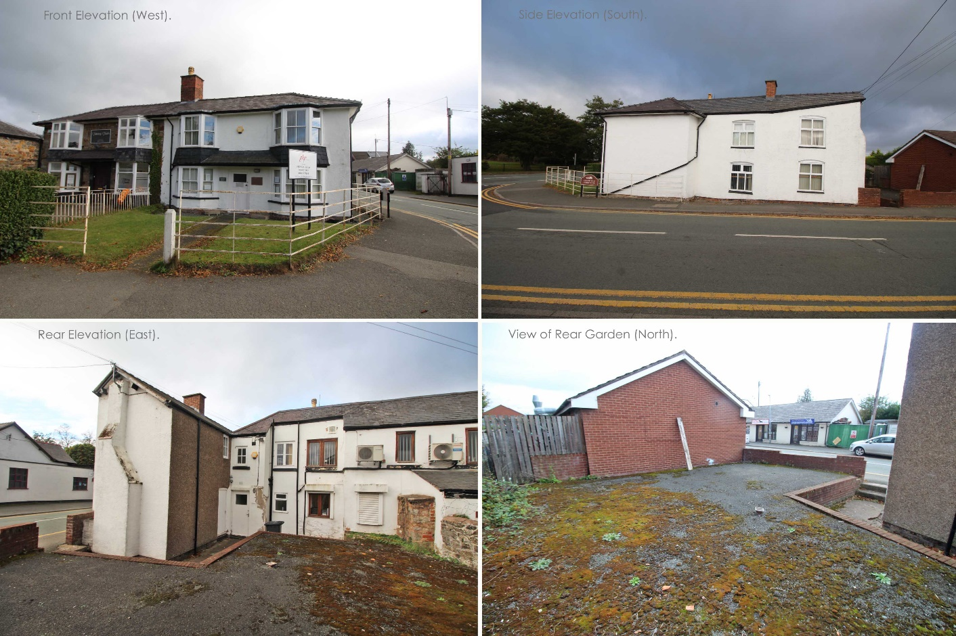
- Conservation Considerations.
The property falls within the demarcation zone of the Chirk Conservation Area. This area is understood to have been created under an “Article (4)2 Direction” and was designated on 23/07/2002. The Chirk Conservation Area plan map is attached as “Appendix A” hereunder. In addition to this, there is a Chirk Conservation Area Character Assessment and Management Plan, which has been adopted since October 2014. This document provides a list of Statutory Designated Heritage Assets that feature within the Conservation Area. The subject property “Spring House” does not feature as a specific entry on this list, although it is specifically mentioned as a building of the street scene.

Paragraph 4.30 describes the attributes of the buildings on Holyhead Road and paragraph 4.34 does specifically refer to the property and its mirror next door, albeit in a passing reference.

4.34 Talking Teeth Dentist Surgery and Stevens Lucas Solicitors are set between Stanton House and the junction with Colliery Road completing the row. The two buildings are likely to have early to mid 19th Century origins and originally comprised two cottages. Talking Teeth Dentist Surgery, formerly used as the Post Office, retains the original sandstone construction however the original pattern of fenestration to both properties has been obscured through the addition of two storey canted bay windows either side of the centrally positioned entrances. Windows to both properties are renewed in timber with sliding sash windows to Stevens Lucas Solicitors and mullion and transom windows to Talking Teeth. The two properties are enclosed behind iron railings with small front gardens softening their appearance.

- Conservation Conclusion.
It is recognised that the property is situated within the Conservation Area and as such any scheme of renovation for the building should be handled with appropriate sensitivity. The planning application for Change of Use does not however make any material requirement to alter the elevations of the property.

It is likely that a future purchaser of the property will wish to have the rear hard surfacing of the garden to be grubbed up and replaced with a softer garden, which is seen as an enhancement to the conservation area provisions.

The current owners do not wish to carry out the works of conversion or refurbishment to the property and intend to leave this element to a future prospective purchaser.

- Floorplans

Existing
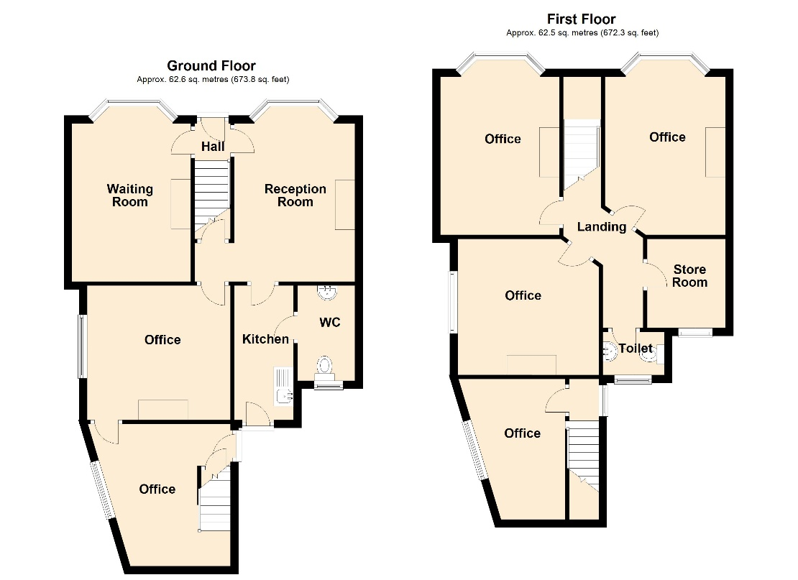

Proposed

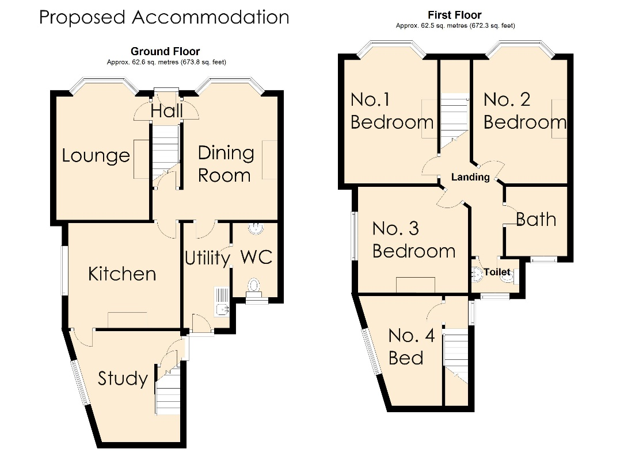

- Site Plan

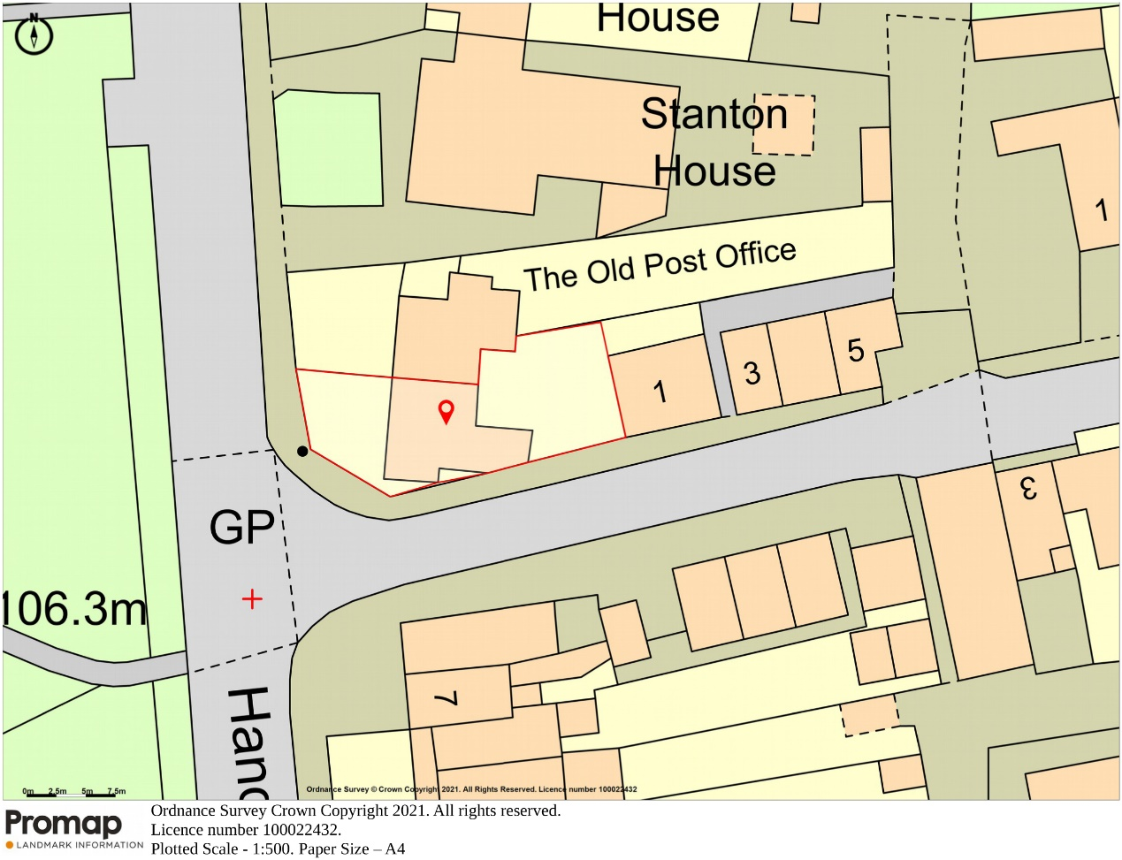

Date: 12th October 2021

James Nicholas Sumner MRICS Registered Valuer

Bowen Son and Watson
1 King Street
Wrexham
LL11 1HF

T. 01978 340000
E. james@bowensonandwatson.co.uk

