Mr David Williams
Planning Service Manager
Wrexham County Borough Council
Guildhall Wrexham
WREXHAM
LL11 1AY

Ref: Telephone Number: Date:
KB/DW/02/2021 01691 775320 10th August 2021

Subject: Planning Case Number. P/2017/0700 - Building Extension to Store MDF and Particle Board

Dear Mr Williams:

Please find below and attached our application to discharge the conditions related to the planning approval listed above:

Condition 3: Noise mitigation measures in the Noise Impact Assessment 30/05/2017 must
be implemented.

I can confirm that the noise mitigation measures detailed in the above noise impact assessment will be carried out.

Condition 4: Dust Management plan prior to construction to be submitted and approved.

Our proposed dust management plan is attached for your approval:

Dust Management Plan

Dust Management Plan KB (003) 2021.02.25 MT

Raw Board Warehouse Location Plan

7000_643

Condition 5: Samples of external facing and roofing submitted to local planning and
approved in writing.

We have included photographs of the following samples of external cladding:-
RAL 7038 Agate Grey (appendix 1)
RAL DESIGN 100 30 20 Olive Green (appendix 2)

Of these two options for the building cladding we are of the opinion that the Agate Grey sample is the appropriate and preferred option from our point of view.

A photograph of the roof facing sample is also included for your approval:

Appendix 3: Roof Facing Sample

Condition: 6, 7, 8, 9: Site investigation scheme to cover risks associated with
contamination of the site, previous uses etc. and remediation measures
required. Prior to commencement of work a verification report demonstrating
completion of all identified remedial actions.

To cover the conditions listed above please find attached Reports:

Specification for Ground Investigation

1620010941-RAM-XX-XX-SP-GE-0001 rev 02

Draft Contaminated Land Interpretive Report

RBS Contaminated Land Interpretive Report P03.pdf

Condition 10: Scheme for drainage, foul and surface water

See the enclosed Technical Advice from our consultant Ramboll which covers the proposed drainage design along with associated drawings:

Surface Water Drainage Technical Note

1620010941-RAM-XX-XX-TN-D-00001 Drainage Diversion

Drainage Details – Drawing (Sheet 1)

1620010941-RAM-XX-XX-DR-D-00400 (12428)
Drainage Details – Drawing (Sheet 2)

1620010941-RAM-XX-XX-DR-D-00401 (12429)

Drainage Details – Drawing (Sheet 3)

1620010941-RAM-XX-XX-DR-D-00402 (12430)

Proposed Drainage Realignment – General Arrangement

1620010941-RAM-XX-XX-DR-D-00100 (12427)

Condition 11: Piling or other penetrative methods shall not be permitted without written
consent from the local planning authority.

A piling study has been carried out related to this project which consisted of generating eight feasible pile layouts for:

- The support of the legs of the proposed structural racking system
- Building and rails for the fixed automated cranes operating between the racking.

For each pile layout option the design consultant also undertook the following:
a) Outline scheme design of supporting concrete ground beams and generation of related approximate reinforcement densities.
b) Outline scheme design of suspended concrete ground slab and generation of approximate reinforcement density.
c) Definition of indicative pile lengths required for each option for 3No CFA pile diameters.

All the proposed methods use a CFA (Continuous Flight Auger) piling method which is a none percussive method.

CFA piling involves drilling holes into the ground with a long continuous flight auger attached to a piling rig. An excavator works alongside the piling rig to remove displaced earth. Once the auger reaches the design depth, concrete if pumped through the centre of the auger as the auger is withdrawn. This fills the resultant void with concrete. Once the auger is fully withdrawn and the void is full of concrete, a steel reinforcing cage is pushed down into the wet concrete. When the concrete has set and cured the pile is now formed.

Once the pile is formed, any reduction in height at the top of the pile is achieved using a hydraulic cropping device, specifically designed for cutting down CFA piles with crushing rather than percussive force.

Each of the eight options have varying numbers of piles, ranging from 282 up to 448. Option 2 has the least number of piles at 282, this is not the most cost effective option due to the increased size of ground beams and subsequent quantity of rebar required within the ground beams. However the piling program is reduced and any risk associated with drilling into the ground is reduced. The CFA piling operation takes up a relatively large portion of the available space within the construction zone which can limit concurrent activities, hence the advantages of a reduced piling program.

Taking all factors into account we have decided that Option 2 is our preferred method.

We hope that the piling option we have chosen meets with your approval. Please confirm with written consent so that we can proceed with our preparations to use this method.

If you have any questions about our responses please do not hesitate to contact me.

Keith Baker
Safety Health and Environment Manager

Appendix 1: External Cladding Colour: RAL 7038 Agate Grey
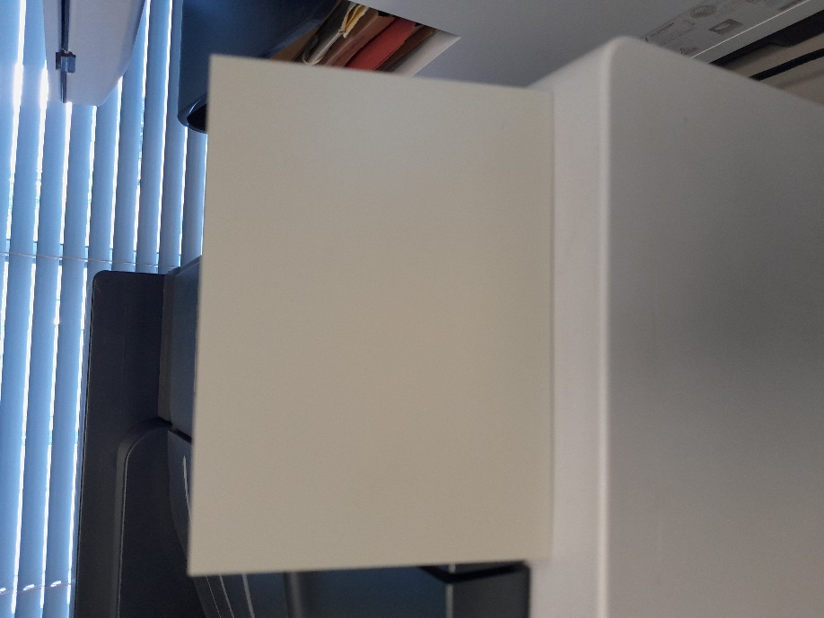

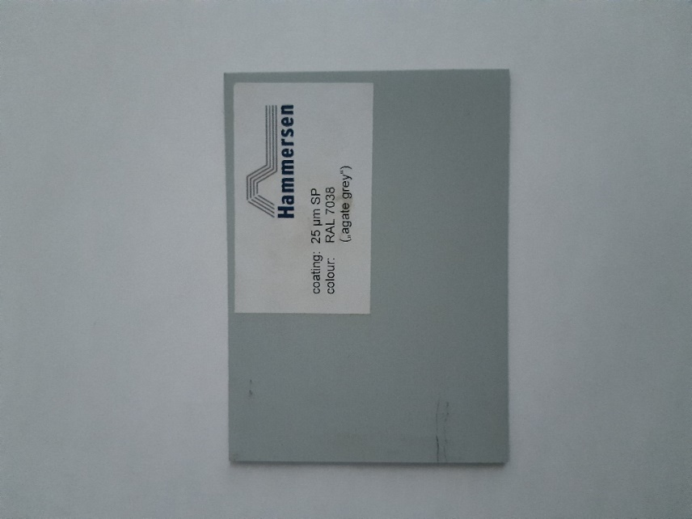

Appendix 2: RAL DESIGN 100 30 20 Olive Green
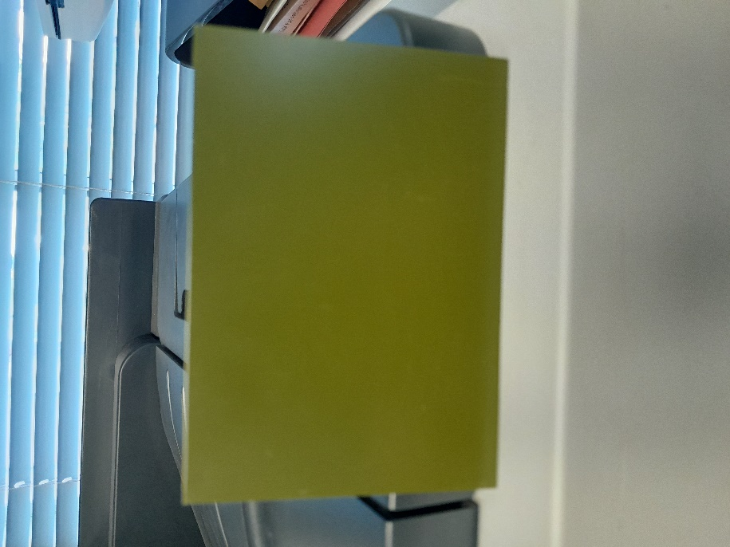

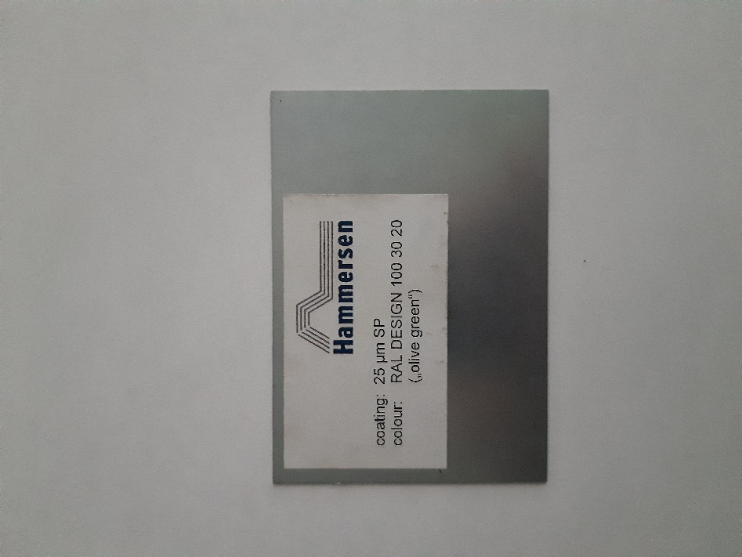

Appendix 3: Roof facing sample

