REF: 1411/BD/Val/Plots 1 to 4/mjs

Tim Edwards
Ty Derw
Oak Alyn Court
Cefn y Bedw
Wrexham LL12 9YT

3rd October 2018

Dear Tim,

RE: QUEENS ROAD, BRYMBO: VALIDATION PLOTS 1 to 4

The findings of our validation for Plots 1 to 4 are presented below, which you should pass onto Stacey Inglis at the Local Authority.

We understand that these plots have been changed from houses to Apartments, consequently, there will not be any gardens for the individual use of the residents. We also understand that there is to be no front garden, with parking and minor landscaping at the front.

The site visit to inspect Plots 1 to 4 was undertaken on the 27th September 2018, photographs taken during the visit are presented below.

Due to the landslip it has been necessary to support the land leading up to Queens Road, with the land being retained by a Timbercrete wall, see photograph below.

The space at the rear of the apartments is currently covered by a thin layer of imported quarry gravel used in the construction of the wall, and it is intended to bring this up to the slab level with further imported gravel.

Two hand dug trial pits were excavated in the formation to depths of around 400mm, both of which proved the formation to be in glacial till. This is in line with the findings of the site investigation, and not surprising given that the ground level has been lowered substantially in this area. The slope above the timbercrete wall is to covered in bark and landscaped.

We therefore consider that these plots do not present a risk to site end users.

We also understand that Stacey has some outstanding queries regarding the validation of previous plots. As far as we are aware, we have answered all of her queries, however, we would be pleased to address any outstanding matters.

We trust this is satisfactory, should you have any queries please call Mike Scott on 01244 661361.

Yours sincerely

M J Scott

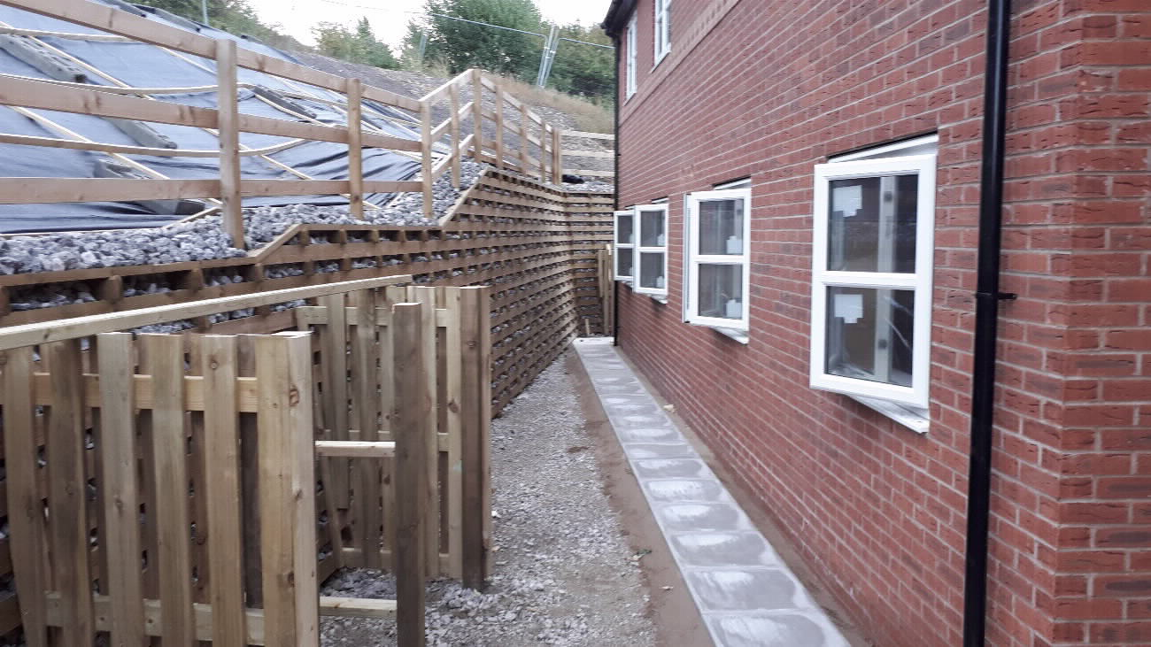
Plot 1 and 2
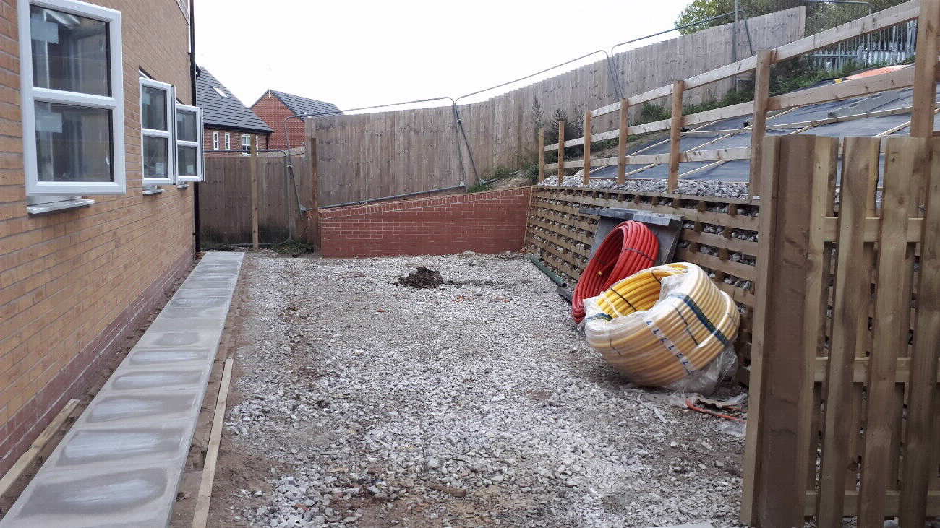
Plots 3 and 4

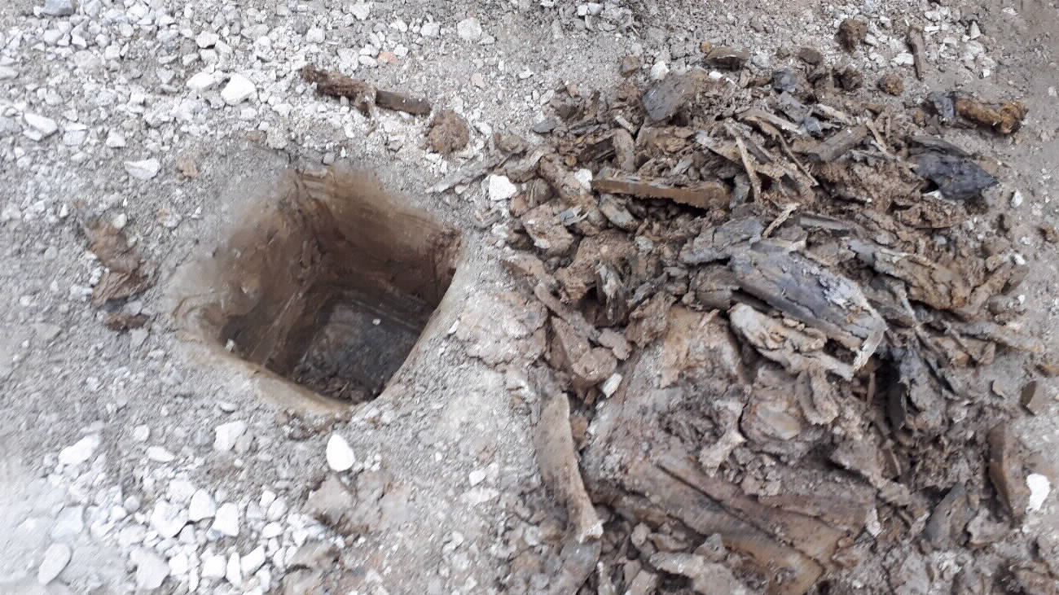
Hand dug trial pit 1 showing glacial till at surface

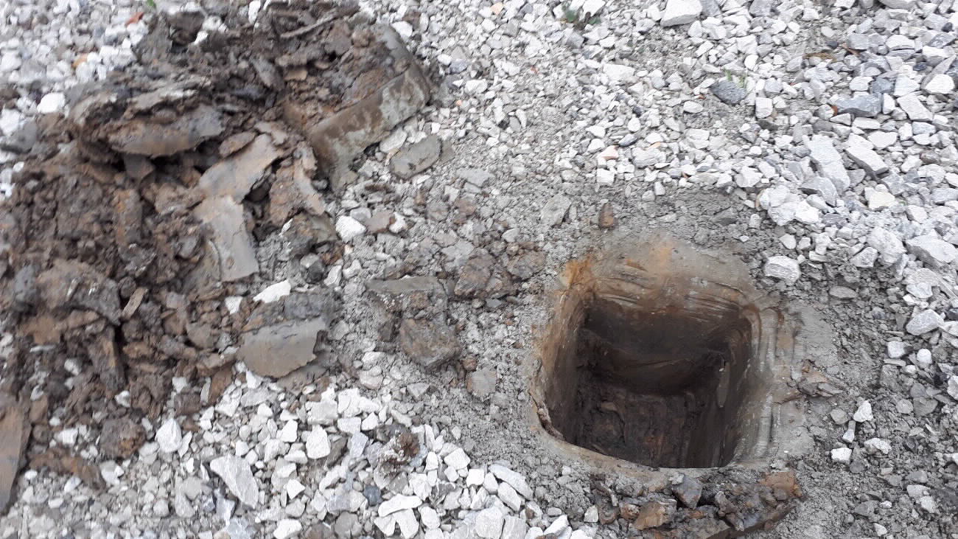
Hand dug trial pit 2 showing glacial till at surface
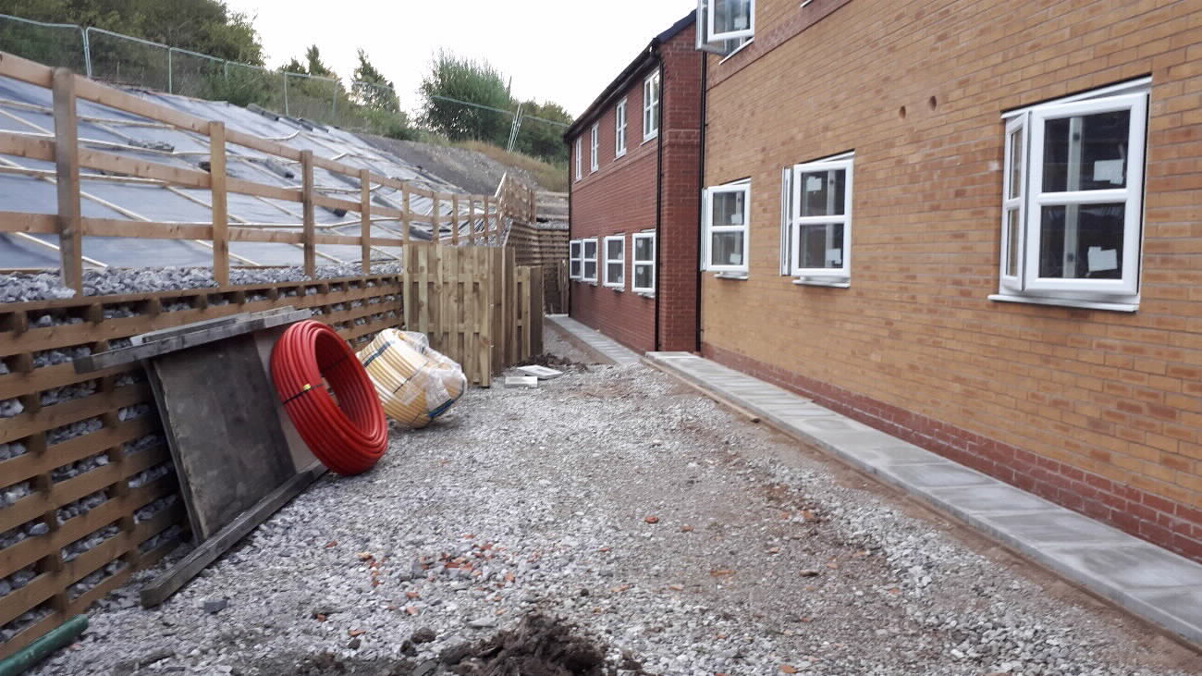
Photograph showing rear of Plots 1 to 4
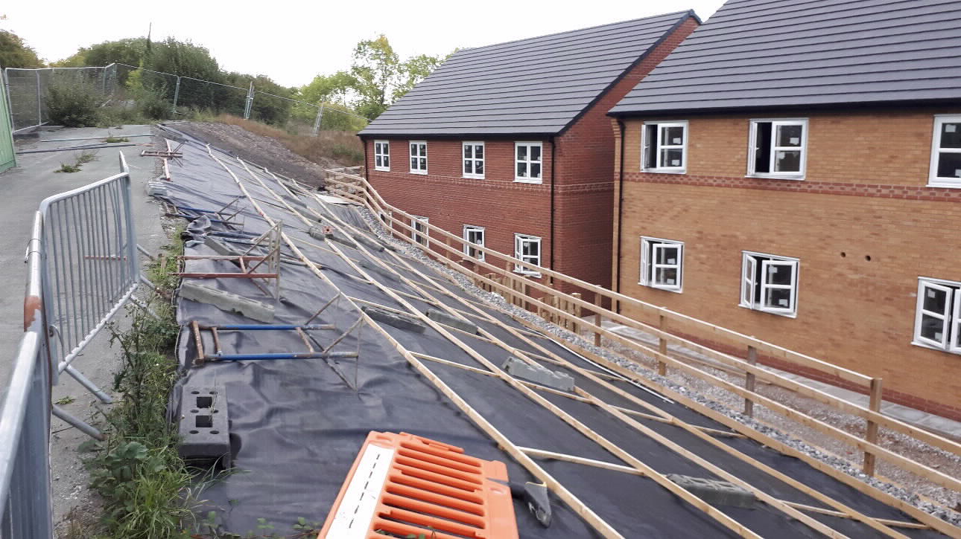
Site from Queens Road showing slope and Plots 1 to 4

