

CAR PARK MANAGEMENT PLAN
Plas Coch Lodge Proposal, Wrexham, LL11 2BW

Marstons Inns and Taverns currently own and operate the Plas Coch Pub/ Restaurant on Plas Coch Retail Park in Wrexham. This report has been prepared in support of the planning application for a new build lodge style hotel within the surplus land on the existing site.

The existing public house has 80 car parking spaces including 3 accessible spaces. The proposed lodge includes an additional 15 spaces 2 of which will be for accessible spaces. The site also has motors cycle spaces and cycle wracks.

The day to day management of the car park will be the responsibility of the pub manager who lives on site. There are no existing issues; abuse or fly parking at this public house which Marston’s have owned and operated for a number of years.

Fig 1. Existing Site Layout.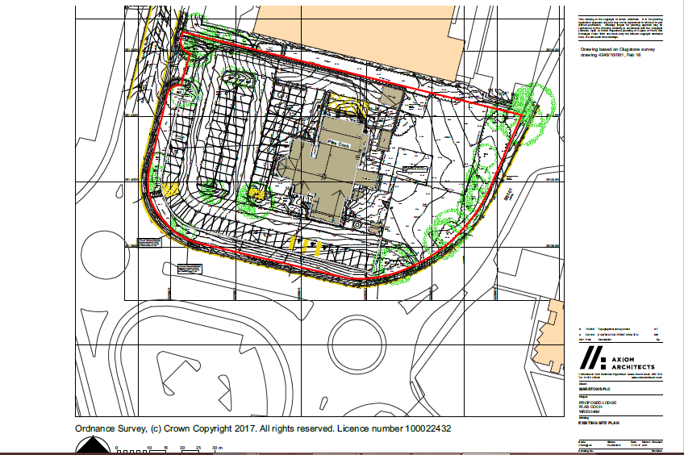

Fig 2 Aerial View of Existing Pub, Car Park in context of Wider Area.

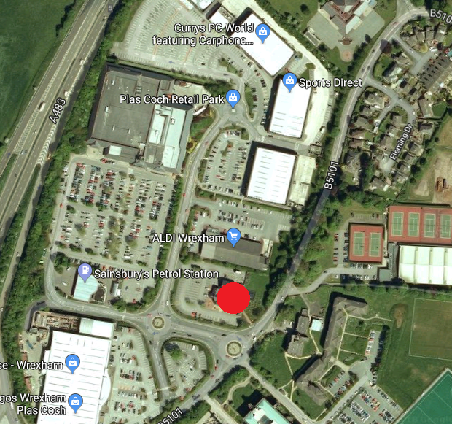

Fig 3 Proposed Site Layout

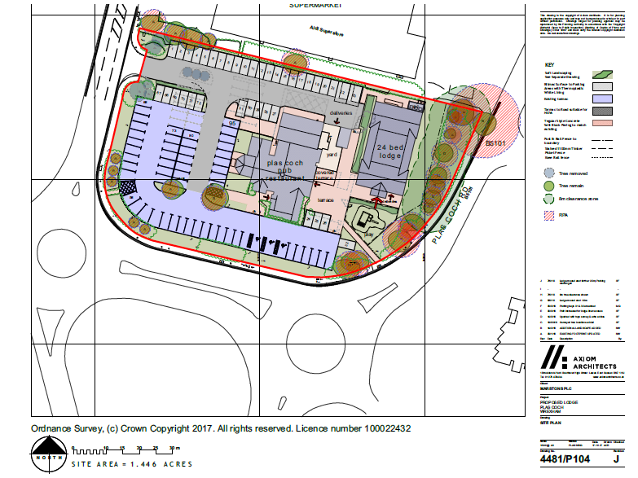

There is an existing gate at the site entrance which can be used (opened / closed) at the manager’s discretion should parking become an issue.

Whilst “fly parking” has never been an issue at this site we will have signs placed within the car park reminding visitors that its use is for pub and lodge customers only.

ANPR systems are to be avoided as they are difficult to manage and tend to upset genuine customers for whom free parking for the duration of their stay is key to our business model.

It is in Marston’s best interests for the pub and lodge car park to be available for use by genuine customers and as a PLC with c 1,600 in our estate we have the management experience to manage this car park so that it operates efficiently.

Fig 4 and Fig 5 showing Position of Existing Gate

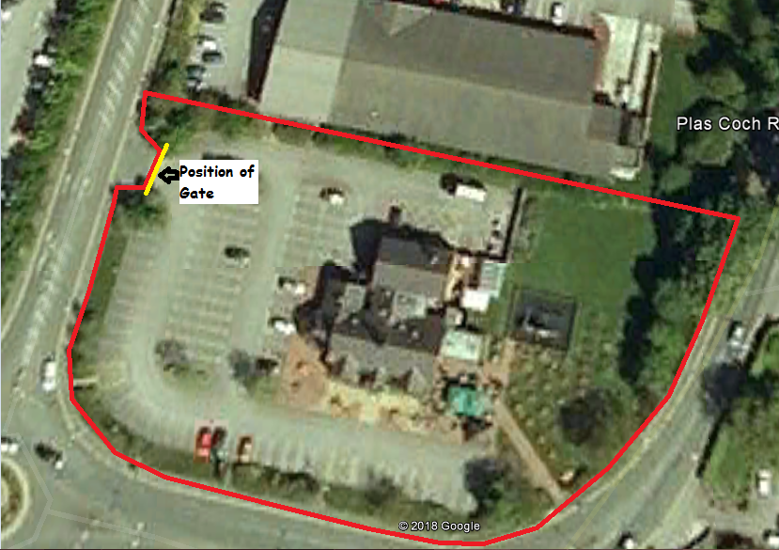

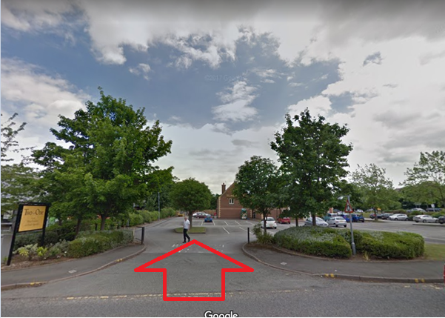

Marstons June 2018

