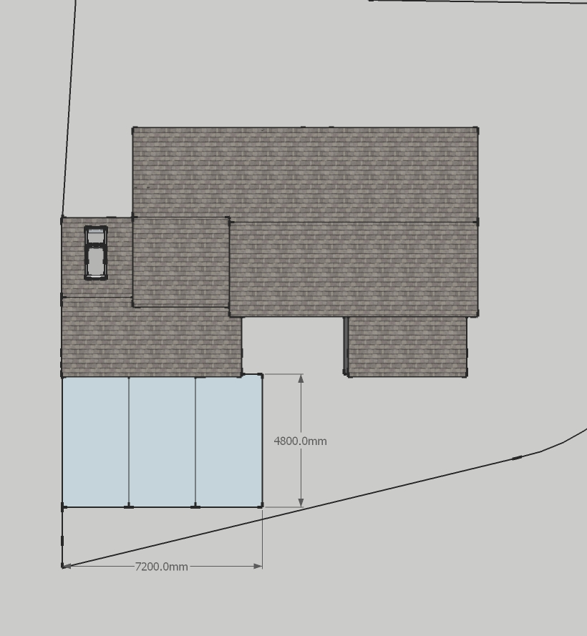
Scale 1:100
A4 print
1 Wern, LL145BW
Proposed parking

