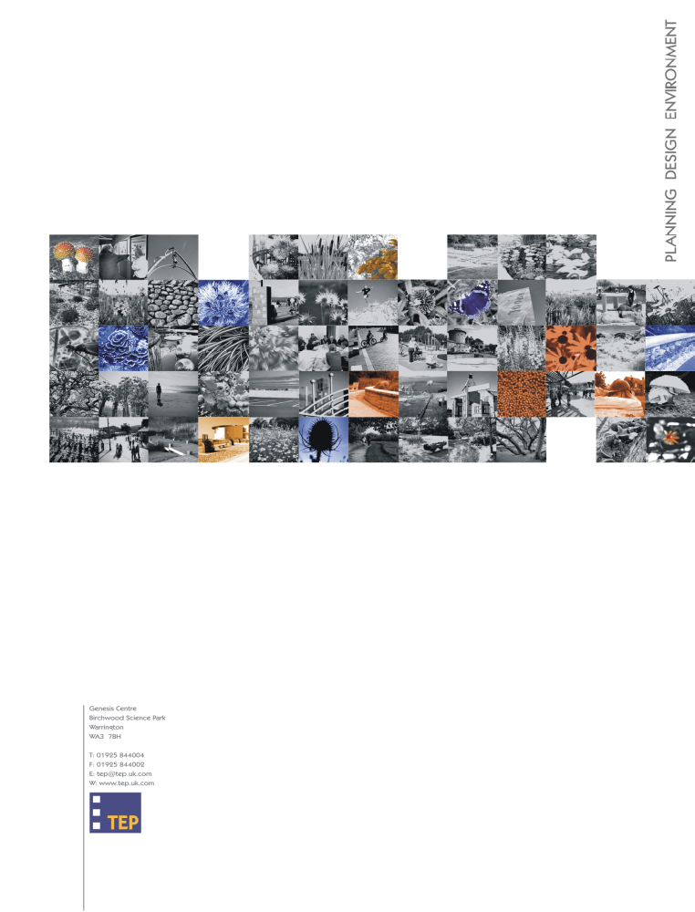

F LLOYD (PENLEY) DEVELOPMENT SITE
WREXHAM INDUSTRIAL ESTATE
NESTING BIRDS METHOD STATEMENT
(Report Ref: 4551.002)
May 2014
Version 1.0

F Lloyd (Penley) Development Site
Wrexham Industrial Estate
Nesting Birds Method Statement
Document Reference: 4551.002
Version 1.0
May 2014

Prepared by: Kerry Stead

TEP
Genesis Centre
Birchwood Science Park
Warrington
WA3 7BH
Tel: 01925 844004
Fax: 01925 844002
e-mail: tep@tep.uk.com

for

F Lloyd (Penley) Ltd
Bridge Road South
Wrexham Industrial Estate
Wrexham
LL13 9SQ

Written: | Checked: | Approved:
KS | ACP | ACP

INTRODUCTION

- TEP has been commissioned by F Lloyd (Penley) to assist in the implementation of the great crested newt licence application associated with development of part of the former Firestone site on Wrexham Industrial Estate (WIE). These works include a substantial amount of scrub clearance.

- Much of the habitat surveyed includes dense scrub and/or trees which will be affected by the proposed works. The dense scrub and trees provide shelter, feeding and nesting opportunities for birds. Damaging or destroying a nest that is either in use or being built is an offence. It is also an offence to disturb certain species of birds (those on Schedule 1 of the Wildlife and Countryside Act 1981 as amended) during the nesting season (March to August inclusive).

- This document sets out the steps to be taken to avoid damaging or destroying nests or disturbing Schedule 1 nesting birds, and thereby avoid committing an offence.

- SITE DESCRIPTION

- The F Lloyd (Penley) site occupies part of the former Firestone site which is situated to the southeast of Wrexham Industrial Estate, adjacent to Bridge Road, and comprises 44.6ha (110 acres) of brownfield land. The F Lloyd (Penley) site measures 2.8ha and is located within the southwestern part of the 44.6ha Firestone site. The site is bounded by Bridge Road to the northwest, industrial units to the southwest and northeast and by the River Clywedog floodplain to the southeast. The approximate central grid reference is SJ 378 489. The location and F Lloyd (Penley) site boundary are illustrated in Drawing G4551.001.

- The proposed works will involve the construction of two industrial/warehousing units, hardstanding and associated soft landscaping areas. The development works will involve the loss of unmanaged species-rich modified neutral grassland interspersed with areas of dense and scattered scrub, scattered broad-leaved trees, tall ruderal vegetation and swamp.

- METHOD

Work Carried Out During Bird Nesting Season
- As the removal of vegetation is to take place during the bird nesting season (March to August inclusive) then a suitably qualified ecologist will be required to carry out a nesting bird check prior to any work taking place.

- This check will involve observing potential nesting sites from a number of vantage points for set periods of time. If no nesting activity is observed, vegetation removal must take place within 24 hours. If longer than 24 hours elapses, an additional check must take place before work can commence.

- If evidence of nesting is observed, the ecologist will advise as to an appropriate protective buffer (depending on species) to be applied inside which no work can take place. Further visits by the ecologist will be required to establish when nesting has ceased and when work can recommence.

Work Carried Out From September to February
- The nesting bird season is generally accepted as being from March to August inclusive. Work carried out within this period carries a low risk of affecting nesting birds, although unseasonably warm weather in late winter may encourage nesting to start early for some species. If a nesting bird is encountered during tree or scrub removal, work must stop immediately and advice be sought from a suitably qualified ecologist.

- Arisings from vegetation thinning, such as brash, have the potential to provide nesting opportunities for birds if left onsite. If brash piles are not going to be disturbed later, they can be left in situ. However, if they are to be disturbed, removed or, for example, chipped, this should be done immediately after thinning to prevent birds from using them as nest sites.

- SUMMARY

- Site clearance works on the F Lloyd (Penley) development site involves the removal of dense scrub and some scattered trees. This habitat is likely to support nesting birds, particularly ground nesting birds, and it is an offence to damage or destroy active nests, including those under construction. It is also an offence to disturb nesting birds listed on Schedule 1 of the Wildlife and Countryside Act 1981 as amended.

- Work between March and August can only take place once an ecologist has surveyed the site for nesting birds and has confirmed that no nests will be disturbed or damaged through the proposed works.

- If nesting birds are found, the ecologist will advise as to the safe working buffer to be applied. Work may not recommence within the protective buffer until an ecologist has confirmed nesting has ceased.

- Work between September and February may take place as long as the resulting brash is dealt with appropriately (if it is likely to be later removed or disturbed) so as not to provide future nesting opportunities for birds once the nesting season arrives.
- If nesting birds are found at any time, work must cease immediately and advice be sought from a suitably qualified ecologist.

