
Bob Dewey

PLANNING
GROUNDS OF APPEAL

PROPOSED ERECTION OF DWELLING
The Stables, Bowling Bank, Wrexham.

PROPOSAL:

The proposal is to replace the windows and doors on the property with identical patterns of glazing contained in uPVC frames.

PLANNING HISTORY:

The permission for the development of the conversions of farm buildings to form 9 residential units was granted on 10 Dec 2001 (ref (P/2001/0830)

Conditions imposed included the following:
3. Notwithstanding the provisions of the Town and Country Planning (General Permitted Development) Order 1995, no extensions or additions to any dwelling shall be built, erected or constructed.
(reason: Due to the relationship between the proposed units it is considered important to ensure no additional development is carried out without the permission of the Council. Whilst ensuring the Council policies for housing in the Countryside are not compromised.
4. Notwithstanding the provisions of the Town and Country Planning Act 1990, no buildings (including any sheds, greenhouses, outbuildings etc.) walls or structures shall be erected within the residential curtilage (area within red line) without prior written approval of the Local Planning Authority.
(reason: to ensure any additional built development does not detract from the character of the building does not detract from the character of the Countryside or compromise policies for housing in the Countryside.

The appellant sought advice from the Council by way of an informal planning enquiry on 11 March 2020. (ref ENQ 2020/0131). After considerable chasing, she eventually received a bland “planning permission will be required” at the end of August 2020. She then submitted an application (ref P/2020/0507) but only after considerable chasing did she received a refusal notice dated 5th March 2021. Almost a year since she started the process.

REASON FOR REFUSAL:

The appeal application was refused for the following reason:
The proposals, by virtue of the use of upvc, would not be reflective of the traditional character and appearance of the dwelling and barn conversion complex as a whole. The proposals would appear overly domestic in their style and appearance, resulting in discordant additions which would not make a positive contribution to the dwelling or the surrounding barn complex. The
proposal would conflict with UDP Policy GDP1 and the provisions set out in
in Local Planning Guidance Note 03.

.
PLANNING POLICY:

In its decision, the Council refers to the General Development Policy (GDP!) and to the Supplementary Guidance in SPG3 No detailed guidance is given as to which particular guidance/policy is alleged to be infringed. The entirety of those polices is included at the end of this statement.

Wrexham U D P
Policy GDP1 All new development should:-
a) Ensure that built development in its scale, design and layout, and in its use of materials and landscaping, accords with the character of the site and makes a positive contribution to the
appearance of the nearby locality.

Wrexham “Converting rural buildings local planning guidance note no 3”

Windows and Doors
O Traditional or vernacular windows and doors should be retained, repaired and re-used;
O New or replacement windows and doors (including patio/French doors) should match the originals and/or reflect the character of the building. Standard designs
primarily intended for insertion in modern buildings will not be acceptable;
O Windows and doors should be painted or, in the case of sustainably - sourced hardwoods such as oak, left untreated - modern timber stains should be
avoided;
O New window and door frames should be recessed at least 100 millimetres within an opening to give depth to the façade;

Welsh Government Planning Policy Wales 10 includes:-
Environmental Sustainability
3.7 Good design promotes environmental sustainability and contributes to the achievement of the well-being goals. Developments should seek to maximise energy efficiency
Planning authorities should through a process of negotiation seek to improve poor or average developments which are not well designed, do not take account of their context and consider their place, or do not meet the objectives of good design. Where this cannot be achieved proposals should be rejected. However, they should not attempt to impose a particular architectural taste or style arbitrarily
All new development should be of a scale and design that respects the character of the surrounding area

THE COUNCIL’S REASONING:

Some detailed reasoning behind the Council’s decision is contained in their officer’s report

Planning Officer’s report

No’s 2 – 8 are traditional in their form and appearance, forming a typical barn conversion complex.

No 9 is a single storey property. Whilst it is attached No 8, it is considered to be detached from the remainder of the complex, by virtue of the high hedge and fence at the rear, and a brick wall at the front. In my opinion it reads as a completely separate entity from the remainder of the complex.

The entire barn conversion complex (No’s 2 – 8) are all served by timber openings. The complex is traditional and typically agricultural in nature. The proposal is considered would harm the character and appearance of the existing dwelling and barn conversion complex as a whole, eroding its typical rural appearance. For this reason, the proposal is recommended refusal

GROUNDS OF APPEAL

Firstly, the appellant and various qualified planners to whom she has spoken have been unable to understand the council’s reasoning that planning permission is needed.

Planning permission is not normally needed for replacing windows in a house within the existing openings. The council argues that in this case, that the conditions of the 2001 permission removed that right. Whilst accepting that this does restrict what can be done in this case, the appellant believes that the Council is exceeding the powers contained in that permission.

The condition only relates to “ …extensions or additions to any dwelling…” and it our belief that replacing windows of the same size in the same openings cannot be an extension or an addition. The dwelling is not being extended and nothing is being added. The Oxford dictionary advises that “add” means to “join one thing to another as an increase or supplement..” The dwelling is not being increased and nothing supplementary is being added.

However, the condition also lists the actions that may not be done – i.e. “..shall be built, erected or constructed.. ” We suggest that no one would ever speak of building new windows nor erecting new windows or constructing new windows. The prosed supplier of the windows uses the word “install” and this is the word that we believe most accurately describes the application proposal.

It is our submission that no planning permission was needed for the development and we ask the inspector to concur with that view.

The appellant would welcome formal confirmation that the explicit threat from the Council’s planning officer of enforcement be withdraw.

Planning merits

To complete the picture the appellant would provide the following information regarding her proposals.

It would appear form the wording of the refusal notice that the only stumbling block is the material proposed.
“by virtue of the use of upvc,”
In other words, it seems that the windows glazing pattern sizes and so on are entirely satisfactory if they were in wood. Photos attacked to this appeal show the existing windows together with a sample window and we can find no evidence that the appearance is so very different as to cause harm to the amenity of the area.

Prior to the decision being issued the Council was asked (in writing)
Good morning, I have been asked to try and assist the applicants with this planning application ((P/2020/0507). I will met them on site tomorrow (Friday)

It would greatly help me if you could give some guidance as to precisely what you consider the problems to be..

Is the thickness of the frames? the layout of the glazing bars? or is it simply the material and/or its finish?

I would really appreciate your assistance.

No response was received.

We agree that when uPVC was first introduced, the profiles and appearance of the frames was much heavier and clumsy but this was many years ago and manufacturers and suppliers have devoted much time and effort tot improving the appearance of their product.

One of the options open to the appellant was a product in the Residence collection. (Web address: residencecollection.co.uk). They specifically design with a view to meeting the stipulations of Conservation Areas and Listed Buildings. Although almost unrecognisable as uPVC even within few inches of the window, (and probably) preferred (albeit a lot more expensive) by the appellant, she recognised that the product would have appeared different from the existing. Photo 1 shows an example – the grey colour happened to be the sample available . Whilst the typical appearance of the uPVC framing is smooth faced which can have a shine on it when new, It is now available as a “wood grain finish” which greatly enhances the appearance.
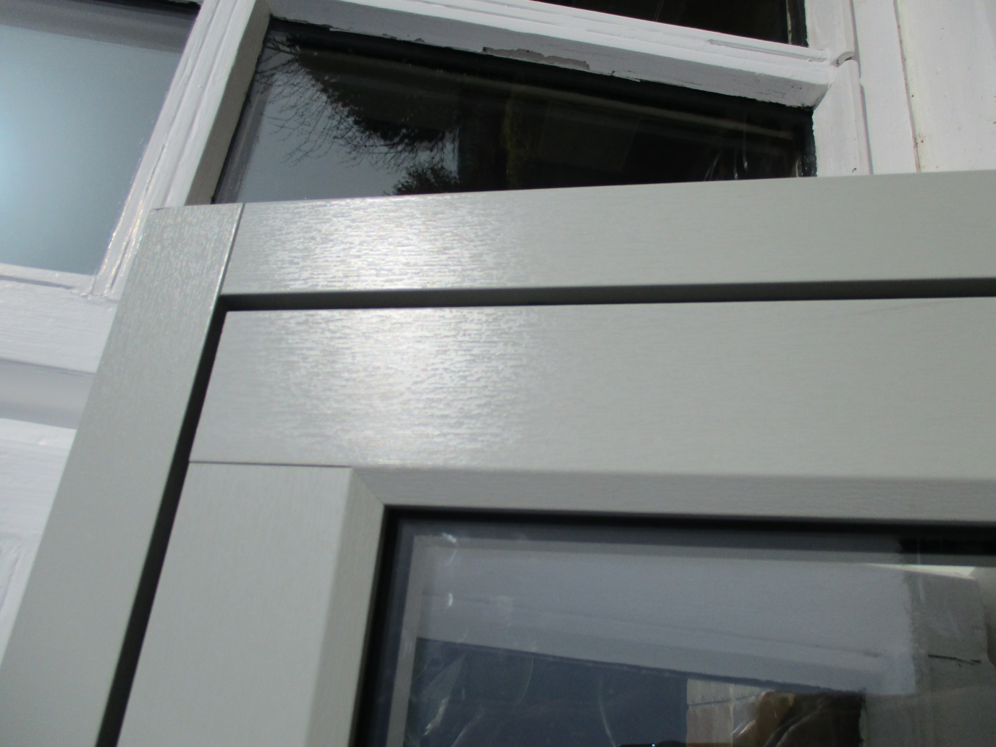
Picture 1: this shows the texture of the proposed window frame

The second photo shows the proposed window style most closely matching the existing. It should be noted that other residents have replaced windows previously (in soft wood) and the precise details of the windows has not been raised as an issue.

The appellant intended to make her new windows as close as possible to the existing in terms of glazing patterns.

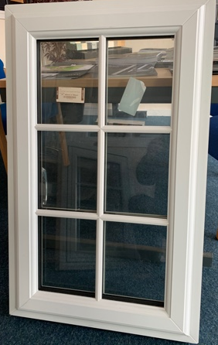
Sample of window to show details (but using traditional uPVC (but not textured as intended - see previous picture

However it is noted that the Council did apparently have no concerns about uPVC and granted the use of upVC windows on unit 9 (two doors away) claiming that :
:
It was considered to be distinct from the main elevation and would not harm the overall detail of the fenestration as a whole. Your property lies quite central and is an integral part of the main façade. The impact of any change here would be far more conspicuous and could potentially harm the entire elevation. We also have to bear in mind that other adjoining properties may also wish to replace their windows with UPVC, the principle of which, would be difficult to resist once accepted along this elevation. There is no guarantee for example, that others will use the same window company and there will inevitably be variations in design. This whole elevation is far more sensitive and it is important to preserve its integrity. Relaxing our position here would undermine our ability to protect the building as a whole.

The original architect’s drawing show the elevation as a single entity with matching windows throughout. (see extracts below) and a subsequent argument from planning that the planting between numbers 8 $& 9 created a significant break allowing different treatments to be acceptable seems to us gratuitous and would suggest that the objection is no to the material but the degree of views from outside the site.

The views of number 7 from the public highway are very limited indeed, so weight should be given to that too.

It is clear that the approved scheme created a domestic frontage to the former barns and the change in window materials would make no significant change in that aspect.

CONCLUSION

Permission is not required for the change of the windows but in any event, the appellant has made every effort to use a high quality of product.

We believe that it would greatly help the inspector to see a sample of the window at the site and we propose to make that available for the site visit.

The inspector is respectfully asked to use his absolute discretion to determine that permission is not required but in the vent he is unable to make that judgment, he is asked to grant permission.

Robert A Dewey BA(hons) MBA MRTPI
Bobdeweyplanning
March 31 2021 r6

WREXHAM UDP

Policy GDP1 All new development should:-
a) Ensure that built development in its scale, design and layout, and in its use of materials and landscaping, accords with the character of the site and makes a positive contribution to the appearance of the nearby locality.
b) Take account of personal and community safety and security in the design and layout of development and public / private spaces.
c) Make the best use of design techniques, siting and orientation in order to conserve energy and water resources.
d) Ensure safe and convenient pedestrian and vehicular access to and from development sites, both on site and in the nearby locality.
e) Ensure that built development is located where it has convenient access to public transport facilities, and is well related to pedestrian and cycle routes wherever possible.
f) Ensure the safety and amenity of the public and safeguard the environment from the adverse effects of pollution of water, land or air, hazards from industry and quarrying, and associated noise, odour or vibration arising from development.
g) Secure public services (e.g. gas, water, electricity) to development at minimum public cost.
h) Safeguard sites and areas of nature conservation and wildlife interest, and to provide new habitats where there is an unavoidable loss of existing habitats and areas of wildlife interest.
i) Ensure that development does not result in, or is subject to, flooding, soil erosion, landslides or contamination, either on or off the site.
j) Have regard to the need to safeguard those areas that possess a strong Welsh cultural and/or linguistic identity from development that could harm this identity.
k) Secure the development of sustainable communities, through the promotion of the economic, social and environmental well-being of the area.

WREXHAM CBC CONVERTING RURAL BUILDINGS
LOCAL PLANNING GUIDANCE NOTE NO 3

Converting Rural Buildings
This guidance note explains the approach which the Council takes towards dealing with proposals to change the use of and convert rural buildings. It supports and amplifies the relevant policies (particularly GDP1, H3, E5 and CLF9) contained in the Wrexham Unitary Development Plan.
The note will form a material consideration in the determination of planning applications.
Background
There is a varied range of buildings in the countryside which are no longer suitable for their original purposes. The majority are likely to be agricultural
buildings but there may also be churches, chapels, mills, schools, public houses, stables and others for which an alternative use is being sought.
Many of these buildings make a positive contribution to the character and appearance of the area. Provided they are structurally sound, conversion
of these buildings, for example to employment or community use, visitor accommodation or housing can safeguard their future. By re-using existing resources, conversions can also meet the aims of sustainable built development. However, there are some buildings which are not suitable for conversion,
including those which are:­
O structurally unsound;
O roofless, missing substantial sections of wall, or so ruined that only vestiges remain of the original structure;
O of temporary construction;
O eyesores which should be removed in the interests of landscape conservation;
O unsuitable in terms of size and form of construction ;
O at risk of flooding. In particular, planning permission will not normally be granted if:­
O there is insufficient floor area in the existing building to provide acceptable standards of accommodation (in the case of conversions to dwellings, this
should be a minimum of 40m²);
O the proposals involve rebuilding more than 10% of the walls if the roof structure needs to be rebuilt; or 20% of the walls if the roof structure is to be retained.
Part 1
Development principles With very few exceptions, it is essential that converted buildings should keep their original character and not have the appearance of being fundamentally new structures. The aim should therefore be to retain such key features as:­
O overall form and proportions;
O traditional materials (locallysourced brick, tiles, stone, timber framing, etc);
O architectural detailing;
O existing wall openings;
O roof structures;
O floor levels;
O internal layout;
O principal fixtures and fittings as integral parts of the conversion scheme.
In circumstances where the building has no original or traditional features
of merit, the Council will expect the design of any conversion to reflect the
vernacular character and appearance of other buildings in the locality
Proposals should therefore have regard to the design and layout principles set out below.
Walls
O Re-use existing openings to retain a building's character and reduce the impact of any new works;
O Any new openings should be kept to a minimum and take account of the overall proportions of the building;
O If an opening needs to be blocked up, consider creating a recessed panel to show where the original opening was located;
O Use materials and methods (including traditional pointing techniques) which are appropriate to the building and its setting;
O Unsuitable or inappropriate materials used in previous alterations should be removed and replaced by materials matching the original building.
Windows and Doors
O Traditional or vernacular windows and doors should be retained, repaired and re-used;
O New or replacement windows and doors (including patio/French doors) should match the originals and/or reflect the character of the building. Standard designs
primarily intended for insertion in modern buildings will not be acceptable;
O Windows and doors should be painted or, in the case of sustainably - sourced hardwoods such as oak, left untreated - modern timber stains should be
avoided;
O New window and door frames should be recessed at least 100 millimetres within an opening to give depth to the façade;
O Modern up-and-over style garagedoors will be inappropriate.
O Parking provision will need to comply with the Council's standards (see Local Planning Guidance Note 16).
Part 2
Converting agricultural buildings to dwellings
In the interests of maintaining the rural economy, the emphasis in national planning policy is upon maximising the re-use of redundant buildings for non-residential purposes. This approach is reflected in the Wrexham Unitary Development Plan. Policy H3 in the Plan requires that, in the case of agricultural buildings, proposals for conversion to dwellings must demonstrate:­
O that there is no longer an agricultural need; and
O that alternative non-residential uses have proved inappropriate. Planning applications will therefore need to be accompanied by a supporting statement explaining why the building is no longer suitable; cannot be made suitable; or is now not required for agricultural purposes. The statement should also give the reasons why a conversion to a use other than housing is not practicable or desirable. The statement should therefore have regard to the material
considerations listed in the shaded section below.
Where it appears that a building is suitable for non-residential use, applicants will be expected to advertise it for sale or lease for non-residential purposes prior to
submitting a planning application. The results of the advertisement should be
included in the supporting statement. If no advertisement has been undertaken, the Council may request that this be done after submission of the application depending on the Chief Planning Officer's assessment of the case. However, if there is any doubt regarding the suitability of the building, advertisement will be
essential. The minimum period for advertising a building as being potentially suitable for non-residential purposes will normally be six months unless otherwise specified by the Chief Planning Officer. Whether before or after the
application has been submitted, it is recommended that details of any marketing and advertisement procedures should be discussed and agreed with planning officers.
External appearance
Conversions of agricultural buildings should seek to maintain the agricultural character and appearance of the existing structure. While this can normally be achieved by residential conversions, commercial uses may require the insertion of larger windows, delivery doors, air vents and the attachment of other external equipment. Only if the building could be adapted without needing major external alterations is it likely to be suitable for non-residential purposes.

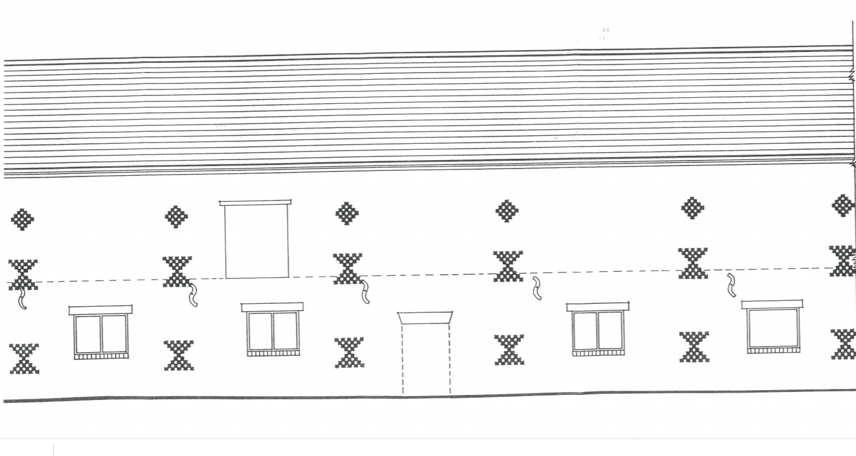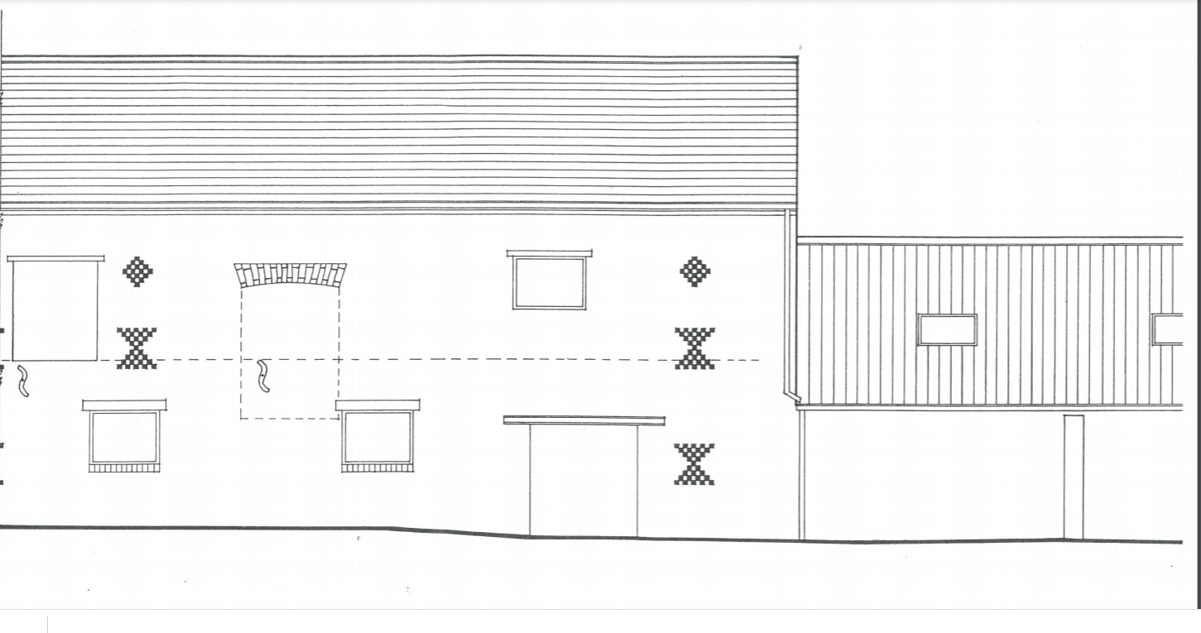
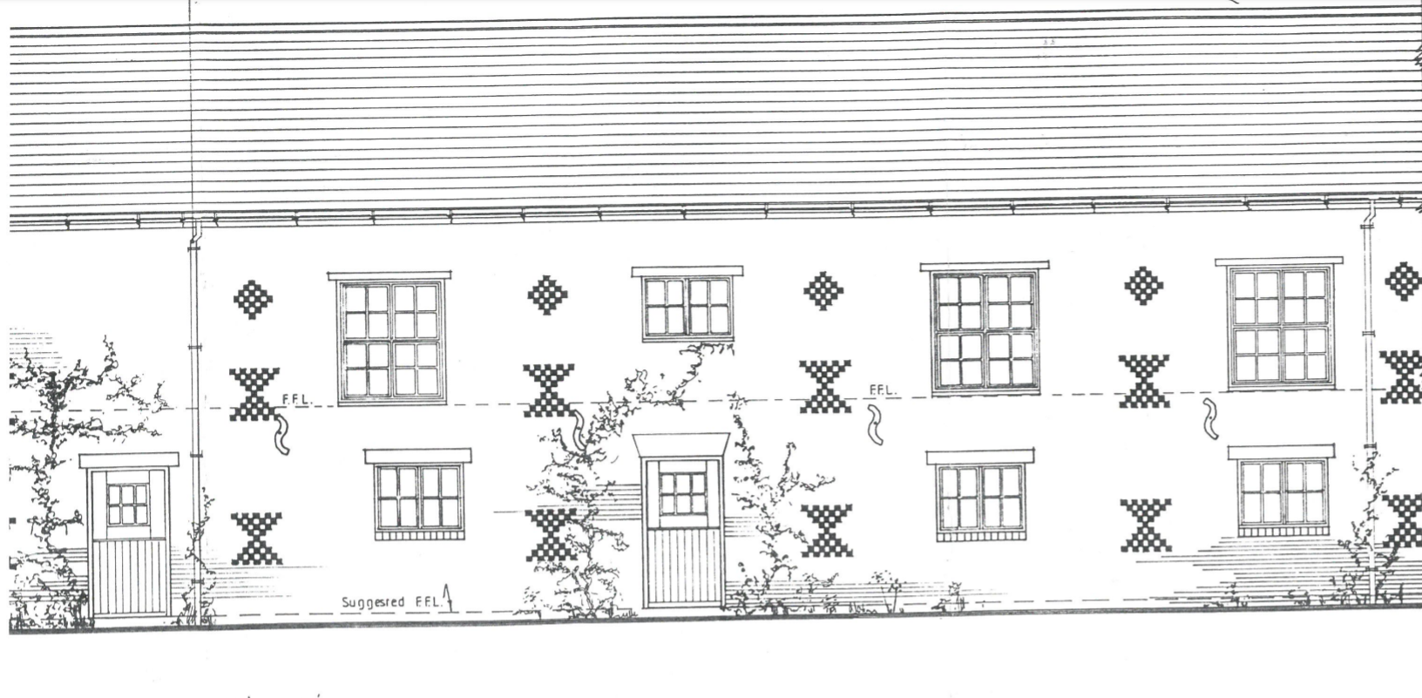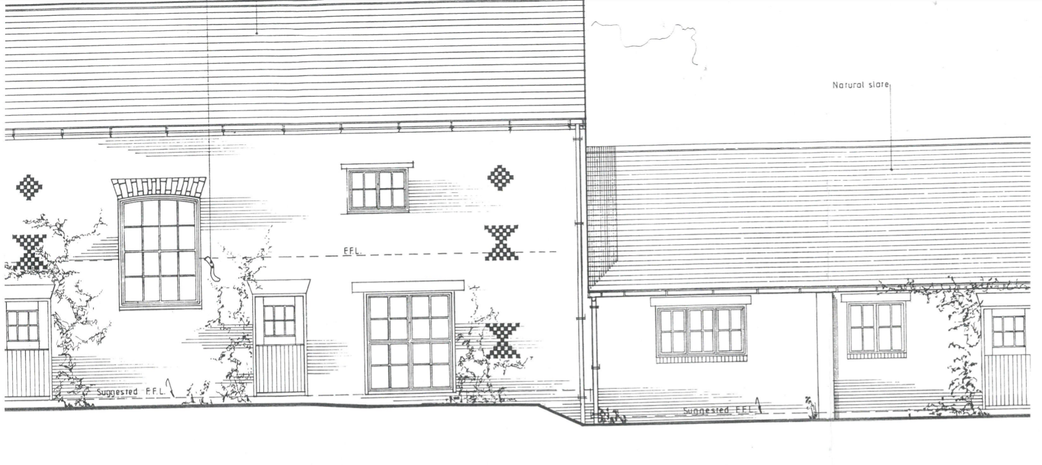
Plans from application (ref (P/2001/0830

