
Bob Dewey

PLANNING
GROUNDS OF APPEAL
ALTERATIONS TO ACCESS
THE STABLES, SONTLEY ROAD, WREXHAM

PROPOSAL:

The proposal is (in retrospect) to alter an access to a property which was formed by conversion of farm buildings to a single dwelling

PLANNING HISTORY:

Following a challenge by the Council, application P/2021/0039 was submitted to widen and retain access to front of property (in retrospect)”

It was submitted on 12 January 2021 and was refused on 15th March 2021
for the following reason:-

“1. By reason of the siting and design of the proposal there is restricted visibility at the proposed access and the increased use would increase the likelihood of danger to road users. As such the development is not considered to ensure safe pedestrian or vehicular access to and from the development site. It would therefore fail to comply with policy GDP1 of the Wrexham UDP (2005).”

Planning permission was granted for the “Conversion And Extension Of Existing Stable Block to form 1 No. Dwelling And Construction Of New Shared Access Off Sontley Lane” on 7 September 2017. Conditions were imposed including condition 2 and 5 which required that

Condition 5 deals more specifically with the access and requires that:
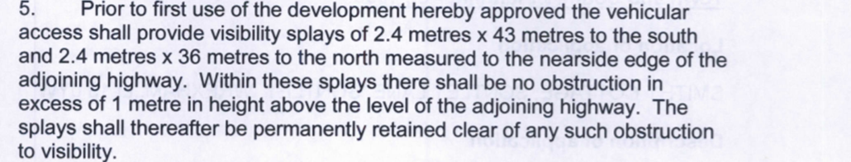

Condition 2 says:-

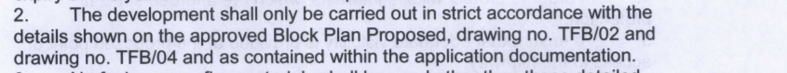

PLANNING POLICY:

The Wrexham Unitary Development Plan (policy GDP1) requires that “all new development should (d) ensure safe and convenient pedestrian and vehicular access to and from development sites …”

Determination of what is considered is ”safe” is set out in a Government publication “Manual for Streets” and in Welsh Government’s Technical Advice Note 18 annex B

BACKGROUND INFORMATION:

After the development had been substantially completed, it was discovered that delivery vehicles and particularly the vehicle servicing the bio disc plant, had considerable difficulty in accessing the property because of the narrowness of Sontley Road and the sharp turn double turn into the site.

The appellant concluded that the simplest way of dealing with the matter was to re use the former field gate which was now incorporated into his site.

He was not aware of any stipulation that would prevent this happening but nevertheless did not envisage it being used in the normal course of events and thus it was fenced off and its use is limited by the inclusion of a bollard in the centre to support the fence/gates.

THE COUNCIL’S REASONING:

The Council’s Highway Officer advised that:-
The proposed development site is located on Sontley Lane which is a classified road subject to a 60 mph speed limit. However, I would estimate typical vehicle speeds at being around 30 mph given the geometry of the road along this section. Assuming speeds of 30 mph, any proposed / existing access in this location would normally be required to provide visibility splays of 2.4 x 43 m in both directions measured to the nearside edge of the adjoining highway in accordance with Manual for Streets.

Previous planning consent ref: P/2017/0482 at Smithy Cottage for the conversion of the stable block included improvements to the existing main access to form a shared access to serve both properties. I understand that this consent included the permanent closure of the gated field access located north of the main access. The widened access is 3.8m wide and is gated at approximately 3m behind the edge of carriageway. The access is unsurfaced. Visibility from this access is inadequate in both directions providing splays of approximately 2.4 x 30m in both directions measured to the nearside edge of the adjoining highway. Visibility is impeded in the southerly direction by the existing boundary wall and by the existing tree / hedgerow to the north. I would normally recommend such an access be gated at least 5m behind the highway boundary and surfaced with hard bound materials for at least 5m behind the highway boundary. I would therefore recommend that the application is REFUSED for the following reason:- There is restricted visibility at the proposed access and increased use would increase the likelihood of danger to road users.

The Planning officer concluded that:-
Design:
The scale, length and design of the access gate is considered to be in keeping with its
surroundings and the use of timber is considered to be appropriate for its open countryside setting. The access gate is not considered to dominate the appearance of the road frontage.

Amenity

The access would be located sufficient distances away from neighbouring residential properties and as such would not impinge on the amenities of neighbouring occupiers byway of loss of daylight/sunlight or outlook.

Highway safety
Policy GDP1 requires safe and convenient pedestrian or vehicular access to and from the development sites. The access fronts onto a classified road where the speed limit is 60 mph however it is estimated that speeds of vehicles are estimated to be around 30 mph given the layout and geometry of the road. Visibility splays are obstructed by a tree and hedge to the north and walled boundary treatment to the south. As such the visibility splays, at 2.4 x 30m in both directions would fall short of the minimum distances required by Manual for Streets (2.4 x 43m). One of the aims of Manual for Streets is to ensure streets are designed to be safe.
The Council’s Highway’s Officer has objected to the proposal. Typically the gated access should be set at least 5m from the highway boundary and surfaced and 2.4m x 43 m should be achieved. The proposal fails to meet these thresholds. Whilst thresholds these can occasionally be applied flexibly due to individual site circumstances it is not considered that there is a case to be made in this instance. Whilst it is noted that a narrow gate had been in place historically, due to the change in use of the property and the widening of the access, the previous arrangement is not considered to justify the acceptability of this new residential vehicular access in this particular location. Previous planning consent ref: P/2017/0482 at Smithy Cottage for the conversion of the stable block included improvements to the existing main access to form a shared access to serve both properties, it is recommended that the applicant implements this arrangement in full.
Given the above assessment it is considered that the proposal would fail to meet the objectives of policy GDP1. Consequently the application is recommended for refusal.

GROUNDS OF APPEAL

Firstly, in making a decision on this appeal, the inspector is respectfully asked to consider whether planning permission was need for the re-use of the access. We include a photograph showing that there was a vehicular access and it appears that the Council accept that fact:
There was an access there before but streetview shows that is was a lot smaller than that which has been created (email from Council’s enforcement Officer 26th March 2021).

.
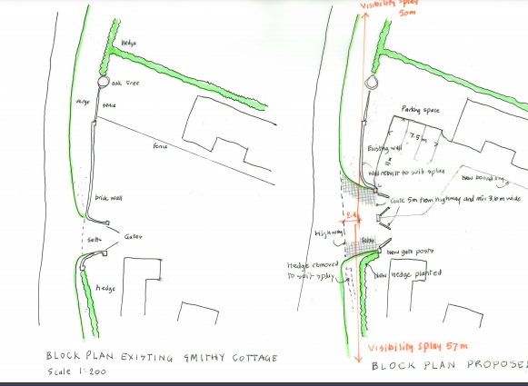

Extracts from the plans approved in 2017

These show that the existing and the proposed are identical with regard to this part of the site.

The photograph is also included at the end of this statement showing the situation before the access was altered.

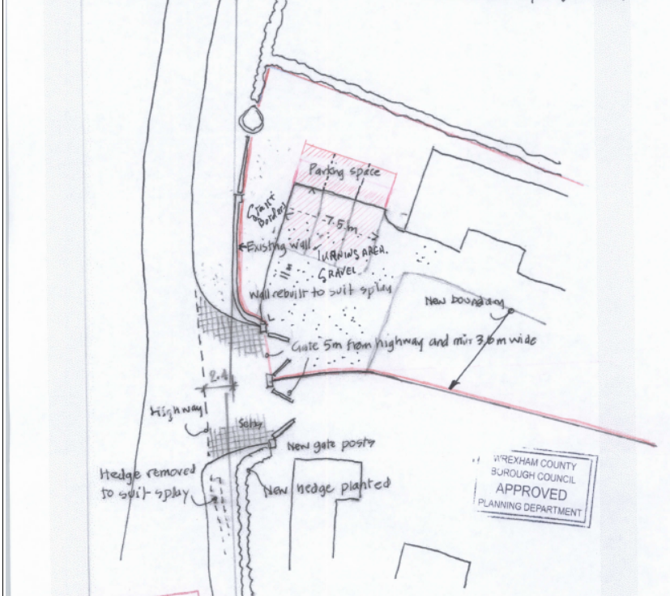
2017 approved plan

The appellant accepts that the access may be slightly wider than it was previously but planning permission is only needed if the widening involved “engineering operations”.

“there must, of course, be development requiring planning permission….” And “.. this requires some physical engineering operation, it does not extend to the simple removal of a hedge or of a removable fence in order to obtain access…” (planning encyclopaedia p 39081)

At best, then, the works undertaken amounted to removal of the former gate and a short length of unkempt wooden fence. It is our submission that no planning permission was needed.

The only development which is conceded may have needed planning permission is the erection of a fence exceeding one metre in height if it considered to be adjacent to a highway.

It should be recognised that the Council officers have accepted that:-
The scale, length and design of the access gate is considered to be in keeping with its surroundings and the use of timber is considered to be appropriate for its open countryside setting. The access gate is not considered to dominate the appearance of the road frontage.
However, if the inspector were not in agreement with this, the appellant would be willing to consider alternative treatments.

However, if the inspector disagrees with the above conclusions, then the issue to be addressed is whether
“ …the increased use would increase the likelihood of danger to road users….”

Firstly, it is not clear how the Council has quantified the amount of usage. As indicated above, the use of the access is very strictly limited to the very occasional delivery where the vehicle concerned is unable to turn through the double right angles into the new access. Also about once a year to allow the vehicle servicing the bio-disc sewage treatment plant. The appellant estimates that the gates were opened less than a dozen times during the previous twelve months. It is difficult to believe that this amounts to an increase in usage – if it is, it most certainly would not be a material increase.

Secondly, it is alleged that this access will result in danger.
The highway officer has assessed traffic speeds as being typically 30 mph. Given the narrowness of the road, the bends and the very poor state of repair of the road, this seems to be excessively generous. All along the lane are various unregulated accesses with equally limited visibility and anyone driving on this lane is most likely to be aware of the need for continuous caution. Although classified as a Class 3 road, to most drivers it appears to be a narrow country lane where agricultural traffic is likely to predominate.

The recommended stopping sight distances (SSD) in Manual For Streets (MFS) and TAN18 are “the desirable minimum” and “drivers are normally able to stop much more quickly than this in response to an emergency” . A 5 mph reduction in speed (which seems to us to be not unreasonable) would result in a reduction of some 25% in the required SSD only 33 m. The permission for the conversion of the building to a dwelling specified a visibility if 36 m in a northerly direction – we are not aware of any evidence to suggest why a greater distance is now required.

An examination on site will clearly show that the view from north bound traffic will be some 80 m taken in a pragmatic way for a driver of a vehicle (i.e. not necessary wholly along the notional kerb line). Likewise, for south bound vehicles, the driver is almost inevitably going to be at or near the centre of the carriageway and thus requiring the traditional “near side kerb line” measurement is unreasonable and unnecessary.

The minor distance measured into the site has an important role in this case. The Council seeks 2.4 m whereas the MFS clearly accepts that
A minimum figure of 2 m may be considered in some very lightly-trafficked and slow-speed situations, but using this value will mean that the front of some vehicles will protrude slightly into the running carriageway of the major arm.

The photograph also clearly shows that visibility at the access before the alterations was severely restricted by epicormics growth from the trunk of tree.

However, it must be recognised (and is accepted by the Council, we believe) that the issue is the widening of the access – not the formation of a new access. Accordingly, it is difficult to see how widening of it can cause any material harm to road safety.

Because the very wide verge, any vehicle emerging from the site will be clearly visible to oncoming traffic for a much greater distance than the distance viewed by the emerging driver.

In every case, the use of the access would be solely by commercial vehicles with the driver being in an elevated positon and thereby having a much enhanced view of traffic. Furthermore because the access can only be used when the occupier of the property is present and is able to give clear guidance to the driver and any traffic on the lane, the situation would be much safer than any other of the various substandard accesses along Sontley Road. Additionally the vehicle using the access would be taller and much more readily visible to on-coming traffic.

In the Highway Officer’s observations, there is the suggestion that the conversion permission required the closure of this existing access. We have found no evidence to support that view and he has either misunderstood the situation or has been given misleading information.

DECISION

It is our submission that the only matter which may have required planning permission was the erection of a fence exceeding 1 m in height.

In that case, the only possible matter requiring control might be the appearance of the fencing. (colour etc) That could be dealt with by a condition.

If the inspector concludes that the widening of the access required permission, then a condition could be imposed on the lines of:
“The access shall only be used by large vehicles unable to use the main access to the property. The gates shall be kept closed except when needed for this purpose, After use, the gates shall be closed and secured.”

The above conditions are intended to assist the Inspector but should not be taken as conceding the main thrust of our case.

CONCLUSION

The appellant is confident that the very low usage of the access and the specific circumstances of this case make the rigid imposition of guidance in the dogmatic way that the Council seeks to do is unreasonable.

The inspector is respectfully asked to use her/ his absolute discretion and allow this appeal.

Robert A Dewey BA(hons) MBA MRTPI
Bobdeweyplanning
April 8 2021 V7

