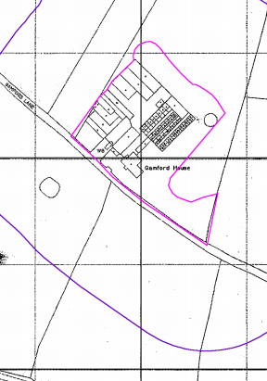
Location Plan: Gamford House, Rossett LL12 0EW
Scale: 1:1250@A4

