WREXHAM COUNTY BOROUGH COUNCIL

PLANNING COMMITTEE MEETING OF

2nd November 2020

REPORT OF THE CHIEF OFFICER PLANNING AND REGULATORY

ADDENDUM REPORT

This report summarises information received since the Agenda was compiled including, as appropriate, suggested amendments to recommendations in the light of that information. It also lists those people wishing to address the Committee.

Where the Council has received a request to address the Committee, the applications concerned will be considered first in the order indicated in the table below. The remaining applications will then be considered in the order shown on the original agenda unless indicated by the Chair.

ITEM 4 – DEVELOPMENT CONTROL APPLICATIONS

Page  Nos | Community | Planning  Ref | Speaker Against | Speaker  For
13-24 | GWE | P/2020/0108 |  | √
25-30 | BRY | P/2020/0203 |  | √
39 -42 | ESC | P/2020/0220 |  | √
61 - 68 | WRO | P/2020/0306 |  | √
69 - 82 | WRO | P 2020/0307 |  | √

Pages 13-24 P/2020/0108
Car Park of Former Black Horse Inn, Top Road, Summerhill, Wrexham,
LL11 4TA
SPEAKER: FOR – Mark Williams Representative of Moss Homes

Pages 25-30 P/2020/0203
Former Storage Barn at Quarry off Wesley Road Ruthin Road Bwlchgwyn
LL11 5UY
SPEAKER: FOR – Eoghan Carbery

Pages 39-42 P/2020/0220
Land at Field Parcel 4504, Bronwylfa Road, Aberoer, Wrexham, LL14 4ND
SPEAKER: FOR – Huw Evans (Agent)

Pages 61-68 P/2020/0306
38-41 High Street, Wrexham
SPEAKER: FOR – Mr John Blaney (Applicant)

Pages 69-82 P/2020/0307
38-41 High Street, Wrexham
SPEAKER: FOR – Mr John Blaney (Applicant)

PAGES 61-81

P/2020/0306
LISTED BUILDING CONSENT FOR CONVERSION WORKS TO FIRST AND SECOND FLOORS

P/2020/0307
CONVERSION OF FIRST AND SECOND FLOORS INTO 21 APARTMENTS

38-41 High Street, Wrexham LL13 8HY

Consultations
Local member: Councillor Alun Jenkins
Whilst I share the concerns of the Community Council regarding over-intensive development of town centre sites, I understand the argument put forward in the report that one bedroomed development here is preferable to family units, as this would probably reduce the number of vehicles owned by tenants, and the requirement for open amenity space and other facilities which cannot be provided in a town centre site. I do worry that quality is lost as the cost of greater quantity, and that some of these developments do not always meet the aims and objectives of our adopted Local Housing Strategy to raise the quality of the housing within the County Borough. Whilst our Planning Guidance would expect 35 parking spaces and 46 cycle spaces for this size of development, this is clearly not possible within the town centre, and our policies at present do not allow us to make conditions that would help to protect the residential areas just outside the immediate town centre where the new tenants will seek to find free parking for their vehicles in areas where parking spaces are already under pressure.

My main concern therefore for Monday’s meeting relates to the totally inadequate Refuse and Recycling facilities contained within the submitted plans. I hope that there is time for this to be dealt with before the Addendum Report is completed so as to avoid unnecessary discussion at the meeting on Monday

I am disappointed to see from the report that despite the request to the developers to reconsider the arrangements for the storage of the refuse containers, no changes have been made from the original proposals. I attach copies of the relevant sections of the Design, Access and Planning statement . In paragraph 5.15 on page 16 of 19, they conclude that in order to deal with the waste and recycling from the 23 (now 21) apartments, 3 x 240 litre recycling bins and one 1100 litre general waste bin will be required. Figure 5.1 on page 17 of the same document (copy also attached) shows that this will be provided in a room at the bottom of the stairs leading up to the apartments, just off the lobby leading onto High Street. This can be seen more clearly In the bottom right hand corner of the submitted document “SK05 – proposed site plan” (copy also attached). Scaling from the plan shows that the proposed storage room for the refuse containers measures around 3ft wide, and 5ft deep, with an inward hinged door, which then limits its capacity. Given that the size of a standard 240 litre bin is some 2ft square and around 4ft high, the suggested room would be barely sufficient for just one such bin. An 1100 litre bin would measure around 4ft 8 inches long and 4 ft wide, considerably larger than the proposed room, and too wide to even fit through the door! A considerably larger room than proposed would be required to house one large and three smaller wheelie bins, and to allow residents space to access them. Further, the location of the proposed bin storage room so close to the stairs leading to the flats could be a considerable fire hazard, and could prevent escape from the apartments in the case of a fire. In addition, in this location, and with no natural ventilation, smells from the refuse could dominate the lobby and stairs area, with considerable loss of amenity for the tenants.

The “Consultations” section of the report to Committee shows on page 73 that there were no objections from Highways, yet the web site shows that in their response on August the 4th., they also raise their concerns at the inadequacy of the proposed bin storage:
It is important that any proposed bin store 1 compound is of adequate size / design to accommodate the required number / type of bins and is suitably located to serve such a development ie/ in close proximity to the adjoining highway. I would strongly recommend that you consult with our Waste Strategy Officer -Catherine Golightly on Tel: 01978729693 to discuss the above detail and the adequacy of any area allocated to waste collection.

Further, in their e-mail to the Case Officer dated 30th September, in which they claim to have “Completed” their investigation of the issue, they include a plan showing the location of the bin storage area in the lobby of the doorway leading into the ground floor Restaurant which quite clearly cannot be the intention. Apart from again being too small, and blocking the only pedestrian entrance into the Restaurant, it is in an area not accessible to the tenants of the upper floor apartments - so is not a solution to the problems

I realise that it is now too late to achieve a satisfactory amendment to the proposals from the applicants before Monday’s planning meeting. There are two solutions.
Either - to defer consideration of the two application on Monday evening until satisfactory plans are submitted and can be considered by Committee,
Or - to amend the recommendation so as to make the location, size and layout of the bin storage area a reserved matter, so that approval of the development can be dependent on the satisfactory provision of bin storage arrangements. This would require an additional condition to be added to both recommendations - the current condition 4 refers to the current management plan which is clearly incomplete and insufficient. There would also be a need to amend Condition 2 in both cases - Document “SK05 Proposed site layout” (referred to in both conditions were implemented) needs to be amended to show adequate and satisfactory bin storage arrangements, and the changes clearly shown in the “Design and Access Statement” and in the “Waste Management Plan” before we can approve it and insist that “the development is carried out in strict accordance with the details shown in them” - otherwise we will be left with a problem that it is then impossible to enforce. No-one would want to see a row of wheelie bins permanently parked on the High Street pavement fronting the building as a consequence of not having provided suitable and adequate space within the building.

In terms of the Listed Building/Conservation Area aspects, I am happy that the proposed development will not have a detrimental impact on the appearance of this important building, and fully support the additional Condition 3 which requires the developers to come back to planning with details of any further changes that might affect the character and appearance of the building. However, until the Refuse and Recycling proposals have been completed satisfactorily, decisions on the two applications need to be taken at the same time.

Representations
Objection received on grounds of:

The space standards adopted for all of the flats as described in the Officers Report as 17x 1 bed flats and 4x 1/2 bed flats fall short of the 2016 proposed mandatory standard and guidance for new and rehabilitated dwellings and the current consultation on the Mandatory quality standards for new homes which closes on the 1st November 2020. It is important that the Committee understand the under-pinning evidence behind the quality and space standards that are proposed to be mandatory and will be extended to all types of housing in 2025. Under these circumstances the LPA should not be granting approval to a development that is woefully inadequate on space standards and will result in flats that range in size from 13m2 to 46m2. In the 2016 proposed standard 1 bedsit space requirement was defined as 32m2 and a 1/2 flat as 46m2. On the basis of the reduced scheme of 21 flats the area shortfall is 44.7% amounting to some 269m2 shortage of floor space to accommodate the requisite development.

Applicant’s Submission
The agent has supplied an updated plan that shows the correct size for the bin store. The plan also shows that the room will incorporate fire suppression system and an extractor fan, and that the door has been angled to allow the bins to be taken directly out of the building. The agent has also amended the Planning Statement to reflect these plans in Figure 5.1.
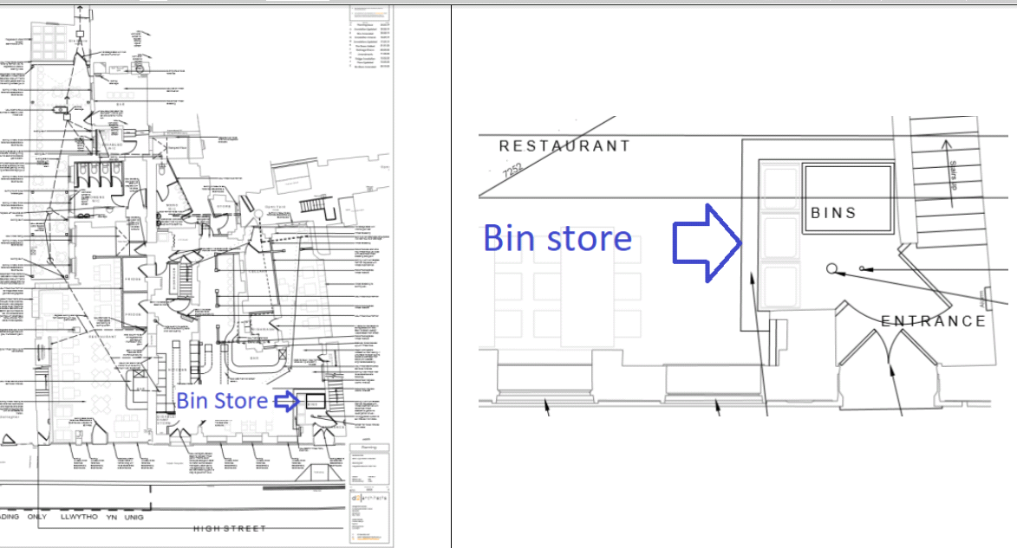

Observations for P/2020/0306
No further comments

Observations for P/2020/0307
Waste Storage
The agent has clarified the waste storage proposals as shown above. The waste collection will be a private arrangement.

Residential amenity
Contravention of space standards set out in the current consultation document, which refers to affordable housing and schemes attracting Social housing Grant, is not considered to be a reason for refusal under adopted policies.

Recommendation
Amend condition 2 of both recommendations to add drawing SK02K, and revised Planning statement October 2020.

ALL OTHER APPLICATIONS WILL BE SHOWN IN THE ORIGINAL ORDER OF
THE AGENDA

