
Materials specified at:
The Whitehouse
Grove Road
Wrexham
LL11 1DY

Planning Approval Ref: P/2019/0576
Condition(s) to satisfy: no. 3

External Facing Material:
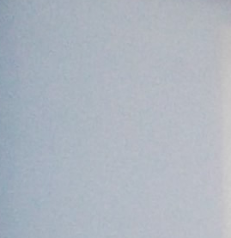
Sand and cement render painted white to match existing building.

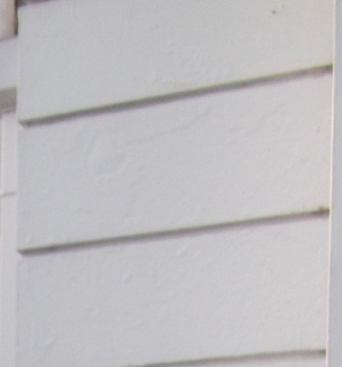
Corner Stone’s to match existing.

Roof Covering:

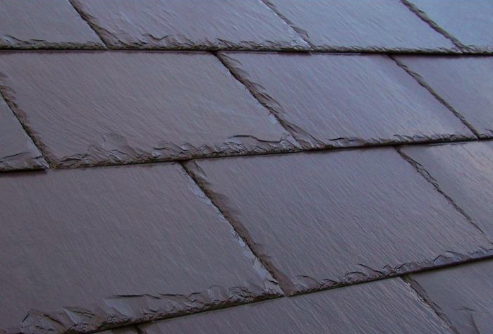
Natural Slates to match existing

Windows:
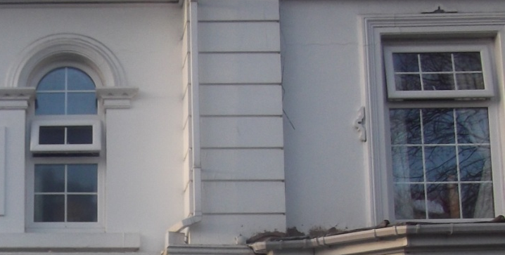

UPVC in White

