Built Form of the Surrounding Area
    - The site is situated within a street that is interspersed with a variety of house types, sizes, finishes, and styles – some of which have also been extended.
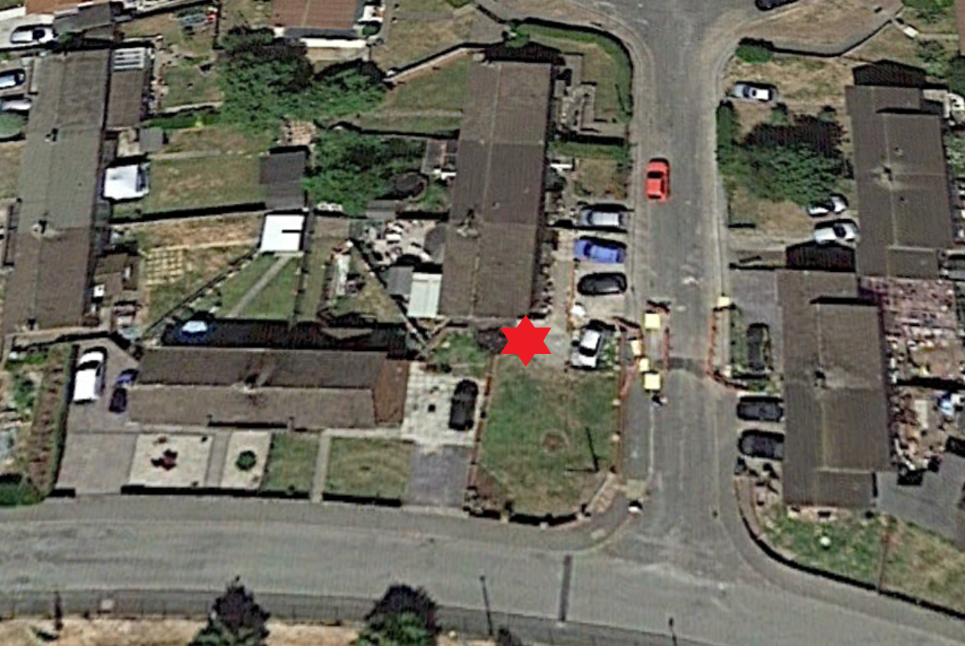
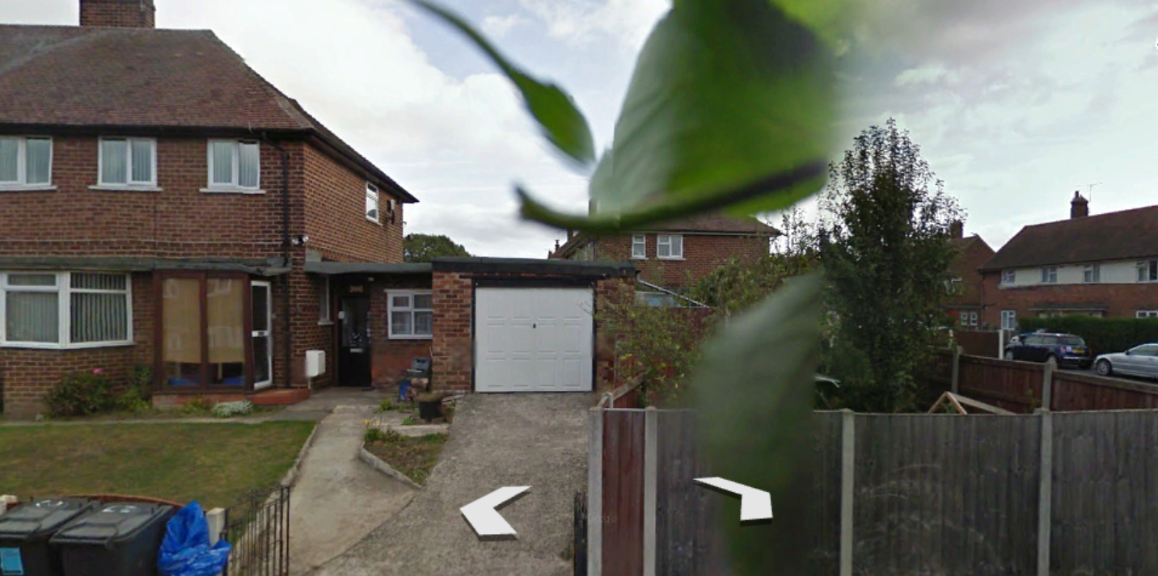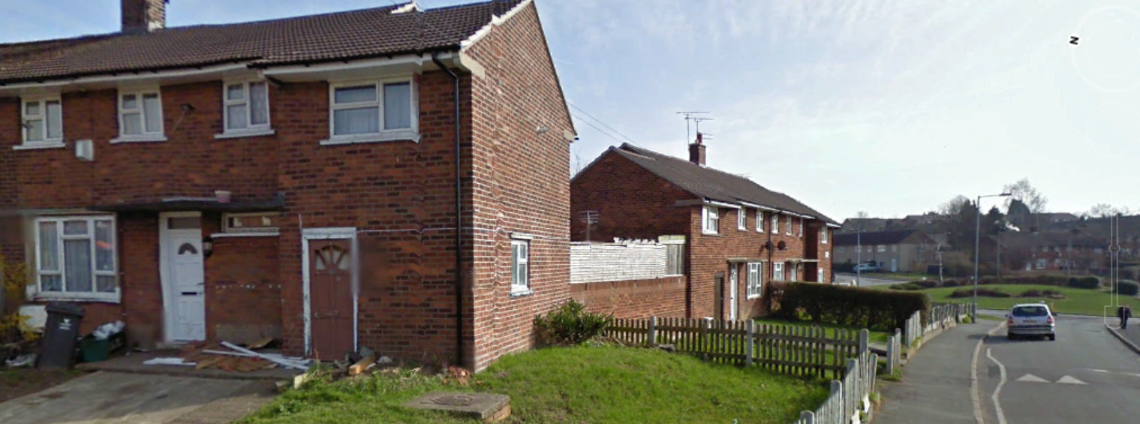

PLANNING HISTORY & POLICY

Summary
    - No relevant planning history, no previous alterations to 1 Rosewood Avenue.
    - This application for Planning Permission is submitted to Wrexham Council due to the extension protruding beyond the principle elevation of the property.
    - The site is in a Residential Area and the driveway accesses onto an unclassified road.

Planning Policy Wales (PPW)
    - The 2018 PPW sets out the Government’s planning policies for Wales and how these are expected to be applied and re-iterates that applications for planning permission must be determined in accordance with the development plan unless material considerations indicate otherwise.

Unitary Development Plan (UDP)
    - The following UDP policies are relevant to the determination of this application and are considered to align with the principles, aims and objectives of the PPW and are considered to carry significant weight.
Policy GDP1 – Development Principles
    - Policy GDP1 All new development should: -
a) Ensure that built development in its scale, design, and layout, and in its use of materials and landscaping, accords with the character of the site and makes a positive contribution to the appearance of the nearby locality.
b) Take account of personal and community safety and security in the design and layout of development and public / private spaces.
c) Make the best use of design techniques, siting, and orientation in order to conserve energy and water resources.
d) Ensure safe and convenient pedestrian and vehicular access to and from development sites, both on site and in the nearby locality.
e) Ensure that built development is located where it has convenient access to public transport facilities and is well related to pedestrian and cycle routes wherever possible.
f) Ensure the safety and amenity of the public and safeguard the environment from the adverse effects of pollution of water, land or air, hazards from industry and quarrying, and associated noise, odour or vibration arising from development.
g) Secure public services (e.g. gas, water, electricity) to development at minimum public cost.
h) Safeguard sites and areas of nature conservation and wildlife interest, and to provide new habitats where there is an unavoidable loss of existing habitats and areas of wildlife interest.
i) Ensure that development does not result in, or is subject to, flooding, soil erosion, landslides, or contamination, either on or off the site.
j) Have regard to the need to safeguard those areas that possess a strong Welsh cultural and/or linguistic identity from development that could harm this identity.
k) Secure the development of sustainable communities, through the promotion of the economic, social, and environmental well-being of the area.

Local Planning Guidance Note No.20 – House Extensions
    - The Development Plan stresses that generally house extensions will be permitted, providing that they reflect and enhance the appearance of the existing property, adjoining properties, and their setting in terms of scale, design, and materials. However, there are a substantial number of detailed issues that need to be considered in designing domestic extensions.

PLANNING CONSIDERATIONS

Introduction
    - The relevant development plan policies are contained within the PPW, and the relevant policies of the adopted UDP. The main planning considerations raised by this planning application are:
- Use
- Layout, Scale and Appearance
- Amenity

Use
    - This planning application seeks approval for the alteration to the existing dwelling to create a garage for domestic use that will enable the applicant to make improvements to the front of the dwelling and accommodate a secure parking space within a garage for his vehicle, which will also give him storage space to put his domestic clutter.
    - The parking of vehicles currently is on the highway and hardstanding to the front of the dwelling. It is proposed that the status quo remain the same and improved with the provision of a garage parking space.

Layout, Scale and Appearance
    - The proposal seeks to add a single storey garage attached to the side of the existing dwelling. The front elevation contains a garage door and access into the house will be retained through the existing porch.
    - The main policy considerations are Wrexham Unitary Development Plan Policy GDP1 and Local Planning Guidance note no.20 – house extensions.
    - Policy GDP1 of the adopted UDP states, inter alia, that planning permission will be granted for development provided there is no adverse impact on residential amenity or the character of the area and subject to other policies of the Plan.
    - Local Planning Guidance note no.20 states, inter alia, that Planning permission will be granted for house extensions which accord with the following criteria:
the scale, design, orientation, and materials of the extension, respects the character of the existing dwelling and adjacent properties.
    - Streetscene - Given the nature of the proposal it is inevitable that the garage extension will be visible from the street by passers-by, however these views are not visually unusual and viewed in context of the built-up surroundings and the character of the original dwelling. Notwithstanding, the resulting changes the alterations present are complementary and do not adversely impact visually on the streetscene.
    - The landscaping improvements that the applicant plans under permitted development will remove a section of the existing hardstanding across the frontage, to be replaced with a planted landscaped garden area. In addition, the grass to the side will be replaced by gravel in order to reduce maintenance and to tidy the appearance of the site.
    - Design – The proposed addition to the house would not be detrimental to the architectural character of the building and has been designed so not to over-dominate - retaining the character, scale, design, and materials of the original dwelling. The proposed works seek to preserve the character and appearance of the building using sympathetic external materials to match the existing. This will ensure that the alterations will compliment and assimilate with the existing house – but providing a modern update to the overall appearance.
    - Character of the area – The urban area that the dwelling is located in is truly mixed, many of which have undertaken significant alterations over the years, some of which in the immediate locality are stepped forward of the building line due to the awkward juxtaposition of garden boundaries, which is characteristic of the age of the housing development.

Amenity
    - Neighbour amenity - The application seeks permission for a garage located to the side of the dwelling. It is considered that the extension complies with the Council's guidelines regarding garden size, separation distances, residential amenity, and impact on streetscape.
    - As this is a corner plot, special attention has been paid to the size of the single storey extension so that a generous garden area is still retained, and the extension assimilates within and does not dominate the streetscene.
    - The positioning of the garage extension presents no adverse impact on neighbour amenity with regards to loss of privacy or enjoyment of their gardens, with sightlines towards the building softened by their own domestic clutter and vegetation. The applicant has discussed the proposal with his neighbour in advance of the application’s submission. The extension does not result in a significant loss of privacy, daylight, or sunlight to neighbouring properties, and as the immediate neighbouring property has no windows that overlook the extension it is considered not to be visually overbearing when viewed from adjoining houses.

Conclusions

Summary
    - This Statement has demonstrated that the proposed extension is fully compliant with the Planning Policy Wales and the policies set out in the UDP and the Local Planning Guidance note no.20.
    - The overall size, scale, siting, and distance are such that the single storey garage extension does not adversely impact on the amenity of neighbouring properties. The garage has been designed to be respectful of the style and proportions of the existing dwelling.
    - The PPW identifies that a good standard of amenity should be provided for future and adjoining occupiers of land. Policies within the UDP all highlight that development needs to respect the living conditions of existing neighbouring residential occupiers and future occupiers. The development is considered not to have a significant impact on the privacy or amenity of surrounding neighbours, thereby according with policies. This is by reason of appropriate scale, siting, massing, and design that harmonises with the original dwelling and preserves the character of the area and streetscene.

