ADAPTION OF EXISTING OUTBUILDING, INCLUDING EXTENSION TO PROVIDE GARAGING AND CONSTRUCTION OF STABLES AND
CAR PORT

AT KNOLTON HALL
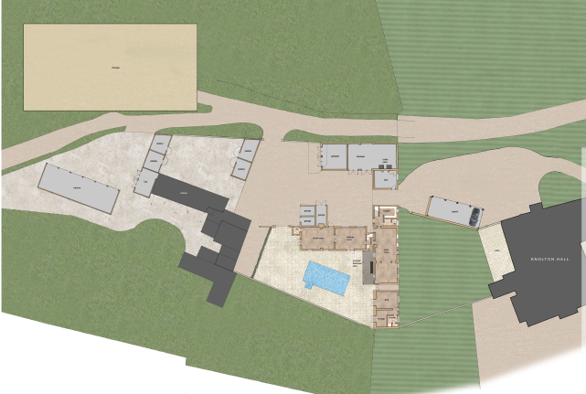

BIOSECURITY RISK ASSESSMENT
LOCATION
Knolton Hall, Oswestry Road, Overton WREXHAM Powys LL13 0LG
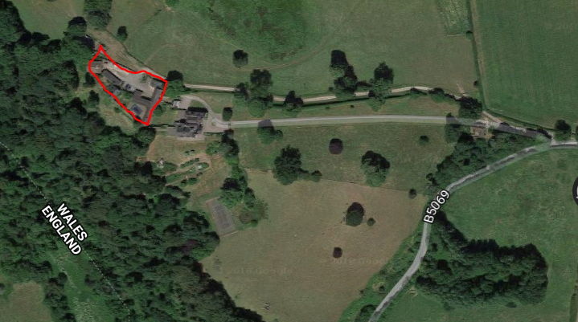
Study area
Knolton Hall
Source: Googlemaps
DETAILS
This desktop Biosecurity Risk Assessment has been prepared by Moss Co LLP on behalf of Mr and Mrs Edward Chantler in support of the householder and listed building application for the adaption of existing range of buildings, extension to provide garaging, and construction of stables and car port at Knolton Hall, Oswestry Road, Overton WREXHAM Powys LL13 0LG.

Application P/2019/0397 was granted on 12th December 2019.

Condition 7 of the above consent requests:

- No part of the development shall commence including the clearing of vegetation on site until a Biosecurity Risk Assessment has been submitted to and approved in writing by the Local Planning Authority. The risk assessment shall include measures to control, remove and for the longer term management of invasive species both during construction.

BIOSECURITY RISK ASSESSMENT
Moss Co has considered the following issues in relation to the Biosecurity Risk Assessment:

The following measures will be adopted throughout the construction period of the proposed development:
Reasonable Avoidance Measures
Great Crested Newts (GCN)
- Site operatives will be informed by ‘tool box’ talk at the start of the construction period on ecological responsibilities and what to look out for during works.
- There will be no impacts on boundary hedgerows and no potential places of shelter (e.g. rubble / log piles) will be disturbed during the construction phase. In any case artificial hibernacula, pile of wood and stones covered in soil will be constructed prior to start on site.

- Site operatives will keep a watching brief throughout the construction phase; especially during initial ground clearance operations.
- Between March and October inclusive (when amphibians and reptiles are active) - All excavations left open overnight or longer should be checked for animals prior to the continuation of works or infilling.
- If a GCN is found, work must stop immediately and contact should be made with a licensed, qualified ecologist, who will liaise with Natural England.

Bats
- A bat roost was found in the outbuilding 3, BUT there is no intention to carry out any works on the first floor or roof and therefore there is no change in their habitat.
- 1FF bat box is designed as a summer roosting box. The box is made from the same woodcrete material and will also last 20 – 25 years. The open bottom allows droppings to fall out reducing the requirement for maintenance. This provides ideal quarters for bats that inhabit crevices, such as Pipistrelle Pipistrellus sp. and noctule bats Nyctalus noctula.
- In order provide biodiversity betterment 2No 1FF Schwegler bat boxes are located on the south facing elevation of the outbuilding, positioned at a height of between 3 to 6 metres.
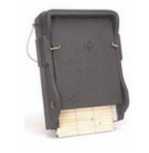
1FF Schwegler bat box
General
- The River Dee is located 560metres to the north of the study area. No work to be carried out near any freshwater.
- Shell Brook a tributary of the Dee is located 130 metres to the west. No work to be carried out near any freshwater.
- Knolton Wood is a large broadleaved woodland which runs down the western boundary of the study area. There is no intention to enter this wood.
- As far as is known there are no invasive non-native species (INNS) on site or in the immediately locality.
- The land with the application site is all within ownership of the applicant. There are no public footpaths or likely deliberate trespass of non-native material or species.
- The development is located on existing hardstanding and therefore no digging or removal of ground surface is to be disturbed or removed.
- There is no existing landscaping around and therefore the potential for accidental spread as a consequence of survey, import of materials such as soil and vegetation is limited.
- The Construction Method Statement, written within the planning and access statement will be followed in association of the site preparation and working conditions.

This Bio-security Risk Assessment (BioRA) outlines the measures to be taken to try to ensure this continues to be the case.
- It will be given to all contractors and surveyors working at the site. In addition, all contractors will be asked for their bio-security policies.
- Each policy must include, at the very least, a protocol that matches the NRW “Clean check dry procedure” which can be found at http://www.nonnativespecies.org/checkcleandry/biosecurity-for-everyone.cfm (accessed June 2017).

Therefore there is very little likelihood of any inherent risk to aggravate the possibility of introducing invasive non-native species.

CONTROL MEASURES
This considers:

The well-being, safety and the protection of neighbouring properties, residents and local amenities as well as the general public to ensure they are not adversely affected by the construction works and site operations that may be taking place.

Reasonable Avoidance Measures as stated above, including:

Site Traffic and Deliveries
The site has good access for vehicles and the roadway to the site is capable of taking heavy vehicles in bad weather conditions.

The applicant has no knowledge of potential overland and underground services.

All deliveries will take place in a dedicated location as agreed on site. If necessary, to prevent traffic back log on the road, deliveries will be arranged at suitable times when least impact will be caused to neighbouring residents.

Site traffic, will due to the nature of the site, be limited to within the development boundaries and therefore have little risk to the general public.

Storage of plant and materials
On site storage will be kept to a minimum possible to reduce the attraction to thieves
and vandalism. Materials will be stored in the designated area as agreed on site.

Measures to control emission of dust and dirt from site
During spells of dry weather if the site becomes dusty, a damping down procedure will be in place to prevent effect to neighbouring properties and the transfer of any material.

Due to the nature of the site construction plant will remain on site, reducing the risk of dust and mud being tracked onto the carriageway. Visitors and contractors will park on a hard surface car park as agreed on site.
If applicable, any excavations and other processes that will cause mud to be left on roads, a wheel wash facilities will be put in place. The roads around the site would also be swept on a regular basis to stop the build-up of dust/mud, as necessary.

Material use, waste and recycling
All materials used in the construction will be sourced as environmentally friendly and
economically as possible.

All waste will be sorted into the appropriate skips for either preferably re-use, recycling or as a last resort disposal.

Any hazardous wastes will be dealt with by an appropriately qualified and competent person as shall be disposed of in the correct manor at a registered disposal plant for the particular waste; receipts of disposal shall be kept in the site office as proof of the correct disposal.

No waste materials generated as a result of the proposed construction operations will be burnt on site. All such refuse will be disposed of by suitable alternative methods.

CONCLUSIONS
- Reasonable Avoidance Measures ( RAMS) are in place
- Private land with no public access or footpaths
- Construction work being carried out on existing hardstanding
- Contractors will be guided by the Construction Method Statement
- No work to be carried out near any freshwater – River Dee or Shell Brook
- The main purpose of a biosecurity risk assessment is to prevent or reduce tree health risks both in the short and long term
- The study area is located on existing hardstanding with little or no excavation

REFERENCES
- http://www.nonnativespecies.org/checkcleandry/biosecurity-for-everyone.cfm
- https://data.gov.uk/dataset/5ae2af0c-1363-4d40-9d1a-e5a1381449f8/sssi-impact-risk-zones-england
- https://magic.defra.gov.uk/MagicMap.aspx
- Arbor Vitae Preliminary Ecology Assessment

