
Materials specified at:
Advanced Brighter Future Group
3 Belmont Road
Wrexham
LL13 7PW

Planning Approval Ref: P/2018/0448
Condition(s) to satisfy: no. 3

External Facing Material: Off white K-Render
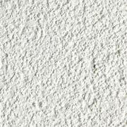

Roof Covering: Polyroof 185 flat roofing system from Polyroof Products Ltd.
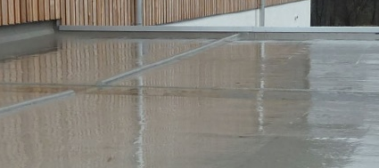

Windows: Anthracite Aluminum Windows
